## TITLE: Arithmetic operations on 16-bit numbers.

PRN: 22510064

DATE: 15/9/2023

AIM: Arithmetic operations on 16-bit numbers.

a.       Write a program to perform 16-bit addition, subtraction, multiplication and division on GNU8085 simulator

b.       Perform 16-bit addition, subtraction, multiplication and division on Dyna 8085 kit.

HARDWARE USED: Dyna Kit.

SOFTWARE USED: GNU8085 simulator

PROCEDURE:

* Install the GNU 8085 simulator software
* Open the simulator and create a new project.
* Write the assembly language code for your program in the editor.
* Assemble the code by clicking on the “assemble” button
* Run the program by clicking on the “run” button.

**ADDITION OF TWO 16 BIT NUMBERS:**

**ASSEMBLY LANGUAGE PROGRAM:**

|  |  |  |  |
| --- | --- | --- | --- |
| **Address** | **Mnemonics** | **OP Code** | **Comments** |
| C000 | MVI A, 00H | 3E | [A]<-00H |
| C001 |  | 00 |  |
| C002 | STA D006H | 32 | [D006H] <- [A] |
| C003 |  | 06 |  |
| C004 |  | D0 |  |
| C005 | LHLD D000H | 2A | Load register pair with contents at memory location D000H and D001H |
| C006 |  | 00 |  |
| C007 |  | D0 |  |
| C008 | XCHG | EB | Exchange contents of register pair DE and HL |
| C009 | LHLD D002H | 2A | Load register pair with contents at memory location D002H and D003H |
| C00A |  | 02 |  |
| C00B |  | D0 |  |
| C00C | DAD D | 19 | Add contents of register pair DE to register pair HL |
| C00D | SHLD D004H | 22 | Store contents of register pair HL to memory location D004H and D005H |
| C00E |  | 04 |  |
| C00F |  | D0 |  |
| C010 | JNC SKIP | D2 | Jump on no carry |
| C011 |  | 18 |  |
| C012 |  | C0 |  |
| C013 | MVI A, 01H | 3E | [A]<-01H |
| C014 |  | 01 |  |
| C015 | STA D006H | 32 | [D006H] <- [A] |
| C016 |  | 06 |  |
| C017 |  | D0 |  |
| C018 | SKIP: HLT | 76 | Stop |

**ADDITION OF TWO 16 BIT NUMBERS ON GNU & DYNA KIT:**

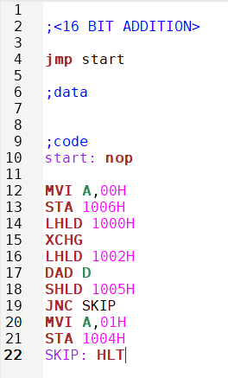

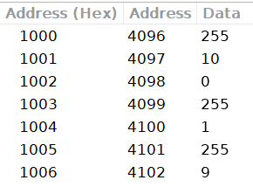

**INPUT:**

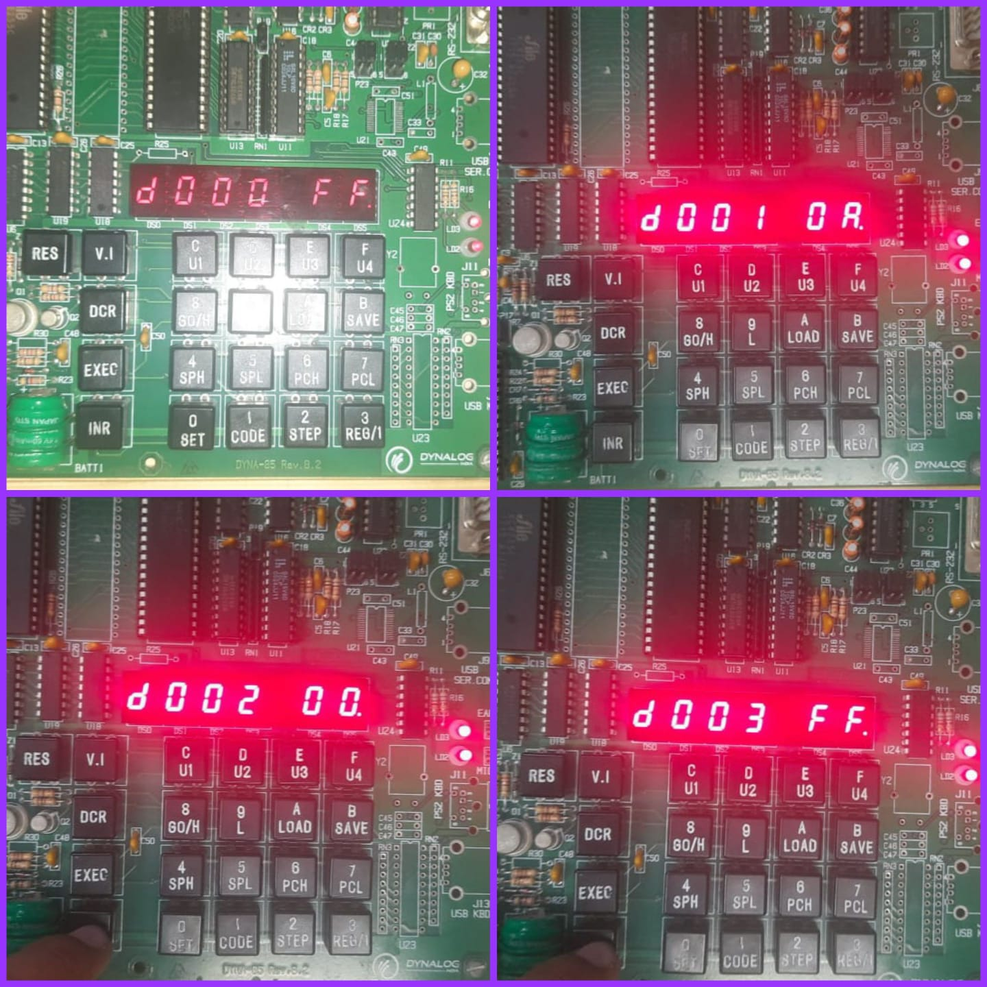

**OUTPUT:**

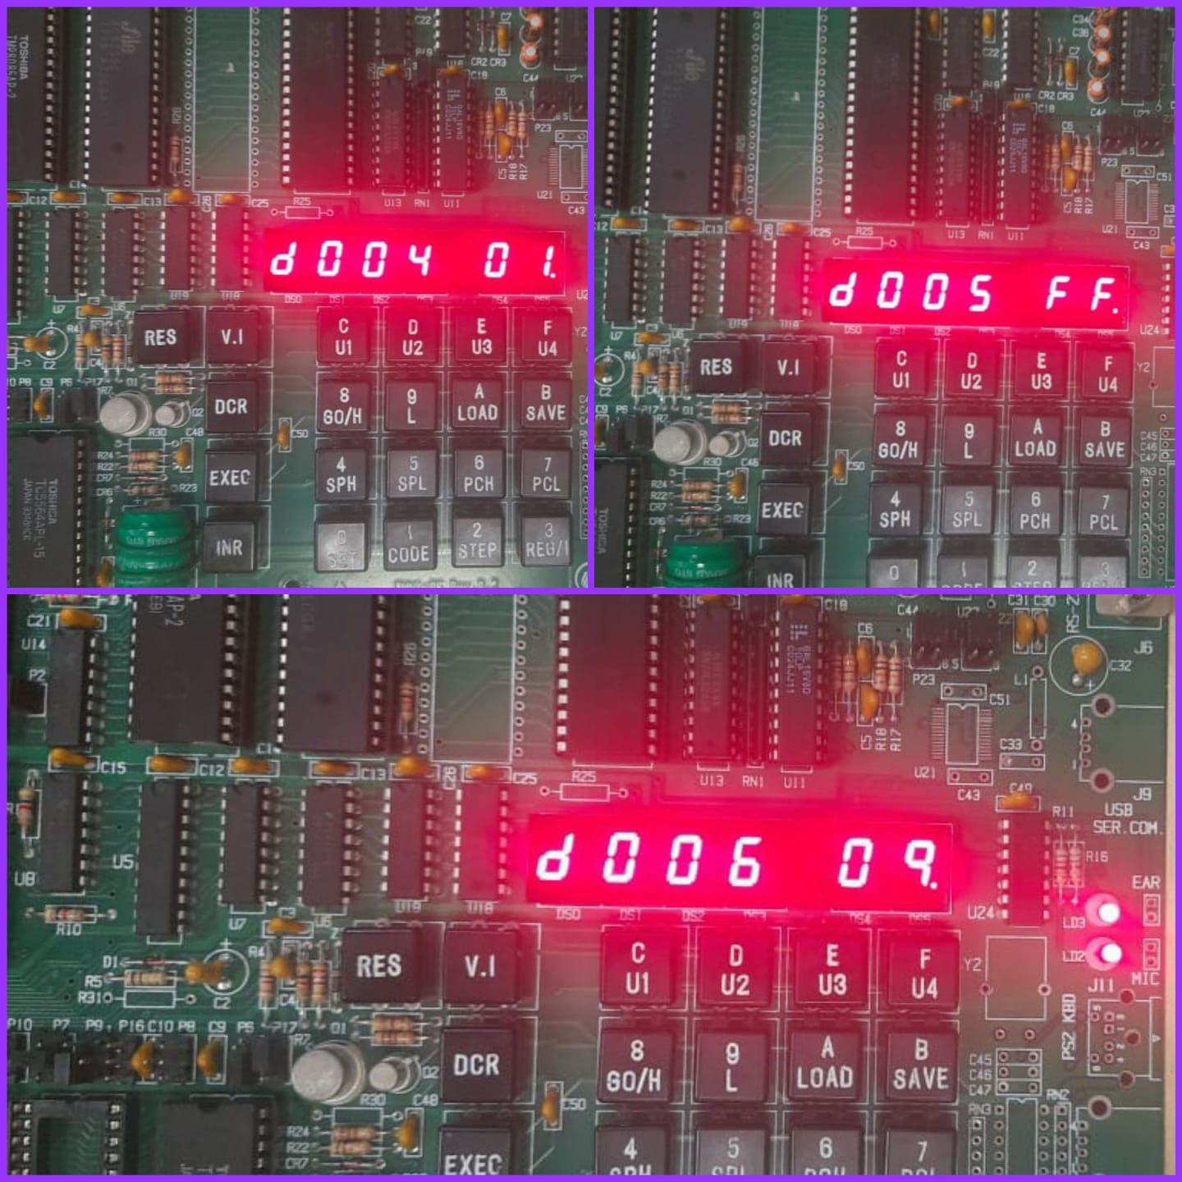

**SUBTRACTION OF TWO 16 BIT NUMBERS:**

**ASSEMBLY LANGUAGE PROGRAM:**

|  |  |  |  |
| --- | --- | --- | --- |
| **Address** | **Mnemonics** | **OP Code** | **Comments** |
| C000 | LHLD D000H | 2A | Load register pair HL with contents of memory location D000H and D001H |
| C001 |  | 00 |  |
| C002 |  | D0 |  |
| C003 | XCHG | EB | Exchange contents of register pair DE and HL |
| C004 | LHLD D002H | 2A | Load register pair HL with contents of memory location D00H and D001H |
| C005 |  | 02 |  |
| C006 |  | D0 |  |
| C007 | MOV A, E | 7B | [A]<-[E] |
| C008 | SUB L | 95 | [A]<-[A]-[L] |
| C009 | MOV L, A | 6F | [L]<-[A] |
| C00A | MOV A, D | 7A | [A]<-[D] |
| C00B | SBB H | 9C | [A]<-[A]-[H]-[Cy] |
| C00C | MOV H, A | 67 | [H]<-[A] |
| C00D | SHLD D004 | 22 | Store contents of register pair HL to memory location D004H and D005H |
| C00E |  | 04 |  |
| C00F |  | D0 |  |
| C010 | HLT | 76 | Stop |

**SUBTRACTION OF TWO 16 BIT NUMBERS ON GNU & DYNA KIT:**

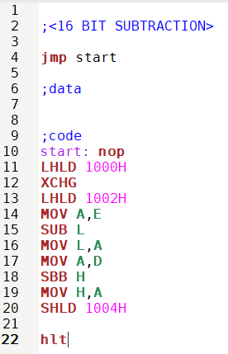

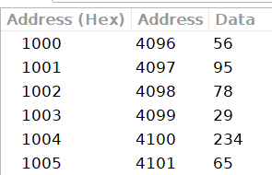

**INPUT:**

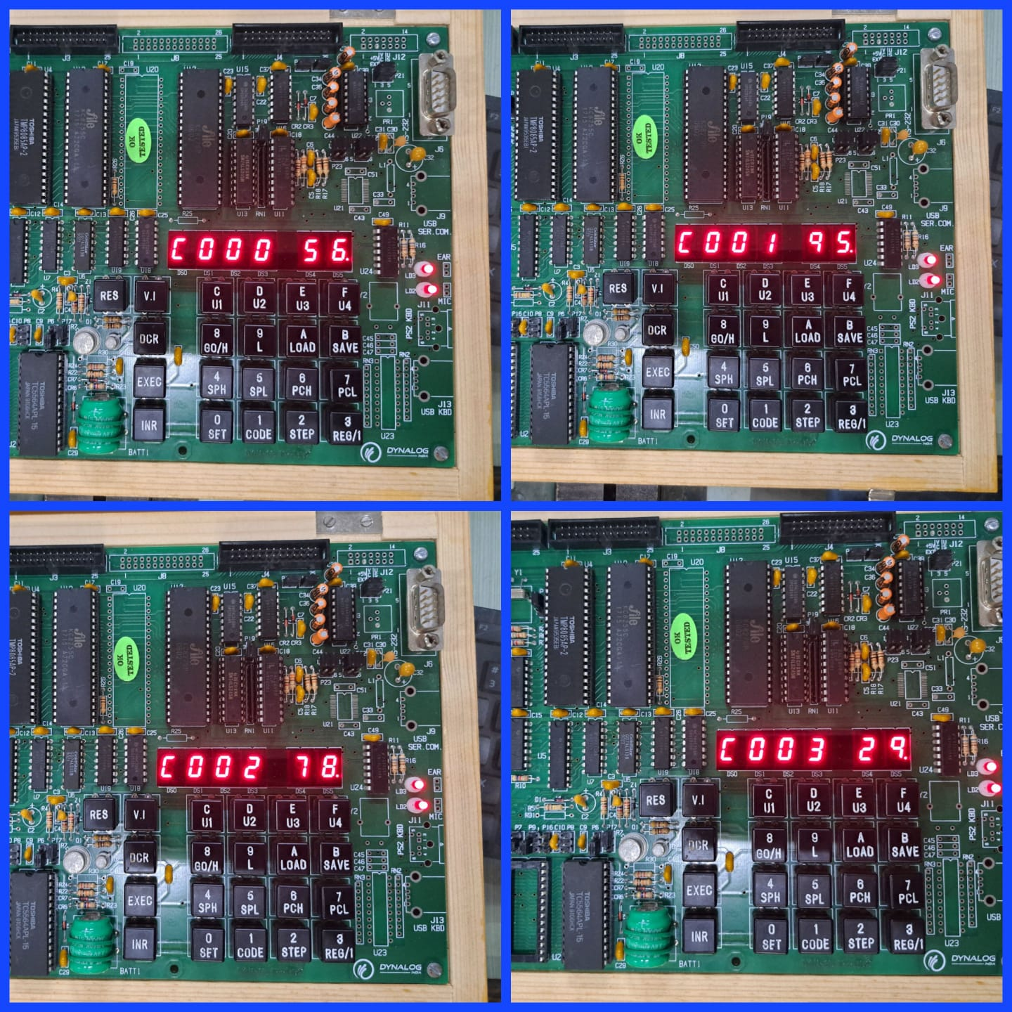

**OUPUT:**

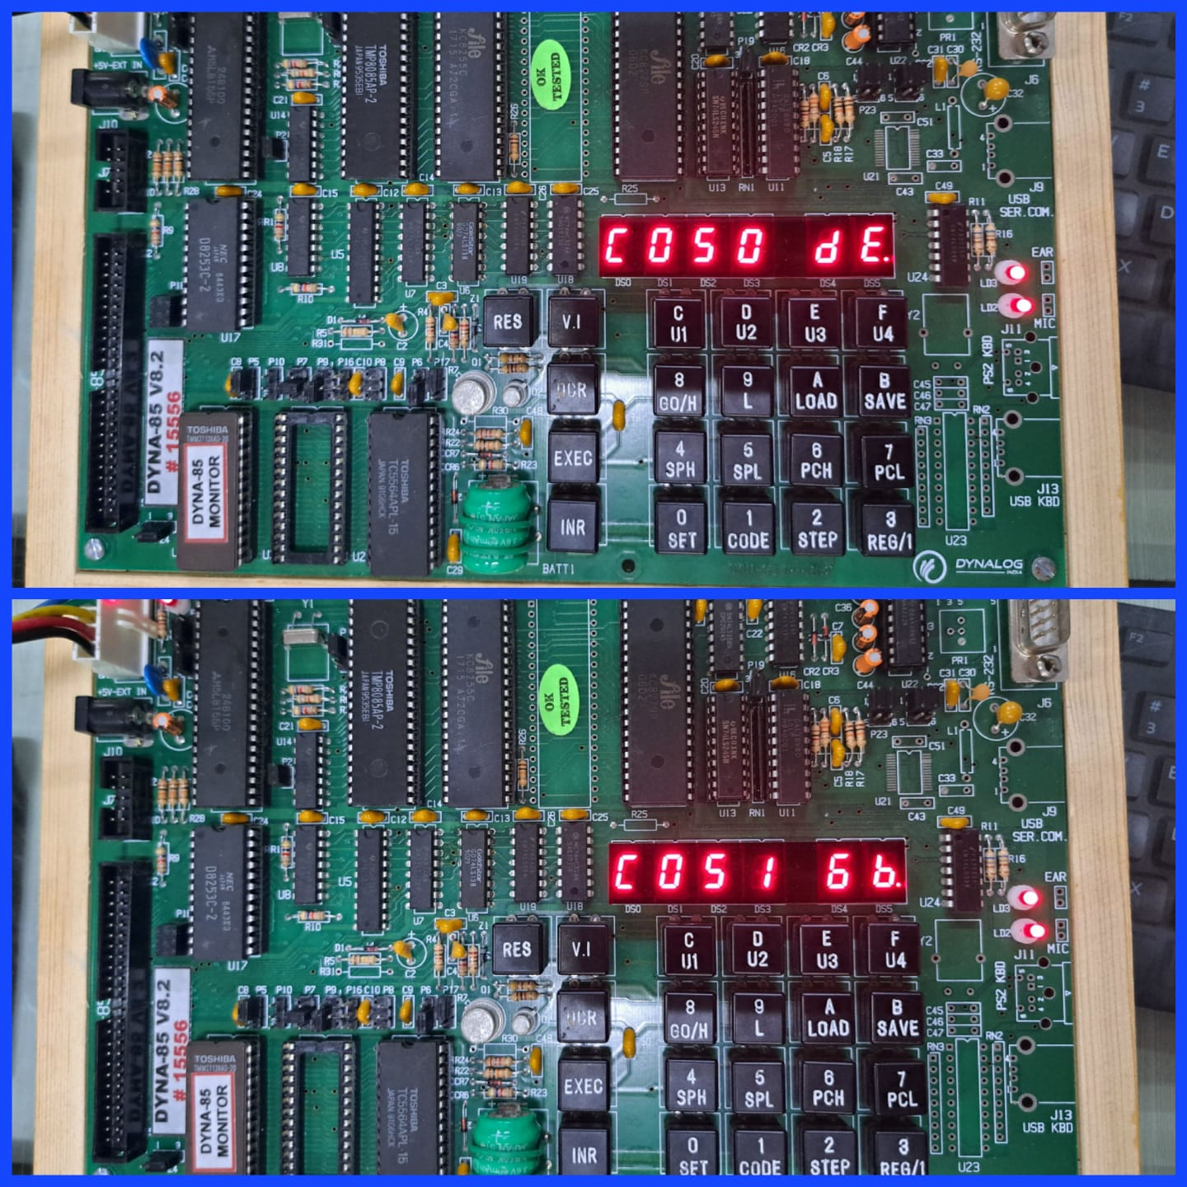

**MULTIPLICATION OF TWO 16 BIT NUMBERS:**

**ASSEMBLY LANGUAGE PROGRAM:**

|  |  |  |  |
| --- | --- | --- | --- |
| **Address** | **Mnemonics** | **OP Code** | **Comments** |
| C000 | LHLD D000H | 2A | Load register pair HL with contents of memory location D000H and D001H |
| C001 |  | 00 |  |
| C002 |  | D0 |  |
| C003 | SPHL | F9 | [SP]<-[HL] |
| C004 | LHLD D002H | 2A | Load register pair HL with contents of memory location D002H and D003H |
| C005 |  | 02 |  |
| C006 |  | D0 |  |
| C007 | XCHG | EB | Exchange contents of register pair DE and HL |
| C008 | LXI H, 0000H | 21 | [HL]<-0000H |
| C009 |  | 00 |  |
| C00A |  | 00 |  |
| C00B | LXI B, 0000H | 01 | [BC]<-0000H |
| C00C |  | 00 |  |
| C00D |  | 00 |  |
| C00E | BACK: DAD SP | 39 | [HL]<-[HL]+[SP] |
| C00F | JNC SKIP | D2 | Jump on no carry |
| C010 |  | 13 |  |
| C011 |  | C0 |  |
| C012 | INX B | 03 | Increment register pair BC |
| C013 | SKIP: DCX D | 1B | Decrement register pair DE |
| C014 | MOV A, E | 7B | [A]<-[E] |
| C015 | ORA D | B2 | [A]<-[A]V[D] |
| C016 | JNZ BACK | C2 | Jump on no-zero |
| C017 |  | 0E |  |
| C018 |  | C0 |  |
| C019 | SHLD D004H | 22 | Store contents of register pair HL to memory location D004H and D005H |
| C01A |  | 04 |  |
| C01B |  | D0 |  |
| C01C | MOV L, C | 69 | [L]<-[C] |
| C01D | MOV H, B | 60 | [H]<-[B] |
| C01E | SHLD D006H | 22 | Store contents of register pair HL to memory location D006H and D007H |
| C01F |  | 06 |  |
| C020 |  | D0 |  |
| C021 | HLT | 76 | Stop |

**MULTIPLICATION OF TWO 16 BIT NUMBERS ON GNU & DYNA KIT:**

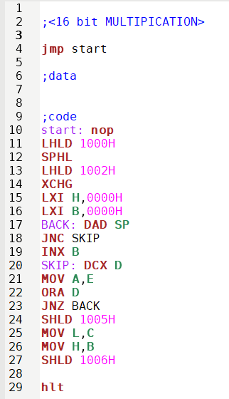

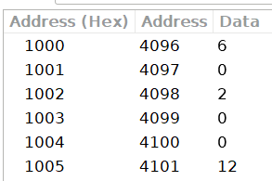

**INPUT:**

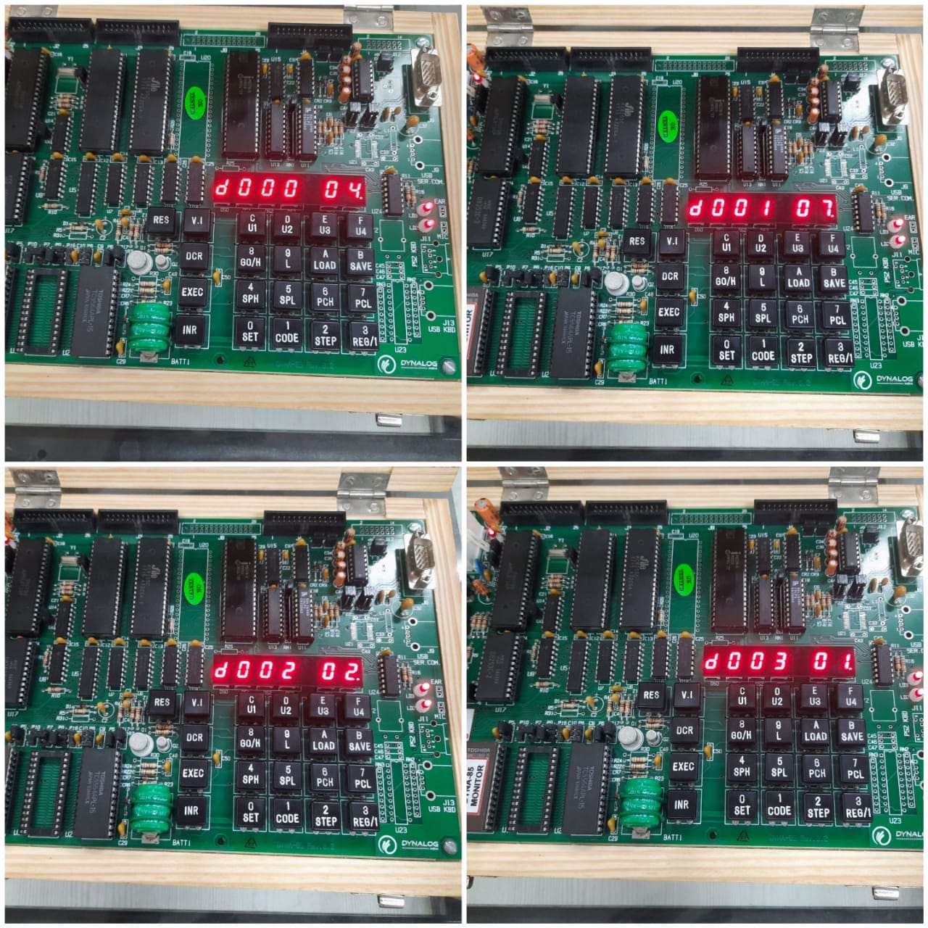

**OUTPUT:**

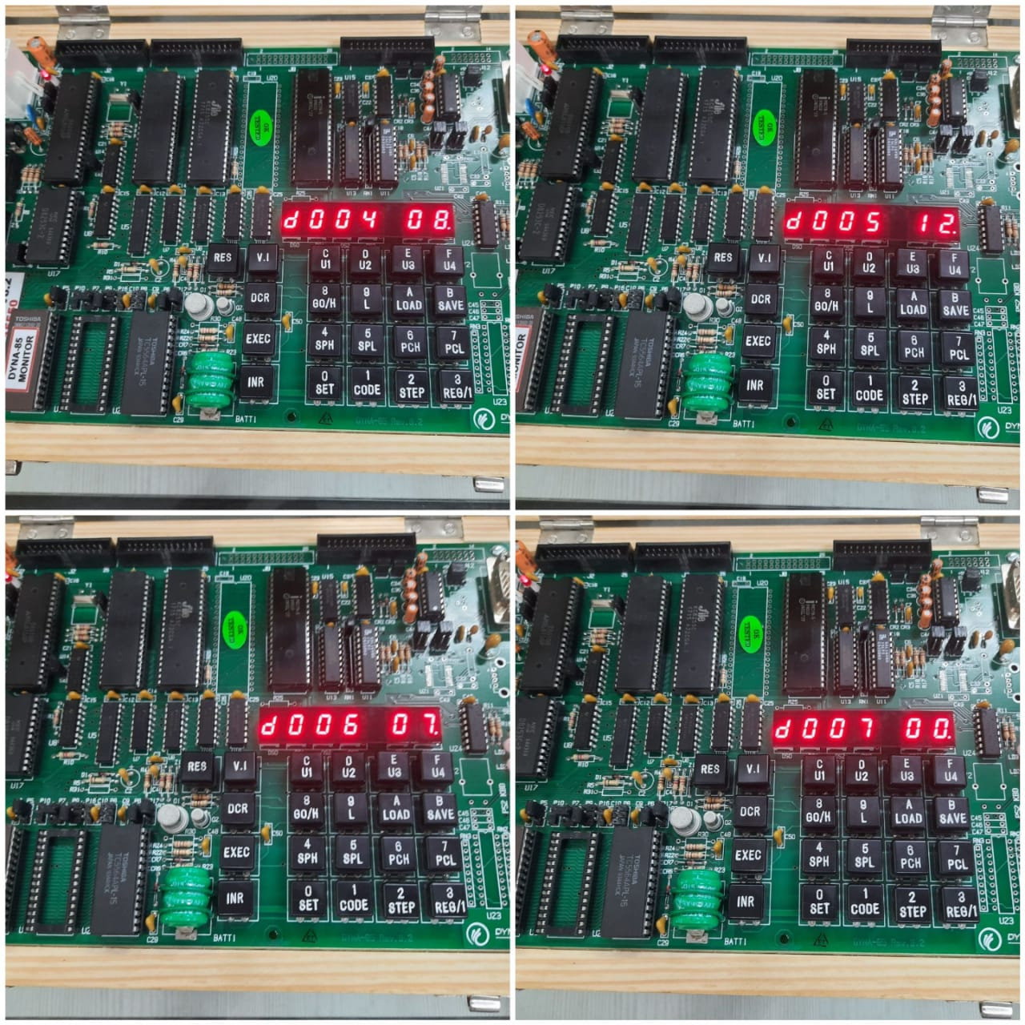

**DIVISION OF TWO 16 BIT NUMBERS :**

**ASSEMBLY LANGUAGE PROGRAM:**

| **MEMORY ADDRESS** | **MNEMONICS** | **COMMENTS** |
| --- | --- | --- |
| 2000 | LXI B, 0000H | INITIALISE QUOTIENT AS 0000H |
| 2003 | LHLD 2052H | LOAD THE DIVISOR IN HL |
| 2006 | XCHG | EXCHANGE HL AND DE |
| 2007 | LHLD 2050 | LOAD THE DIVIDEND |
| 200A | MOV A, L | A<-L |
| 200B | SUB E | A<-A-E |
| 200C | MOV L, A | L<-A |
| 200D | MOV A, H | A<-H |
| 200E | SBB D | A<-A-D |
| 200F | MOV H, A | H<-A |
| 2010 | JC 2017 | JUMP WHEN CARRY |
| 2013 | INX B | B<-B+1 |
| 2014 | JMP 200B |  |
| 2017 | DAD D | HL<-DE+HL |
| 2018 | SHLD 2056 | HL IS STORED IN MEMORY |
| 201B | MOV L, C | L<-C |
| 201C | MOV H, B | H<-B |
| 201D | SHLD 2054 | HL IS STORED IN MEMORY |
| 2020 | HLT | TERMINATES THE PROGRAM |

**DIVISION OF TWO 16 BIT NUMBERS ON GNU & DYNA KIT:**

RESULTS:

* 1) The register window shows the values of the 8085 registers.2) The memory window shows the contents of the memory.3) The instruction window shows the currently executing instruction.4)The debugger window allows you to step through the program one instruction at a time.

CONCLUSION:

* Thus, the addition, subtraction, multiplication and division operations are successfully conducted on kit as well as simulator.