## TITLE: Memory management

PRN: 22510064

DATE: 29/10/2023

AIM: Write an assembly language code to transfer a data block of m size to a new destination address. Choose suitable value for m. Perform the same on Dyna85 kit.

Top of Form

Bottom of Form

HARDWARE USED: Dyna Kit.

SOFTWARE USED: GNU8085 simulator

PROCEDURE:

* Install the GNU 8085 simulator software
* Open the simulator and create a new project.
* Write the assembly language code for your program in the editor.
* Assemble the code by clicking on the “assemble” button
* Run the program by clicking on the “run” button.

**[ HERE THE VALUE OF “M“ IS 8 ,HENCE IT IS 8 BLOCK MEMORY TRANSFER…. ]**

Here 8 block data values are taken into consideration to be transferred from 1000h to 1007h with values ranging from 1 to 8

These values then get transferred to location 1050h to 1057h with same values as previously.

**Memory Management on GNU SIMULATOR:**

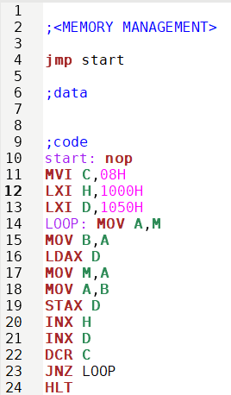

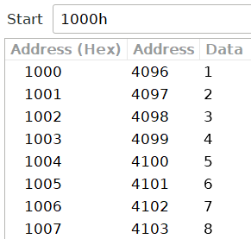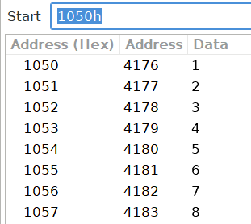

**Memory Management on DYNA KIT:**

**INPUT:**

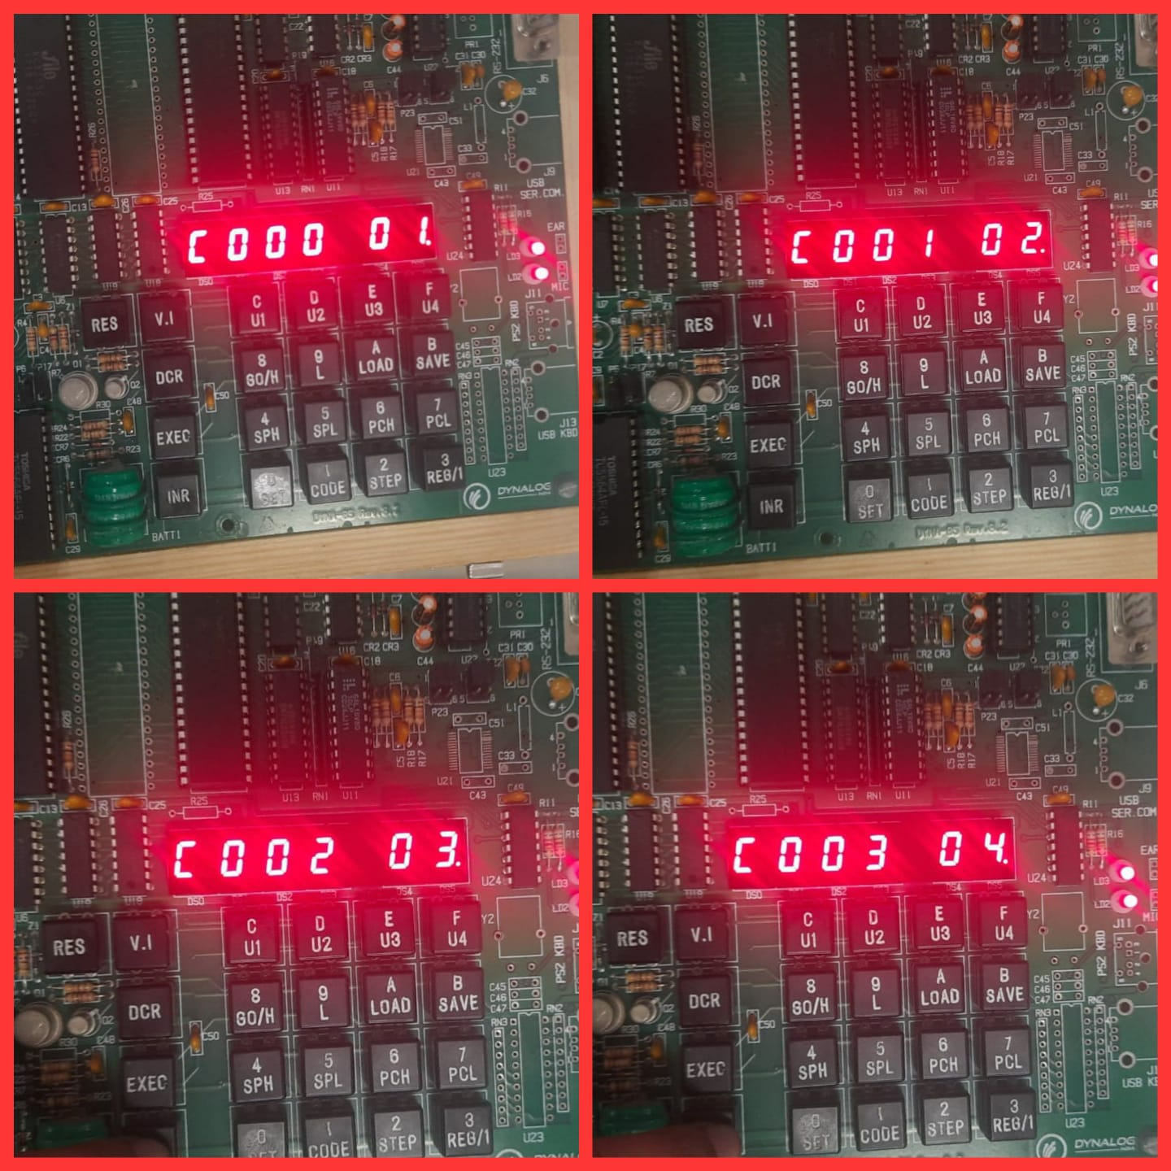

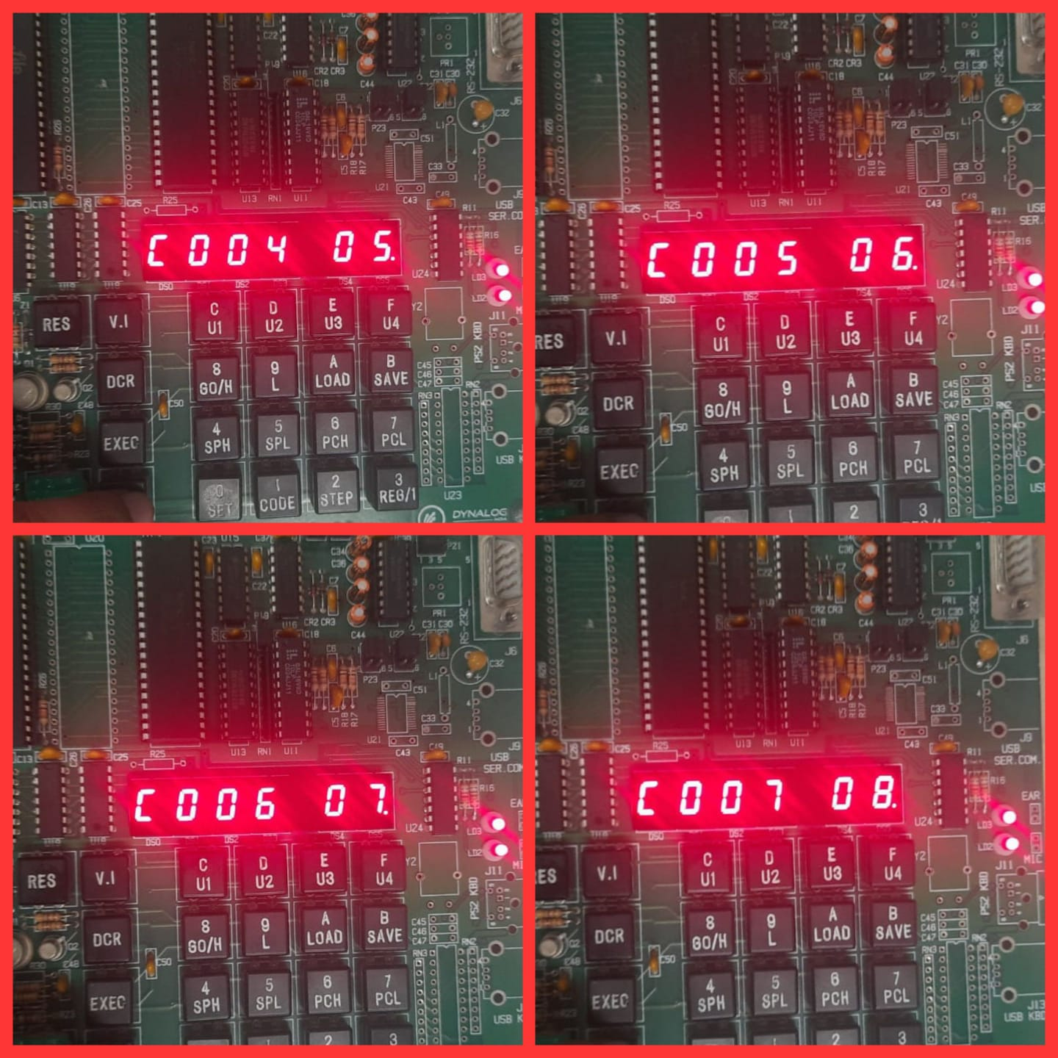

**OUTPUT:**

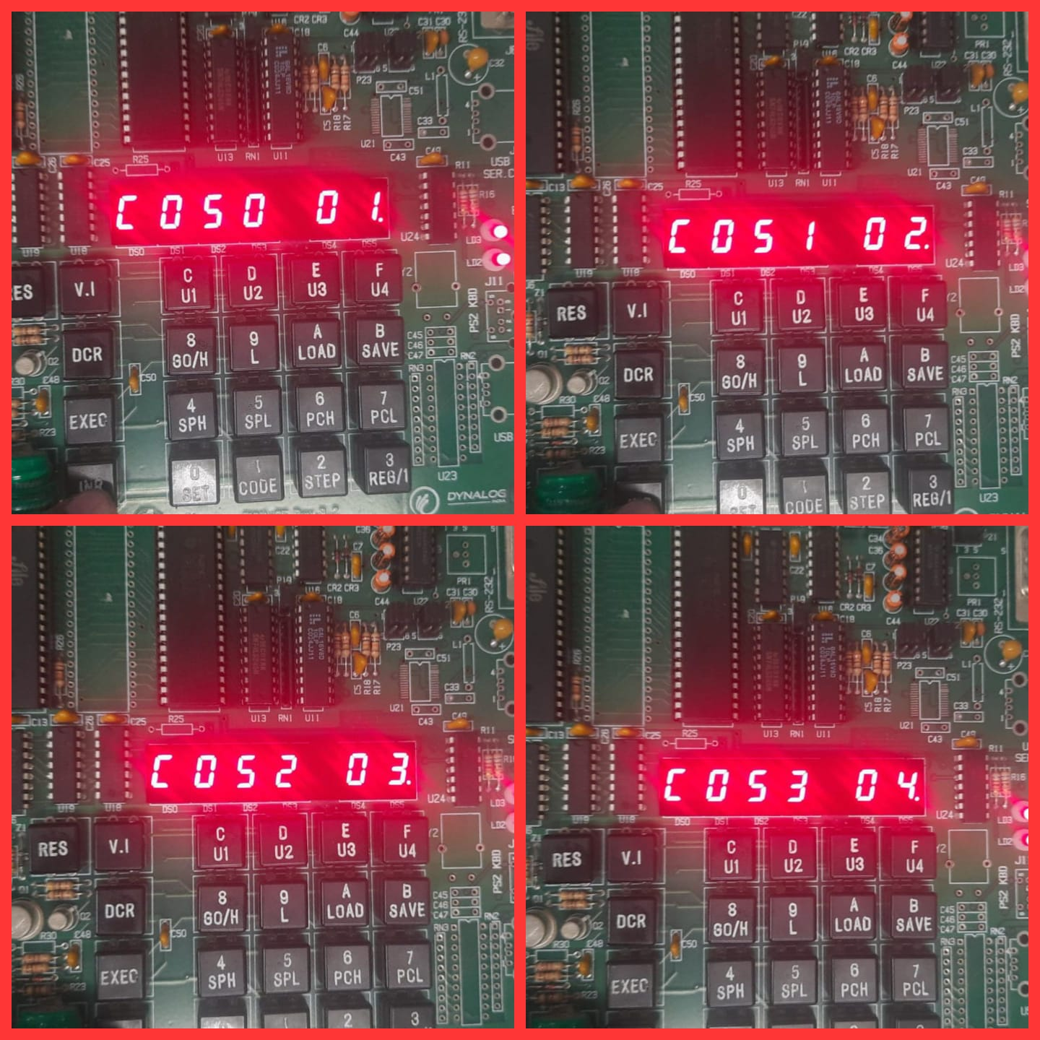

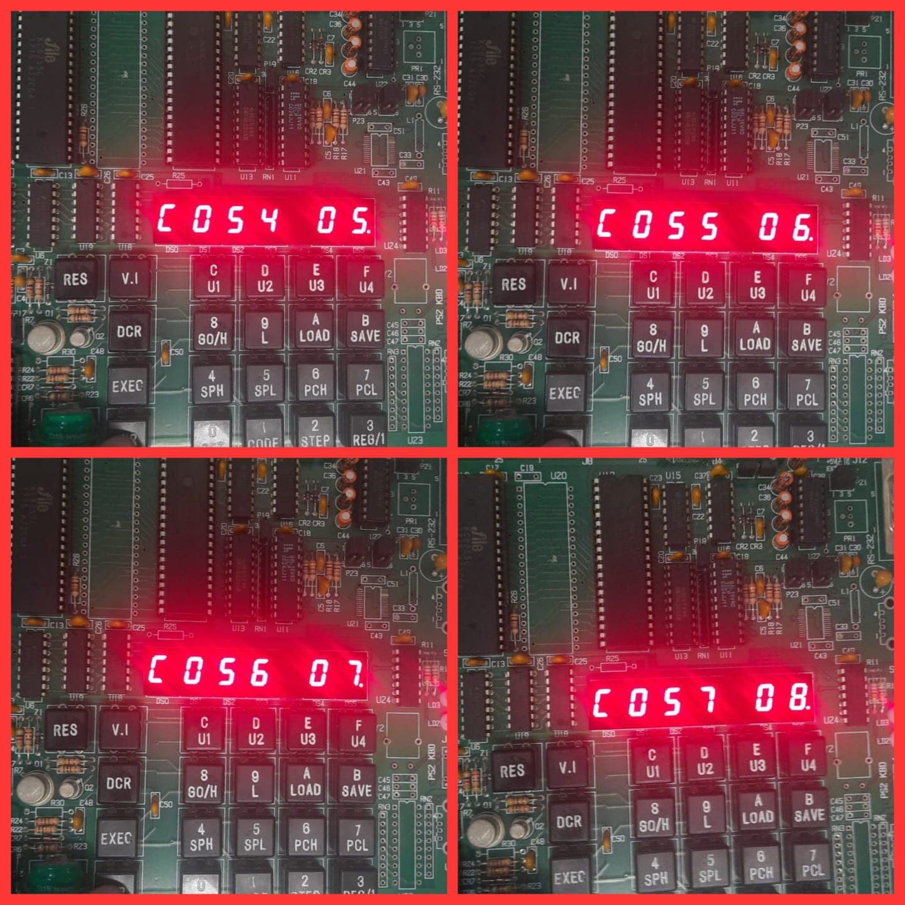

RESULTS:

* 1) The register window shows the values of the 8085 registers.2) The memory window shows the contents of the memory.3) The instruction window shows the currently executing instruction.4)The debugger window allows you to step through the program one instruction at a time.

CONCLUSION:

* Thus, the assembly language code to transfer a data block of m size to a new destination address is performed on simulator as well as kit.