## TITLE: Finding a number in an array

PRN: 22510064

DATE: 29/10/2023

AIM: Write an assembly language code to find a largest and smallest number from an array (data block) of m size to a new destination address. Choose suitable value for m. Perform the same on Dyna85 kit.

Bottom of Form

HARDWARE USED: Dyna Kit.

SOFTWARE USED: GNU8085 simulator

PROCEDURE:

* Install the GNU 8085 simulator software
* Open the simulator and create a new project.
* Write the assembly language code for your program in the editor.
* Assemble the code by clicking on the “assemble” button
* Run the program by clicking on the “run” button.

**FINDING A NUMBER IN AN ARRAY ON GNU SIMULATOR:**

**Here in this run, maximum and minimum both are performed in a program where numbers are stored initially from 2050h to 2053h randomly i.e. 45,6,7,98**

**Then we get output as maximum and minimum stored at 2060h and 2061h respectively…..**

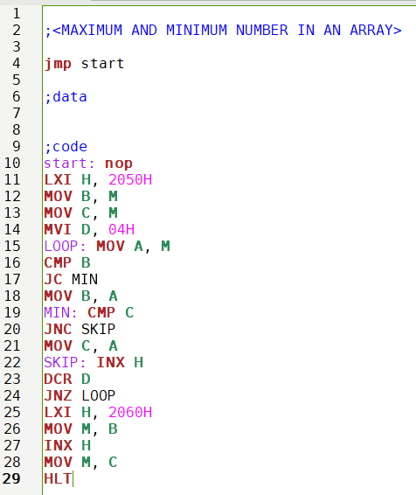

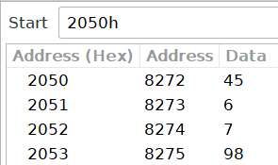

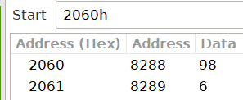

**FINDING A NUMBER IN AN ARRAY ON DYNA KIT:**

**INPUT:**

**1) MINIMUM**

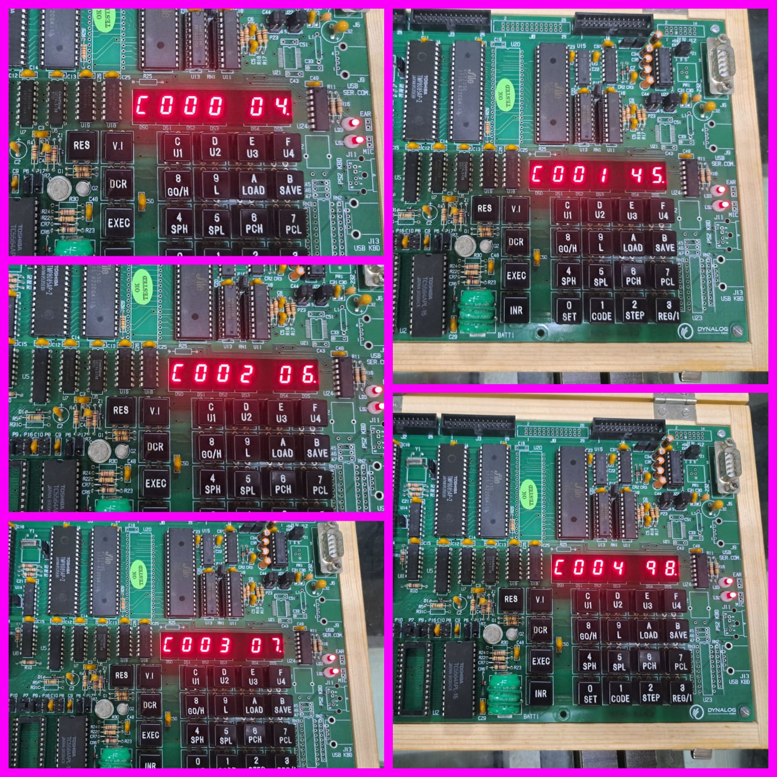

**2) MAXIMUM**

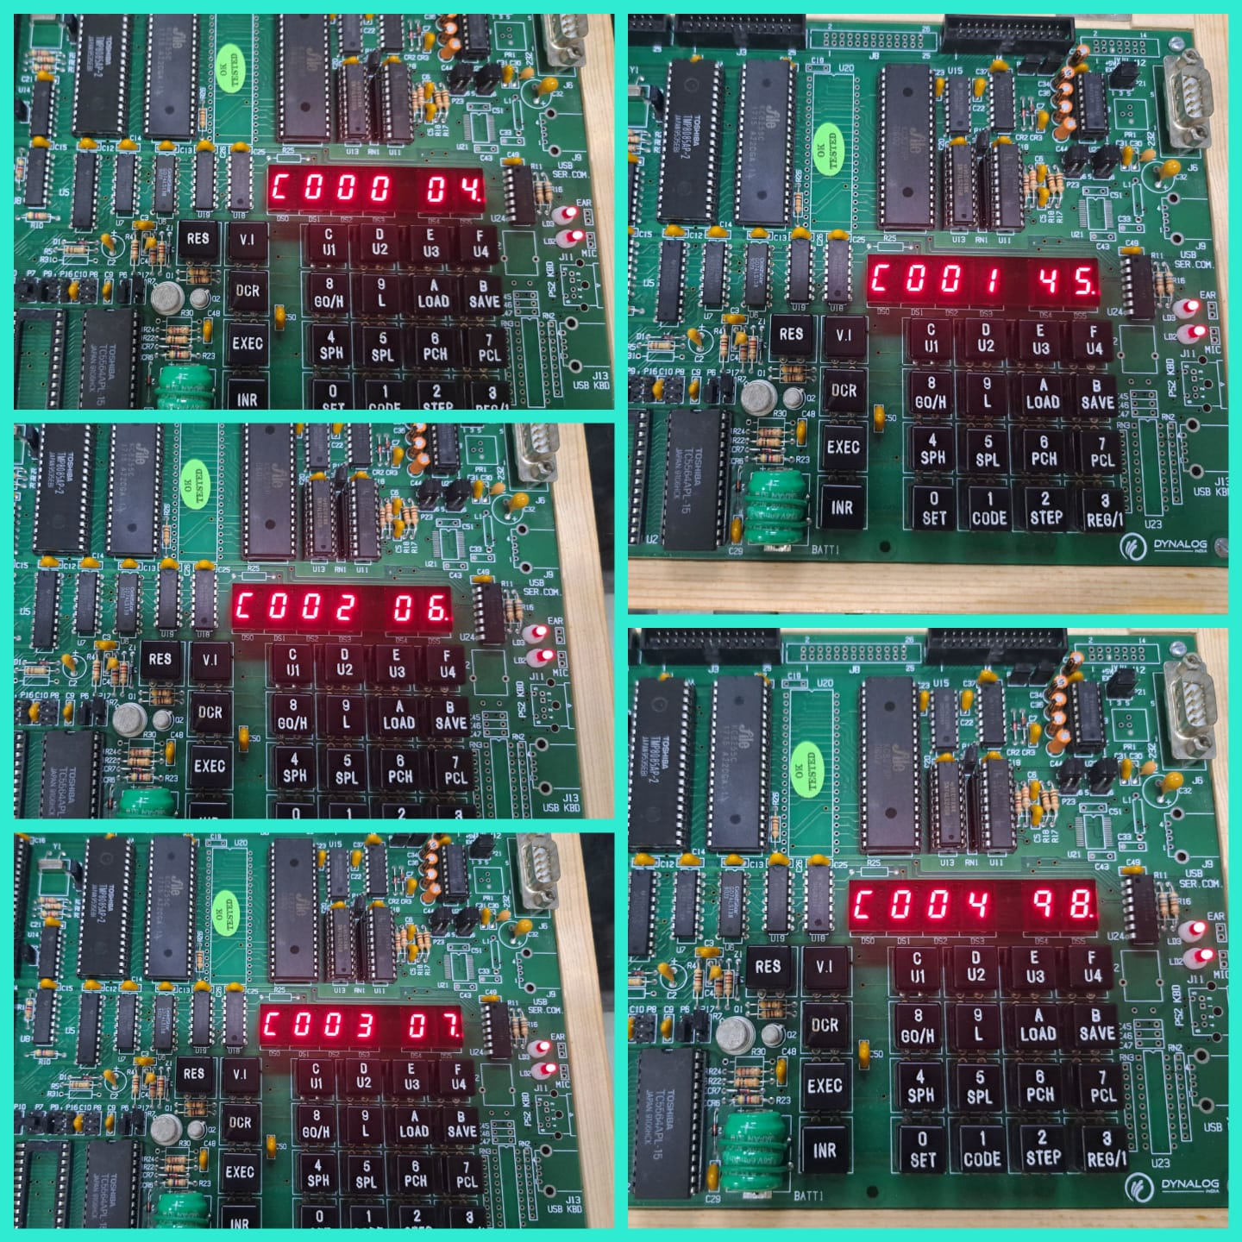

**OUTPUT:**

1. **MINIMUM**

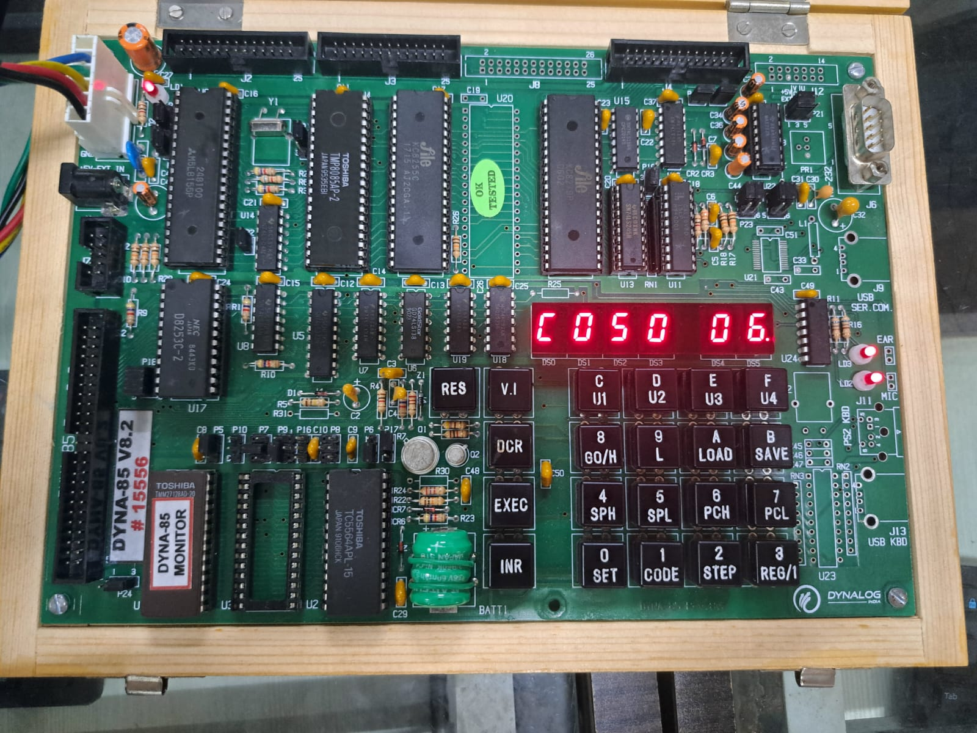

**2) MAXIMUM**

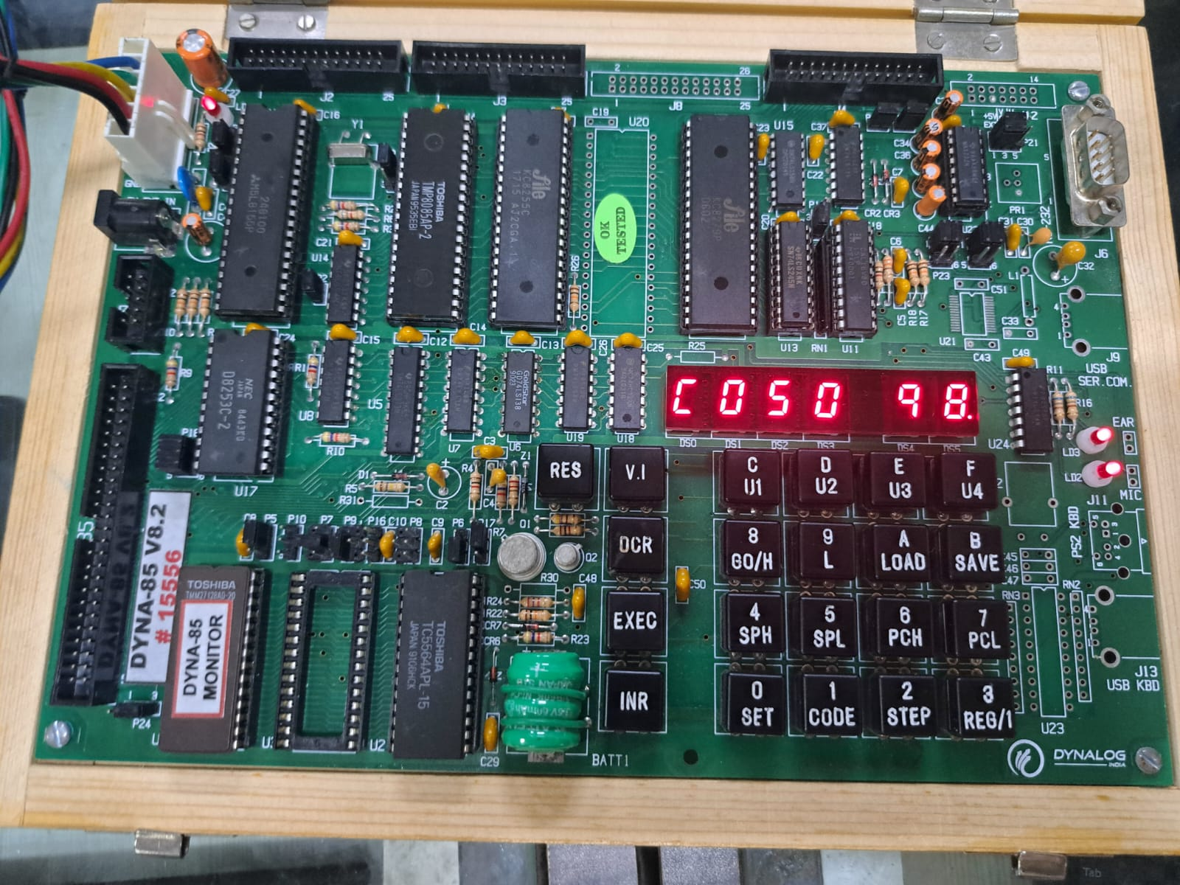

RESULTS:

* 1) The register window shows the values of the 8085 registers.2) The memory window shows the contents of the memory.3) The instruction window shows the currently executing instruction.4)The debugger window allows you to step through the program one instruction at a time.

CONCLUSION:

* Thus, an assembly language code to find a largest and smallest number from an array (data block) of m size to a new destination address is performed on simulator as well as kit.