## TITLE: Array sorting

PRN: 22510064

DATE: 29/10/2023

AIM Write an assembly language code to sort an array in ascending and descending order. Choose suitable value for m. Perform the same on Dyna85 kit.

Top of Form

Bottom of Form

Top of Form

Bottom of Form

HARDWARE USED: Dyna Kit.

SOFTWARE USED: GNU8085 simulator

PROCEDURE:

* Install the GNU 8085 simulator software
* Open the simulator and create a new project.
* Write the assembly language code for your program in the editor.
* Assemble the code by clicking on the “assemble” button
* Run the program by clicking on the “run” button.

**ARRAY SORTING ON GNU SIMULATOR:**

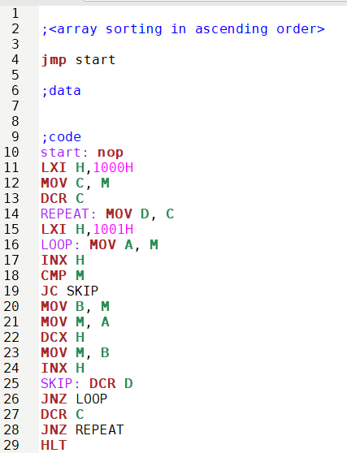

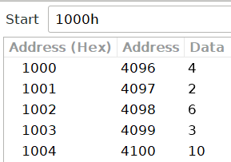

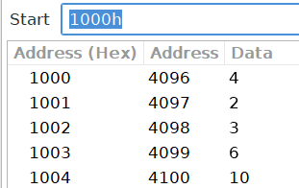

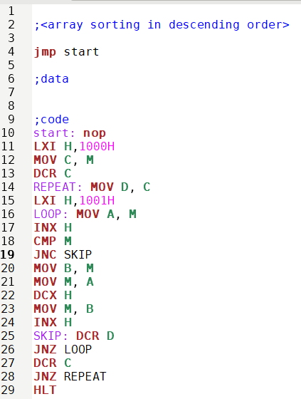



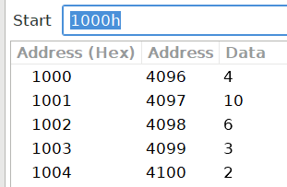

**ARRAY SORTING ON DYNA KIT:**

**INPUT FOR BOTH ASCENDING AND DESCENDING:**

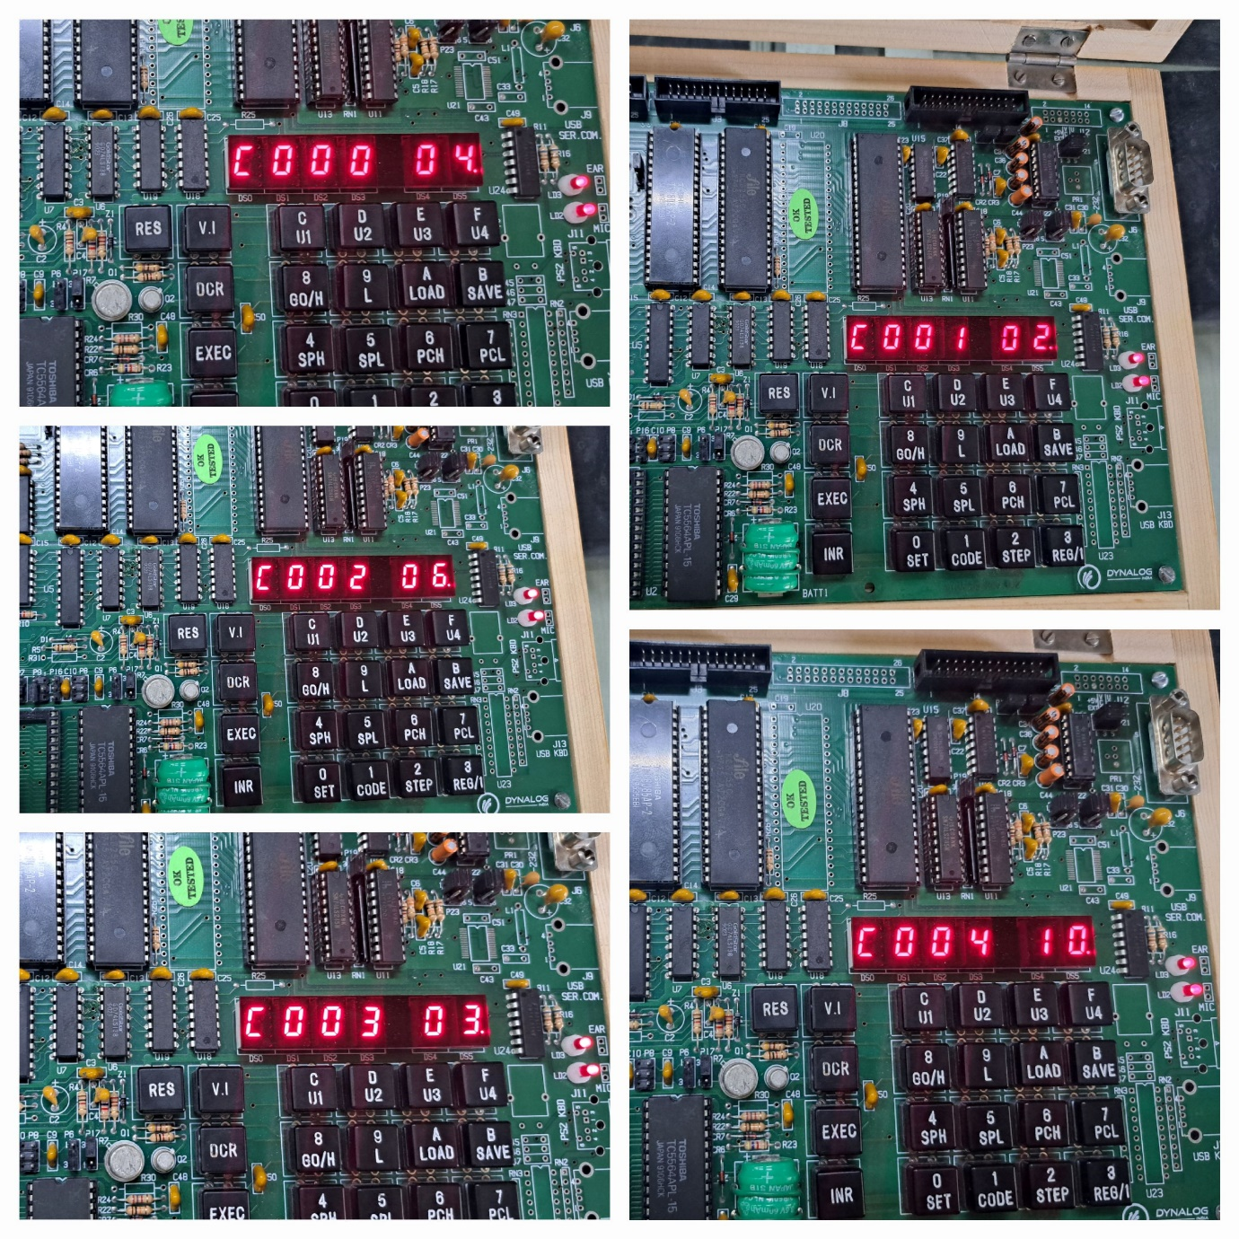

**OUTPUT FOR ASCENDING ORDER:**

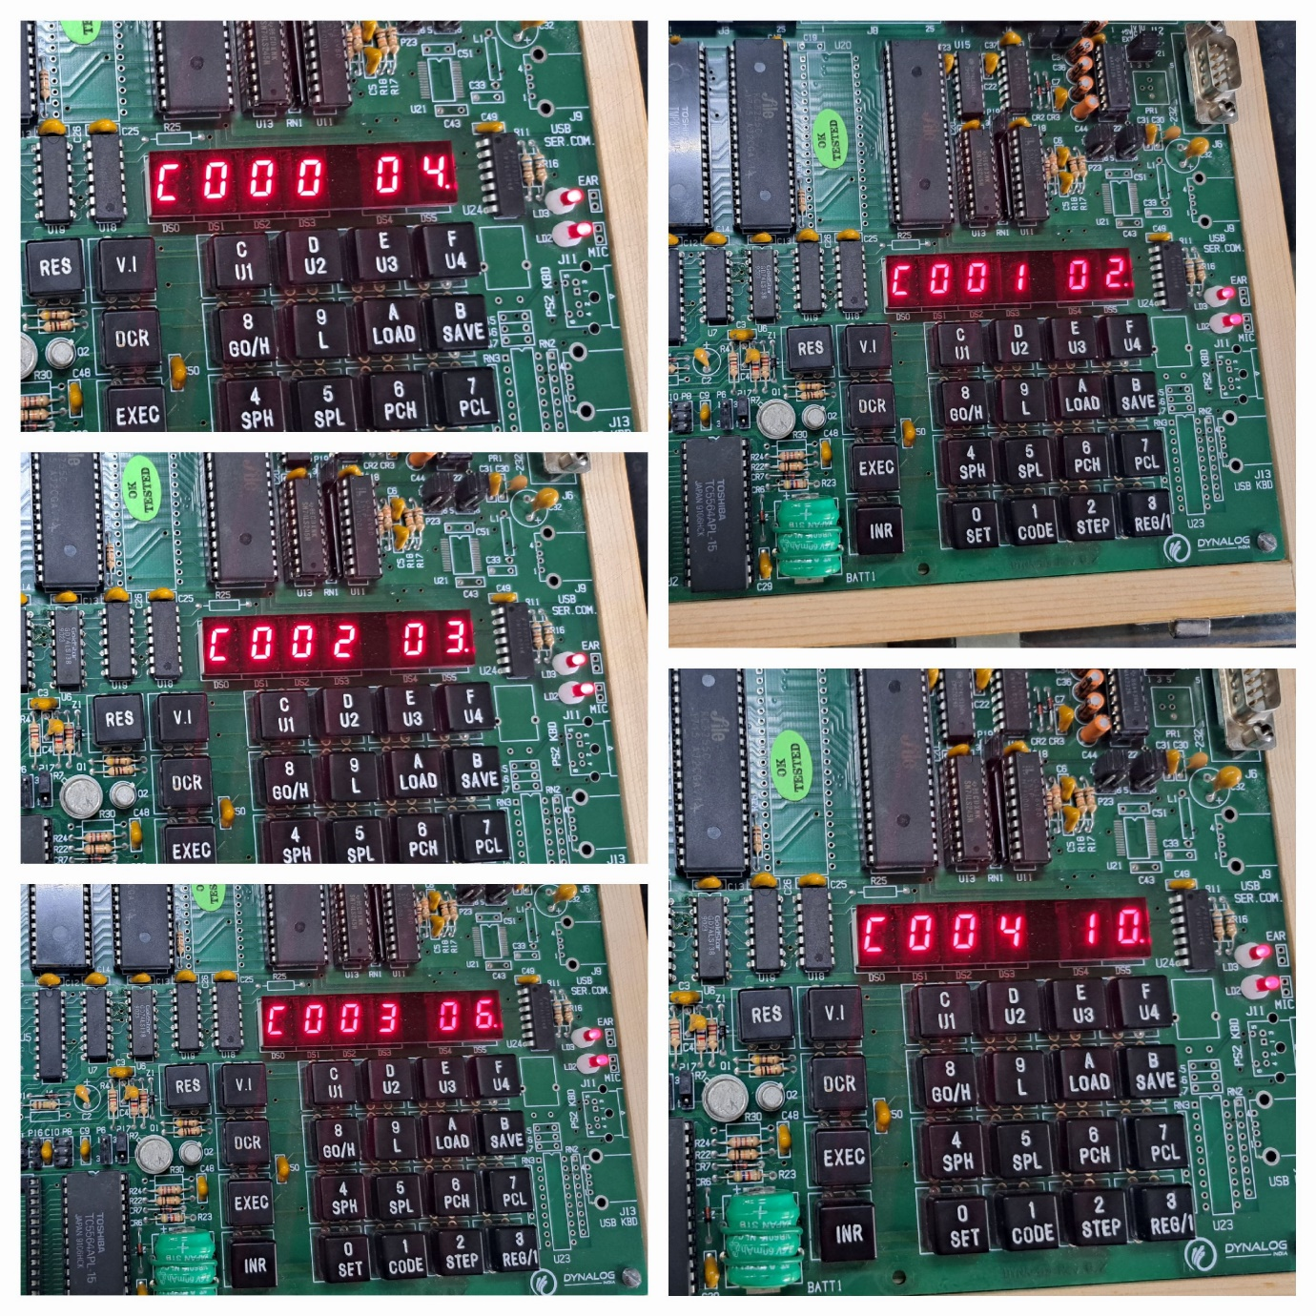

**OUTPUT FOR DESCENDING ORDER:**

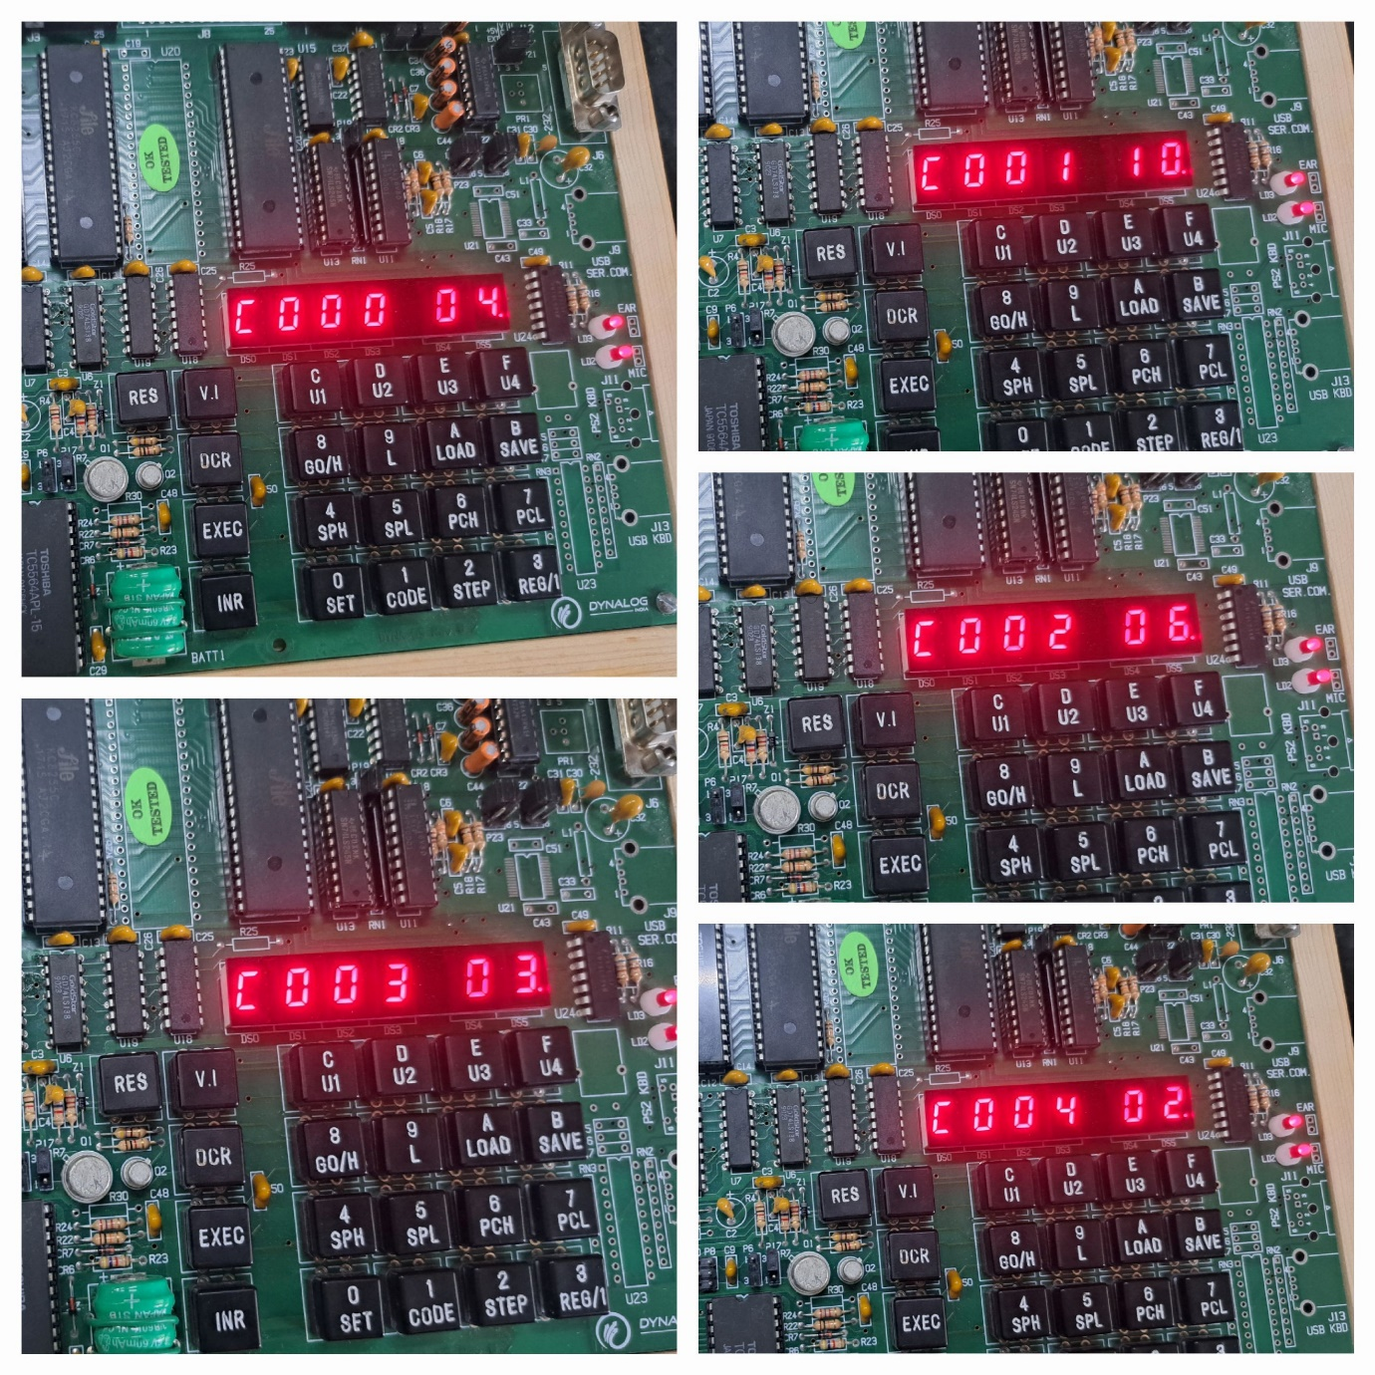

RESULTS:

* 1) The register window shows the values of the 8085 registers.2) The memory window shows the contents of the memory.3) The instruction window shows the currently executing instruction.4)The debugger window allows you to step through the program one instruction at a time.

CONCLUSION:

* Thus, an assembly language code to sort an array in ascending and descending order. Choose suitable value for m is performed on simulator as well as kit.