## TITLE: Arithmetic operations in x86 – I

PRN: 22510064

DATE: 27/11/2023

AIM: a.       Perform addition of any two 8-bit numbers on 8086 emulator

b.       Perform addition of any two 16-bit numbers on 8086 emulator

HARDWARE USED: NO

SOFTWARE USED: 8086 Emulator

PROCEDURE:

* Install the 8086 Emulator software
* Open the simulator and create a new project.
* Write the assembly language code for your program in the editor.
* Run the program by clicking on the “emulate” button.

***Perform addition of any two 8-bit numbers on 8086 emulator:***

INPUT:

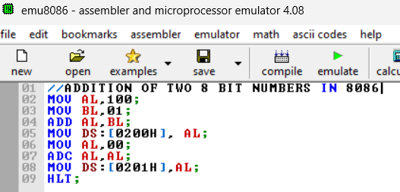

OUTPUT:

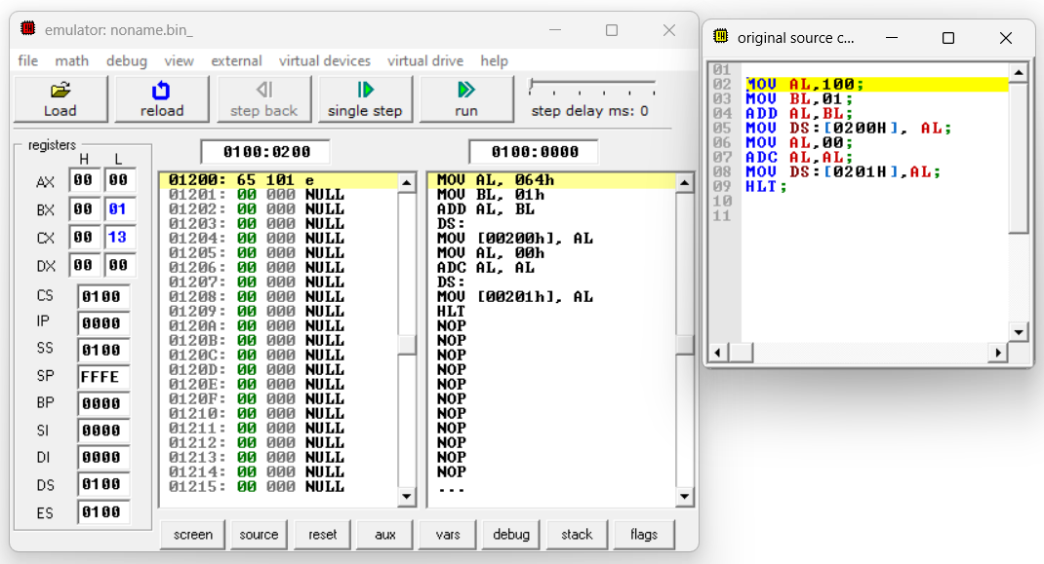

***Perform addition of any two 16-bit numbers on 8086 emulator:***

***INPUT:***

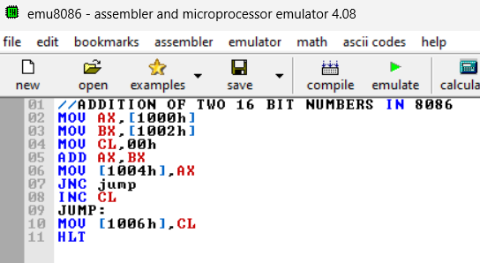

***OUTPUT:***

