PARSHWA HERWADE 22510064

DATABASE LAB EXPERIMENT 1

INSTALL ORACLE DATABASE 11G EDITION

Installing Oracle Database 11g involves several steps. Here is a basic outline of the process. Please note that the steps may vary depending on your operating system, and you should always refer to the official Oracle documentation for the most accurate and up-to-date instructions.

Prerequisites:

1. Check System Requirements:

- Ensure that your system meets the hardware and software requirements specified by Oracle for Oracle Database 11g.

2. Download Software:

- Download the Oracle Database 11g software from the official Oracle website. Ensure that you have the correct version for your operating system.

3. Create Oracle Account:

- You may need to create an Oracle account to download the software. Follow the instructions on the Oracle website to create an account if you don't have one.

Installation Steps:

4. Extract the Software:

- Extract the downloaded software to a directory on your machine.

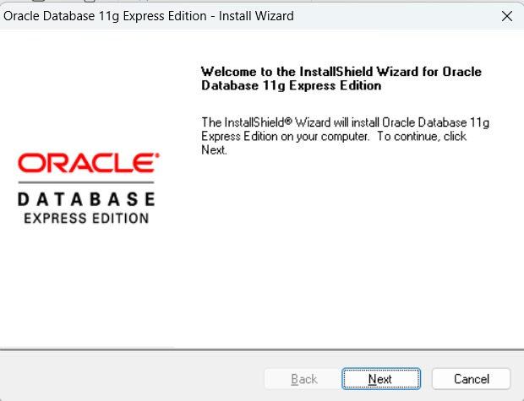

5. Run Installer:

- Navigate to the directory where you extracted the files and run the installer. This is usually done by executing a command or running a setup executable file.

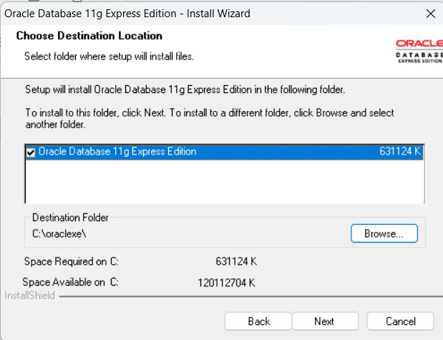

6. Follow Installer Steps:

- The Oracle Universal Installer (OUI) will guide you through the installation process. Follow the on-screen instructions.

- You will be prompted to provide information such as the installation type (Typical, Custom, etc.), Oracle home location, and other configuration settings.

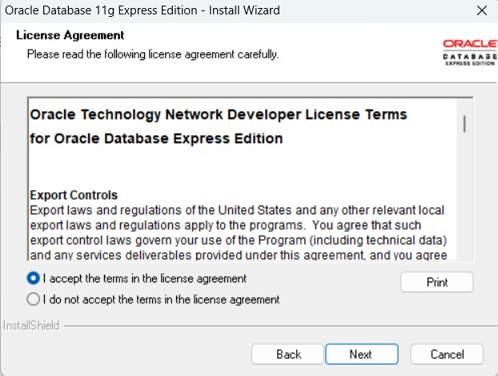

7. Configure Database:

- During the installation, you will need to configure the database. Provide the necessary information such as the database name, system and sys user passwords, and other configuration settings.

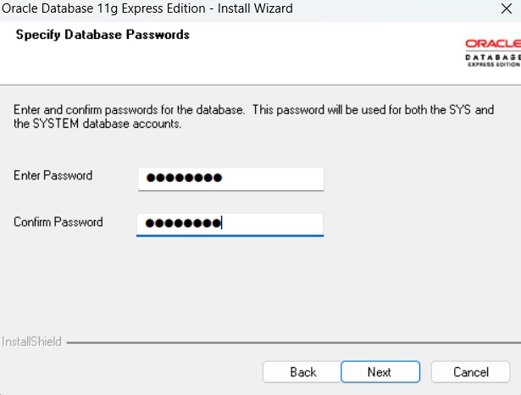

8. Run Configuration Scripts:

- After the installation is complete, the installer will prompt you to run certain configuration scripts. These scripts are crucial for setting up and configuring the database.

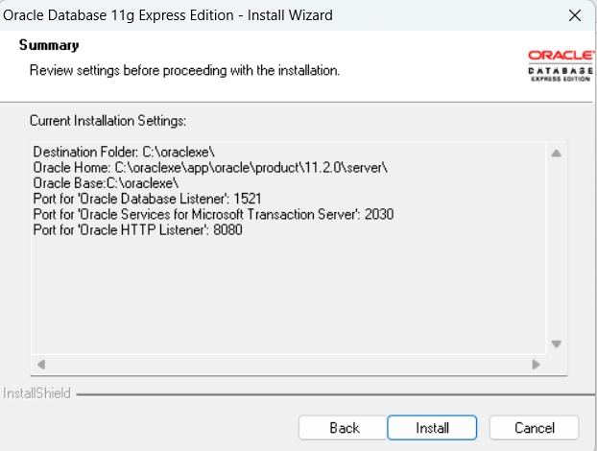

9. Complete Installation:

- Once the configuration scripts are run successfully, the installation process is complete.

