PARSHWA HERWADE 22510064

DBMS EXPERIMENT 3

DRAW ER & RELATIONAL DIAGRAM OF ONLINE RAILWAY TICKET RESERVATION (+2 xtra diagrams)

1)ONLINE RAILWAY TICKET RESERVATION

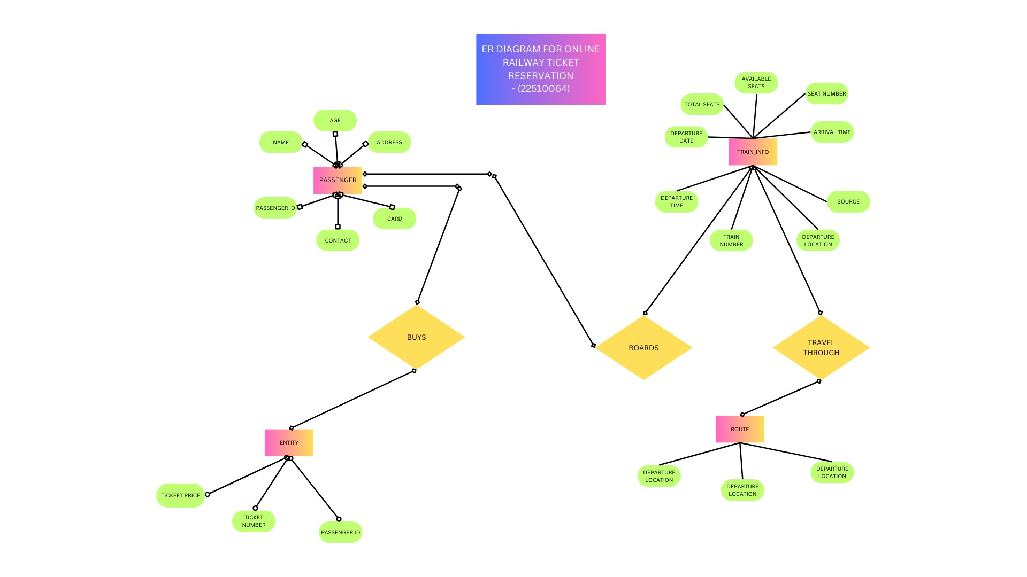

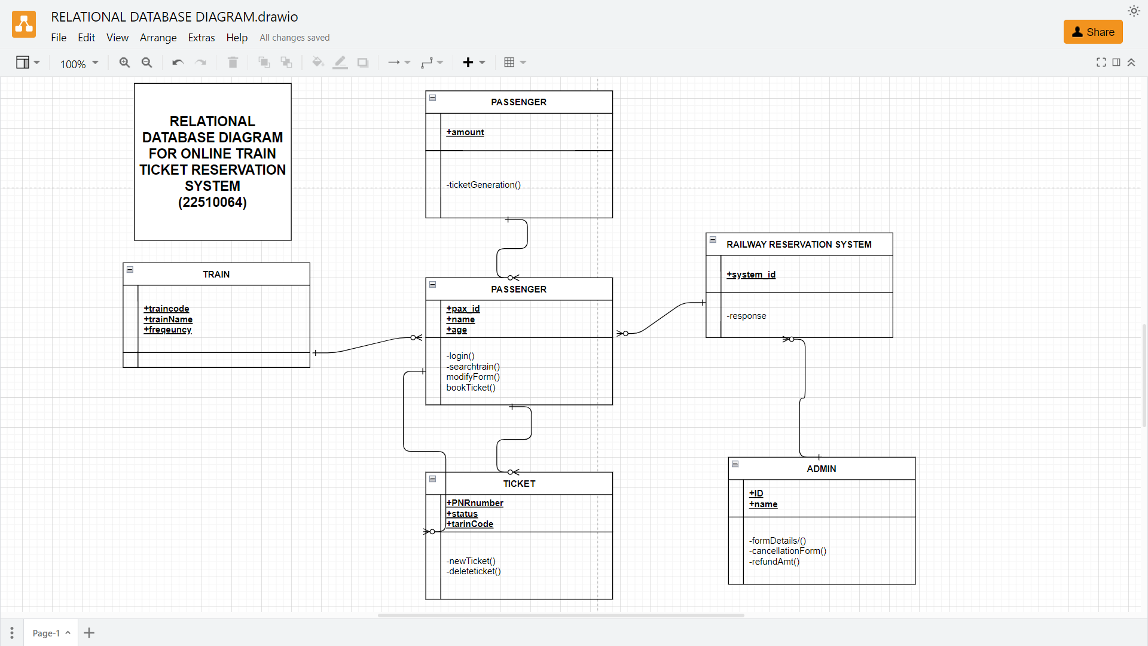

2)STUDENT ENROLLMENT SYSTEM

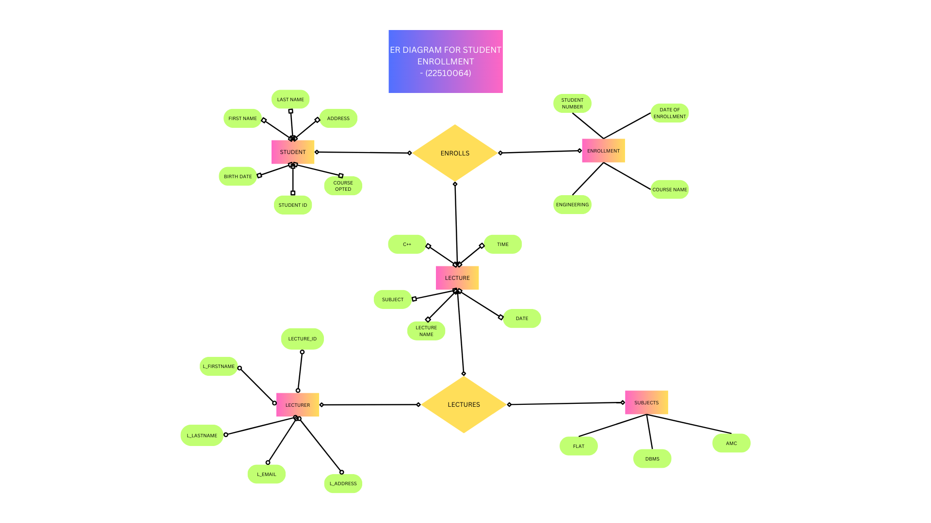

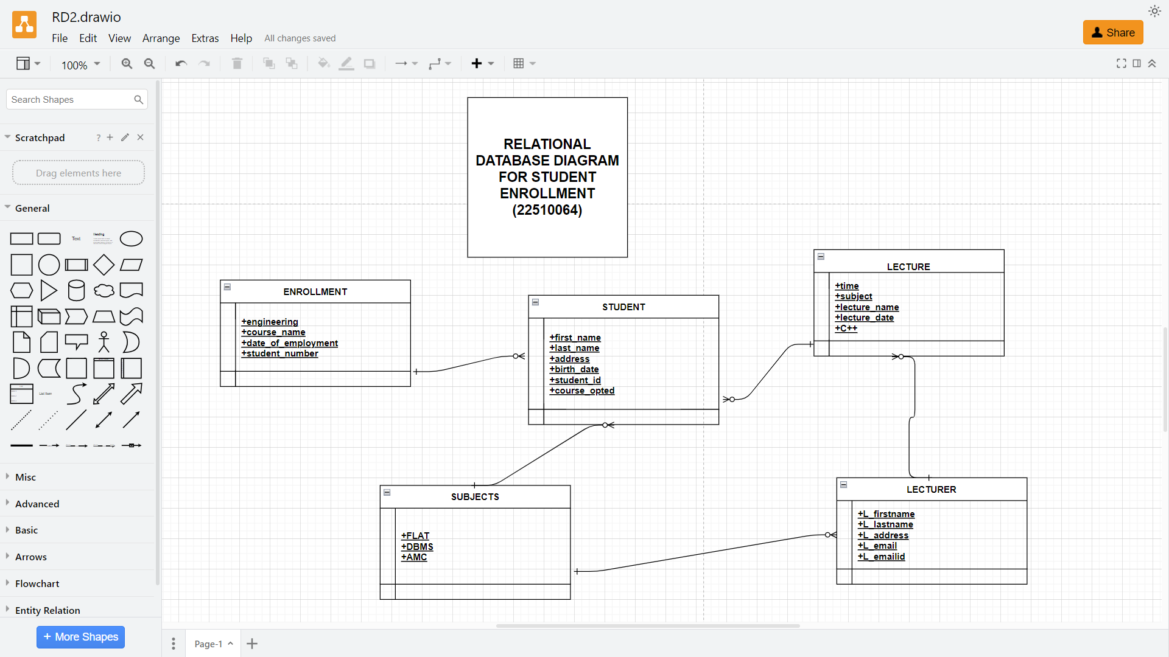

3)LIBRARY MANAGEMENT SYSTEM

