22510064 PARSHWA HERWADE

DBEL ASSIGNMNET 4

IMPEMENTATION OF DDL &DML QUERIES

**Q1. Create the following tables:**

1. client_master

|  |  |  |
| --- | --- | --- |
| **columnname** | **datatype** | **size** |
| client_no | varchar2 | 6 |
| name | varchar2 | 20 |
| address1 | varchar2 | 30 |
| address2 | varchar2 | 30 |
| city | varchar2 | 15 |
| state | varchar2 | 15 |
| pincode | number | 6 |
| bal_due | number | 10,2 |

ANS: Query Snapshot.

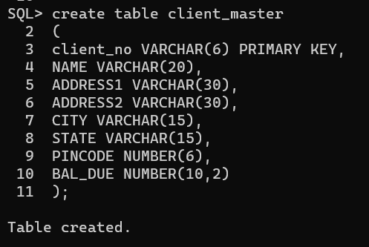

Schema snapshot.

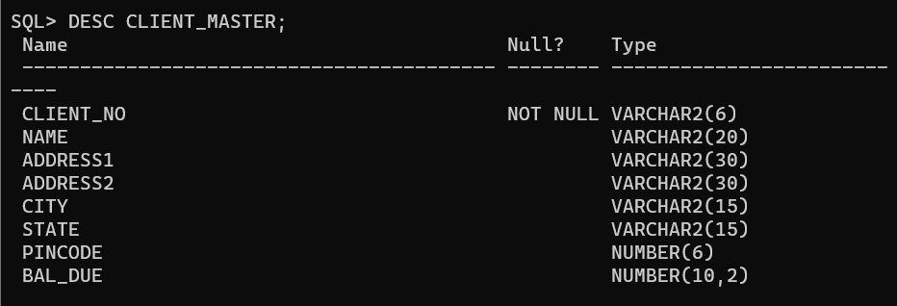

1. Product_master

|  |  |  |
| --- | --- | --- |
| **columnname** | **datatype** | **size** |
| Product_no | varchar2 |  |
| Description | varchar2 |  |
| Profit_percent | number |  |
| Unit_measure | varchar2 |  |
| Qty_on_hand | number |  |
| Reoder_lvl | number |  |
| Sell_price | number |  |
| Cost_price | number |  |

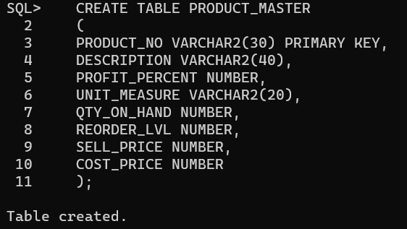

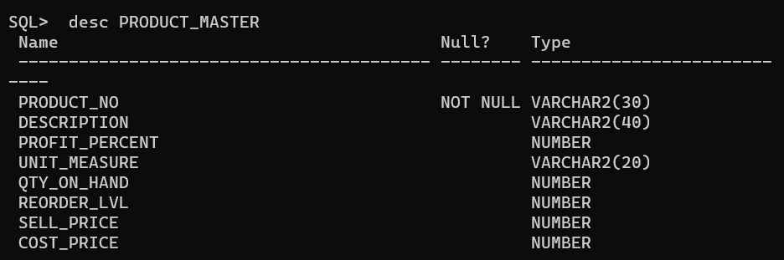

**Q2- Insert the following data into their respective tables:**

|  |  |  |  |  |  |
| --- | --- | --- | --- | --- | --- |
| **Clientno** | **Name** | **city** | **pincode** | **state** | **bal.due** |
| **0001** | **Ivan** | **Bombay** | **400054** | **Maharashtra** | **15000** |
| **0002** | **Vandana** | **Madras** | **780001** | **Tamilnadu** | **0** |
| **0003** | **Pramada** | **Bombay** | **400057** | **Maharashtra** | **5000** |
| **0004** | **Basu** | **Bombay** | **400056** | **Maharashtra** | **0** |
| **0005** | **Ravi** | **Delhi** | **100001** |  | **2000** |
| **0006** | **Rukmini** | **Bombay** | **400050** | **Maharahstra** | **0** |

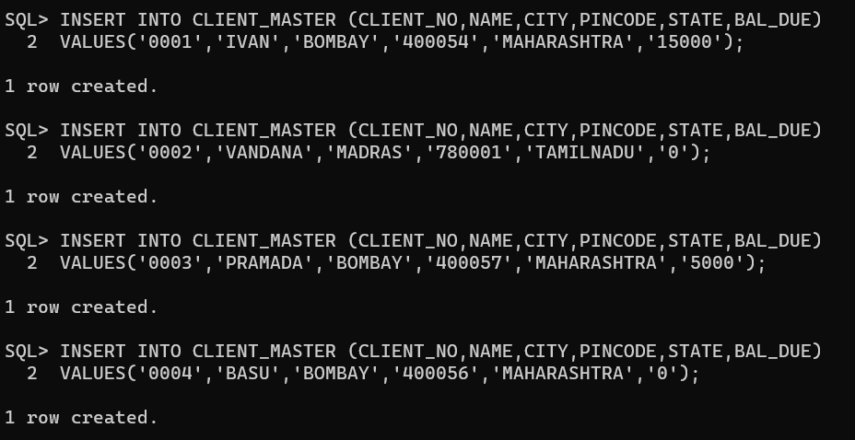

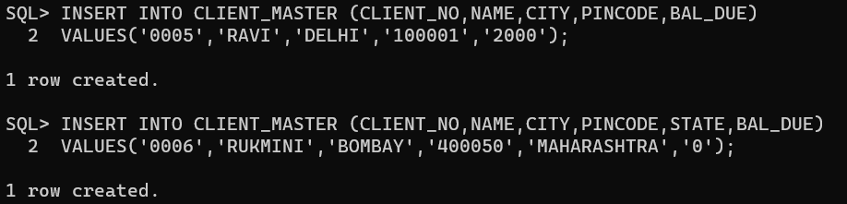

**Data for Product Master:e**

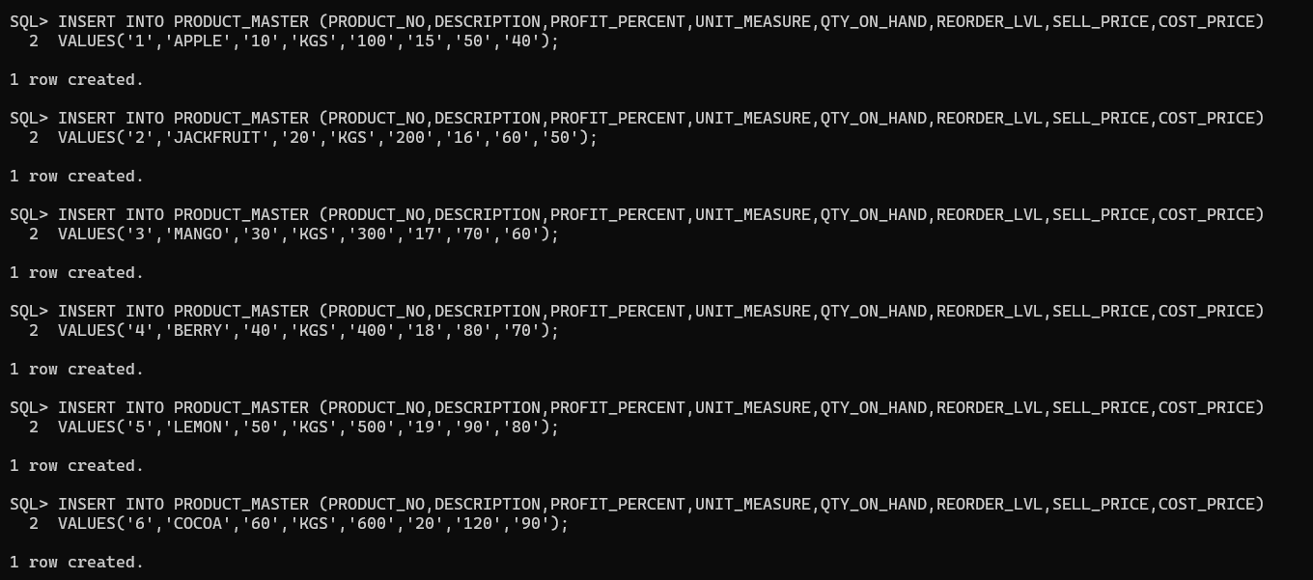

**Q3:- On the basis of above two tables answer the following Questionries:**

1. **Find out the names of all the clients.**

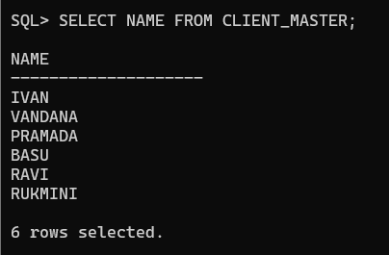

1. **Retrieve the list of names and cities of all the clients.**

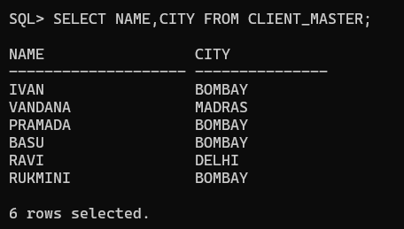

1. **List the various products available from the product_master table.**

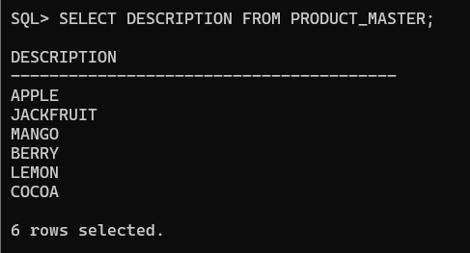

1. **List all the clients who are located in Bombay.**

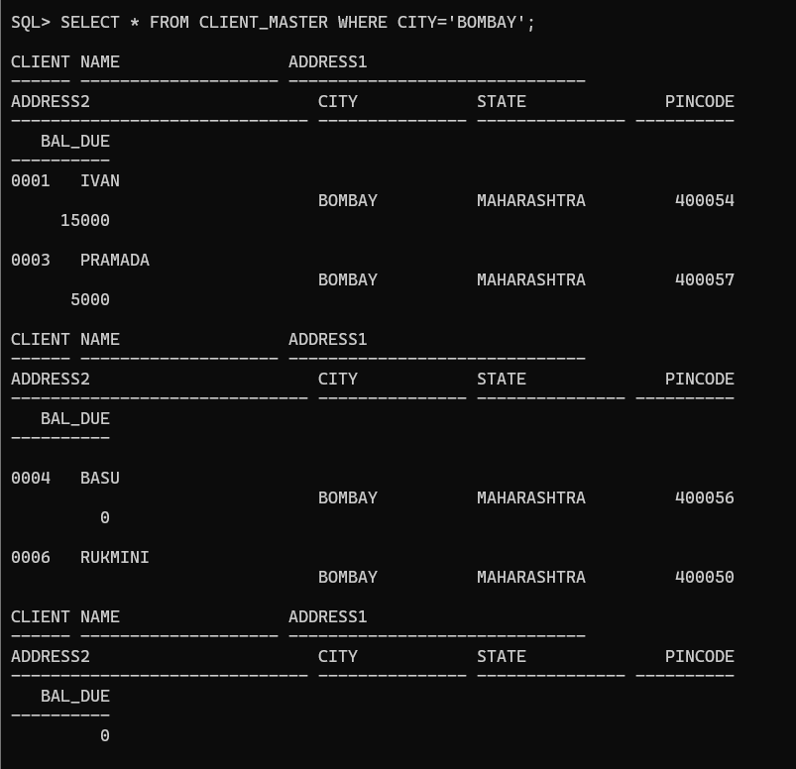

1. **Display the information for client no 0001 and 0002.**

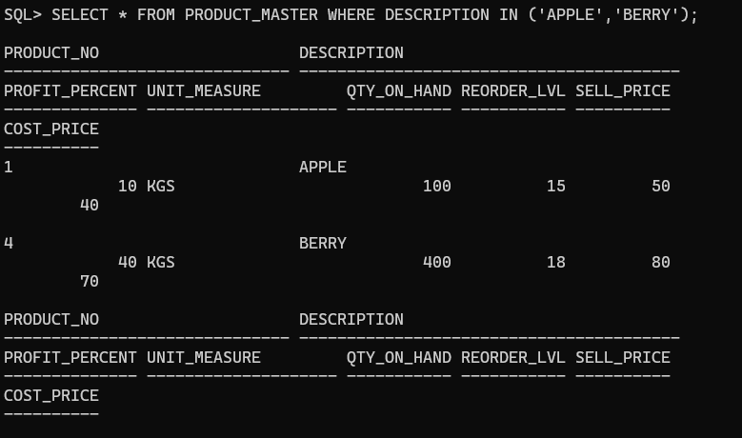

1. **Find the products with description as ‘APPLE’ and ‘BERRY’.**

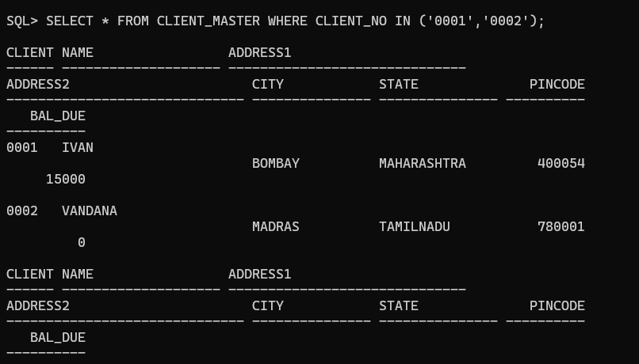

1. **Find all the products whose sell price is greater then 50.**

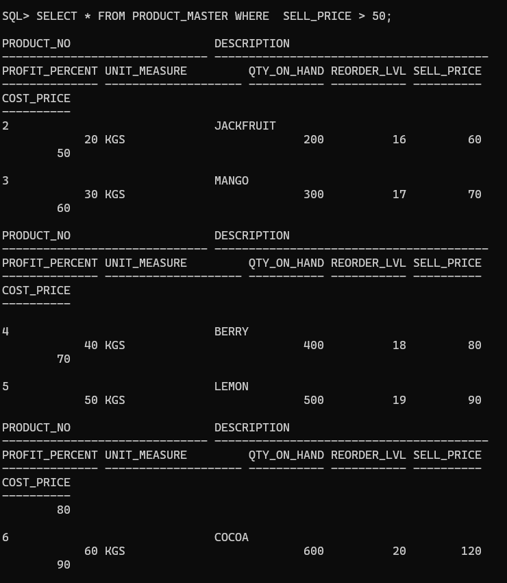

1. **Find the list of all clients who stay in in city ‘Bombay’ or city ‘Delhi’ or ‘Madras’.**

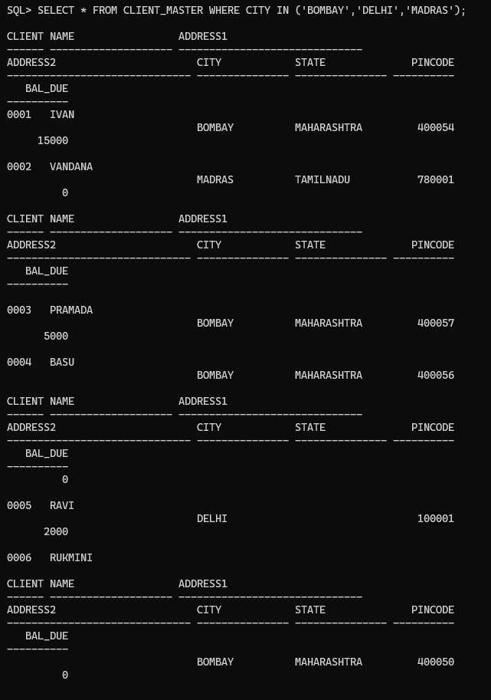

1. **Find the product whose selling price is greater than 50 and less than or equal to 70.**

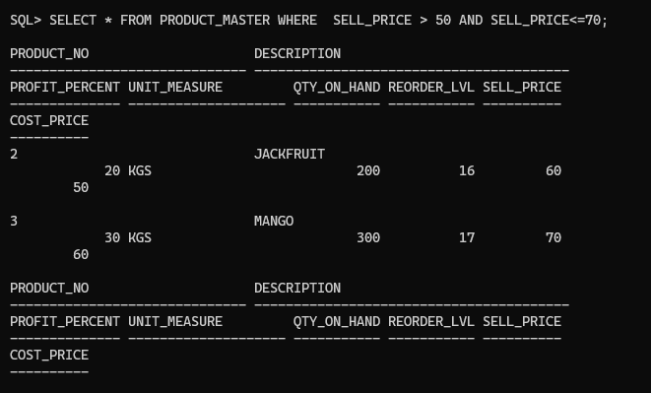

1. **List the name, city and state of clients not in the state of ‘Maharashtra’.**

