**Date: 03/03/2024**

**PARSHWA HERWADE**

**DATABASE ASSIGNMENT 5**

**22510064,SY BTECH CSE**

**Question.1** Using the table client master and product master answer the following Questionnaires.

1. Change the selling price of ‘1.44 floppy drive to Rs.1150.00



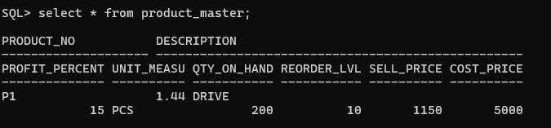

1. Delete the record with client 0001 from the client master table.

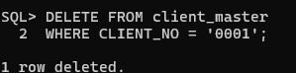

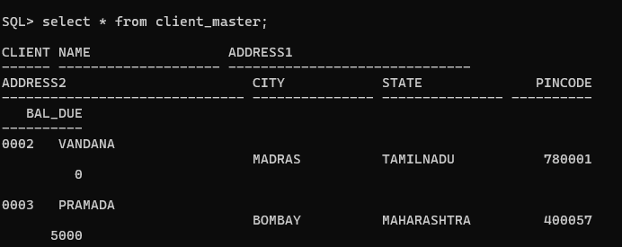

1. Change the city of client_no’0005’ to Bombay.

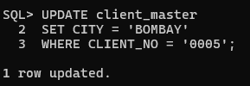

1. Change the bal_due of client_no ‘0001, to 1000.

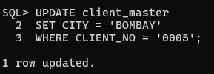

1. Find the products whose selling price is more than 1500 and also find the new selling price as original selling price *15.

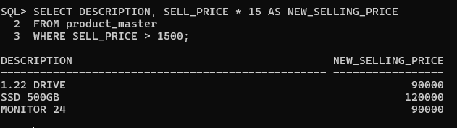

1. Find out the clients who stay in a city whose second letter is a.

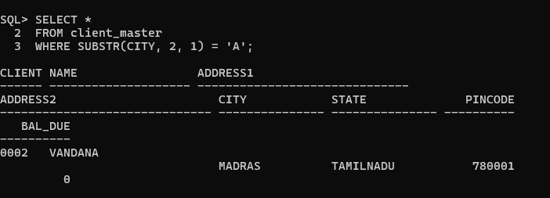

1. Find out the name of all clients having ‘a’ as the second letter in their names.

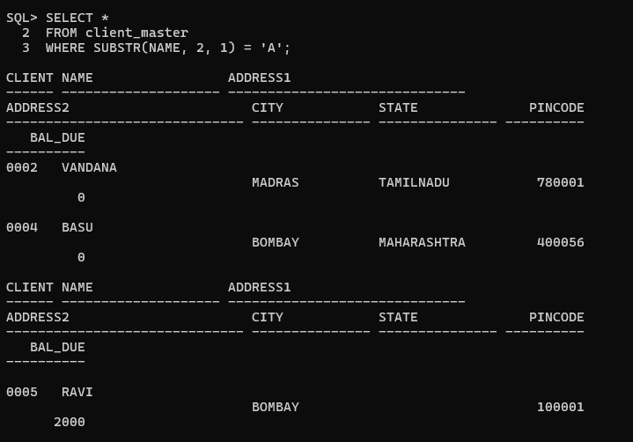

1. List the products in sorted order of their description.

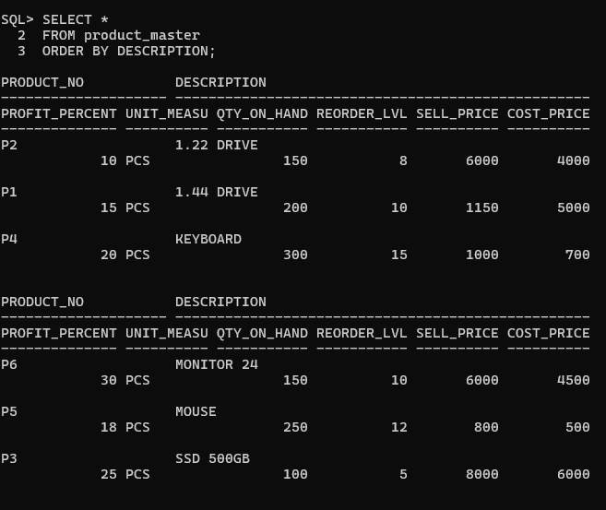

1. Count the total number of orders

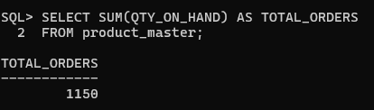

1. Calculate the average price of all the products.

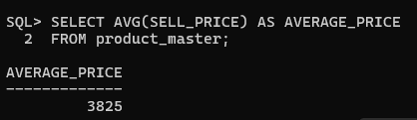

1. Calculate the minimum price of products.

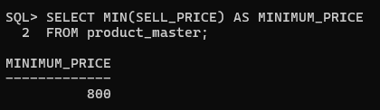

1. Determine the maximum and minimum prices . Rename the tittle as ‘max_price’ and min_price respectively.

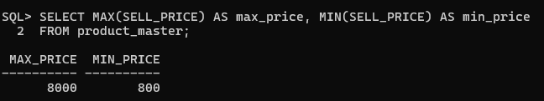

1. Count the number of products having price greater than or equal to 1500.

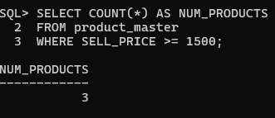

**Question 2.** Create a table EMPLOYEE with following schema:

(Emp_no, E_name, E_address, E_ph_no, Dept_no, Dept_name,Job_id , Salary)

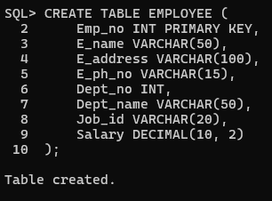

2. Add a new column; HIREDATE to the existing relation.

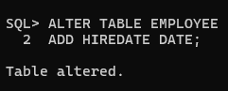

3. Change the datatype of JOB_ID from char to varchar2.

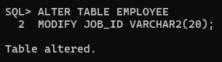

4. Change the name of column/field Emp_no to E_no.

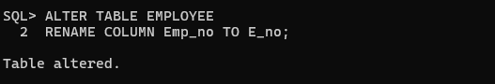

5. Modify the column width of the job field of emp table

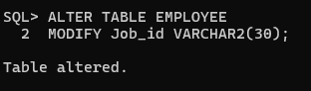

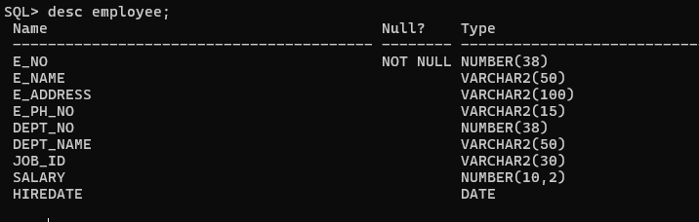

**Question 3.** Create a table EMPLOYEE with following schema:

(Emp_no, E_name, E_address, E_ph_no, Dept_no, Dept_name,Job_id , Salary)

Write SQL queries for following question:

1. Insert aleast 5 rows in the table.

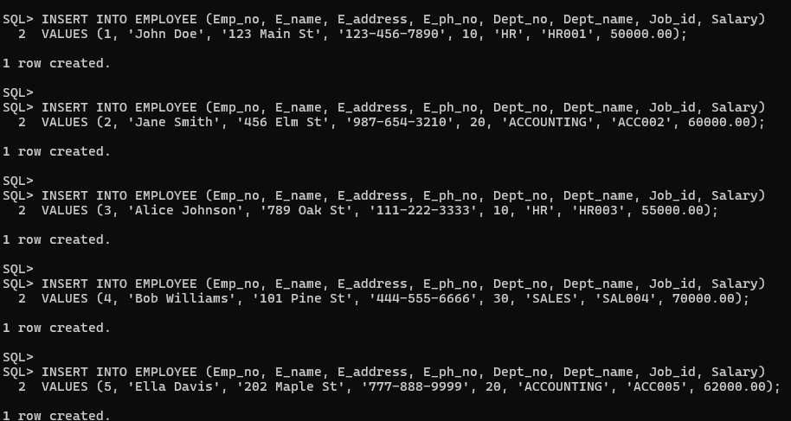

2. Display all the information of EMP table.

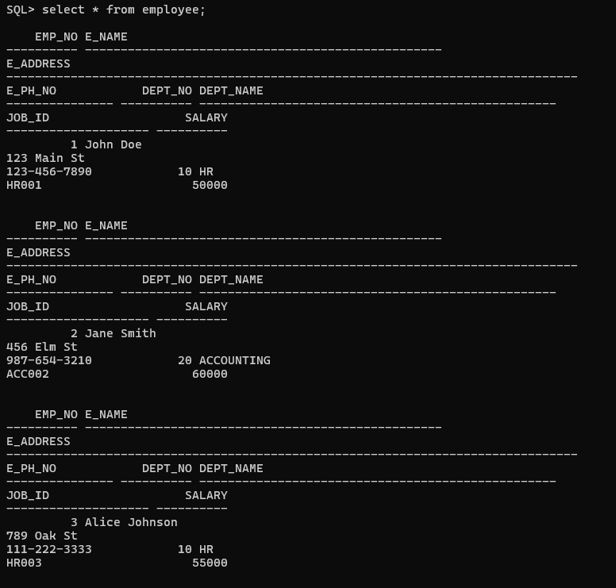

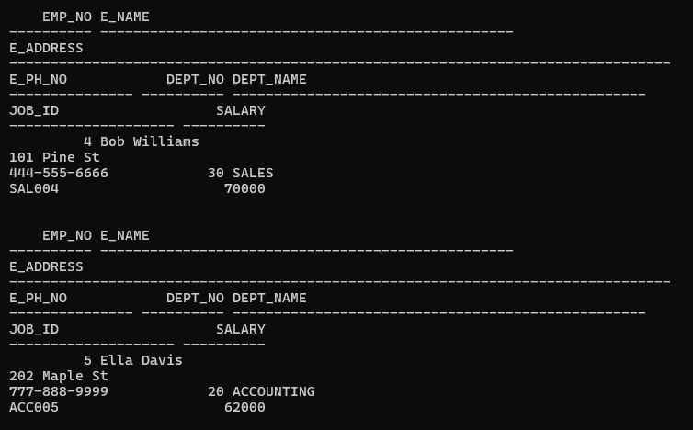

3. Display the record of each employee who works in department D10.

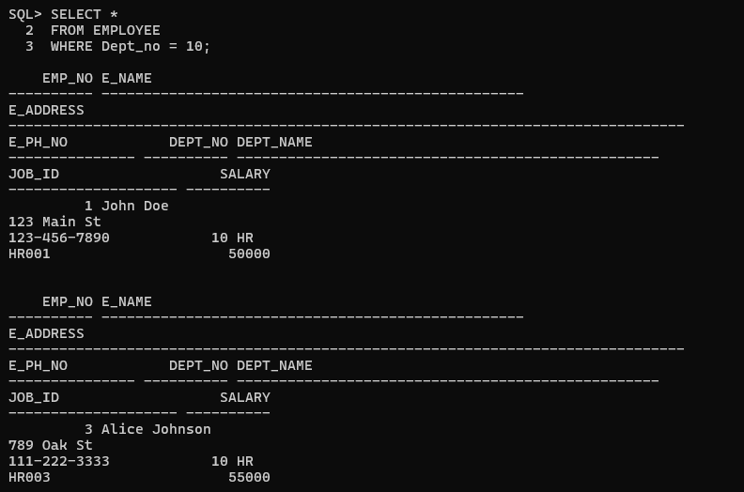

4. Update the city of Emp_no2 with current city as Nagpur.

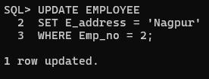

5. Display the details of Employee who works in department HR.

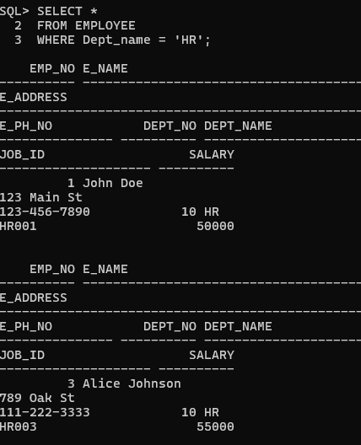

6. Delete the job_id of employee John Doe.

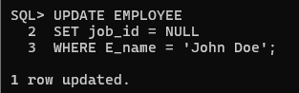

7. Display the complete record of employees working in SALES Department.

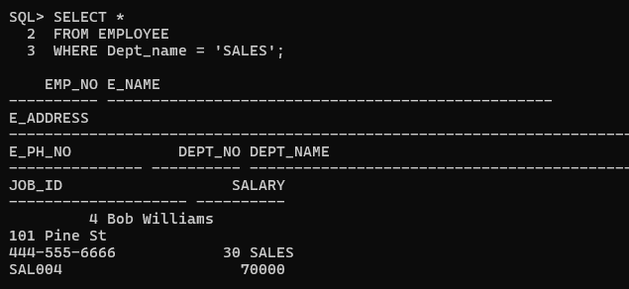

**Question 4:** create a user with your PRN number and give password of your PRN number . Perform some of the DML and DDL tasks by providing permission to the same user. After performance remove permissions given as well as remove user.

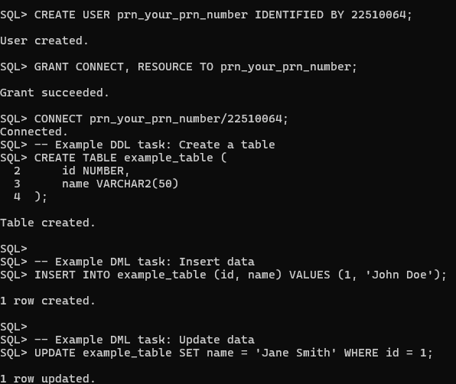

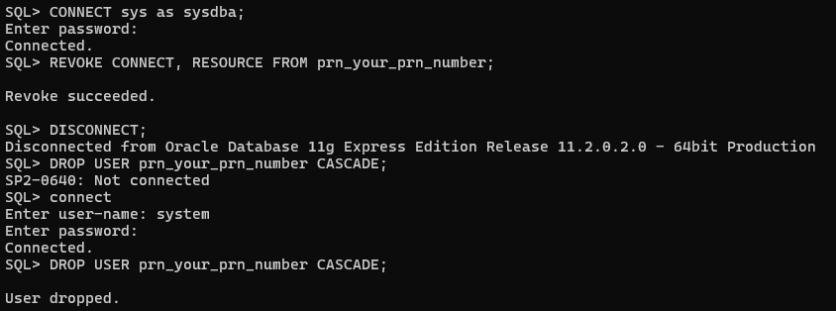

**Question 5**: Create one table of Library and perform all TCL commands.

