DB assignment 6

PARSHWA HERWADE

22510064,SY BTECH CSE

**Name: Implement queries on Constraints.**

Question 1. Create the following tables:

1. **Sales_master**

|  |  |  |  |
| --- | --- | --- | --- |
| **Columnname** | **Datatype** | **Size** | **Attributes** |
| Salesman_no | varchar2 | 6 | Primary key/first letter |
|  |  |  | must start with ‘s’ |
| Sal_name | varchar2 | 20 | Not null |
| Address | varchar2 |  | Not null |
| City | varchar2 | 20 |  |
| State | varchar2 | 20 |  |
| Pincode | Number | 6 |  |
| Sal_amt | Number | 8,2 | Not null, cannot be 0 |
| Tgt_to_get | Number | 6,2 | Not null, cannot be 0 |
| Ytd_sales | Number | 6,2 | Not null, cannot be 0 |
| Remarks | Varchar2 | 30 |  |

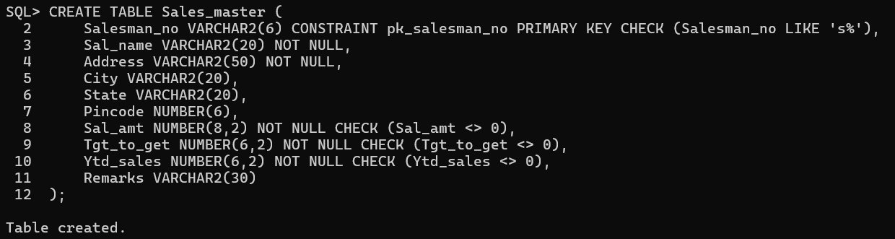

1. **Sales_order**

|  |  |  |  |
| --- | --- | --- | --- |
| **Columnname** | **Datatype** | **Size** | **Attributes** |
|  |  |  |  |
| S_order_no | varchar2 | 6 | Primary/first letter must be 0 |
|  |  |  |  |
| S_order_date | Date | 6 | Primary key reference clientno |
|  |  |  | of client_master table |
|  |  |  |  |
| Client_no | Varchar2 | 25 |  |
| Dely_add | Varchar2 | 6 |  |
|  |  |  |  |
| Salesman_no | Varchar2 | 6 | Foreign key references |
|  |  |  | salesman_no of |
|  |  |  | salesman_master table |
|  |  |  |  |
| Dely_type | Char | 1 | Delivery part(p)/full(f),default f |
|  |  |  |  |
| Billed_yn | Char | 1 |  |
| Dely_date | Date |  | Can not be lessthan |
|  |  |  | s_order_date |
| Order_status | Varchar2 | 10 | Values (‘in |
|  |  |  | process’;’fulfilled’;back |
|  |  |  | order’;’canceled |

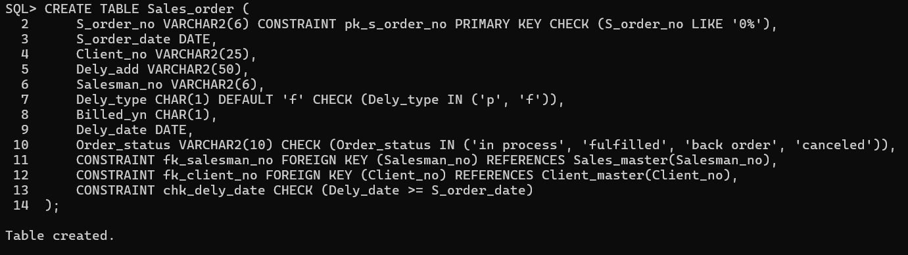

**. Sales_order_details**

|  |  |  |  |
| --- | --- | --- | --- |
| **Column** | **Datatype** | **Size** | **Attributes** |
|  |  |  |  |
| S_order_no | Varchar2 | 6 | Primary key/foreign |
|  |  |  | key references |
|  |  |  | s_order_no of |
|  |  |  | sales_order |
| Product_no | Varchar2 | 6 | Primary key/foreign |
|  |  |  | key references |
|  |  |  | product_no of |
|  |  |  | product_master |
| Qty_order | Number | 8 |  |
| Qty_disp | Number | 8 |  |
| Product_rate | Number | 10,2 |  |
|  |  |  |  |
|  |  |  |  |

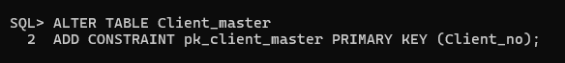

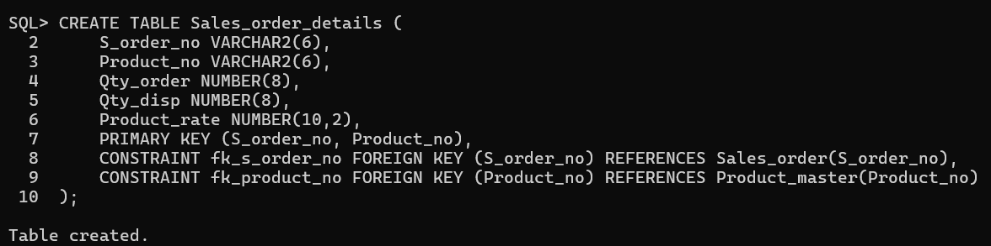

**Data for sales_man master table**

|  |  |  |  |  |  |  |  |  |  |
| --- | --- | --- | --- | --- | --- | --- | --- | --- | --- |
| **Salesman_** | **Salesman** | **Address** | **City** | **Pin** | **State** | **Salamt** | **Tgt_to_get** | **Ytd** | **Rem** |
| **no** | **name** |  |  | **code** |  |  |  | **Sales** |  |
| s00001 | Kiran | A/14 | Bom | 400002 | Mah | 3000 | 100 | 50 | Good |
|  |  | worli | bay |  |  |  |  |  |  |
| s00002 | Manish | 65,narim | Bom | 400001 | Mah | 3000 | 200 | 100 | Good |
|  |  | an | bay |  |  |  |  |  |  |
| s00003 | Ravi | P-7 | Bom | 400032 | Mah | 3000 | 200 | 100 | Good |
|  |  | Bandra | bay |  |  |  |  |  |  |
| s00004 | Ashish | A/5 | Bom | 400044 | Mah | 3500 | 200 | 150 | Good |
|  |  | Juhu | bay |  |  |  |  |  |  |

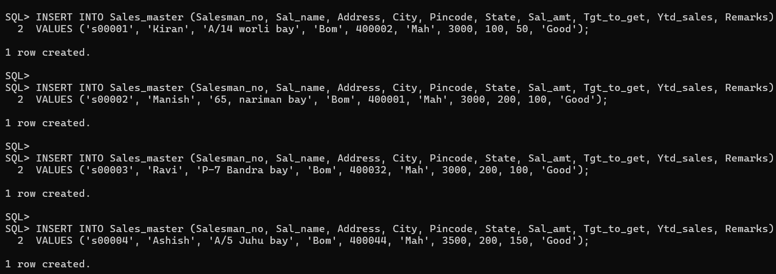

(ii)

**Data for salesorder table:**

|  |  |  |  |  |  |  |  |
| --- | --- | --- | --- | --- | --- | --- | --- |
| S_orderno | S_orderdate | Client no | Dely | Bill | Salesman no | Delay | Orderstatus |
|  |  |  | type | yn |  | date |  |
| 019001 | 12-jan-96 | 0001 | F | N | s00001 | 20-jan- | Ip |
|  |  |  |  |  |  | 96 |  |
| 019002 | 25-jan-96 | 0002 | P | N | s00002 | 27-jan- | C |
|  |  |  |  |  |  | 96 |  |
| 016865 | 18-feb-96 | 0003 | F | Y | s00003 | 20-feb- | F |
|  |  |  |  |  |  | 96 |  |
| 019003 | 03-apr-96 | 0001 | F | Y | s00001 | 07-apr- | F |
|  |  |  |  |  |  | 96 |  |
| 046866 | 20-may-96 | 0004 | P | N | s00002 | 22- | C |
|  |  |  |  |  |  | may-96 |  |
| 010008 | 24-may-96 | 0005 | F | N | s00004 | 26- | Ip |
|  |  |  |  |  |  | may-96 |  |

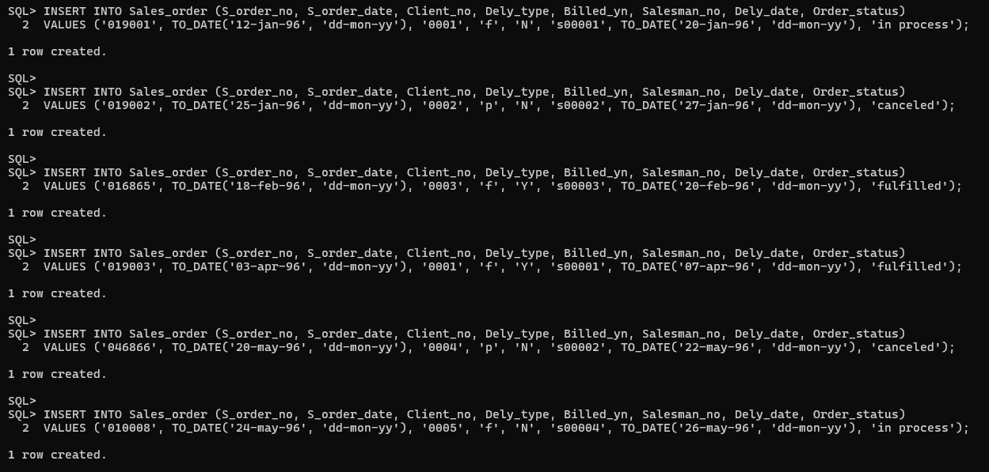

(iii)

**Data for sales_order_details table:**

|  |  |  |  |  |
| --- | --- | --- | --- | --- |
| S_order no | Product no | Qty ordered | Qty disp | Product_rate |
| 019001 | P00001 | 4 | 4 | 525 |
| 019001 | P07965 | 2 | 1 | 8400 |
| 019001 | P07885 | 2 | 1 | 5250 |
| 019002 | P00001 | 10 | 0 | 525 |
| 046866 | P07868 | 3 | 3 | 3150 |
| 046866 | P07885 | 10 | 10 | 5250 |
| 019003 | P00001 | 4 | 4 | 1050 |
| 019003 | P03453 | 2 | 2 | 1050 |
| 046866 | P06734 | 1 | 1 | 12000 |
| 046866 | P07965 | 1 | 0 | 8400 |
| 010008 | P07975 | 1 | 0 | 1050 |
| 010008 | P00001 | 10 | 5 | 525 |

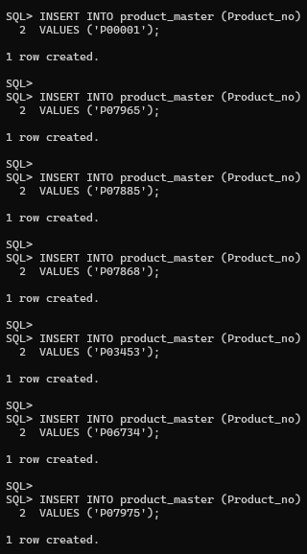

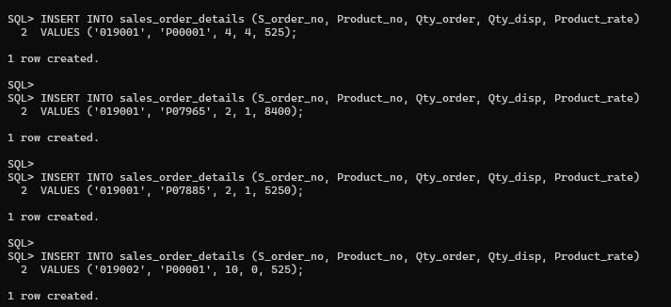

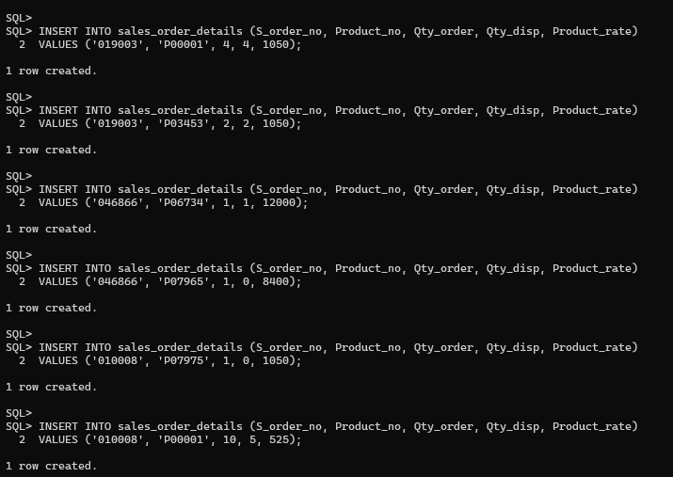  
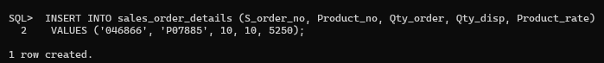



**Challan_Header**

|  |  |  |  |
| --- | --- | --- | --- |
| **Column name** | **data type** | **size** | **Attributes** |
| Challan_no | varchar2 | 6 | Primary key |
| s_order_no | varchar2 | 6 | Foreign key references s_order_no of sales_order table |
| challan_date | date |  | not null |
| billed_yn | char | 1 | values (‘Y’,’N’). Default ‘N’ |

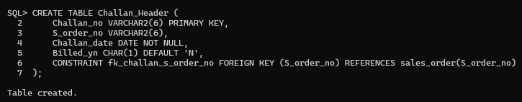

**Table Name : Challan_Details**

|  |  |  |  |
| --- | --- | --- | --- |
| Column name | data type | size | Attributes |
| Challan_no | varchar2 | 6 | Primary key/Foreign key references Product_no of product_master |
| Qty_disp | number | 4,2 | not null |

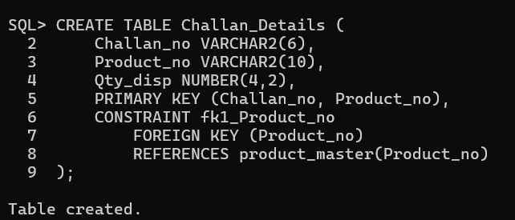

**Q2. Insert the following values into the challan header and challan_details tables:**

|  |  |  |  |
| --- | --- | --- | --- |
| Challan No | S_order No | Challan Date | Billed |
| CH9001 | 019001 | 12-DEC-95 | Y |
| CH865 | 046866 | 12-NOV-95 | Y |
| CH3965 | 010008 | 12-OCT-95 | Y |

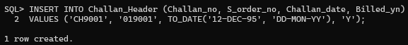

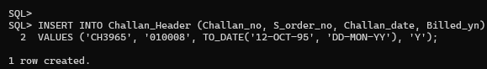

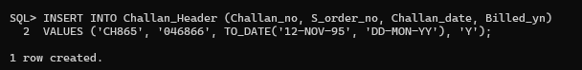

**Data for challan_details table**

|  |  |  |
| --- | --- | --- |
| Challan No | Product No | Qty Disp |
| CH9001 | P00001 | 4 |
| CH9001 | P07965 | 1 |
| CH9001 | P07885 | 1 |
| CH865 | P07868 | 3 |
| CH865 | P03453 | 4 |
| CH865 | P00001 | 10 |
| CH3965 | P00001 | 5 |
| CH3965 | P07975 | 2 |

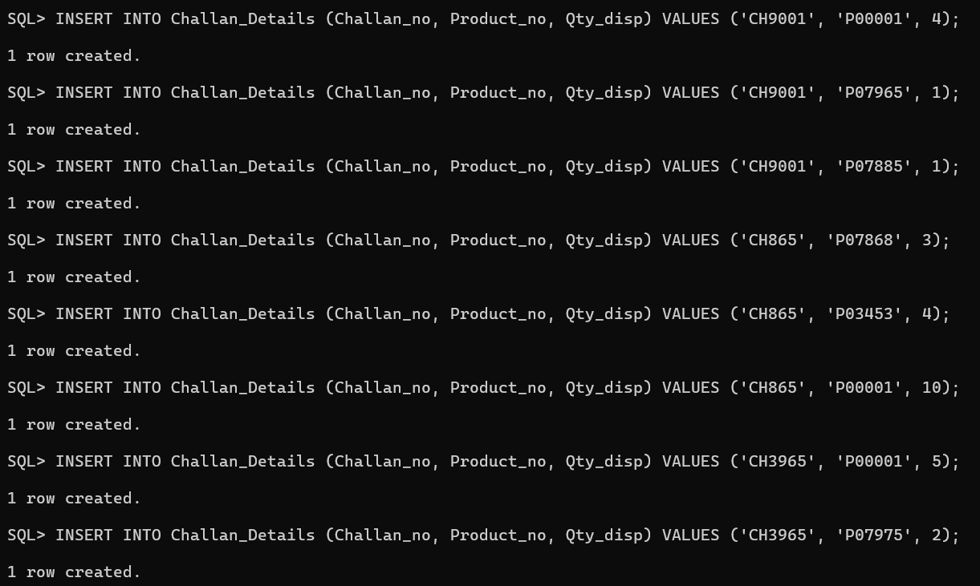

**Answer the following Questionries**

Q1. Make the primary key to client_no in client_master.

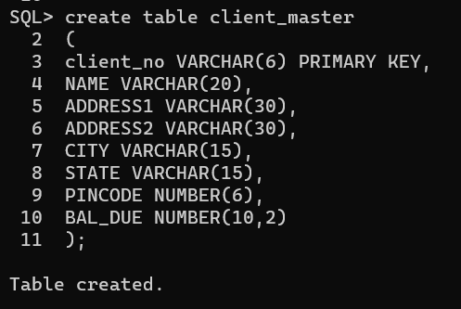

TABLE IS ALREADY HAVING IT AS P_KEY.

Q2. Add a new column phone_no in the client_master table.

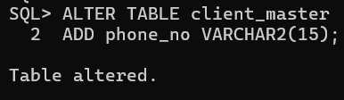

Q3. Add the not null constraint in the product_master table with the columns description, profit percent , sell price and cost price.

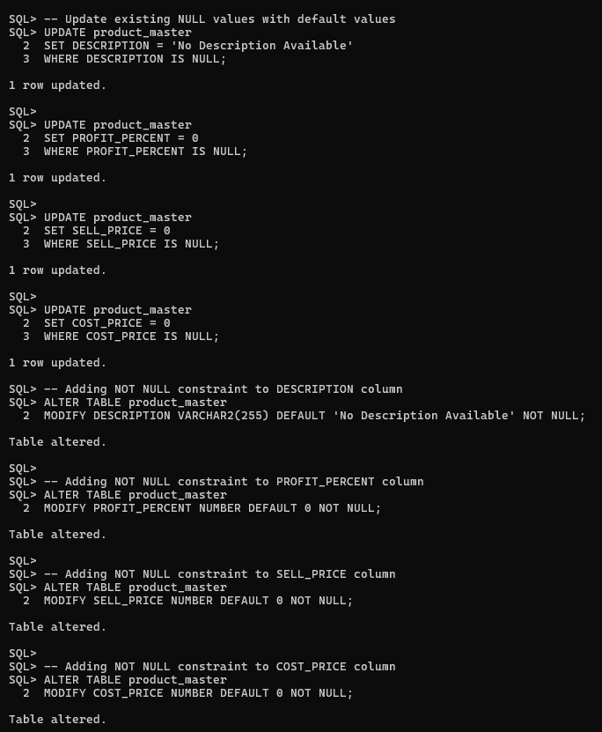

Do this in case there are any values to be updated…

Q4. Change the size of client_no field in the client_master table.

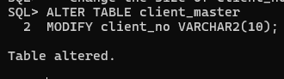

Q5. Select product_no, description where profit percent is between 20 and 30 both inclusive.

