EXPERIMENT -8

PRN : 22510064,S4 (PARSHWA HERWADE)

Subject : Database Engineering Lab

Topic : Implement Aggregate functions, having and group by clause.

1.Write a SQL statement to find the total purchase amount of all orders.

Sample table: orders

ord_no purch_amt ord_date customer_id salesman_id

---------- ---------- ---------- ----------- -----------

70001 150.5 2012-10-05 3005 5002

70009 270.65 2012-09-10 3001 5005

70002 65.26 2012-10-05 3002 5001

70004 110.5 2012-08-17 3009 5003

70007 948.5 2012-09-10 3005 5002

70005 2400.6 2012-07-27 3007 5001

70008 5760 2012-09-10 3002 5001

70010 1983.43 2012-10-10 3004 5006

70003 2480.4 2012-10-10 3009 5003

70012 250.45 2012-06-27 3008 5002

70011 75.29 2012-08-17 3003 5007

70013 3045.6 2012-04-25 3002 5001

Step-1: Create the required table:  


Step-2: Insert the data:

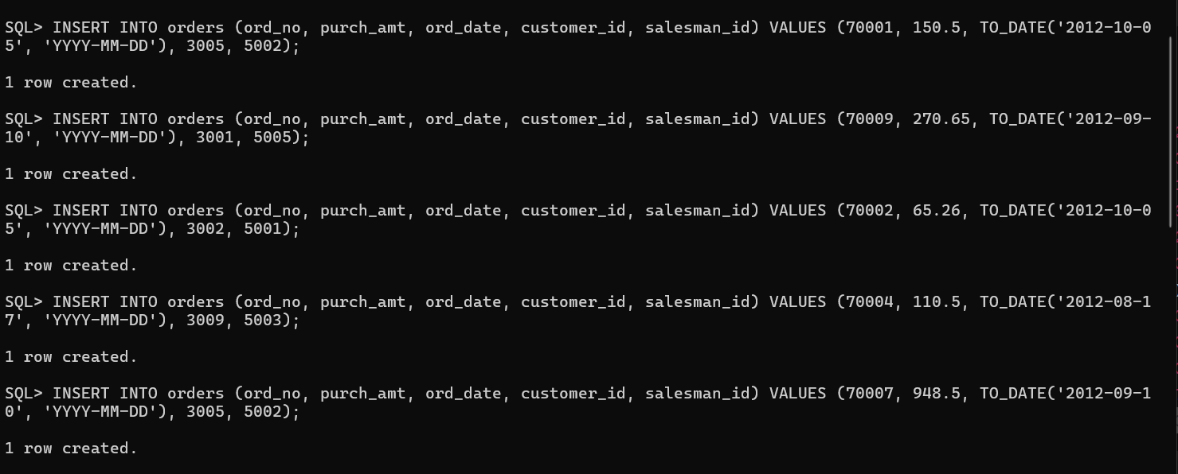

Step-3: Query :  
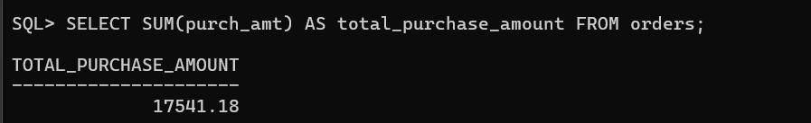

2. Write a SQL statement to find the average purchase amount of all orders.

*Sample table*: orders

ord_no purch_amt ord_date customer_id salesman_id

---------- ---------- ---------- ----------- -----------

70001 150.5 2012-10-05 3005 5002

70009 270.65 2012-09-10 3001 5005

70002 65.26 2012-10-05 3002 5001

70004 110.5 2012-08-17 3009 5003

70007 948.5 2012-09-10 3005 5002

70005 2400.6 2012-07-27 3007 5001

70008 5760 2012-09-10 3002 5001

70010 1983.43 2012-10-10 3004 5006

70003 2480.4 2012-10-10 3009 5003

70012 250.45 2012-06-27 3008 5002

70011 75.29 2012-08-17 3003 5007

70013 3045.6 2012-04-25 3002 5001

Query

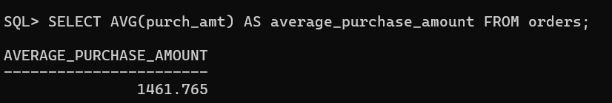

**3.** Write a SQL statement to find the number of salesmen currently listing for all of their customers.

*Sample table*: orders

ord_no purch_amt ord_date customer_id salesman_id

---------- ---------- ---------- ----------- -----------

70001 150.5 2012-10-05 3005 5002

70009 270.65 2012-09-10 3001 5005

70002 65.26 2012-10-05 3002 5001

70004 110.5 2012-08-17 3009 5003

70007 948.5 2012-09-10 3005 5002

70005 2400.6 2012-07-27 3007 5001

70008 5760 2012-09-10 3002 5001

70010 1983.43 2012-10-10 3004 5006

70003 2480.4 2012-10-10 3009 5003

70012 250.45 2012-06-27 3008 5002

70011 75.29 2012-08-17 3003 5007

70013 3045.6 2012-04-25 3002 5001

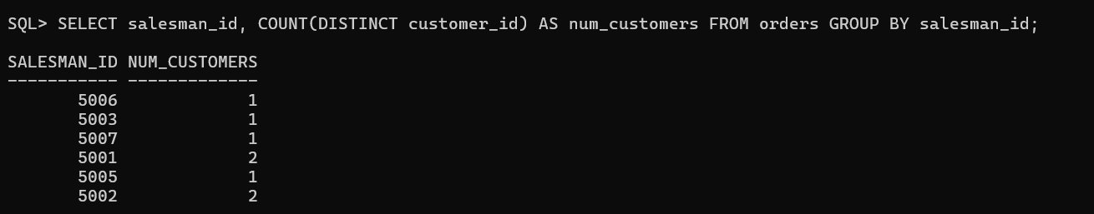

**4.** Write a SQL statement know how many customer have listed their names.

*Sample table*: customer

customer_id | cust_name | city | grade | salesman_id

-------------+----------------+------------+-------+-------------

3002 | Nick Rimando | New York | 100 | 5001

3007 | Brad Davis | New York | 200 | 5001

3005 | Graham Zusi | California | 200 | 5002

3008 | Julian Green | London | 300 | 5002

3004 | Fabian Johnson | Paris | 300 | 5006

3009 | Geoff Cameron | Berlin | 100 | 5003

3003 | Jozy Altidor | Moscow | 200 | 5007

3001 | Brad Guzan | London | | 5005

Step-1:Create the required table:  


Step-2:Insert the values:

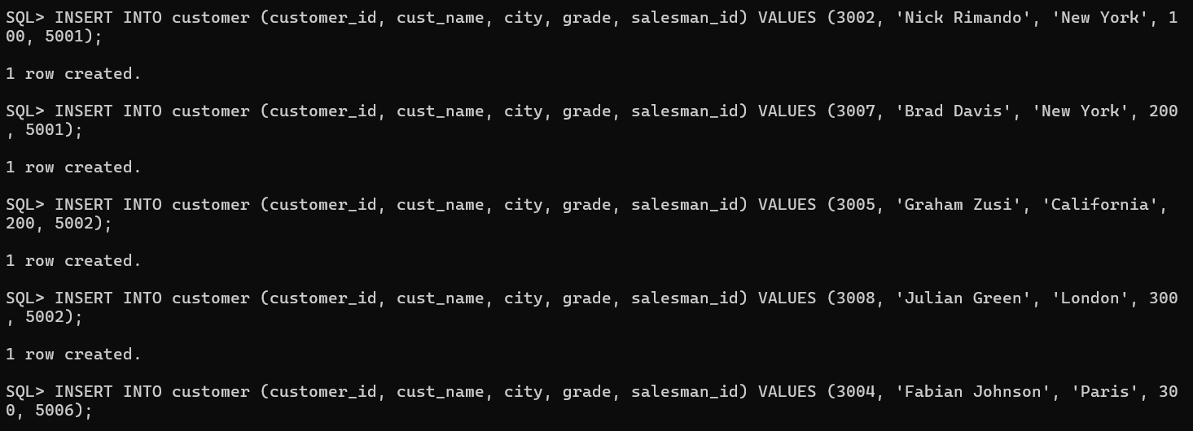

Step-3:Query:

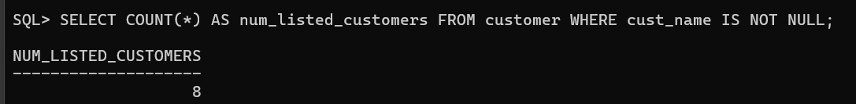

**5.** Write a SQL statement find the number of customers who gets at least a gradation for his/her performance.

*Sample table*: customer

customer_id | cust_name | city | grade | salesman_id

-------------+----------------+------------+-------+-------------

3002 | Nick Rimando | New York | 100 | 5001

3007 | Brad Davis | New York | 200 | 5001

3005 | Graham Zusi | California | 200 | 5002

3008 | Julian Green | London | 300 | 5002

3004 | Fabian Johnson | Paris | 300 | 5006

3009 | Geoff Cameron | Berlin | 100 | 5003

3003 | Jozy Altidor | Moscow | 200 | 5007

3001 | Brad Guzan | London | | 5005

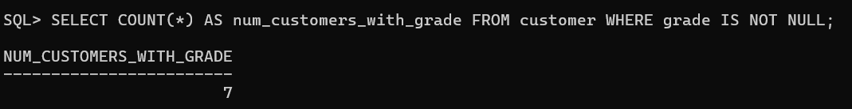

**6.** Write a SQL statement to get the maximum purchase amount of all the orders.

*Sample table*: orders

ord_no purch_amt ord_date customer_id salesman_id

---------- ---------- ---------- ----------- -----------

70001 150.5 2012-10-05 3005 5002

70009 270.65 2012-09-10 3001 5005

70002 65.26 2012-10-05 3002 5001

70004 110.5 2012-08-17 3009 5003

70007 948.5 2012-09-10 3005 5002

70005 2400.6 2012-07-27 3007 5001

70008 5760 2012-09-10 3002 5001

70010 1983.43 2012-10-10 3004 5006

70003 2480.4 2012-10-10 3009 5003

70012 250.45 2012-06-27 3008 5002

70011 75.29 2012-08-17 3003 5007

70013 3045.6 2012-04-25 3002 5001

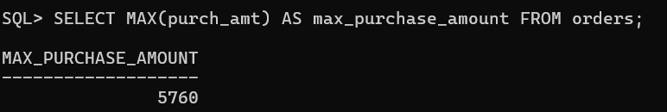

**7.** Write a SQL statement to get the minimum purchase amount of all the orders.

*Sample table*: orders

ord_no purch_amt ord_date customer_id salesman_id

---------- ---------- ---------- ----------- -----------

70001 150.5 2012-10-05 3005 5002

70009 270.65 2012-09-10 3001 5005

70002 65.26 2012-10-05 3002 5001

70004 110.5 2012-08-17 3009 5003

70007 948.5 2012-09-10 3005 5002

70005 2400.6 2012-07-27 3007 5001

70008 5760 2012-09-10 3002 5001

70010 1983.43 2012-10-10 3004 5006

70003 2480.4 2012-10-10 3009 5003

70012 250.45 2012-06-27 3008 5002

70011 75.29 2012-08-17 3003 5007

70013 3045.6 2012-04-25 3002 5001

