**Batch T4**

**Practical No. 1**

**Title of Assignment :**

**Installation, configuration & testing of MySQL**

**Student Name: Parshwa Herwade**

**Student PRN: 22510064**

1. Download / get setup CD of Server & Client (Win/Linux).

2. Read and follow the prerequisite for installation and accordingly

set the system.

3. If server already installed, uninstall it.

4. Install MySQL Server on one machine.

5. Install Client (MySQL Workbench) on another machine.

6. Check the connectivity from Web client and SQL command line.

(Note use the demo/example schema)

7. Create new user by your PRN e.g. 22511234.

8. Create sample database, create sample tables in newly created

database

9. Repeat the step 6 for this new database.

10. Demonstrate the DML on new tables.

11. Create simple form in Angular which will connect to the

database created in step 7. Allows to choose available tables.

Provision in Angular Form to perform the CRUD operations on

selected table.

**Objective / Aim**

The objective of this assignment is to:

* Install and configure MySQL Server and MySQL Workbench on separate machines.
* Establish connectivity between the server and client.
* Create a database and perform CRUD operations using SQL commands.
* Develop a simple Angular-based web interface for interacting with the database.

**Introduction**

MySQL is an open-source relational database management system (RDBMS) widely used for its robustness and scalability. It allows users to store, manipulate, and retrieve data efficiently. MySQL Workbench serves as a graphical client tool to manage MySQL databases. Angular, a popular front-end framework, is used for building dynamic web applications, including interfaces for database interaction. This assignment involves:

1. Setting up MySQL Server and Workbench.
2. Creating and managing a database and its tables.
3. Developing an Angular-based web form for CRUD operations.

**Theory / Algorithms**

**Steps for Database Installation and Setup:**

1. **Server Installation:** Install MySQL Server on the host machine. Ensure proper configuration during installation.
2. **Client Installation:** Install MySQL Workbench on a separate machine to interact with the database server.
3. **Connectivity Testing:** Use Web Client and SQL command line to test server-client connectivity.
4. **User and Database Creation:**
   * Create a user with a specific PRN (e.g., 22510064).
   * Create a new database and sample tables under this user.

**CRUD Operations Algorithm:**

1. **Create Operation:**
   * Insert data into the table using SQL INSERT statements or Angular form submission.
2. **Read Operation:**
   * Retrieve data using SQL SELECT queries or display in the Angular web form.
3. **Update Operation:**
   * Modify table data using SQL UPDATE queries or Angular form.
4. **Delete Operation:**
   * Remove records using SQL DELETE queries or Angular form.

**Documentation**

**Functional Block Diagram:**

1. **MySQL Server**: Stores and processes database queries.
2. **MySQL Workbench**: Acts as a client to manage the server and database.
3. **Angular Application**:
   * Frontend form for CRUD operations.
   * Backend API for database connectivity.

**Data Flow Diagram (DFD):**

**Level 0**: User interacts with the Angular form for database operations. **Level 1**:

* User sends input via Angular form.
* Angular sends requests to MySQL Server through API.
* MySQL Server processes the query and returns a response.

**Procedure**

1. Download the MySQL Server and Workbench installation files.
2. Install MySQL Server on one machine and configure it.
3. Install MySQL Workbench on another machine.
4. Configure and test the connectivity between the server and client.
5. Create a new user and database.
6. Create sample tables in the new database.
7. Test CRUD operations using SQL command line or Workbench.
8. Develop an Angular application:
   * Create a form for selecting tables and performing CRUD operations.
   * Connect the Angular app to the MySQL database using a backend API.
9. Test CRUD operations from the Angular form.
10. Capture screenshots of the results.

**Actual Experiments / Simulation, Results / Observations**

**Results:**

1. Successfully installed MySQL Server and Workbench.
2. Connectivity between server and client was established.
3. Created user (PRN: 22510064), database, and tables.
4. Performed CRUD operations using SQL commands.
5. Developed an Angular form for performing CRUD operations.

**Observations:**

1. The Angular application successfully interacted with the MySQL database.
2. CRUD operations were performed seamlessly via the web interface.
3. The form dynamically handled table selection and data operations.

**Screenshots:**

Include the following:

1. MySQL Server installation success.
2. Workbench setup and successful connection.
3. CRUD operations performed in the Angular app.
4. Final Angular web interface.

**Conclusion**

This assignment demonstrated the installation and configuration of MySQL Server and Workbench. It successfully established connectivity between server and client machines. A new database and user were created, and CRUD operations were performed both via SQL commands and a custom Angular web interface. This exercise provided hands-on experience with database management and integrating Angular for dynamic web applications.

Uninstall and install workbench and server on different PCs.

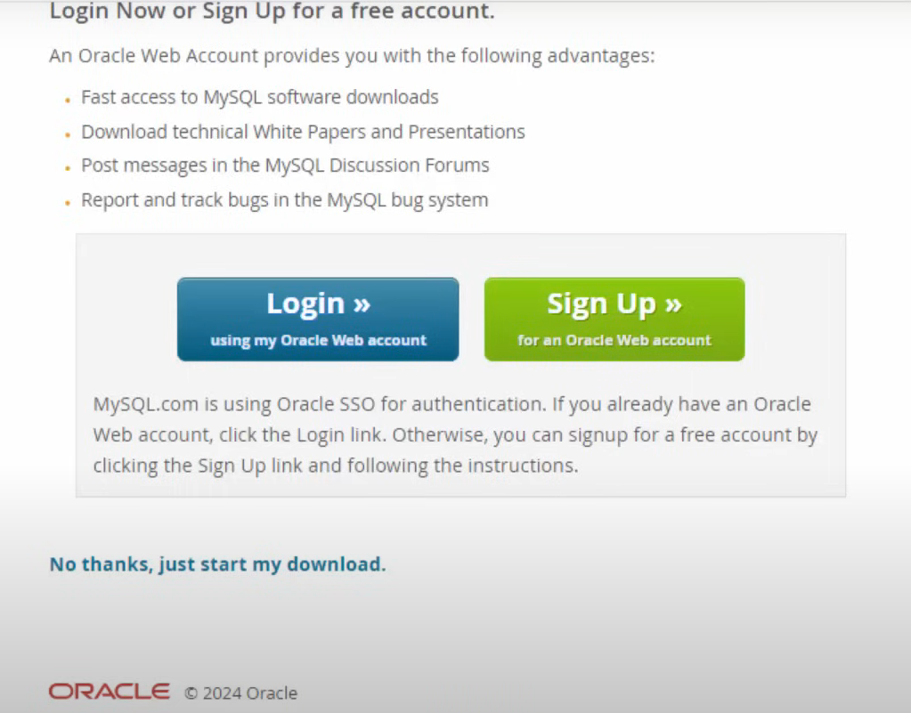

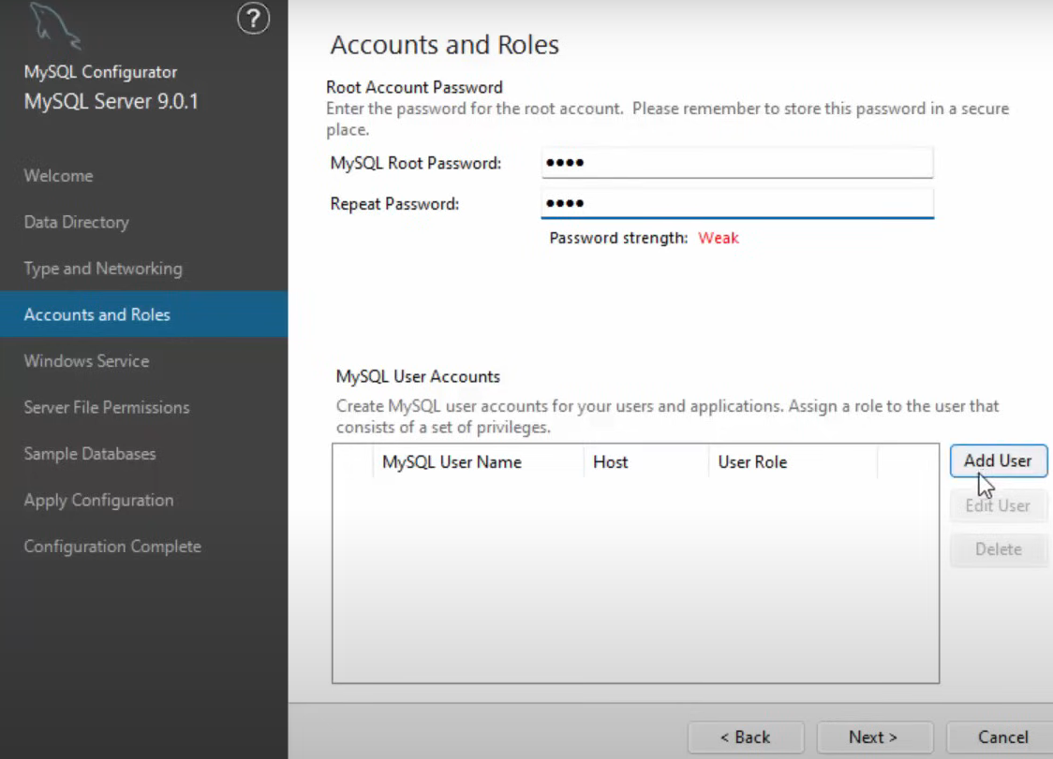

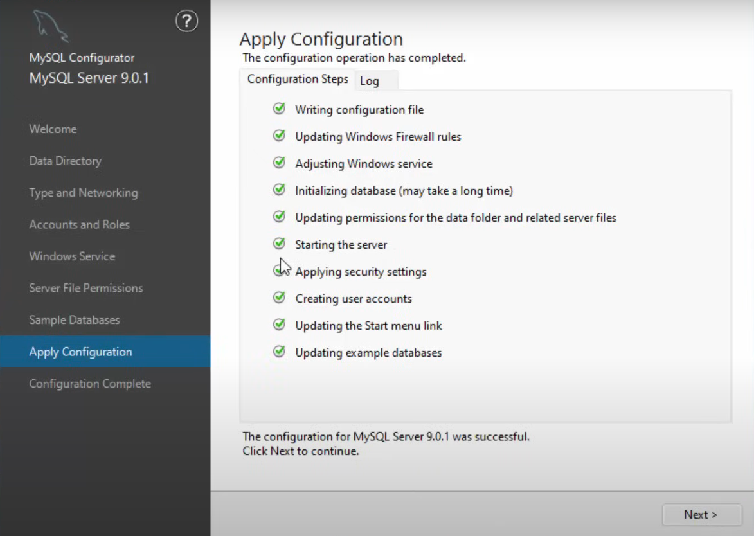

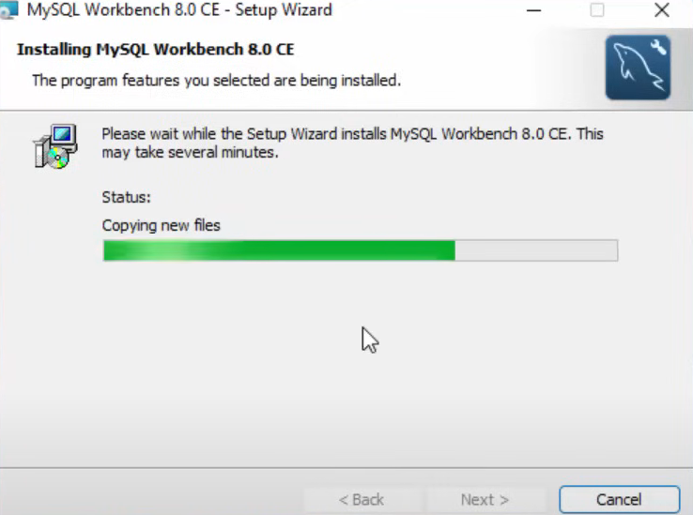

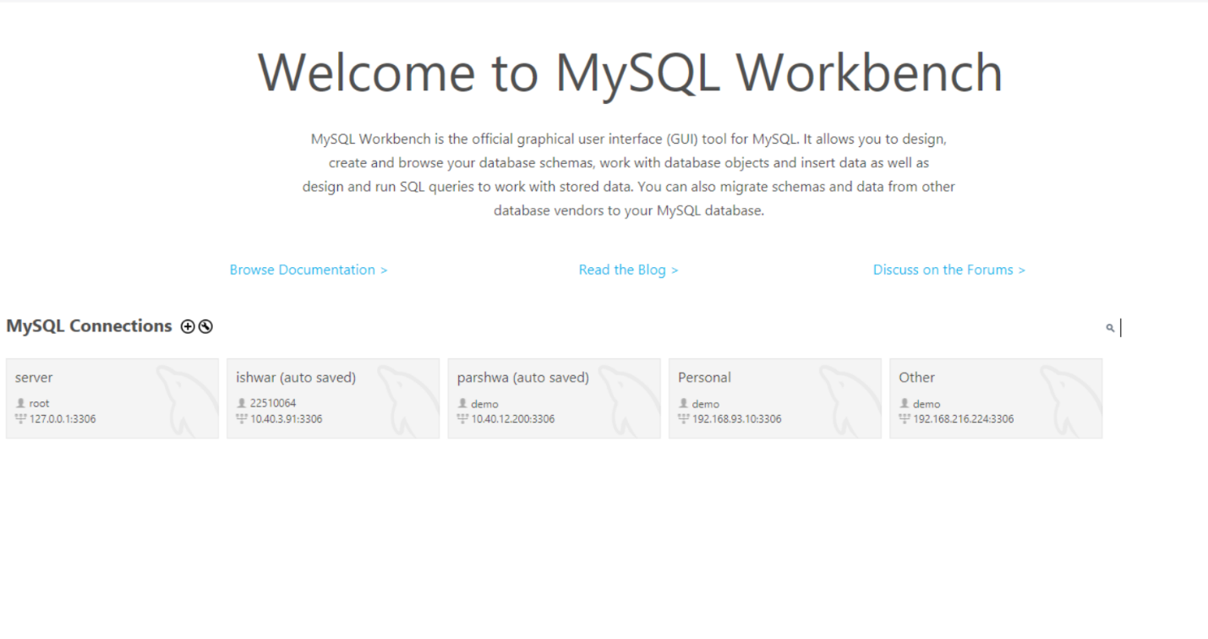

**STEPS:**

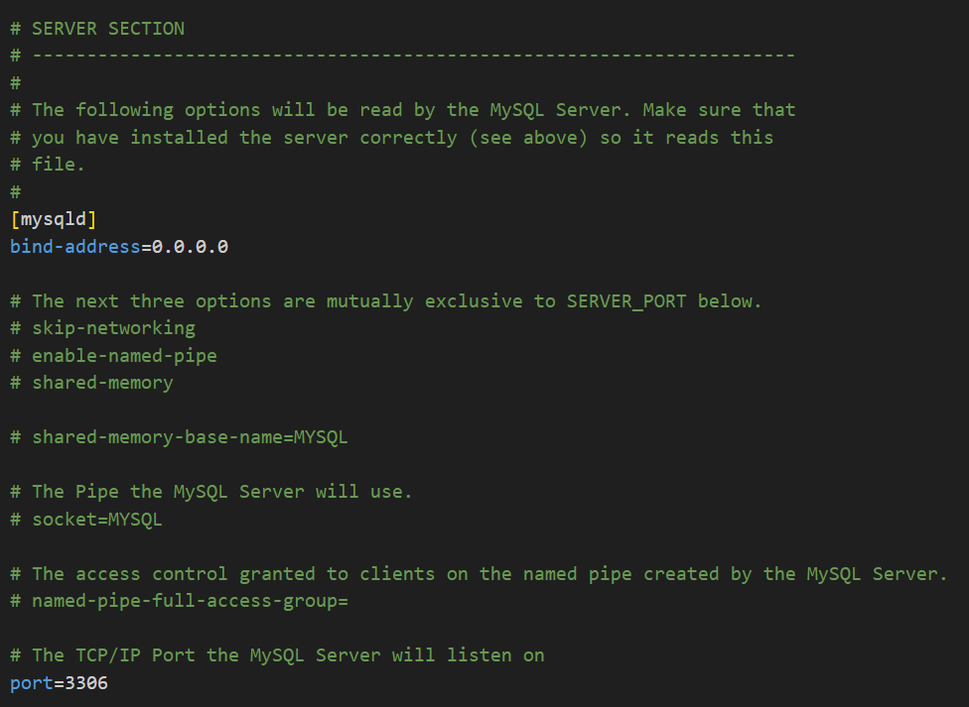

Change the bind-address to 0.0.0.0 so that anyone can access the server.  
  
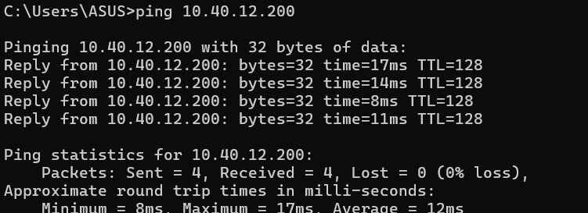

Ping to check the server client network.

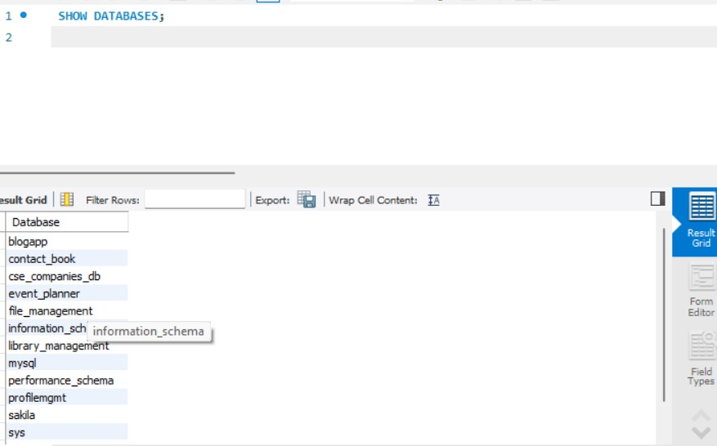

Creation of database and checking the availability.

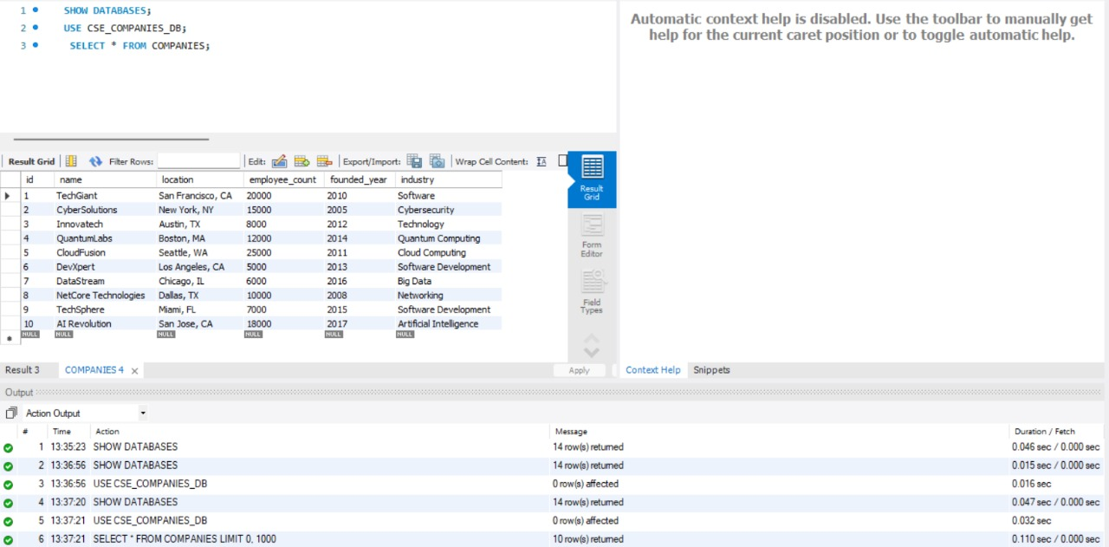

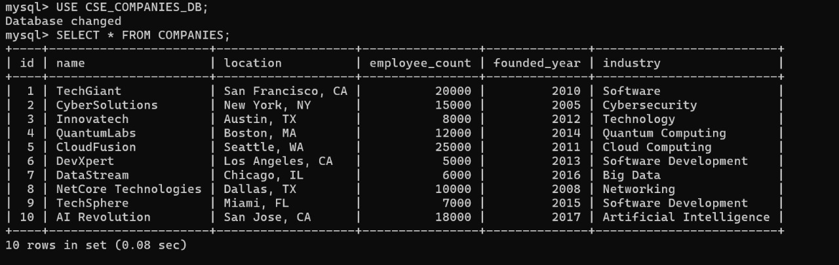

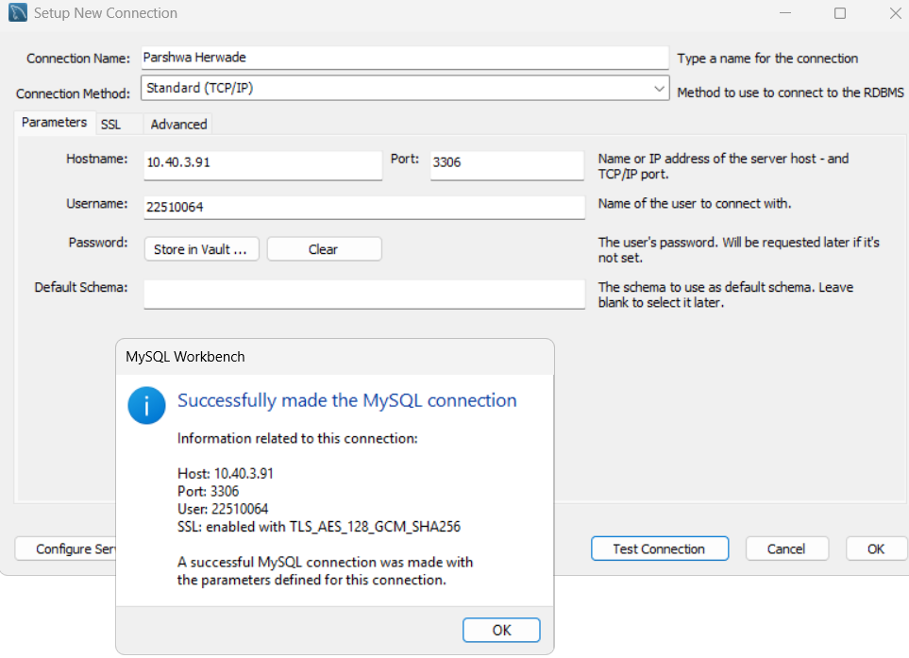

Also, connect new user with the IP address of the server to be given to client for connection over the same network if required.

As u can see the connection is successful.

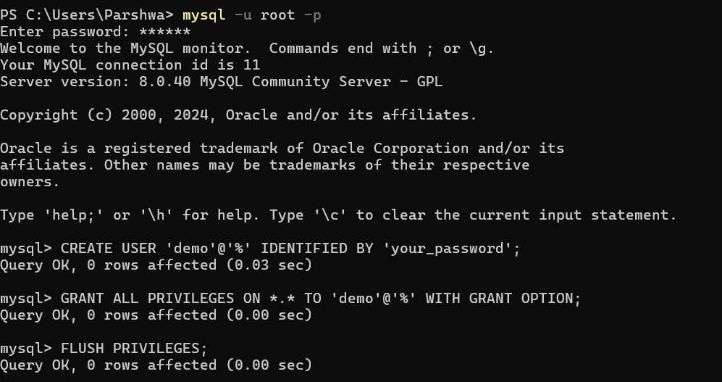

Also, extra user demo is created with all privileges ,the same is done for PRN 22510064.

SETUP VS CODE:





Create the angular app and server side of the form filling platform

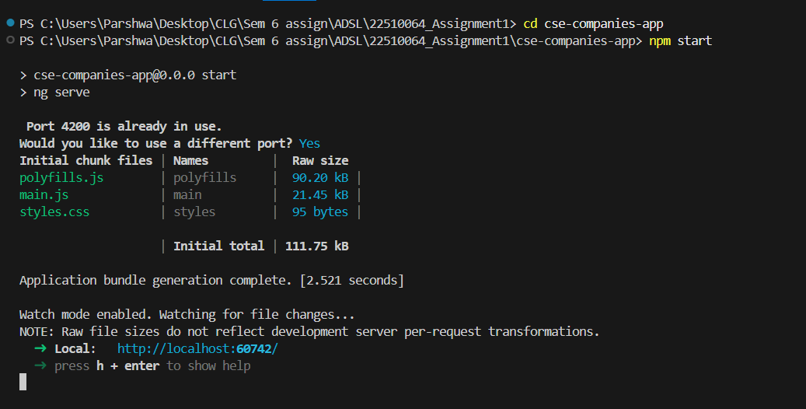

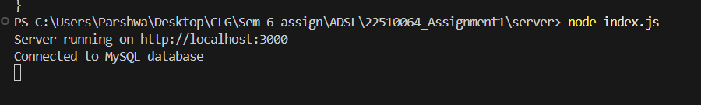  
Verify the connection:  
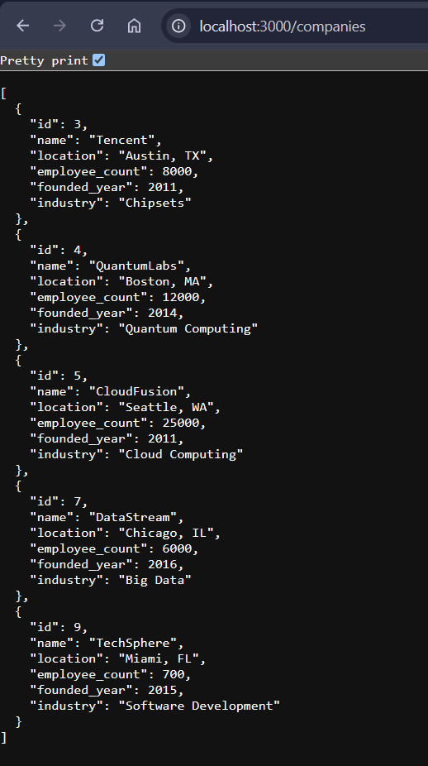

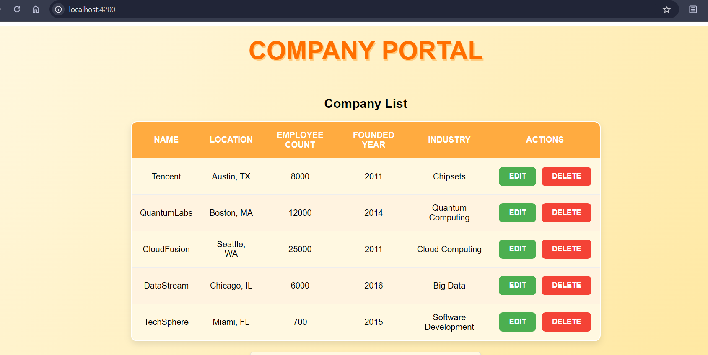

CRUD: EDIT, DELETE, SAVE , ADD.

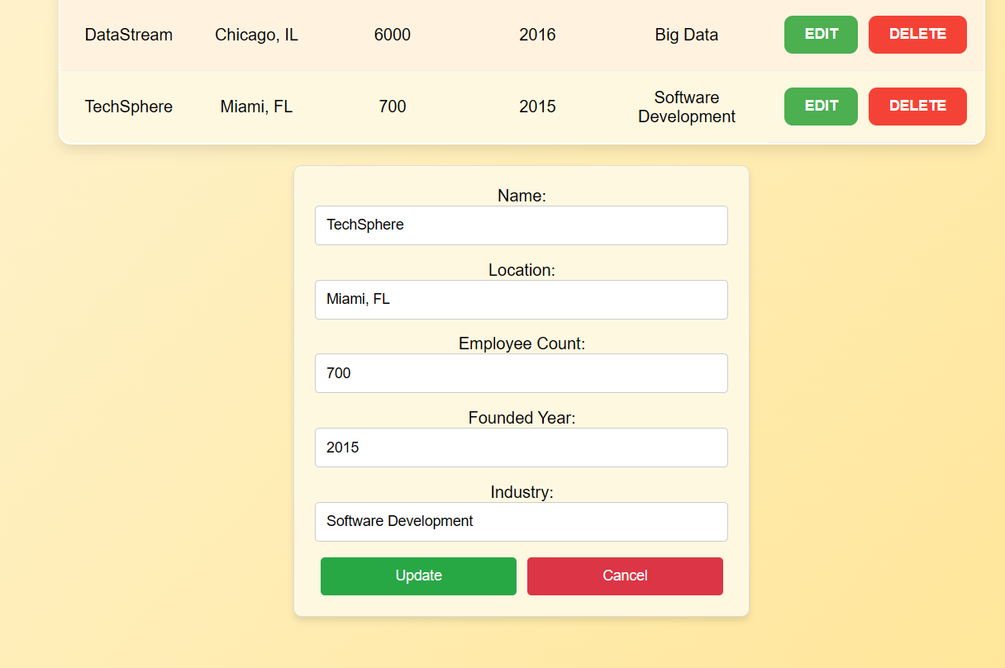

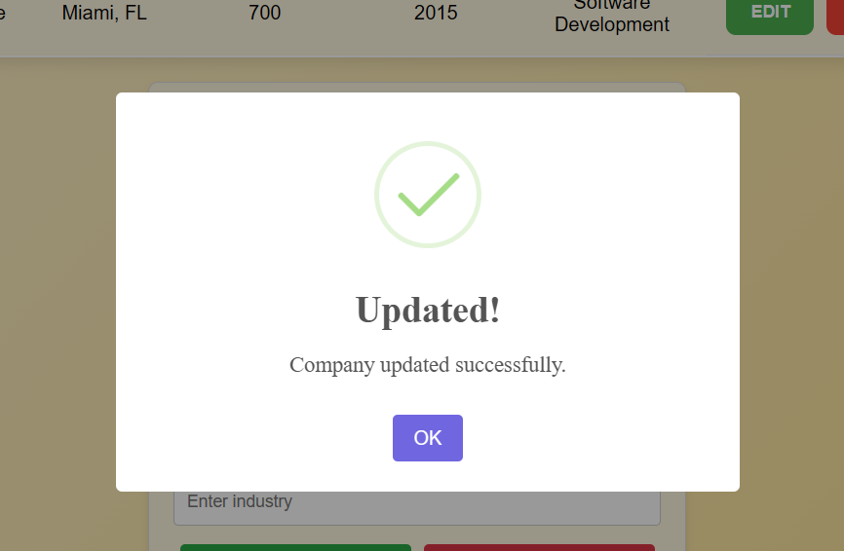

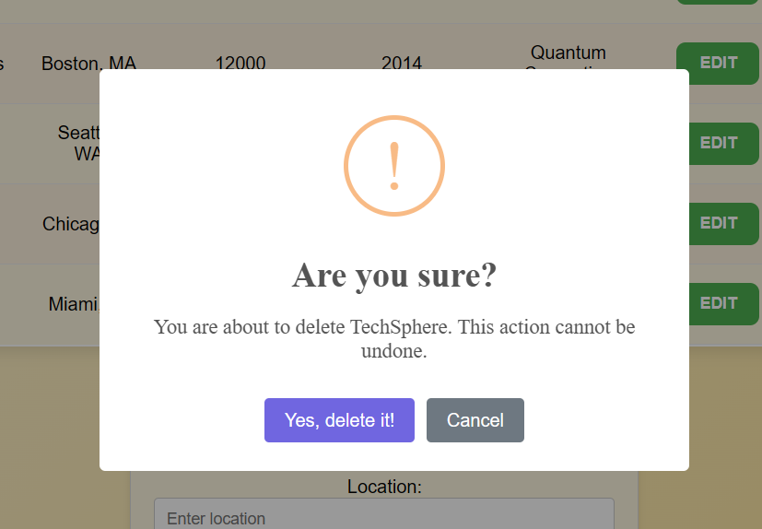

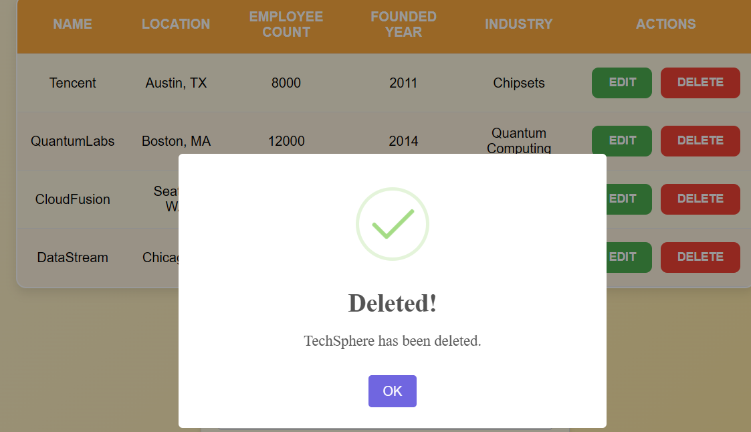

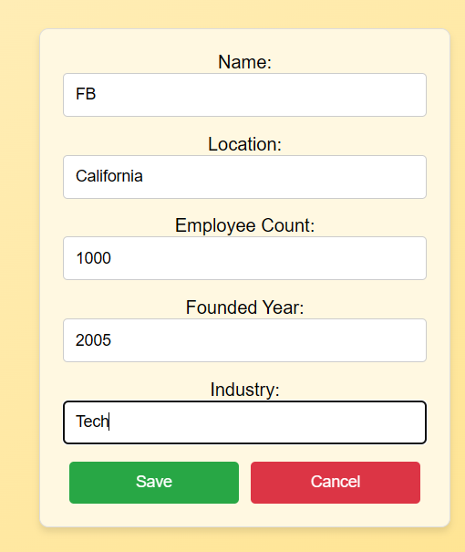

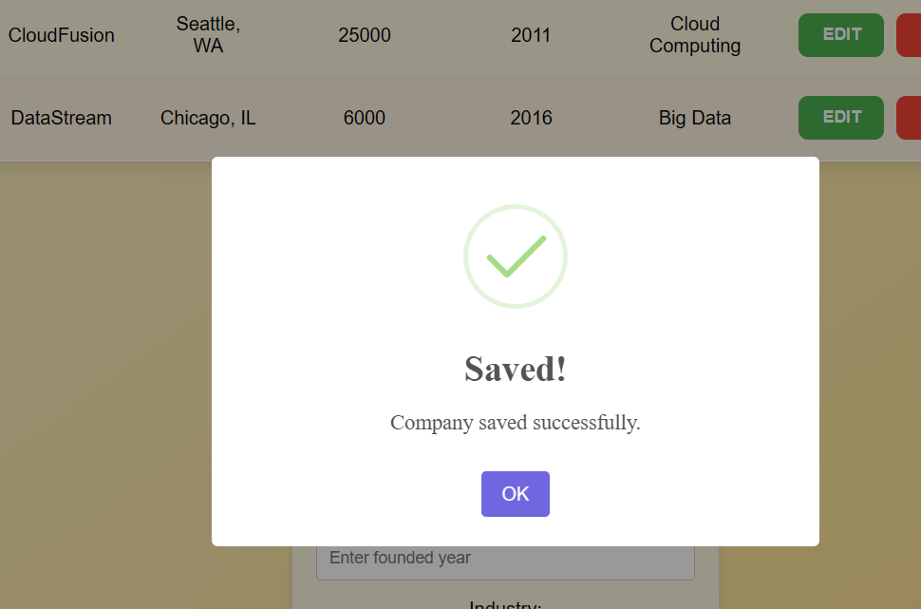

UPDATED FINAL TABLE IN MYSQL:

