**Batch T4**

**Practical No. 5**

**Title of Assignment :**

Performance Testing of Web-based Student MIS and Online MCQ Exam System

**Student Name: Parshwa Herwade**

**Student PRN: 22510064**

**APACHE J METER**

(FOR MORE REF SEE THE .CSV FILES IN THE FOLDER TO UNDERTSAND THE TESTING OF THE APPS FOR ASSIGNMENT 3,4)

**Objective / Aim:**

To evaluate the performance of the Student Management Information System (MIS) and Online MCQ Exam System using Apache JMeter. The goal is to measure key performance metrics, identify bottlenecks, and ensure system scalability under load.

**Introduction:**

Performance testing is crucial for web applications to ensure they can handle concurrent users without degradation in response time. Apache JMeter, an open-source performance testing tool, is used to simulate multiple users and analyze system behavior under different load conditions.

**Theory / Algorithms:**

**Performance Testing Metrics:**

1. **Response Time:** The time taken by the server to respond to a request.
2. **Throughput:** The number of requests processed per second.
3. **Error Rate:** The percentage of failed requests.
4. **CPU & Memory Utilization:** The impact of load on server resources.
5. **Concurrent Users:** Number of users the system can handle before performance degrades.

**JMeter Test Plan Configuration:**

* **Thread Group:** Defines the number of users, ramp-up time, and loop count.
* **HTTP Request Sampler:** Simulates user requests to test different API endpoints.
* **Listeners:** Used to collect test results (Summary Report, Graphs, Tables).
* **Assertions:** Validates responses to check if the application behaves as expected.

**Procedure:**

1. **Setup JMeter:** Install and configure JMeter on the testing machine.
2. **Create Test Plan:**
   * Define Thread Groups (simulate users).
   * Configure HTTP Requests to target endpoints of Student MIS and MCQ Exam System.
   * Add Listeners to capture results.
3. **Run Performance Tests:** Execute the test plan with varying user loads.
4. **Monitor System Metrics:** Check server CPU, memory, and database performance.
5. **Analyze Results:** Compare response times, error rates, and throughput under different loads.

ASSINMENT 3:  
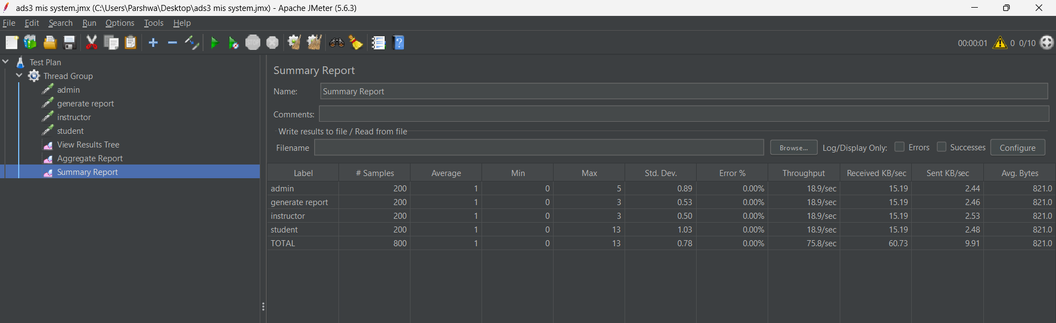

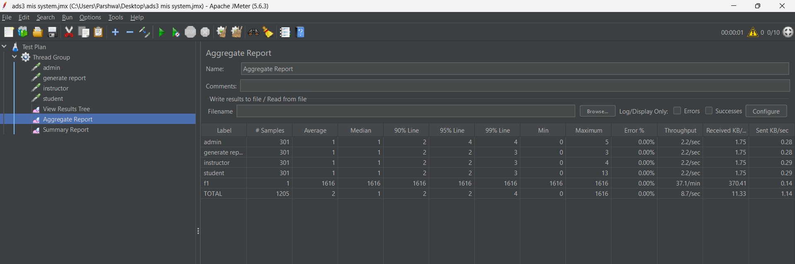

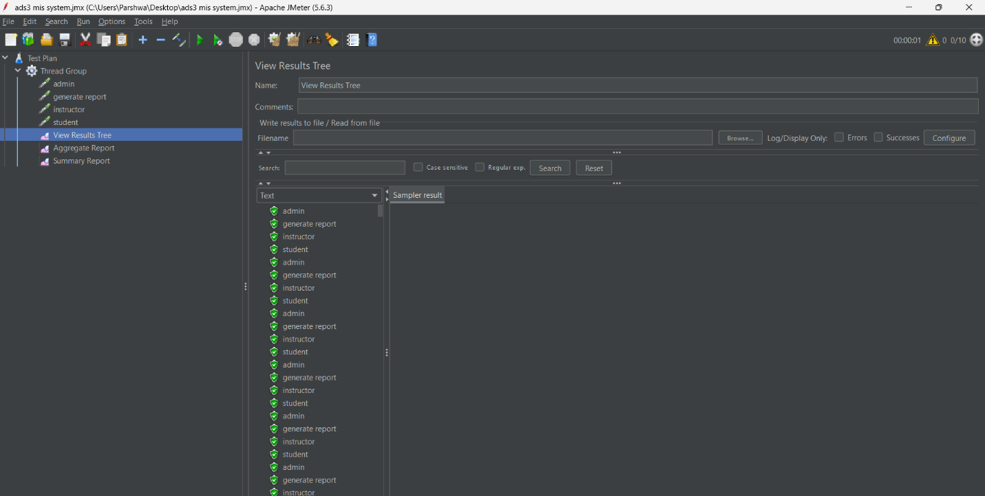

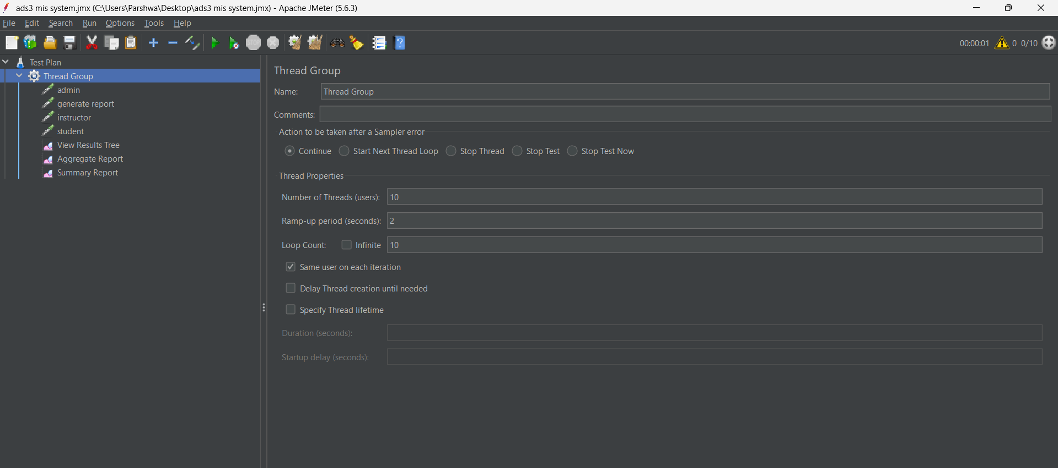

ASSIGNMENT 4:  
