**Batch T4**

**Practical No. 8**

**Title of Assignment :**

Distributed Systems

**Student Name: Parshwa Herwade**

**Student PRN: 22510064**

1. Do the installation and configuration of Oracle/MySQL/IBM DB2 distributed databases. [ Take minimum 3 nodes ] 2. Use the above installed distributed database as backend for Assignment No.3 & 4. 3. Demonstrate the working by connecting portals to different nodes, adding data from one node and available / display on portal connected to another node etc.

***Title: Installation and Configuration of Oracle/MySQL/IBM DB2 Distributed Databases with Multi-Node Connection***

**Objective / Aim:**

* To install and configure a distributed database system using Oracle, MySQL, or IBM DB2 on a minimum of three nodes.
* To utilize the distributed database as a backend for further assignments.
* To demonstrate real-time data synchronization between different nodes.

**Introduction:** A distributed database system (DDBS) is a collection of databases distributed across multiple locations that appear as a single database to users. The aim of this assignment is to install and configure Oracle/MySQL/IBM DB2 across three nodes and test the data sharing capabilities among them. The nodes will communicate through replication or other distributed database techniques to ensure data consistency and availability.

**Theory / Algorithms:**

* **Distributed Database Concept:** A distributed database is a database that is stored on multiple physical locations and managed through a distributed database management system (DDBMS).
* **Replication:** Ensures that copies of data exist across multiple nodes to provide fault tolerance and high availability.
* **Sharding:** Splits a database into smaller chunks and distributes them across multiple databases.
* **Two-Phase Commit (2PC):** Ensures consistency in transactions across nodes.
* **Master-Slave Replication:** A method where one server acts as the master and others as read-only replicas.

**Documentation: Functional Block Diagram/DFD:**

* A functional block diagram of the distributed database system showing communication between the nodes.
* Data Flow Diagram (DFD) illustrating how data is synchronized between nodes.

**Procedure:**

1. **Installation of Distributed Database:**
   * Install Oracle/MySQL/IBM DB2 on three different machines (nodes).
   * Configure necessary dependencies and services required for database management.
2. **Configuration of Distributed Database:**
   * Assign unique server IDs to each node.
   * Enable replication/sharding based on the chosen database system.
   * Set up users with appropriate privileges for communication between nodes.
3. **Testing Data Synchronization:**
   * Connect different portals to different nodes.
   * Insert data from one node and verify its availability on other nodes.
   * Perform queries to check real-time updates.

**Actual Experiments/Simulation, Result / Observations:**

* **Experiment:** Connecting to different nodes and ensuring data replication.

**Conclusion:** The distributed database system was successfully installed and configured on multiple nodes. The experiments demonstrated that data added on one node is available on other nodes, verifying the proper functioning of the distributed setup. This setup enhances database reliability, availability, and fault tolerance.

**References:**

1. MySQL Documentation - https://dev.mysql.com/doc/
2. Oracle Database Documentation - https://docs.oracle.com/en/database/
3. IBM DB2 Knowledge Center - https://www.ibm.com/docs/en/db2

* The databases used here that is MYSQL have been already installed in the systems:  
  Here 1 master and 2 slaves machines have bees used .
* A user has been created and has been added in the master machine plus the user credentials have been given to other slaves for connecting to the master machine
* Privliges have been given to the slaves and through the master status we can see that the file created in master with the position of it.

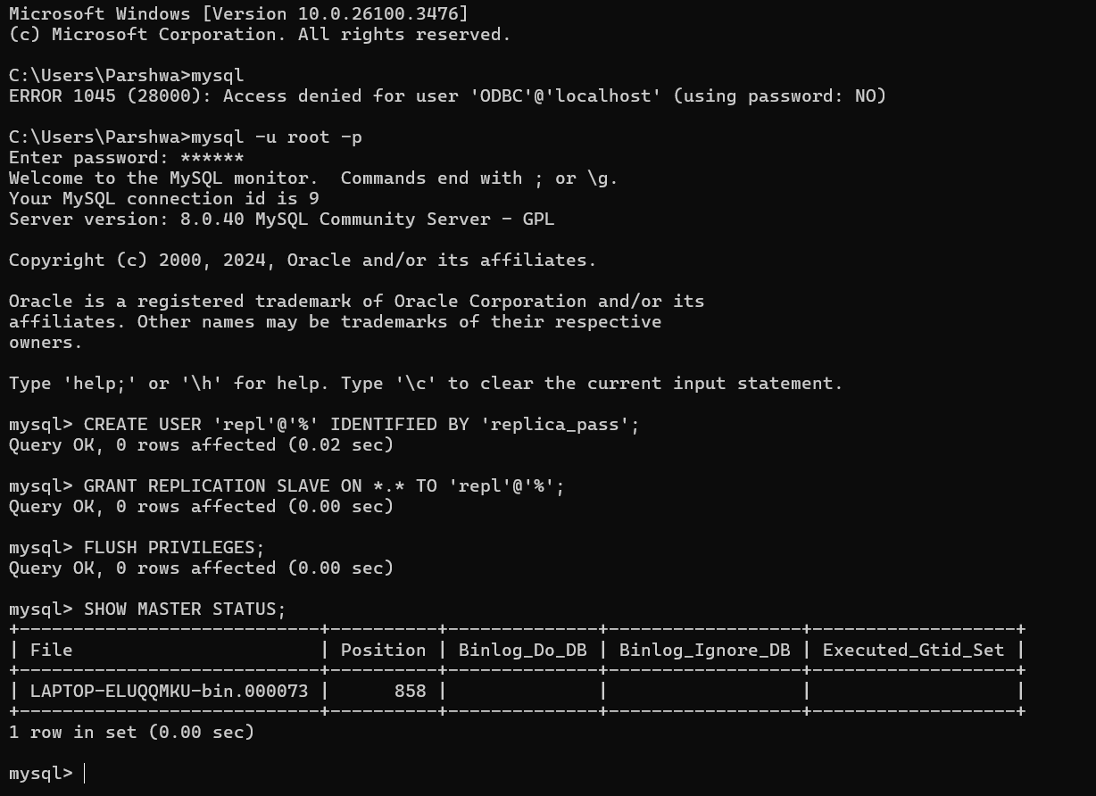

* Before this chechout the my.ini file and changes made to it
* A mysqld section has been added with the Ips of all the master and slave being replicated in all of the files of .ini in each if the sql server 8.0 folder of the installed version of the MYSQL.
* So here for server the id that is given is 1 and for the other slaves its been set up as incremental as +1 i.e. 2,3 as per the screeshot below.

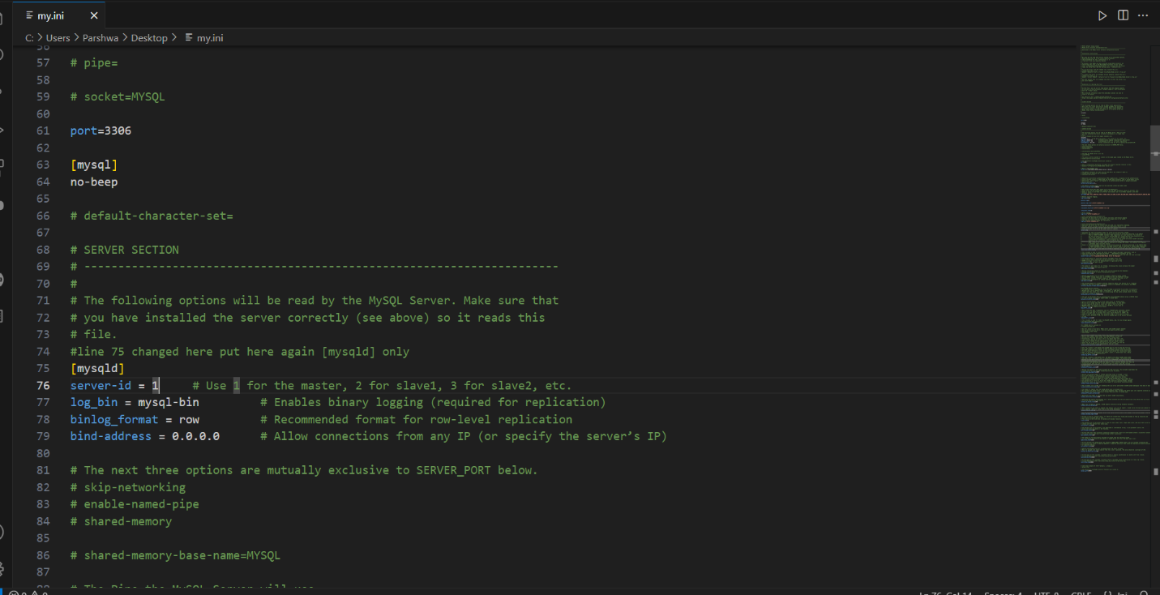

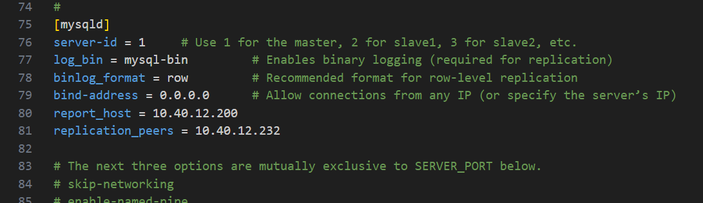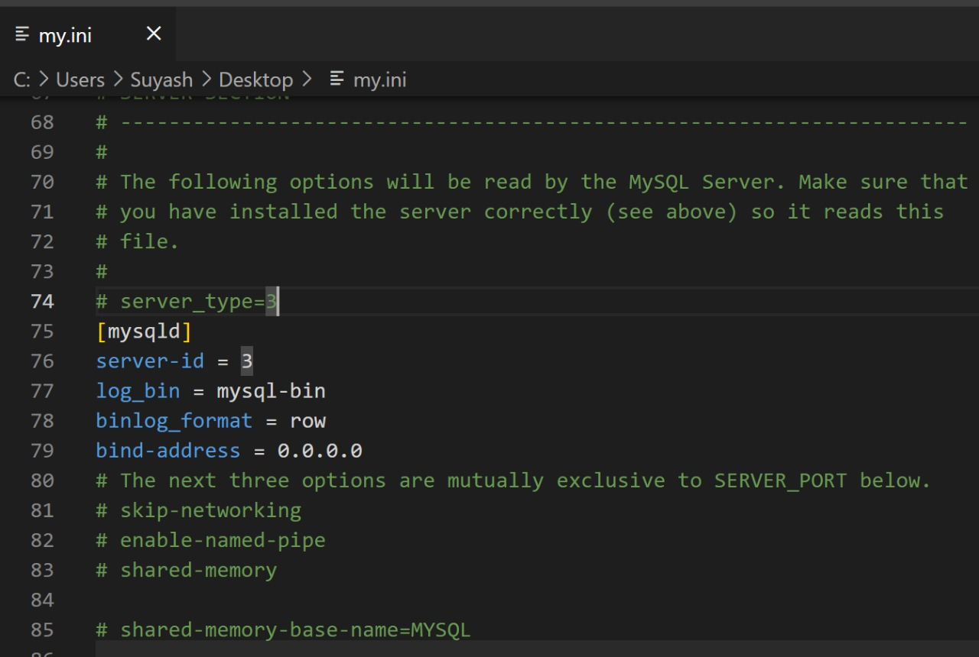

* On the slave machine u can see that with the master IP and other credentials and start slave we can see the connection has been set up rightly i.e  
  slave_sql and slave_io is successfully running: YES.

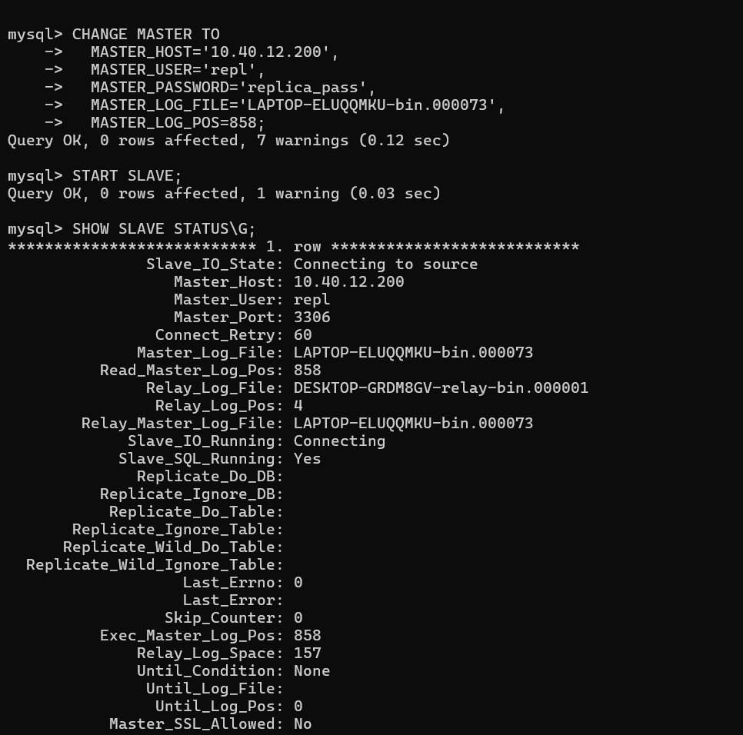

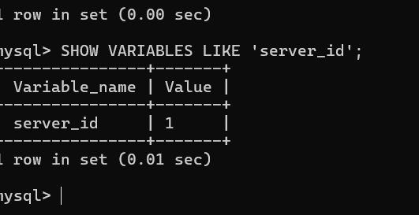

This is the database and the changes that are reflected in the distributed system machines:  
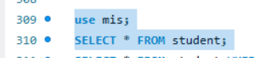

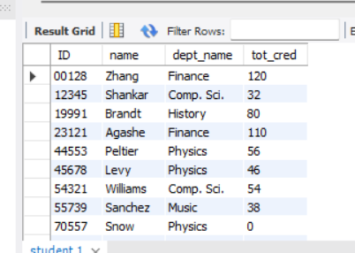

  
Updated value being reflected in the master from what is above and also in the other connected machines.

