**ETL in Tableau: Advanced Data Preparation & Processing**

* **PRN:** 22510064
* **Name:** Parshwa Herwade
* **Topic No.:** 42
* **Topic Name:** ETL in Tableau: Advanced Data Preparation & Processing
* **TY CSE**
* **18/2/2025**

**Abstract**

This presentation explores the advanced techniques used in ETL (Extract, Transform, Load) processes within Tableau. It demonstrates how Tableau Desktop and Tableau Prep can be leveraged for efficient data cleaning, transformation, and loading, ultimately enhancing data quality and visualization performance on Tableau Public. A literature survey supports the methodologies discussed, showing how academic research, official documentation, and industry case studies validate these best practices.

**1. Introduction**

**Objective**

* To investigate advanced ETL techniques using Tableau tools.
* To illustrate how proper data preparation leads to improved dashboard performance and more reliable business insights.

**Background**

* ETL processes are crucial for transforming raw data into a structured format suitable for analysis.
* Tableau offers native ETL capabilities that simplify data extraction, transformation, and loading.
* With the increasing volume of data in organizations, adopting advanced ETL practices is essential for maintaining high data quality and performance.

**2. Overview of ETL in Tableau**

**Definition**

* **Extract:** Retrieve raw data from diverse sources such as Excel, CSV, databases, and cloud services.
* **Transform:** Clean, restructure, and enrich the data using various techniques (e.g., handling null values, data type conversions, calculated fields).
* **Load:** Import the processed data into Tableau for visualization and analysis.

**Importance**

* **Data Quality:** Ensures that visualizations are built on clean, reliable data.
* **Performance:** Reduces the computational load, leading to faster and more responsive dashboards.
* **Decision-Making:** Provides accurate insights that support strategic decisions.

**3. Detailed ETL Methodology**

**A. Data Extraction**

* **Process:**
  + Connecting to multiple data sources (e.g., Excel, CSV, SQL databases, Google Sheets).
  + Choosing between Live Connection (real-time updates) and Extract Mode (using a static snapshot such as a .hyper file for enhanced performance).
* **Application:**
  + In our demonstration, we connected an Excel file to Tableau Public, showcasing the simplicity of data extraction.

**B. Data Transformation**

* **Key Tasks:**
  + **Data Cleaning:** Remove duplicates, handle missing values using functions like IFNULL() and ISNULL().
  + **Data Enrichment:** Convert data formats (e.g., transforming dates with DATEPARSE) and create calculated fields (e.g., currency conversion from USD to INR).
* **Application:**
  + Using Tableau Prep, we demonstrated cleaning a messy dataset, splitting full names into first and last names, and joining multiple datasets for comprehensive analysis.

**C. Data Loading**

* **Strategies:**
  + Loading the cleaned and transformed data into Tableau Desktop as an extract to boost performance.
  + Applying filters, aggregations, and further calculations during the loading phase.
* **Application:**
  + We showcased the process of loading data into Tableau Public, with examples of interactive filters that enhance user experience.

**4. Advanced Calculated Fields**

**Examples**

* **Handling NULL Values:**

IFNULL([Salary], WINDOW_AVG([Salary]))

* **Department Standardization:**

IF ISNULL([Department]) THEN "Unknown" ELSE [Department] END

* **Currency Conversion (USD to INR):**

IF [Currency] = "USD" THEN [Salary] * 83.10 ELSE [Salary] END

* **Date Formatting:**

DATEPARSE("dd-MM-yyyy", [Hire Date])

These calculated fields illustrate how Tableau’s built-in functions enable advanced data transformation without external scripting.

**5. Tableau Prep for ETL Workflows**

**Overview**

* Tableau Prep is designed for visual, drag-and-drop data preparation.
* It simplifies complex ETL processes by allowing users to connect to raw data, apply a series of transformations, and output clean extracts ready for analysis.

**Workflow**

1. **Connect:** Import raw data from various sources.
2. **Transform:** Execute data cleaning, merging, and calculation operations.
3. **Output:** Generate a refined data extract for Tableau Desktop.

**Demonstration**

* The presentation includes a live demonstration (or video recording) of a Tableau Prep workflow that transforms a raw dataset into a final extract used in Tableau Public.

**6. Material & Literature Survey**

**Purpose**

* To validate the ETL methodologies and best practices discussed, through a review of academic and industry literature.

**Key Sources**

* **Books & Research Papers:**
  + *Data Preparation for Tableau* – Details practical techniques for data cleaning and transformation.
  + *The Data Warehouse Toolkit* by Ralph Kimball – Provides foundational insights into ETL design and data modeling.
* **Official Documentation & Blogs:**
  + Tableau Help Documentation – Offers step-by-step guides on using Tableau’s ETL features.
  + Tableau Blog – Showcases real-world case studies and advanced data processing techniques.
* **Online Articles & Tutorials:**
  + “ETL vs. ELT: What’s the Difference?” – Explores modern data processing approaches.
  + “Data Cleaning and Transformation with Tableau Prep” – Provides hands-on examples for effective data preparation.

**Key Findings**

* **Data Quality:** Clean data is fundamental for accurate visualizations.
* **Performance:** Utilizing Extract Mode and incremental updates enhances dashboard performance.
* **Scalability:** Hybrid ETL methods are necessary for managing large datasets effectively.
* **Industry Validation:** Case studies on Tableau Public confirm that advanced ETL workflows lead to better insights and decision-making.

**7. Challenges & Best Practices**

**Challenges**

* Managing large datasets without compromising performance.
* Dealing with inconsistent data formats and missing values.
* Complexity in joining and blending data from diverse sources.

**Best Practices**

* **Pre-clean Data:** Use Tableau Prep to handle initial data cleaning.
* **Use Extracts:** Leverage .hyper extracts for improved dashboard speed.
* **Optimize Calculations:** Pre-aggregate data where possible and limit overly complex calculated fields.
* **Automate Updates:** Schedule incremental refreshes to maintain data currency.

**8. Conclusion**

This presentation has demonstrated that advanced ETL techniques in Tableau—using both Tableau Desktop and Tableau Prep—are essential for ensuring high-quality, high-performance data analysis. By adopting best practices in data extraction, transformation, and loading, organizations can achieve reliable visualizations and robust decision-making frameworks. Continuous improvement in ETL processes, validated by academic research and industry case studies, is key to managing evolving data challenges.

**9. References**

1. *Data Preparation for Tableau*
2. *The Data Warehouse Toolkit* by Ralph Kimball
3. Tableau Help Documentation: https://help.tableau.com
4. Online Articles: “ETL vs. ELT: What’s the Difference?”, “Data Cleaning and Transformation with Tableau Prep”

DATA BEING IMPORTED TO TABLEAU AND EXTRACTED…

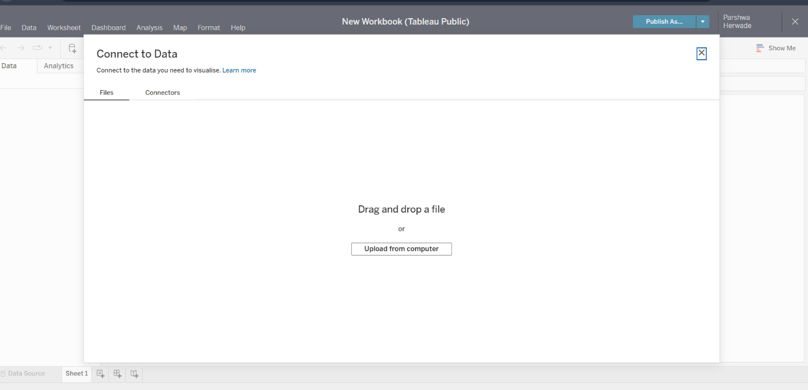

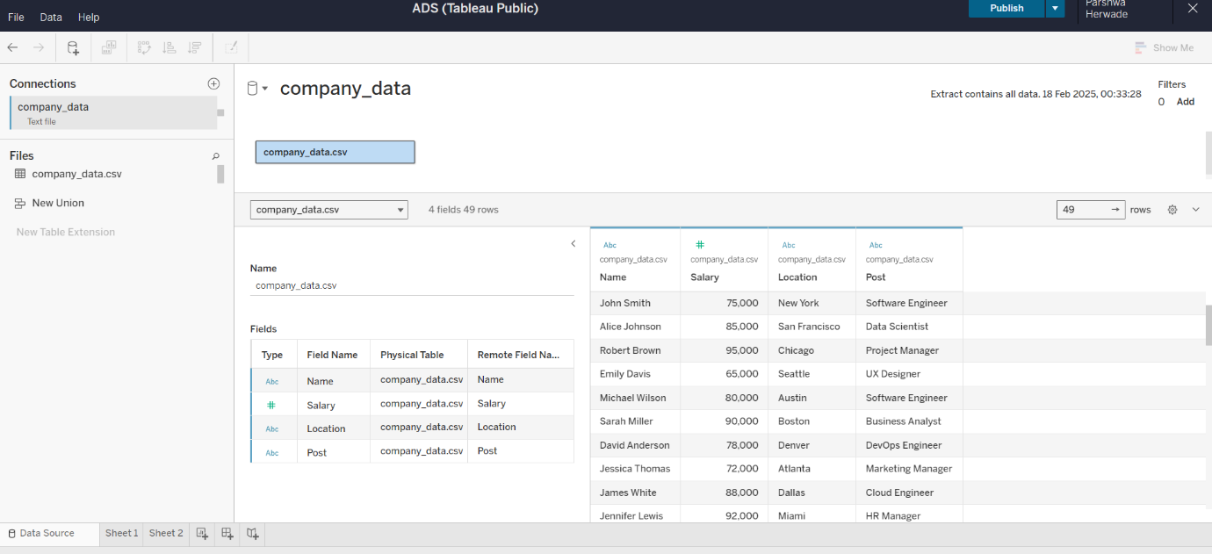

FILTERS BEING SET UP:

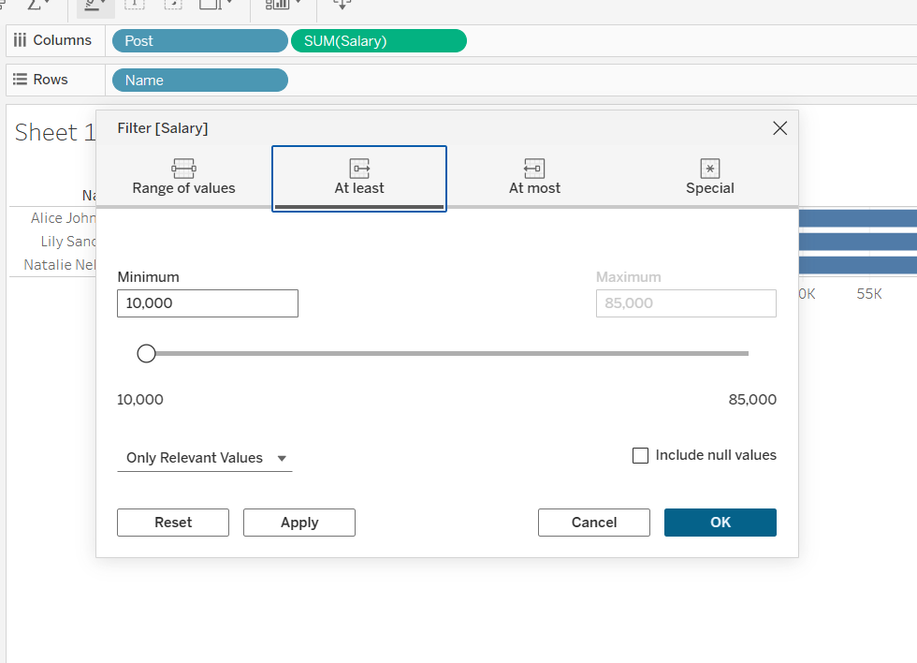

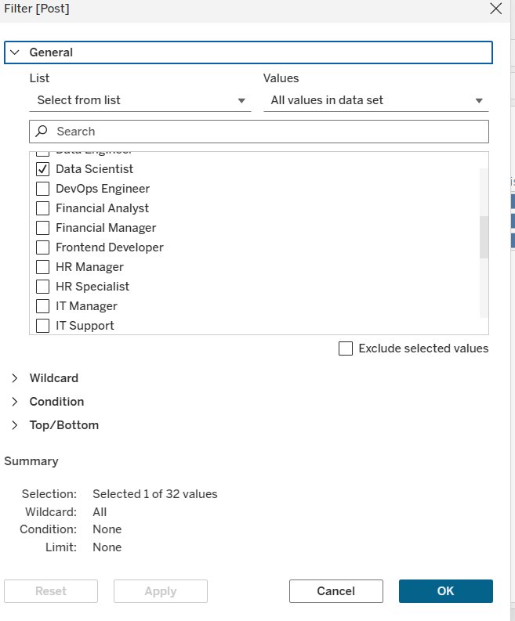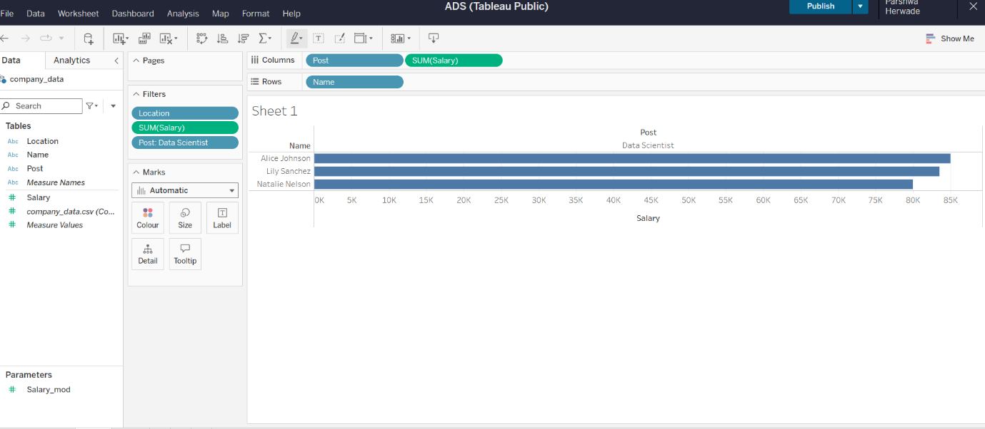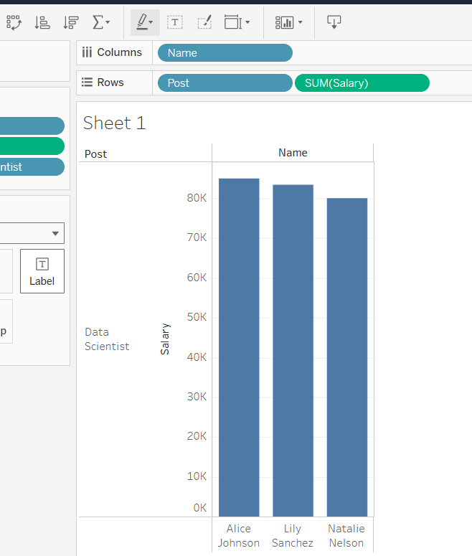

ALL THE EMPLOYEES EVEN THE ONES WHOSE SALARY VALUES ARE NOT ENETERED  
(DATA WITH ANOMALIES)

