OpenTrace
Federated Software Supply-Chain Metadata Infrastructure

OpenTrace is an open-source research and development project focused on evidence-based package identity resolution, provenance-aware metadata normalization, and federated software supply-chain metadata verification.
The project aims to establish a transparent and reproducible approach to reconciling software package metadata across heterogeneous package registries without relying on a single centralized authority.

1. The Problem
Modern software ecosystems depend on package metadata distributed across multiple registries, vulnerability databases, and licensing sources.
However, these sources may contain:
- Inconsistent package identifiers and version information.
- Conflicting license declarations.
- Missing or incomplete provenance records.
- Different release dates for apparently identical package versions.
- Insufficient evidence to establish whether two records represent the same software artifact.
These inconsistencies make software supply-chain auditing, dependency verification, and security analysis more difficult.
OpenTrace addresses this challenge by introducing an evidence-based reconciliation framework that preserves source information and makes uncertainty explicit.

2. Project Objectives
OpenTrace focuses on three primary technical objectives:
2.1 Evidence-Based Package Identity Resolution
Identify whether metadata records from different sources refer to the same package and version.
The matching process considers:
- Package name and normalized identifiers.
- Version information.
- Cryptographic checksums and hashes, when available.
- Build and artifact metadata.
- Source-specific identifiers.
Instead of relying exclusively on package names, OpenTrace evaluates multiple matching signals and records the evidence supporting each decision.

2.2 Provenance-Aware Metadata Normalization
Every collected metadata claim retains its original source and observation timestamp.
The normalization engine aims to:
- Standardize metadata representations.
- Preserve original source claims.
- Detect conflicting metadata.
- Maintain traceability between normalized records and their sources.
- Avoid silently overwriting conflicting information.

2.3 Federated Metadata Distribution
OpenTrace is designed around modular collectors and decentralized data distribution.
The project will investigate interoperability with the CodeSupply Federated Data Catalog and develop machine-readable exports and API interfaces compatible with its validated integration requirements.

3. Proposed Architecture
The proposed architecture consists of five logical components:
External Metadata Sources

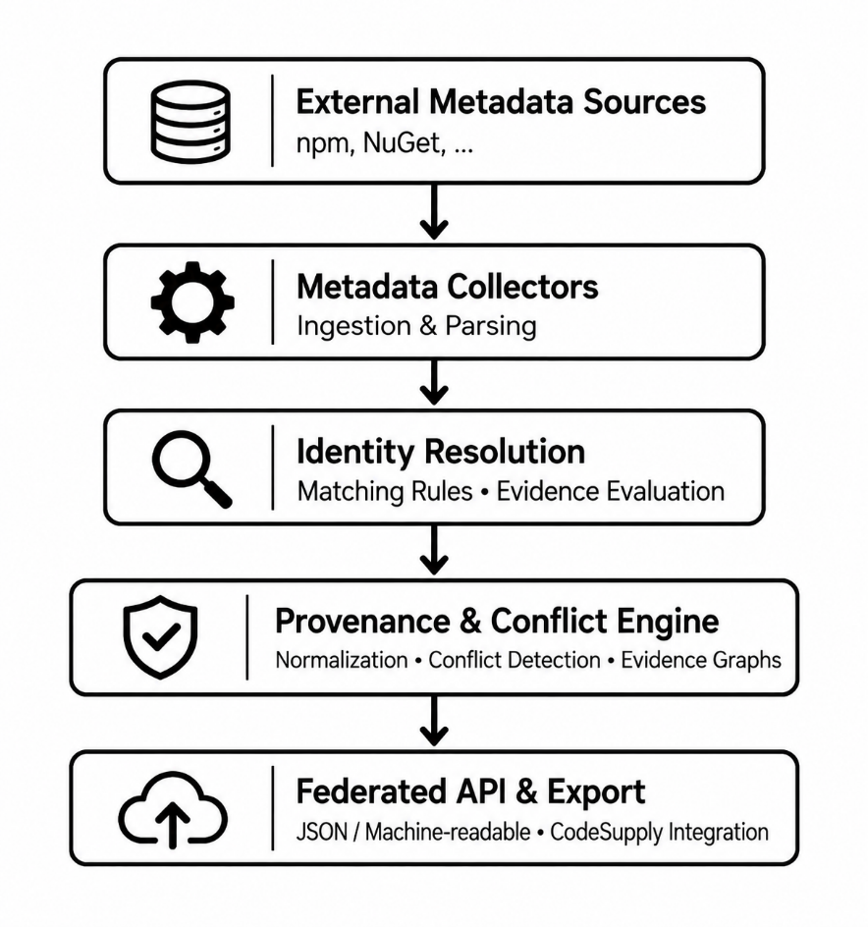
Note: This diagram represents the proposed system architecture.

4. Core Technical Concepts
4.1 Package Identity Matching
OpenTrace uses a multi-signal matching approach.
For two metadata records, A and B, the system evaluates a set of matching signals:
Signal | Description
Name | Normalized package name
Version | Semantic version comparison
Checksum | Cryptographic artifact identity
Build metadata | Build and artifact information
Source ID | Original registry identifier
The matching engine produces an explicit decision:
- MATCHED: Sufficient evidence supports identity equivalence.
- UNRESOLVED: Available evidence is insufficient.
- CONFLICT: Evidence contains contradictory identity information.
A conceptual matching score can be expressed as:
[
$$S(A,B)= \sum_{i=1}^{n}{w_{i}m_{i}}(A,B)$$]
Where:
- ($w_{i}$) represents the weight assigned to a matching signal.
- ($m_{i}$) represents the normalized result of comparing that signal.
- ($S(A,B)$) represents the combined matching score.
Cryptographic checksum equality, when the checksum covers the same artifact representation, provides stronger evidence than name similarity alone.

4.2 Provenance Model
Each metadata claim is associated with:
- Source registry.
- Original package identifier.
- Package version.
- Metadata field.
- Observed value.
- Observation timestamp.
- Evidence reference.
This model enables historical traceability and reproducible metadata analysis.

4.3 Conflict Detection
Examples of conflicts include:
Metadata Field | Source A | Source B
License | MIT | Apache-2.0
Release Date | 2025-01-10 | 2025-01-12
Package Version | 2.1.0 | 2.1.1
OpenTrace aims to preserve both claims and identify the nature of the discrepancy rather than automatically selecting one source as authoritative.

5. Planned Repository Structure
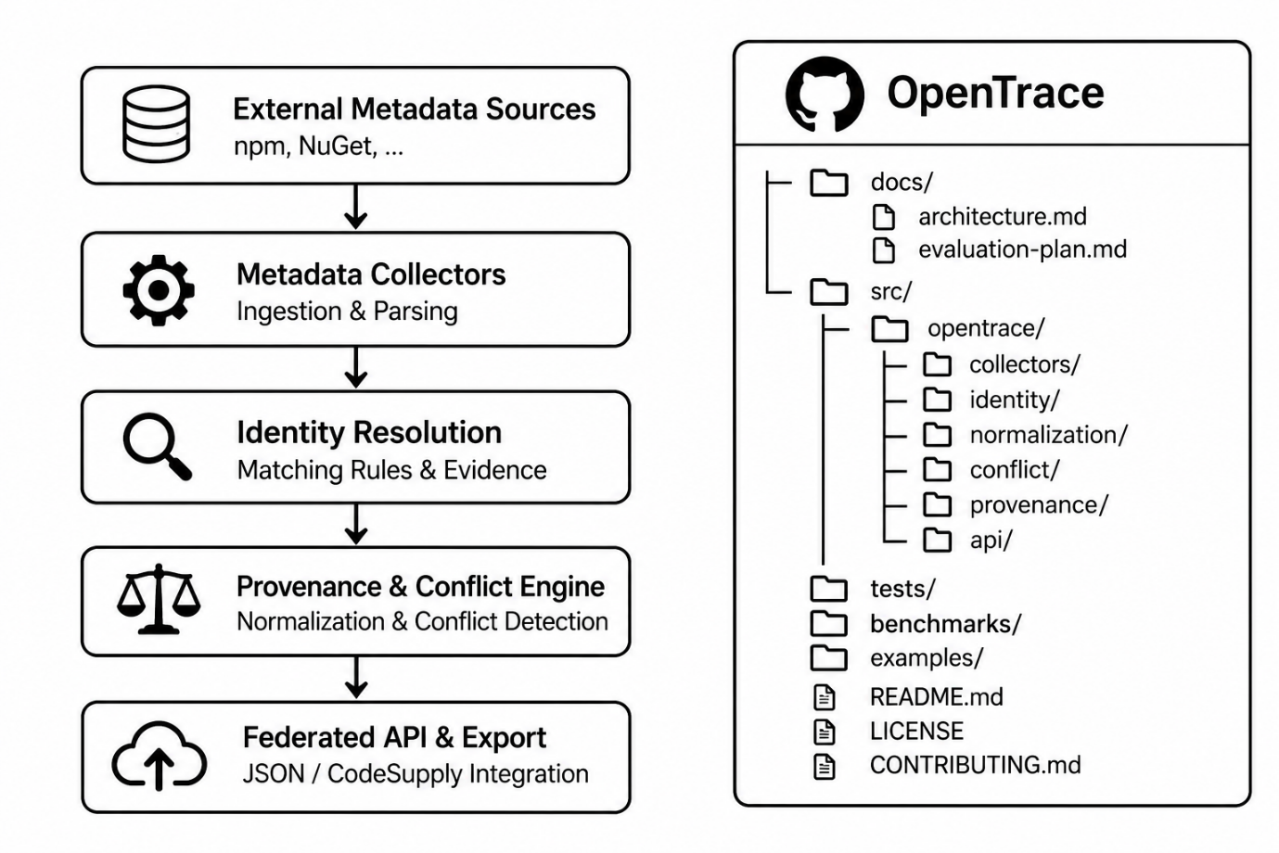
This is the proposed development structure. Components will be added as implementation progresses.

6. Development Roadmap
Phase | Timeline | Planned Deliverables
Phase 1 | Months 1–2 | Methodology, provenance model, identity engine
Phase 2 | Months 3–4 | npm/NuGet collectors, normalization, federation API
Phase 3 | Months 5–6 | Benchmarking, validation, documentation, FOSS release
Target Evaluation Metrics
The project aims to evaluate its performance against an independently prepared test corpus.
Metric | Target
Identity Resolution Precision | ≥95%
Conflict Detection Precision | ≥90%
Conflict Detection Recall | ≥90%
Evaluation Corpus | ≥10,000 records
These values are project targets, not yet experimentally validated results.

7. Technology Stack
The proposed implementation will use:
- Python: Core processing and evaluation components.
- JSON: Machine-readable metadata representation.
- REST APIs: Metadata access and interoperability.
- GitHub Actions: Continuous integration and regression testing.
- PostgreSQL / Graph-oriented storage: Evaluation of persistent metadata and evidence relationships.
Technology choices may be refined during the architecture and implementation phases.

8. Open-Source Principles
OpenTrace is designed around transparency, reproducibility, and interoperability.
The intended licensing model is:
- Source code: Apache License 2.0.
- Project-created schemas and documentation: CC-BY 4.0.
- Project-created benchmark datasets: CC0 where appropriate.
- External metadata: Original source licensing and redistribution conditions will be respected.

9. Expected Impact
OpenTrace aims to provide reusable infrastructure for:
- Software supply-chain security.
- Open-source dependency auditing.
- License compliance verification.
- Software metadata interoperability.
- Federated digital infrastructure.
- Civic technology and environmental monitoring platforms.
By making metadata claims traceable and conflicts visible, OpenTrace seeks to improve trust and reproducibility across software ecosystems.

10. Funding & Project Context
Funding Program: NLnet CodeSupply Open Call (2026-11Y)
Project Duration: 6 Months
Requested Funding: €45,000
Research and Development Focus: Federated metadata infrastructure, package identity resolution, provenance tracking, and software supply-chain verification.

11. Project Status
OpenTrace is currently presented as a research and development prototype proposal.
The repository will progressively include:
- Technical specifications.
- Core implementation modules.
- Metadata collection tools.
- Reproducible benchmark datasets.
- Automated evaluation scripts.
- Integration documentation.
Contributions, technical feedback, and collaboration from the open-source community are welcome.
OpenTrace — Transparent Evidence for a Federated Software Ecosystem.

