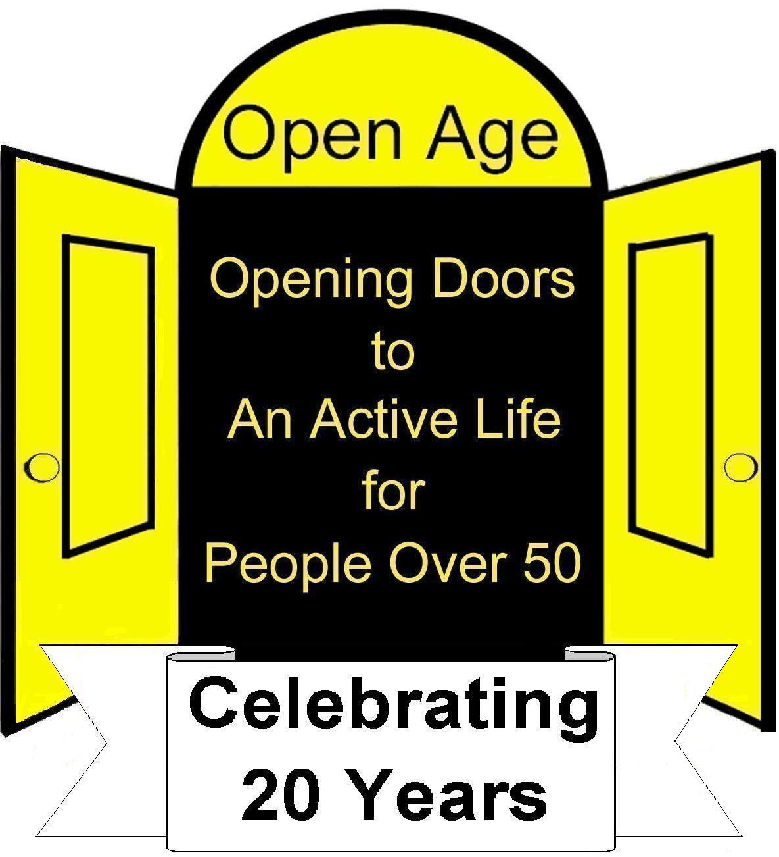  Charity Number 1039520 | Open Age  Membership Form 2014 - 2015 | Office use only
  Card
  Information
  Light bulbs
  If benefits ticked
  Donation cash
  Donation chq
  Initial
Open Age: Championing an Active Life
for Older People for 21 Years!
St Charles Centre for Health & Wellbeing, Exmoor Street, London, W10 6DZ
Tel: 020 8962 4141 www.OpenAge.org.uk

Personal details (Please complete in BLOCK CAPITALS)
Title | Dr. Mr. Miss. Ms. Mrs. |  |  |  |  |  |  | Date of Birth
First Name |  |  |  |  |  |  |  | Surname
Telephone |  |  |  |  |  |  |  | Mobile
Address

Postcode
Address  Postcode |  |  |  |  |  |  |  |  | Borough
Email
❑ Living alone |  |  | ❑ Pensioner |  |  |  | ❑ Unemployed |  |  |  |  |  |  | ❑ Unpaid Carer
How did you hear about Open Age?
At which activity/office did you complete this form? _____________________________
Ethnic Origin
Asian/Asian British |  | Black / Black British |  |  |  | Mixed |  |  |  | White |  |  |  |  | Other
❑ Bangladeshi   Indian   Pakistani   Chinese   Other Asian  background |  | ❑ African   Caribbean   Other Black  background |  |  |  | ❑ White & Asian   White & Black  African   White & Black  Caribbean   Other Mixed  background |  |  |  | ❑ British   Irish   Gypsy or Irish  Traveller   Other White  background |  |  |  |  | ❑ Arab   Filipino   Iranian   Moroccan   Other please specify  ____________
Benefits
❑ Attendance Allowance |  |  |  | ❑ Housing Benefit |  |  |  |  |  |  |  | ❑ Job Seekers Allowance
❑ Campden Charities |  |  |  | ❑ Incapacity |  |  |  |  |  |  |  | ❑ Pension Credit
❑ Council Tax Benefit |  |  |  | ❑ Employment Support Allowance (Income Support) |  |  |  |  |  |  |  | ❑ Universal Credit
❑ Disability Living Allowance |  |  |  | ❑ Other (Please specify) ______________________________
Disability and Health information (tick & circle detail)
❑ Arthritis: Osteo/Rheumatoid |  |  |  |  | ❑ Fall in last 12 months |  |  |  |  |  | ❑ Mobility Issues
❑ Breathing: Asthma/COPD |  |  |  |  | ❑ Hearing Impairment |  |  |  |  |  | ❑ Osteoporosis
❑ Back/Neck Trouble |  |  |  |  | ❑ Heart Condition |  |  |  |  |  | ❑ Parkinson’s Disease
❑ High/Low Blood Pressure |  |  |  |  | ❑ Learning Difficulties |  |  |  |  |  | ❑ REGISTERED DISABLED
❑ Dementia   Diabetes |  |  |  |  | ❑ Mental Ill Health |  |  |  |  |  | ❑ Stroke
❑ Epilepsy |  |  |  |  | ❑ Migraine |  |  |  |  |  | ❑ Taking medications
❑ Emotional / behavioural difficulties |  |  |  |  | ❑ Joint Replacements: Hip / Knee / Shoulder |  |  |  |  |  | ❑ Visual Impairment
any other condition, illness, injury or disability ______________________________

PARQ - Physical Activity Readiness Questionnaire
GPs name and telephone_______________________________________________
If you have ticked any of the above or if you have had RECENT SURGERY please check that your doctor approves you attending this class.
I confirm that I have revealed to the best of my knowledge, anything that may affect me during or as a result of exercise. I confirm that my participation in any exercise session is entirely at my own risk.
Housing
❑ Owner Occupied |  | ❑ Private Rented |  |  | ❑ Residential Care
❑ Council Housing |  | ❑ Housing Association |  |  | ❑ Sheltered Housing
If you live in a Housing Association Property or Sheltered Housing, please specify your landlord below:
 Anchor |  |  Notting Hill Housing Ass. |  |  |  Sheppard Trust
 Brent Council |  |  Octavia Housing |  |  |  Stadium Housing Ass.
 Catalyst Housing (Formerly KHT) |  |  Paddington Churches |  |  |  Sutton Housing
 City West Housing |  |  Peabody Trust |  |  |  TMO / Council
 Family Housing |  |  Private Nursing Home |  |  |  Viridian Housing
 Genesis |  |  Residential Care |  |  |  WECH
 Housing for Women |  |  Samuel Lewis Trust |  |  |  Women’s Pioneer Housing
 Other (Please specify)
Would you like to volunteer for Open Age?
❑ Yes  No Please state in what capacity/interests you can help?
Emergency contact
Name
Contact number | Home: |  |  | Mobile:
Relationship to contact |  |  | ❑ Partner  Friend  Neighbour  Relative

Although Open Age membership is FREE, we would be grateful if you are able to make a donation of:

❑ £5  £10  £20  £50  Other £_______________

Please make your cheque payable to OPEN AGE and send it with this form to: OPEN AGE,
St Charles Centre for Health & Wellbeing, Exmoor Street, London, W10 6DZ (Please DO NOT send cash in post.)

Data Protection Statement
I understand that Open Age logs the information provided above on a database so that information and programmes can be sent in the post or by eMail to me. In an emergency the information may also be used to make contact with the person nominated to inform them of the incident.

I understand the information provided may be used to create statistics for funders to show Open Age activities reach a variety of older people of different ages and backgrounds (without this information activities may not be funded). Open Age will not disclose my individual personal information to third parties without first seeking my permission.

If you do not want Open Age information sent to you, please tick the relevant box, not by Post  not by eMail .
If you DO NOT want your photograph used by Open Age, or a partner in publicity please tick this box . We would further encourage you to mention this to Open Age photographers when taking photographs.

Signature | _____________________ | Date | ______________

