ITUE301: Advance Web Development Framework 24CS055
Student ID : | 24CS055 | Student Name: | Parth Oza
Subject code & Name : | ITUE301: Advance Web Development Framework | Practical : | 1 | Academic Year | : | 2026-27
Task - 1
Aim
To set up a React development environment using Vite and develop a simple student portfolio application using reusable functional components, demonstrating component-based architecture and data passing through props.
Code
GitHub Link Repository Link: https://github.com/parth-0702/24cs055-awdf-practical1
Output
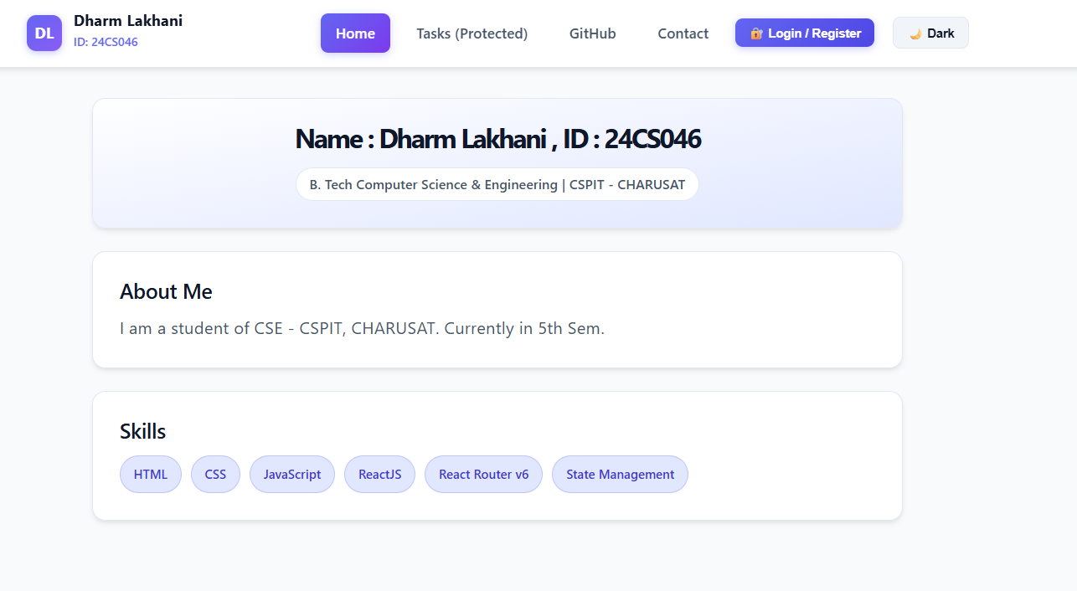

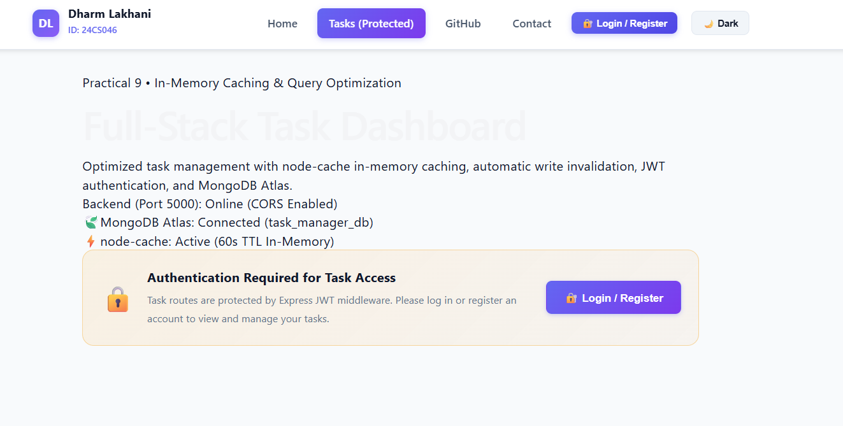
++
Department of Computer Science and Engineering, CSPIT Page 1

