1. Implement textpad application using rich textbox. Make menus like File(New,open ,save,save as and exit),Edit(Cut,copy,paste ,undo ,redo),Format (Bold,italic ,underline ,font,color).use all common dialog control and implement functionalities.

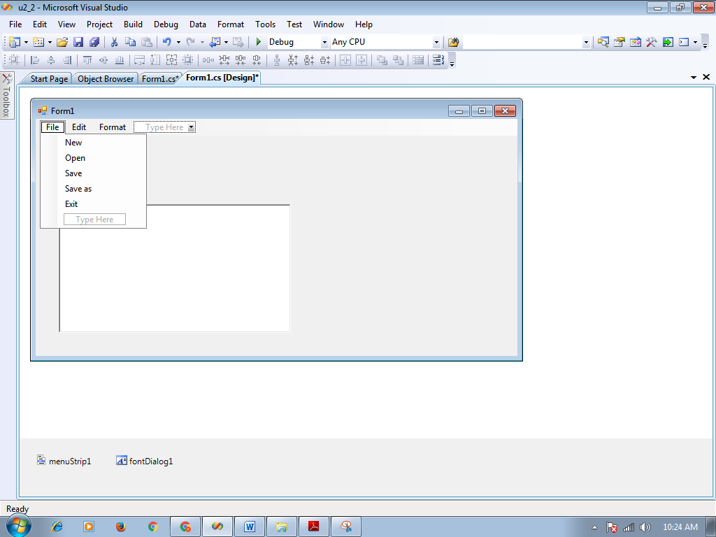

using System;

using System.Collections.Generic; using System.ComponentModel; using System.Data;

using System.Drawing; using System.Linq; using System.Text;

using System.Windows.Forms;

namespace u2_2

{

public partial class Form1 : Form

{

public Form1()

{

InitializeComponent();

}

private void newToolStripMenuItem_Click(object sender, EventArgs e)

{

richTextBox1.Clear();

}

private void cutToolStripMenuItem_Click(object sender, EventArgs e)

{

richTextBox1.Cut();

}

private void copyToolStripMenuItem_Click(object sender, EventArgs e)

{

richTextBox1.Copy();

}

private void pasteToolStripMenuItem_Click(object sender, EventArgs e)

{

richTextBox1.Paste();

}

private void undoToolStripMenuItem_Click(object sender, EventArgs e)

{

richTextBox1.Undo();

}

private void redoToolStripMenuItem_Click(object sender, EventArgs e)

{

richTextBox1.Redo();

}

private void boldToolStripMenuItem_Click(object sender, EventArgs e)

{

richTextBox1.SelectionFont = new Font(richTextBox1.SelectionFont, FontStyle.Bold);

}

private void italicToolStripMenuItem_Click(object sender, EventArgs

e)

{

richTextBox1.SelectionFont = new Font(richTextBox1.SelectionFont,

FontStyle.Italic);

}

private void underlineToolStripMenuItem_Click(object sender, EventArgs e)

{

richTextBox1.SelectionFont = new Font(richTextBox1.SelectionFont, FontStyle.Underline);

}

private void fontToolStripMenuItem_Click(object sender, EventArgs e)

{

if(fontDialog1.ShowDialog()==System.Windows.Forms.DialogResult.OK)

{

richTextBox1.SelectionFont = fontDialog1.Font;

}

}

private void colorToolStripMenuItem_Click(object sender, EventArgs e)

{

if (colorDialog1.ShowDialog() == System.Windows.Forms.DialogResult.OK)

{

richTextBox1.SelectionColor = colorDialog1.Color;

}

}

private void openToolStripMenuItem_Click(object sender, EventArgs e)

{

openFileDialog1.Filter = "TXT|*.txt|DOC|*.doc"; if (openFileDialog1.ShowDialog() ==

System.Windows.Forms.DialogResult.OK)

{

richTextBox1.LoadFile(openFileDialog1.FileName, RichTextBoxStreamType.PlainText);

this.Text = openFileDialog1.FileName;

}

}

private void saveToolStripMenuItem_Click(object sender, EventArgs e)

{

saveFileDialog1.Filter = "TXT|*.txt|DOC|*.doc"; if (saveFileDialog1.ShowDialog() ==

System.Windows.Forms.DialogResult.OK)

{

richTextBox1.LoadFile(saveFileDialog1.FileName, RichTextBoxStreamType.PlainText);

}

}

private void saveAsToolStripMenuItem_Click(object sender, EventArgs

e)

{

richTextBox1.SaveFile(this.Text,

RichTextBoxStreamType.PlainText);

}

private void exitToolStripMenuItem_Click(object sender, EventArgs e)

{

this.Close();

}

private void findToolStripMenuItem_Click(object sender, EventArgs e)

{

int pos;

pos = richTextBox1.Find(textBox1.Text, 1, richTextBox1.TextLength, RichTextBoxFinds.None);

if (pos > 0)

{

richTextBox1.SelectionStart = pos; richTextBox1.SelectionLength = textBox1.TextLength; richTextBox1.SelectionColor = Color.Blue;

}

}

private void replaceToolStripMenuItem_Click(object sender, EventArgs

e)

{

richTextBox1.SelectedText = textBox2.Text;

}

private void findNextToolStripMenuItem_Click(object sender, EventArgs

e)

{

int pos;

pos = richTextBox1.Find(textBox1.Text, 1,

richTextBox1.TextLength, RichTextBoxFinds.None); if (pos > 0)

{

richTextBox1.SelectionStart = pos; richTextBox1.SelectionLength = textBox1.TextLength; richTextBox1.SelectionColor = Color.Blue;

}

}

private void replacAllToolStripMenuItem_Click(object sender, EventArgs e)

{

richTextBox1.Text = richTextBox1.Text.Replace(textBox1.Text, textBox2.Text);

}

private void zoomToolStripMenuItem1_Click(object sender, EventArgs e)

{

richTextBox1.ZoomFactor = 5;

}

private void resizeToolStripMenuItem_Click(object sender, EventArgs

e)

{

richTextBox1.Height = this.Height; richTextBox1.Width = this.Width;

}

private void searchAllHighlightsToolStripMenuItem_Click(object sender, EventArgs e)

{

int index = 0;

Int64 startSearch = 0;

index = richTextBox1.Find(textBox1.Text, 0); while (index > -1)

{

index = richTextBox1.Find(textBox1.Text, Convert.ToInt16(startSearch), richTextBox1.TextLength, RichTextBoxFinds.None);

richTextBox1.SelectionColor = Color.Red; startSearch = index + 1;

}

}

}

}

1. Write a program to read and write binary file.

using System;

using System.Collections.Generic; using System.ComponentModel; using System.Data;

using System.Drawing; using System.Linq; using System.Text;

using System.Windows.Forms; using System.IO;

namespace WindowsFormsApplication3

{

public partial class Form1 : Form

{

public Form1()

{

InitializeComponent();

}

private void button1_Click(object sender, EventArgs e)

{

FileStream fs = new FileStream("d:\\f2.bin",FileMode.Create);

BinaryWriter bw;

bw = new BinaryWriter(fs);

Int32 i = 12; bw.Write(i); double d = 34.45; bw.Write(d); bool b = true; bw.Write(b);

String s = "are"; bw.Write(s);

bw.Close();

fs.Close(); MessageBox.Show("creates");

}

private void button2_Click(object sender, EventArgs e)

{

FileStream fs = new FileStream("d:\\f2.bin",FileMode.Open); BinaryReader br;

br = new BinaryReader(fs); Int32 i;

double d; bool b; String s;

i = br.ReadInt32();

textBox1.Text = i.ToString() + Environment.NewLine;

d = br.ReadDouble();

textBox1.Text += d.ToString() + Environment.NewLine;

b= br.ReadBoolean();

textBox1.Text += b.ToString() + Environment.NewLine; s= br.ReadString();

textBox1.Text += s.ToString() + Environment.NewLine;

br.Close();

fs.Close();

}

}

}

1. **Create MDI form. It must have file menu with option open, close and exit. It should also have window menu to arrange the child forms like tile horizontal, tile vertical, cascade and arrange icons.**

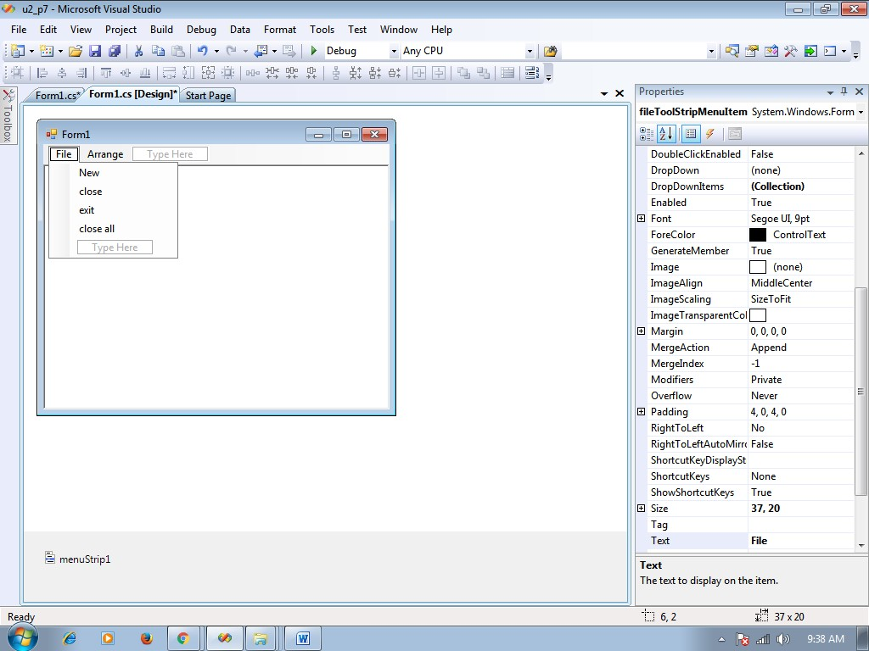

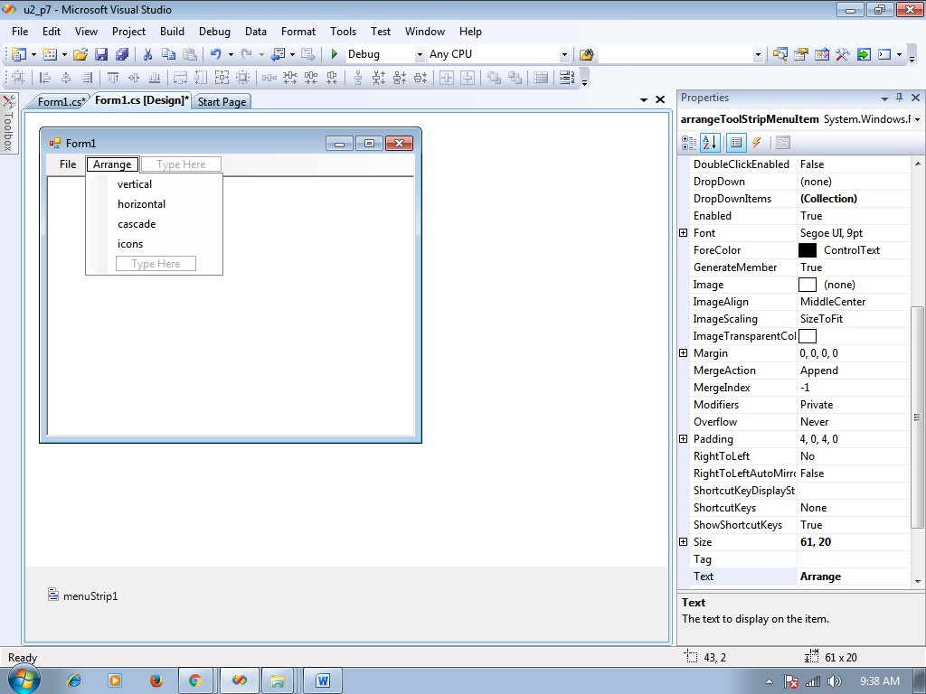

using System;

using System.Collections.Generic; using System.ComponentModel; using System.Data;

using System.Drawing; using System.Linq; using System.Text;

using System.Windows.Forms; using System.IO;

namespace u2_p7

{

public partial class Form1 : Form

{

public Form1()

{

InitializeComponent();

}

private void newToolStripMenuItem_Click(object sender, EventArgs e)

{

Form n;

n = new Form(); n.MdiParent = this; n.Show();

}

private void closeToolStripMenuItem_Click(object sender, EventArgs e)

{

//ActivateMdiChild.close();

}

private void closeAllToolStripMenuItem_Click(object sender, EventArgs

e)

{

foreach (Form f in this.MdiChildren)

{

f.Close();

}

}

private void exitToolStripMenuItem_Click(object sender, EventArgs e)

{

this.Close();

}

private void verticalToolStripMenuItem_Click(object sender, EventArgs

e)

{

this.LayoutMdi(MdiLayout.TileVertical);

}

private void horizontalToolStripMenuItem_Click(object sender, EventArgs e)

{

this.LayoutMdi(MdiLayout.TileHorizontal);

}

private void cascadeToolStripMenuItem_Click(object sender, EventArgs

e)

{

this.LayoutMdi(MdiLayout.Cascade);

}

private void iconsToolStripMenuItem_Click(object sender, EventArgs e)

{

this.LayoutMdi(MdiLayout.ArrangeIcons);

}

}

}

1. **Create MDI form.it must have file menu with option open, close and exit and one picture box. Allow users to open any picture using open dialog box, that picture should be displayed in picture box.**

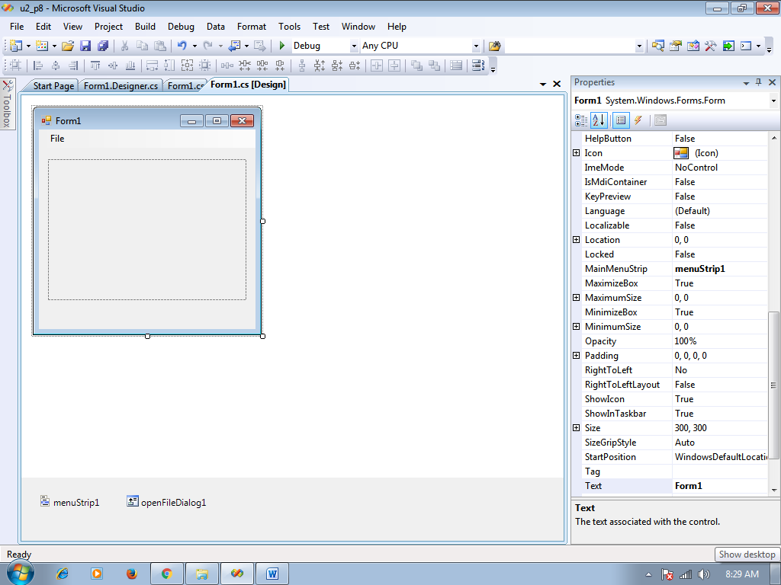

**Code**

using System;

using System.Collections.Generic; using System.ComponentModel; using System.Data;

using System.Drawing; using System.Linq; using System.Text;

using System.Windows.Forms; using System.IO;

namespace u2_p8

{

public partial class Form1 : Form

{

public Form1()

{

InitializeComponent();

}

private void openToolStripMenuItem_Click(object sender, EventArgs e)

{

openFileDialog1.ShowDialog();

pictureBox1.Image = Image.FromFile(openFileDialog1.FileName);

}

private void closeToolStripMenuItem_Click(object sender, EventArgs e)

{

pictureBox1.Image = null;

}

private void exitToolStripMenuItem_Click(object sender, EventArgs e)

{

pictureBox1.Image = null;

}

private void Form1_Resize(object sender, EventArgs e)

{

pictureBox1.Height = this.Height; pictureBox1.Width = this.Width;

}

private void Form1_Load(object sender, EventArgs e)

{

}

}

}

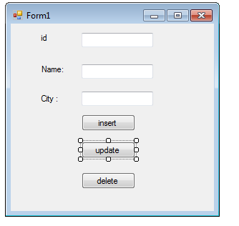

using System;

using System.Collections.Generic;

using System.ComponentModel;

using System.Data;

using System.Drawing;

using System.Linq;

using System.Text;

using System.Windows.Forms;

using System.Data.OleDb;

namespace WindowsFormsApplication3

{

public partial class Form1 : Form

{

public Form1()

{

InitializeComponent();

}

OleDbConnection con = new OleDbConnection("Provider=Microsoft.ACE.OLEDB.12.0;Data Source=D:\\studb.accdb");

private void button1_Click(object sender, EventArgs e)

{

//insert coding

con.Open();

OleDbCommand cmd = new OleDbCommand("insert into student values('" + textBox1.Text + "', '" + textBox2.Text + "' , '" + textBox3.Text + "')", con);

cmd.ExecuteNonQuery();

MessageBox.Show("Data Inserted Successfully.");

con.Close();

}

private void button3_Click(object sender, EventArgs e)

{

//delete coding

con.Open();

OleDbCommand cmd = new OleDbCommand("delete from student where name='" + textBox2.Text + "'", con);

cmd.ExecuteNonQuery();

MessageBox.Show("Data Deleted Successfully.");

con.Close();

}

private void button2_Click(object sender, EventArgs e)

{

//update coding

con.Open();

OleDbCommand cmd = new OleDbCommand("update student set name='" + textBox2.Text + "' where ID=" + textBox1.Text + "", con);

cmd.ExecuteNonQuery();

MessageBox.Show("Data Updated Successfully.");

con.Close();

}

}

}

**1. Write a program the class book. Show Method Overloading.**

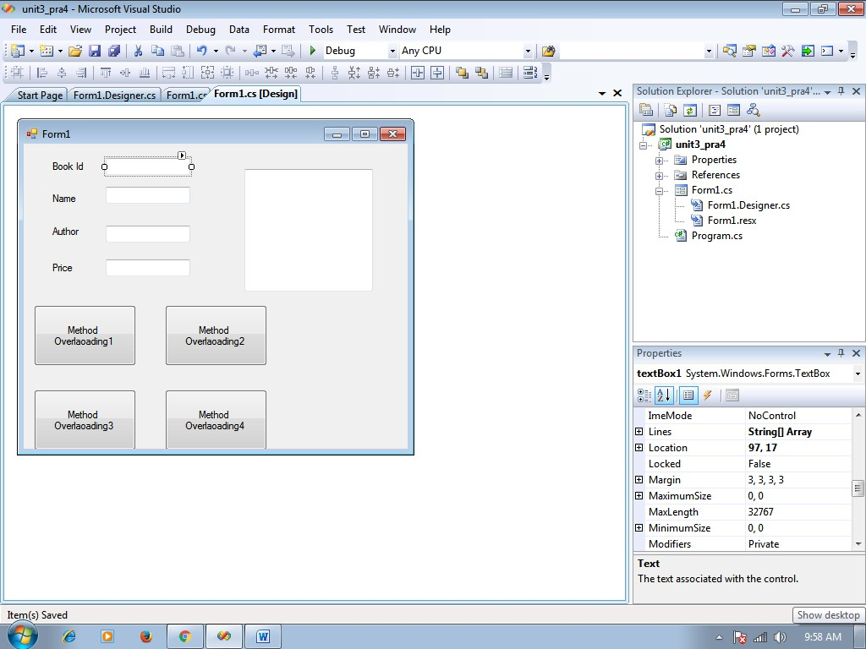

Coding using System;

using System.Collections.Generic;

using System.ComponentModel; using System.Data;

using System.Drawing; using System.Linq; using System.Text;

using System.Windows.Forms;

namespace unit3_pra4

{

public partial class Form1 : Form

{

public Form1()

{

InitializeComponent();

}

//create class class clsprog4

{

public int b_id, b_price;

public string b_name, b_author;

public int getbook_id()

{

return b_id;

}

public void setBook_id(int value)

{

b_id = value;

}

public int getBook_Price()

{

return b_price;

}

public void setBook_price(int value)

b_price = value;

}

public string getBook_name()

{

return b_name;

}

public void setBook_name(String value)

{

b_name = value;

}

public string getBook_author()

{

return b_author;

}

public void setBook_Author(string value)

{

b_author = value;

}

public string showBookDetails()

{

return ("Book id:" + b_id + "\r\n" + "Book Name" + b_name + "\r\n" + "Book Price:" + b_price + "\n\r" + "book_author:" + b_author);

}

public string ShowBookDetails(int bk_id)

{

return ("book id:" + bk_id);

}

public string ShowBookDetails(int bk_id, string bk_name)

{

return ("book_id:" + bk_id + "book name" + bk_name);

}

public string ShowBookDetails(int bk_id, string bk_name, int bk_price)

return ("book_id:" + bk_id + "book name" + bk_name + "book price" + b_price);

}

}

// close class and in below code is button click

private void button1_Click(object sender, EventArgs e)

{

clsprog4 obj = new clsprog4();

obj.b_id = Convert.ToInt16(textBox1.Text); obj.b_name = textBox2.Text;

obj.b_author = textBox3.Text;

obj.b_price = Convert.ToInt16(textBox4.Text); textBox5.Text = obj.showBookDetails();

}

private void button2_Click(object sender, EventArgs e)

{

clsprog4 obj = new clsprog4();

obj.b_id = Convert.ToInt16(textBox1.Text); textBox5.Text = obj.ShowBookDetails(obj.b_id);

}

private void button3_Click(object sender, EventArgs e)

{

clsprog4 obj = new clsprog4();

obj.b_id = Convert.ToInt16(textBox1.Text); obj.b_name = textBox2.Text;

textBox5.Text = obj.ShowBookDetails(obj.b_id, obj.b_name);

}

private void button4_Click(object sender, EventArgs e)

clsprog4 obj = new clsprog4();

obj.b_id = Convert.ToInt16(textBox1.Text); obj.b_name = textBox2.Text;

obj.b_author = textBox3.Text;

obj.b_price = Convert.ToInt16(textBox4.Text); textBox5.Text = obj.showBookDetails();

}

}

}

# 5. Create an Invoice application in which user center the customer name , description, unit price and quantity for the item ordered, then clicks the add item button. The application calculates the order total by multiplying the unit price by the quantity. And calculates a discount based on the order total. The user can then add another item to the order by using all information.

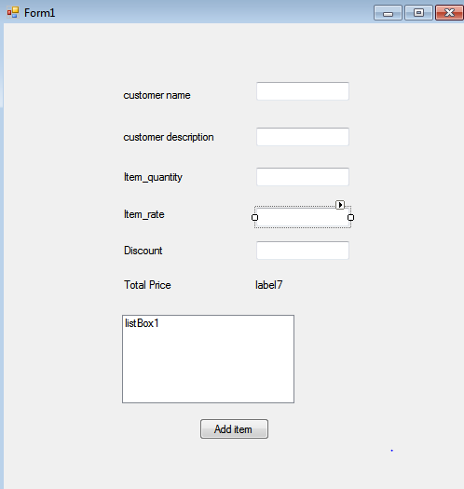

Coding

using System;

using System.Collections.Generic; using System.ComponentModel; using System.Data;

using System.Drawing; using System.Linq; using System.Text;

using System.Windows.Forms;

namespace WindowsFormsApplication7

{

public partial class Form1 : Form

{

public Form1()

{

InitializeComponent();

}

//create class class clsinvoice

{

private string custname, itemdesc; private Int32 itemqty;

private Double itemprice, itemtotalprice; public string customer_name

{

get { return custname; } set { custname = value; }

}

public string item_description

{

get { return itemdesc; } set { itemdesc = value; }

}

public Int32 item_quantity

{

get { return itemqty; } set { itemqty = value; }

}

public Double item_price

{

get { return itemprice; } set { itemprice = value; }

}

public Double item_totalprice

{

get { return itemtotalprice; } set { itemtotalprice = value; }

}

public Double calculateTotalprice()

{

return (item_price * item_quantity);

}

}

// close class and in below code is button click private void button1_Click(object sender, EventArgs

e)

{

clsinvoice inv = new clsinvoice(); inv.customer_name = textBox1.Text; inv.item_description = textBox2.Text; inv.item_quantity =

Convert.ToInt16(textBox3.Text); inv.item_price =

Convert.ToDouble(textBox4.Text); inv.item_totalprice =

(Convert.ToDouble(textBox4.Text) * Convert.ToInt16(textBox3.Text)) - (Convert.ToDouble(inv.calculateTotalprice() * Convert.ToInt16(textBox5.Text) / 100));

label7.Text = Convert.ToString(inv.item_totalprice);

listBox1.Items.Add(inv.customer_name + "|" + inv.item_description + "|" + Convert.ToDouble(inv.item_totalprice));

}

}

}

1. **Write a program to read and write text file. (tool box- textbox ,button1 ,button2)**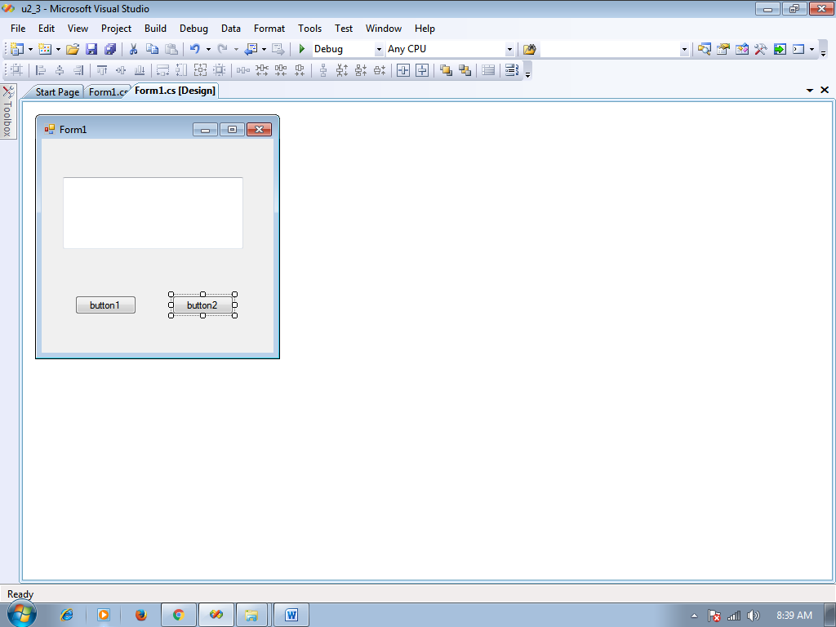

**Code**

using System;

using System.Collections.Generic; using System.ComponentModel; using System.Data;

using System.Drawing; using System.Linq; using System.Text;

using System.Windows.Forms; using System.IO;

// import using System.IO; namespace u2_3

{

public partial class Form1 : Form

{

public Form1()

{

InitializeComponent();

}

private void button1_Click(object sender, EventArgs e)

{

StreamWriter sw;

sw = new StreamWriter("d:\\f1.txt"); sw.WriteLine("hello"); sw.WriteLine(textBox1.Text); sw.WriteLine("hi hello"); sw.Close();

}

private void button2_Click(object sender, EventArgs e)

{

StreamReader sr;

sr = new StreamReader("d:\\f1.txt"); textBox1.Text = sr.ReadToEnd(); sr.Close();

}

}

}