Date: - **15/01/2021**

Roll No. and Name: - **18BCE219 – Parth Shah**

Course Code and Name: - **2CSDE69 – LAMP Technology**

Practical No.: - **1**

Aim: -

**(A)**Configure and understanding of LAMP and XAMPP server.

**(B)** Design your personal profile web page, which contains all your personal, academic, co-curricular information, using basic concept of HTML, CSS and JavaScript.

Methodology: -

**(A) Setup and Start localhost server using XAMPP**

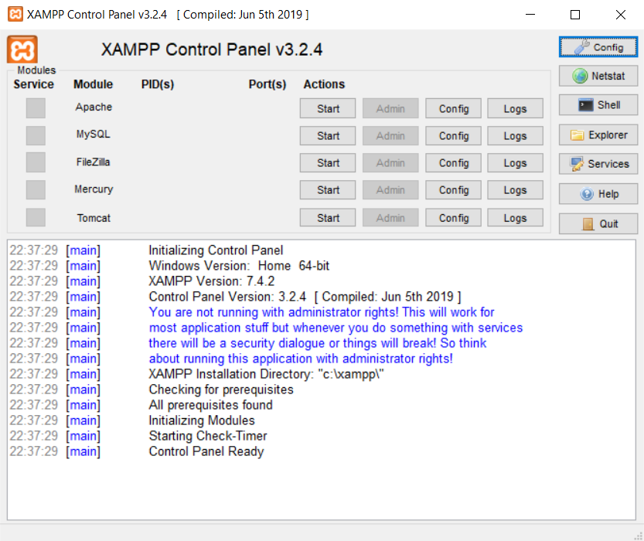 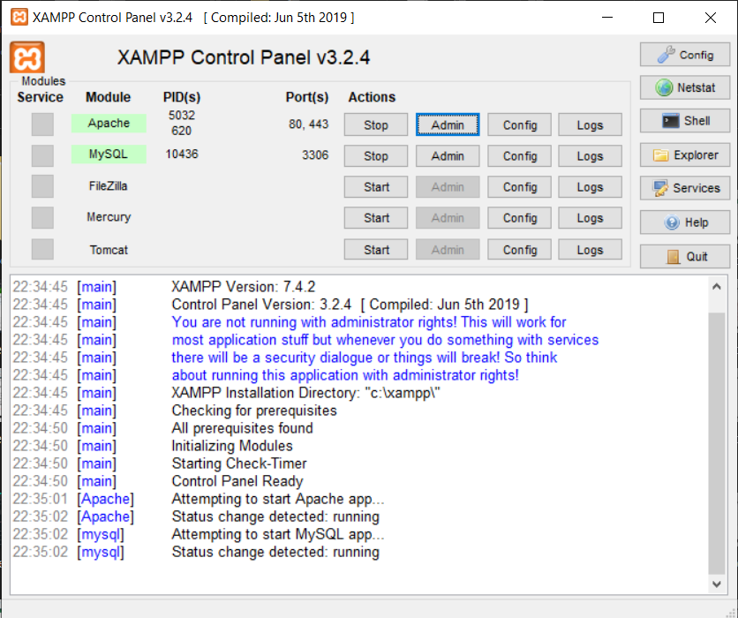

Starting Apache server and MySQL server. Here you can see Apache server listens to 2 default ports: 80(for HTTP) and 443(for HTTPS). You can also change this port numbers if it is already assigned.

XAMPP Control Panel. From here we can start Apache server, MySQL server and other servers for our local computers. (localhost)

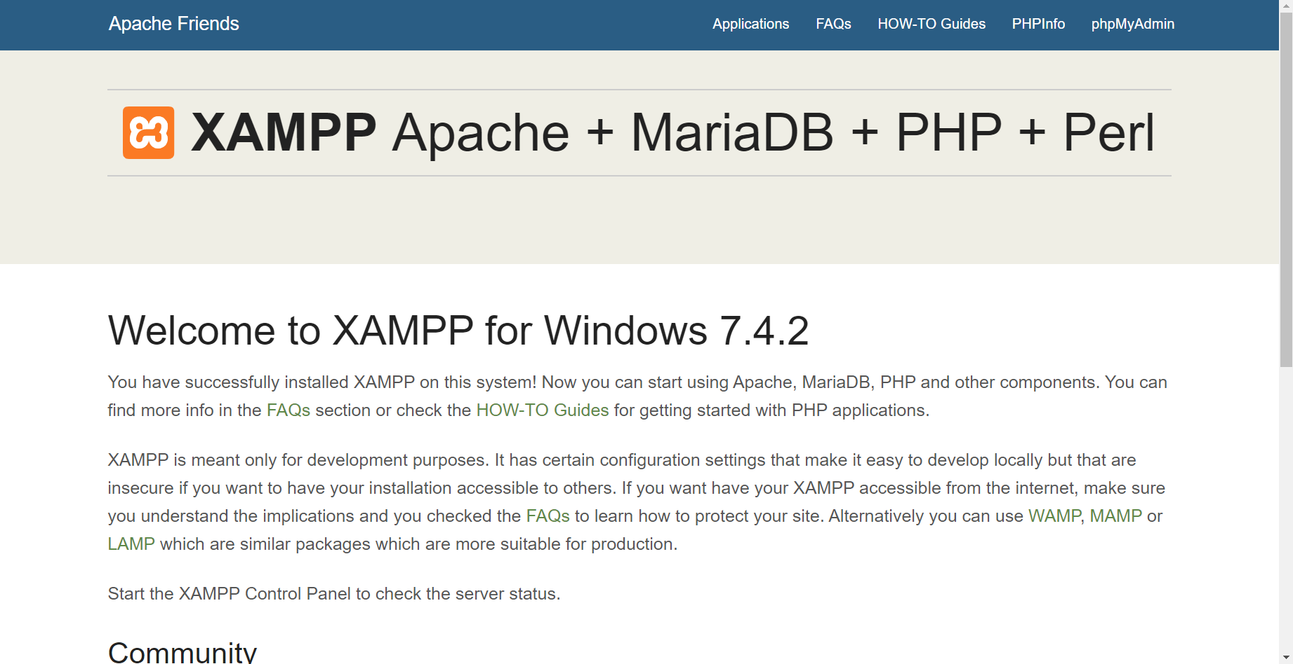

After starting those servers, we can run the server in our local computers by typing localhost/dashboard.

The figure shows Admin page of Apache server.

**(B) Personal Profile**

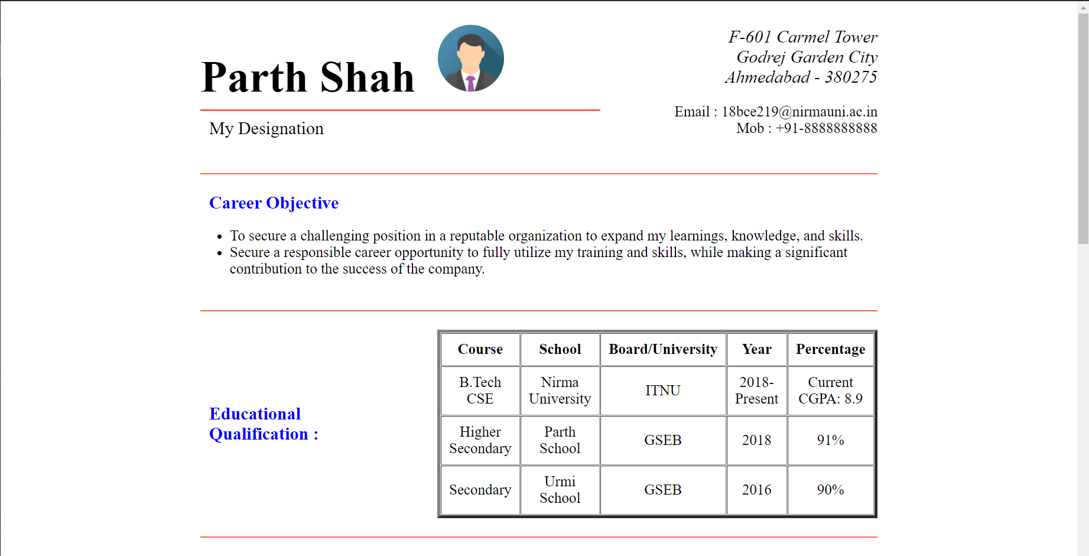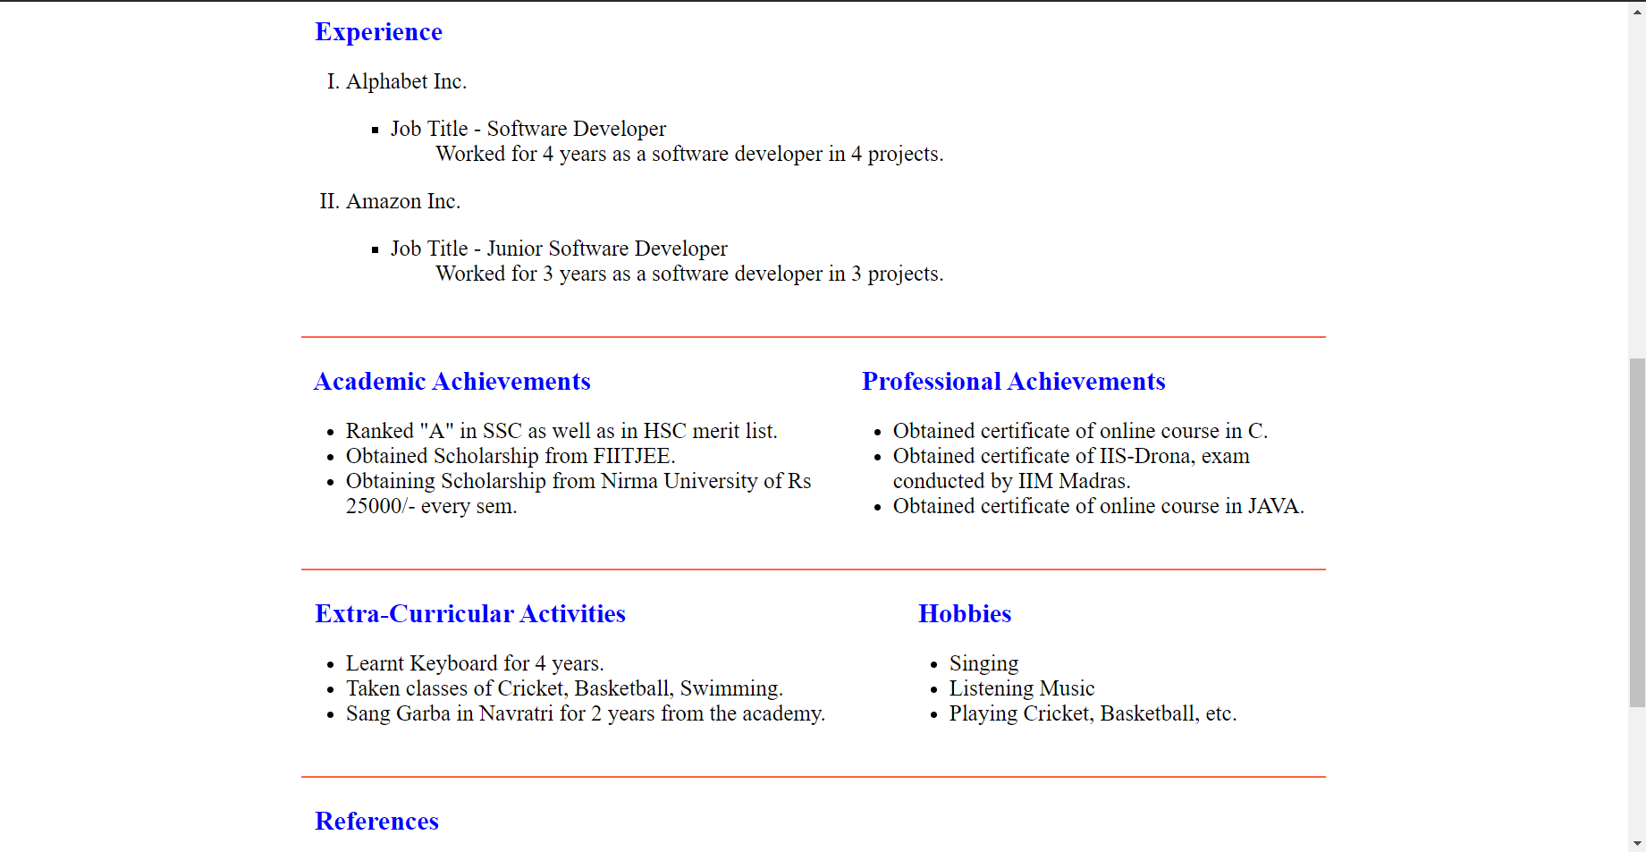



<html>

<head>

<title>My Resume</title>

</head>

<body>

<!-- forming table -->

<table frame="box" cellspacing="5" cellpadding="5" border="0" align="center" width="65%">

<!-- 1st row just for colspanning -->

<tr>

<td colspan="1"></td>

<td colspan="1"></td>

<td colspan="1"></td>

<td colspan="1"></td>

<td colspan="1"></td>

<td colspan="1"></td>

<td colspan="1"></td>

<td colspan="1"></td>

<td colspan="1"></td>

<td colspan="1"></td>

<td colspan="1"></td>

<td colspan="1"></td>

</tr>

<!-- 2nd row Introduction of Profile -->

<tr>

<td colspan="10" align="left">

<font size="10"><b>Parth Shah&nbsp <img src="a.png" height="90" width="90" alt="Image not found" style="border-radius:50%"></b></font><br><hr color="tomato">

<font size="4">&nbsp My Designation</font>

</td>

<td colspan="2" align="right">

<address>

<font size="4">

F-601 Carmel Tower<br>

Godrej Garden City<br>

Ahmedabad - 380275

</font>

</address><br>

<font size="3">Email : 18bce219@nirmauni.ac.in</font><br>

<font size="3">Mob : +91-8888888888</font>

</td>

</tr>

<!-- 3rd row HR tag -->

<tr>

<td colspan="12">

<br>

<hr color="tomato">

</td>

</tr>

<!-- 4th row Career Objective Section -->

<tr>

<td colspan="12">

<font size="4" color="blue"><b>&nbsp Career Objective</b></font>

<ul>

<li>

To secure a challenging position in a reputable organization to expand my learnings, knowledge, and skills.

</li>

<li>

Secure a responsible career opportunity to fully utilize my training and skills, while making a significant contribution to the success of the company.

</li>

</ul>

</td>

</tr>

<!-- 5th row HR Tag -->

<tr>

<td colspan="12">

<hr color="tomato">

</td>

</tr>

<!-- 6th row Education Section -->

<tr>

<td>

<font size="4" color="blue"><b>&nbsp Educational<br>&nbsp Qualification :</b></font>

</td>

<td colspan="11">

<table cellpadding="10" border="4" cellspacing="1" width="100%" height="200">

<tr>

<th>Course</th>

<th>School</th>

<th>Board/University</th>

<th>Year</th>

<th>Percentage</th>

</tr>

<tr align="center">

<td>B.Tech CSE</td>

<td>Nirma University</td>

<td>ITNU</td>

<td>2018-Present</td>

<td>Current CGPA: 8.9</td>

</tr>

<tr align="center">

<td>Higher Secondary</td>

<td>Parth School</td>

<td>GSEB</td>

<td>2018</td>

<td>91%</td>

</tr>

<tr align="center">

<td>Secondary</td>

<td>Urmi School</td>

<td>GSEB</td>

<td>2016</td>

<td>90%</td>

</tr>

</table>

</td>

</tr>

<!-- 7th row HR Tag -->

<tr>

<td colspan="12">

<hr color="tomato">

</td>

</tr>

<!-- 8th row Experience Section -->

<tr>

<td colspan="12">

<font size="4" color="blue"><b>&nbsp Experience</b></font>

<ol type="I">

<li>Alphabet Inc.

<ul type="square">

<li>

<dl>

<dt>Job Title - Software Developer</dt>

<dd>Worked for 4 years as a software developer in 4 projects.</dd>

</dl>

</li>

</ul>

</li>

<li>Amazon Inc.

<ul type="square">

<li>

<dl>

<dt>Job Title - Junior Software Developer</dt>

<dd>Worked for 3 years as a software developer in 3 projects. </dd>

</dl>

</li>

</ul>

</li>

</ol>

</td>

</tr>

<!-- 9th row HR Tag-->

<tr>

<td colspan="12">

<hr color="tomato">

</td>

</tr>

<!-- 10th row Academic Achievements Section -->

<tr>

<td colspan="6">

<font size="4" color="blue"><b>&nbsp Academic Achievements</b></font>

<ul>

<li>

Ranked "A" in SSC as well as in HSC merit list.

</li>

<li>

Obtained Scholarship from FIITJEE.

</li>

<li>

Obtaining Scholarship from Nirma University of Rs 25000/- every sem.

</li>

</ul>

</td>

<td colspan="6">

<font size="4" color="blue"><b>&nbsp Professional Achievements</b></font>

<ul>

<li>

Obtained certificate of online course in C.

</li>

<li>

Obtained certificate of IIS-Drona, exam <br>conducted by IIM Madras.

</li>

<li>

Obtained certificate of online course in JAVA.

</li>

</ul>

</td>

</tr>

<!-- 11th row HR Tag -->

<tr>

<td colspan="12">

<hr color="tomato">

</td>

</tr>

<!-- 12th row Extra-Curricular Activities Section -->

<tr>

<td colspan="9">

<font size="4" color="blue"><b>&nbsp Extra-Curricular Activities</b></font>

<ul>

<li>

Learnt Keyboard for 4 years.

</li>

<li>

Taken classes of Cricket, Basketball, Swimming.

</li>

<li>

Sang Garba in Navratri for 2 years from the academy.

</li>

</ul>

</td>

<td colspan="3">

<font size="4" color="blue"><b>&nbsp Hobbies</b></font>

<ul>

<li>

Singing

</li>

<li>

Listening Music

</li>

<li>

Playing Cricket, Basketball, etc.

</li>

</ul>

</td>

</tr>

<!-- 13th row HR Tag-->

<tr>

<td colspan="12">

<hr color="tomato">

</td>

</tr>

<!-- 14th row References Section -->

<tr>

<td colspan="12">

<font size="4" color="blue"><b>&nbsp References</b></font>

<ul>

<li>

Newspaper

</li>

<li>

Online Advertisement

</li>

</ul>

</td>

</tr>

<!-- 15th row GR Tag -->

<tr>

<td colspan="12">

<hr color="tomato">

</td>

</tr>

<!-- 16th row T&C Section -->

<tr>

<td colspan="12" align="right">

<br><font><b>&nbsp I hereby certify the above information is true and correct to the best of my knowledge and belief.</b></font>

</td>

</tr>

<!-- 17th row Signature Section -->

<tr>

<td colspan="12" align="right">

<br><br><font><b>&nbsp Signature of Applicant</font>

</td>

</tr>

<!-- 18th row just for colspanning -->

<tr>

<td colspan="1"></td>

<td colspan="1"></td>

<td colspan="1"></td>

<td colspan="1"></td>

<td colspan="1"></td>

<td colspan="1"></td>

<td colspan="1"></td>

<td colspan="1"></td>

<td colspan="1"></td>

<td colspan="1"></td>

<td colspan="1"></td>

<td colspan="1"></td>

</tr>

</table>

</body>

</html>

**Practice Codes**

**(A) Understanding Scopes in PHP**

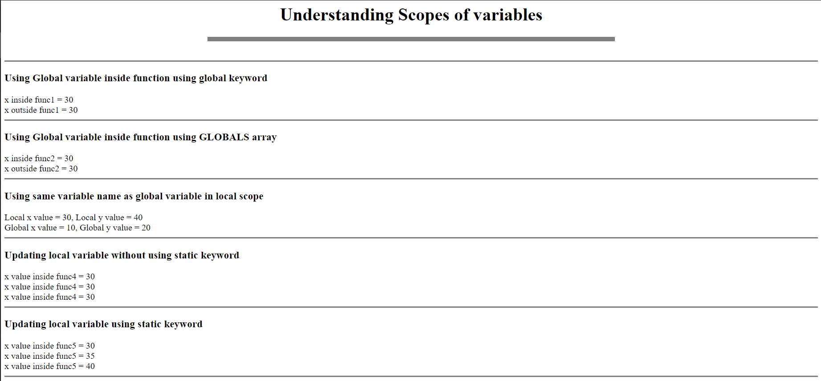

<center><h1>Understanding Scopes of variables</h1></center>

<hr width="50%" size='10' noshade><br>

<?php

echo "<hr size='3' noshade>";

echo "<h3>Using Global variable inside function using global keyword<br></h3>";

$x = 10;

$y = 20;

function func1() {

global $x, $y;

$x += $y;

echo "x inside func1 = $x<br>";

}

func1();

echo "x outside func1 = $x<br>";

echo "<hr size='3' noshade>";

echo "<h3>Using Global variable inside function using GLOBALS array<br></h3>";

$x = 10;

$y = 20;

function func2() {

$GLOBALS['x'] += $GLOBALS['y'];

echo "x inside func2 = ".$GLOBALS['x']."<br>";

}

func2();

echo "x outside func2 = $x<br>";

echo "<hr size='3' noshade>";

echo "<h3>Using same variable name as global variable in local scope<br></h3>";

$x = 10;

$y = 20;

function func3() {

$x = 30;

$y = 40;

echo "Local x value = $x, Local y value = $y<br>";

echo "Global x value = ".$GLOBALS['x'].", Global y value = ".$GLOBALS['y']."<br>";

}

func3();

echo "<hr size='3' noshade>";

echo "<h3>Updating local variable without using static keyword<br></h3>";

function func4() {

$x = 30;

echo "x value inside func4 = $x<br>";

$x++;

}

func4();

func4();

func4();

echo "<hr size='3' noshade>";

echo "<h3>Updating local variable using static keyword<br></h3>";

function func5() {

static $x = 30;

echo "x value inside func5 = $x<br>";

$x += 5;

}

func5();

func5();

func5();

echo "<hr size='3' noshade>";

?>

**(B) String Constants**

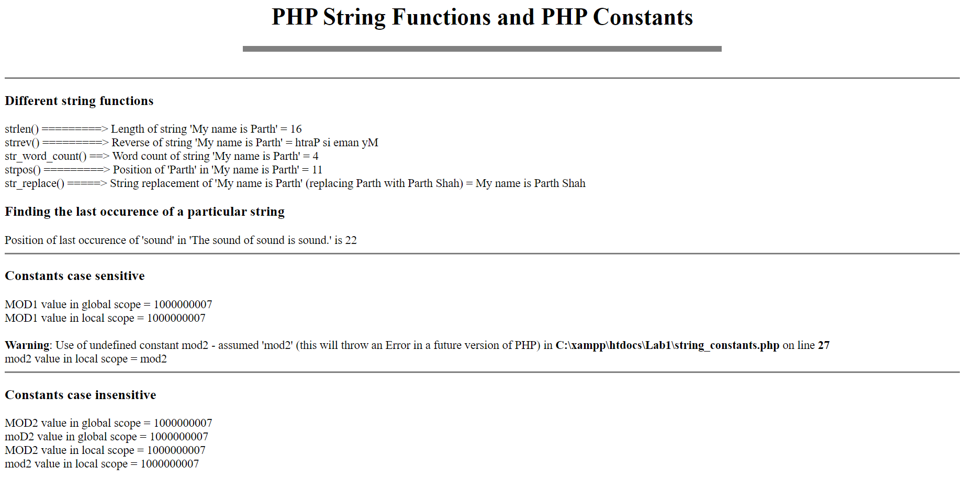

<center><h1>PHP String Functions and PHP Constants</h1></center>

<hr width="50%" size='10' noshade><br>

<?php

echo "<hr size='3' noshade>";

echo "<h3>Different string functions<br></h3>";

$s1 = "My name is Parth";

$s2 = "My Roll No. is 18BCE219";

echo "strlen() =========> Length of string '$s1' = ".strlen($s1)."<br>";

echo "strrev() =========> Reverse of string '$s1' = ".strrev($s1)."<br>";

echo "str_word_count() ==> Word count of string '$s1' = ".str_word_count($s1)."<br>";

echo "strpos() =========> Position of 'Parth' in '$s1' = ".strpos($s1, "Parth")."<br>";

echo "str_replace() =====> String replacement of '$s1' (replacing Parth with Parth Shah) = ".str_replace("Parth", "Parth Shah", $s1)."<br>";

echo "<h3>Finding the last occurence of a particular string<br></h3>";

$s3 = "The sound of sound is sound.";

$s4 = "sound";

echo "Position of last occurence of '$s4' in '$s3' is ".(strlen($s3)-strlen($s4)-strpos(strrev($s3), strrev($s4)))."<br>";

echo "<hr size='3' noshade>";

echo "<h3>Constants case sensitive<br></h3>";

define("MOD1", 1000000007, false);

echo "MOD1 value in global scope = ".MOD1."<br>";

function func1() {

echo "MOD1 value in local scope = ".MOD1."<br>";

echo "mod2 value in local scope = ".mod2."<br>";

}

func1();

echo "<hr size='3' noshade>";

echo "<h3>Constants case insensitive<br></h3>";

define("MOD2", 1000000007, true);

echo "MOD2 value in global scope = ".MOD2."<br>";

echo "moD2 value in global scope = ".moD2."<br>";

function func2() {

echo "MOD2 value in local scope = ".MOD2."<br>";

echo "mod2 value in local scope = ".mod2."<br>";

}

func2();

?>

Conclusion: -

From this practical, we have seen how to setup and start local host server by using XAMPP. Also, we have seen various scopes in PHP like local scope, global scope and static keyword. Also, we have seen many inbuilt string functions provided in PHP.