Date: - **29/01/2021**

Roll No. and Name: - **18BCE219 – Parth Shah**

Course Code and Name: - **2CSDE69 – LAMP Technology**

Practical No.: - **2**

Aim: -

**(A)**Write a PHP function that check whether user entered two numbers are Amicable numbers or not.

**(B)** Write a PHP function to check whether user entered number is Automorphic number or not.

**(C)** Write a PHP function that check whether user entered number is Special number or not.

**(D)** Write a PHP function that check whether user entered number is Kaprekar number or not.

**(E)** Write a PHP function that check whether user entered number is Deficient number or not.

Methodology: -

**(A) Amicable Numbers**

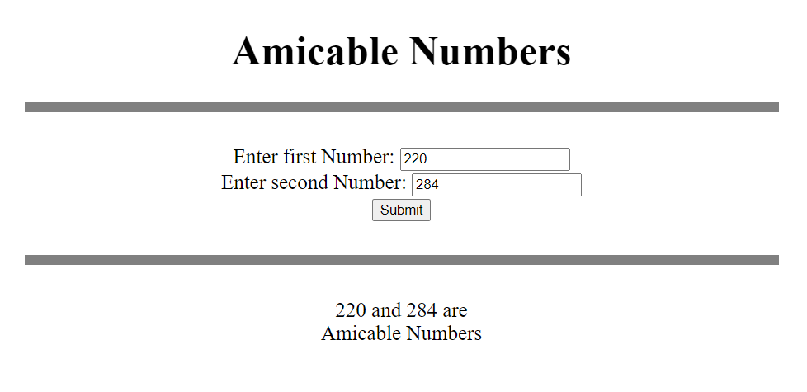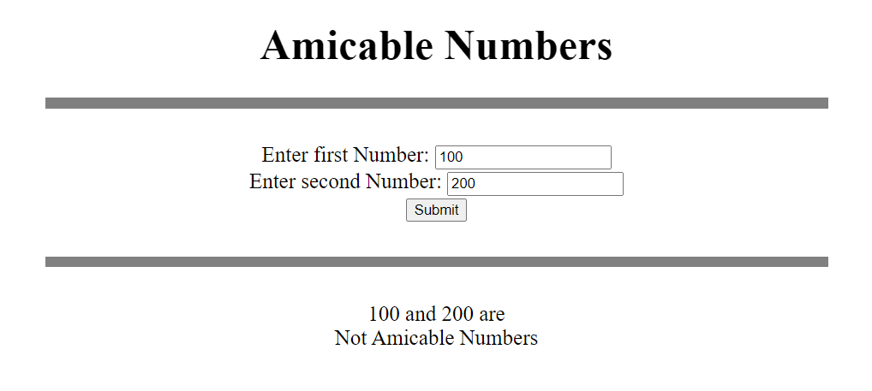

<!DOCTYPE html>

<html>

<body>

<center><h1>Amicable Numbers</h1></center>

<hr width="50%" size='10' noshade><br>

<center>

<form method="post" action="<?php echo $_SERVER['PHP_SELF'];?>">

Enter first Number: <input type="number" name="fno"><br>

Enter second Number: <input type="number" name="sno"><br>

<input type="submit"><br><br>

<hr width="50%" size='10' noshade><br>

</form>

<?php

// function to find sum of all divisors

function sumofdiv($x) {

$suma=1;

for($i=2; $i<=sqrt($x); ++$i) {

if($x%$i==0) {

$suma += $i+($x/$i);

}

}

return $suma;

}

if($_SERVER["REQUEST_METHOD"] == "POST") {

// taking 2 inputs and storing in variables

$x = htmlspecialchars($_REQUEST['fno']);

$y = htmlspecialchars($_REQUEST['sno']);

if(empty($x) or empty($y)) {

echo "Please fill both the inputs!<br>";

}

else {

$sumx = sumofdiv($x);

$sumy = sumofdiv($y);

echo $x." and ".$y." are <br>";

echo (($sumx==$y and $sumy==$x)?"Amicable Numbers":"Not Amicable Numbers");

}

unset($x);

unset($y);

}

?>

<script>

if ( window.history.replaceState ) {

window.history.replaceState( null, null, window.location.href );

}

</script>

</center>

</body>

</html>

**(B) Automorphic Number**

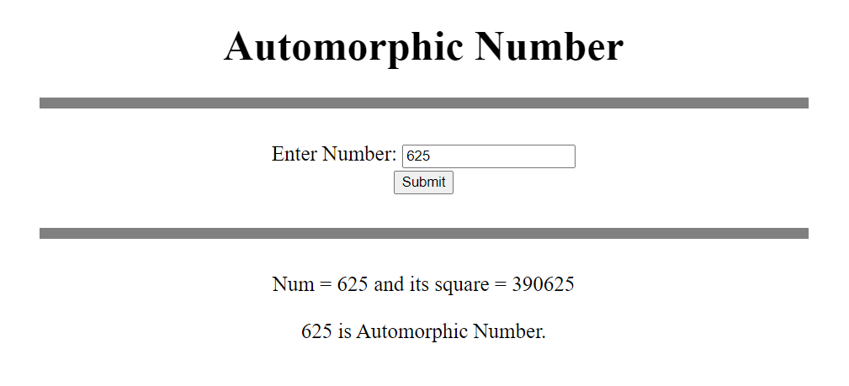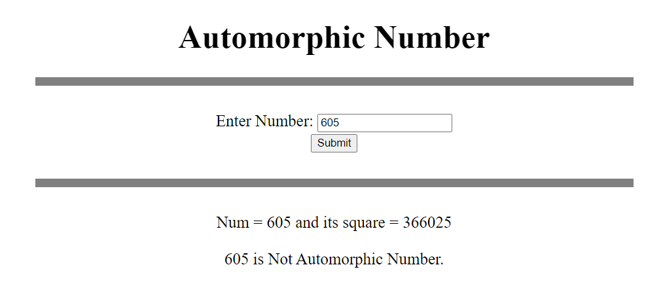

<!DOCTYPE html>

<html>

<body>

<center><h1>Automorphic Number</h1></center>

<hr width="50%" size='10' noshade><br>

<center>

<form method="post" action="<?php echo $_SERVER['PHP_SELF'];?>">

Enter Number: <input type="number" name="num"><br>

<input type="submit"><br><br>

<hr width="50%" size='10' noshade><br>

</form>

<?php

if($_SERVER["REQUEST_METHOD"] == "POST") {

// taking input and storing in variable

$n = htmlspecialchars($_REQUEST['num']);

if(empty($n)) {

echo "Please fill the input!<br>";

}

else {

$square = $n**2;

$temp = $n;

$tempsquare = $square;

$f=0;

// finding whether last digits of square are matching or not

while($temp!=0) {

if($temp%10 != $tempsquare%10) {

$f=1;

break;

}

$temp = intdiv($temp, 10);

$tempsquare = intdiv($tempsquare, 10);

}

echo "Num = $n and its square = $square<br><br>";

echo ($f?"$n is Not":"$n is")." Automorphic Number.<br>";

}

unset($n);

}

?>

<script>

if ( window.history.replaceState ) {

window.history.replaceState( null, null, window.location.href );

}

</script>

</center>

</body>

</html>

**(C) Special Number**

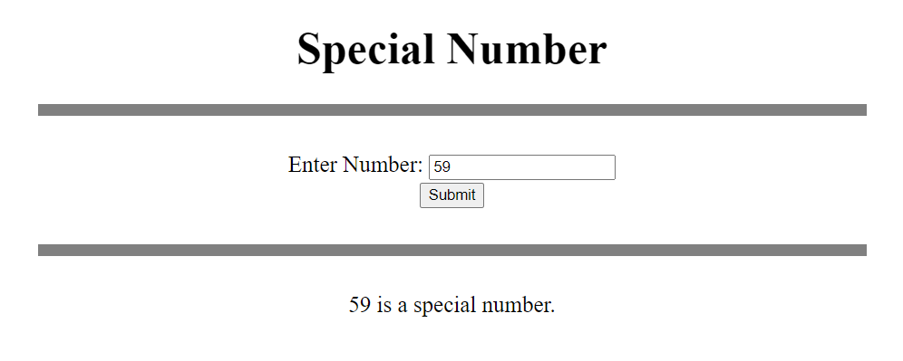 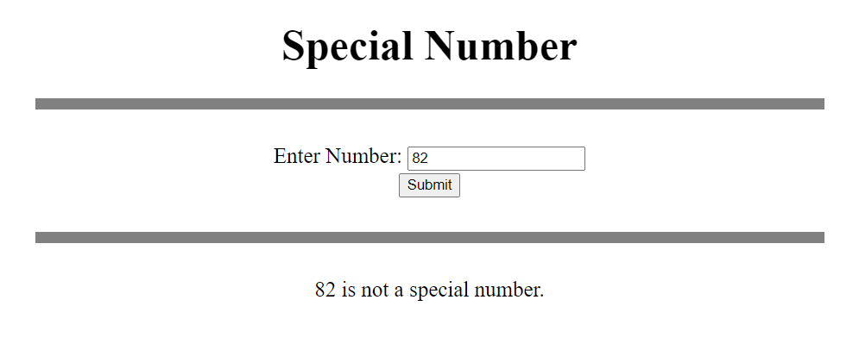

<!DOCTYPE html>

<html>

<body>

<center><h1>Special Number</h1></center>

<hr width="50%" size='10' noshade><br>

<center>

<form method="post" action="<?php echo $_SERVER['PHP_SELF'];?>">

Enter Number: <input type="number" name="num"><br>

<input type="submit"><br><br>

<hr width="50%" size='10' noshade><br>

</form>

<?php

if($_SERVER["REQUEST_METHOD"] == "POST") {

// taking input and storing it in variable

$n = htmlspecialchars($_REQUEST['num']);

if(empty($n)) {

echo "Please fill the input!<br>";

}

else {

// finding sum and multiplication of digits of number

$t = $n;

$add=0;

$mul=1;

while($t>0) {

$add += $t%10;

$mul *= $t%10;

$t = intdiv($t, 10);

}

// checking condition for special number

if($add+$mul==$n) {

echo "$n is a special number.<br>";

}

else {

echo "$n is not a special number.<br>";

}

}

unset($n);

}

?>

<script>

if ( window.history.replaceState ) {

window.history.replaceState( null, null, window.location.href );

}

</script>

</center>

</body>

</html>

**(D) Kaprekar Number**

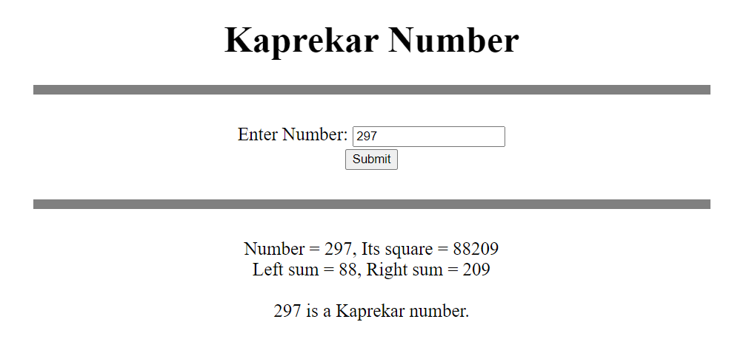 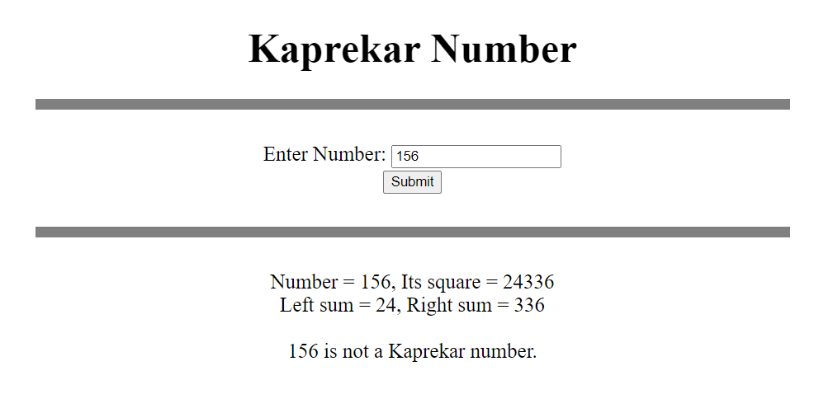

<!DOCTYPE html>

<html>

<body>

<center><h1>Kaprekar Number</h1></center>

<hr width="50%" size='10' noshade><br>

<center>

<form method="post" action="<?php echo $_SERVER['PHP_SELF'];?>">

Enter Number: <input type="number" name="num"><br>

<input type="submit"><br><br>

<hr width="50%" size='10' noshade><br>

</form>

<?php

if($_SERVER["REQUEST_METHOD"] == "POST") {

// taking input and storing it in variable

$n = htmlspecialchars($_REQUEST['num']);

if(empty($n)) {

echo "Please fill the input!<br>";

}

else {

// first counting number of digits in number

$square = $n**2;

$t = $square;

$count = 0;

while($t>0) {

$count++;

$t = intdiv($t, 10);

}

// finding left part and right part of square of number

$right = 0;

$left = 0;

$pow = 1;

$count = intdiv($count+1, 2);

// for right part

while($count--) {

$right += ($square%10)*$pow;

$square = intdiv($square, 10);

$pow *= 10;

}

$pow = 1;

// for left part

while($square>0) {

$left += ($square%10)*$pow;

$square = intdiv($square, 10);

$pow *= 10;

}

echo "Number = $n, Its square = ".($n**2)."<br>";

echo "Left sum = $left, Right sum = $right<br><br>";

// checking condition of Kaprekar number

if($left+$right==$n) {

echo "$n is a Kaprekar number.<br>";

}

else {

echo "$n is not a Kaprekar number.<br>";

}

}

unset($n);

}

?>

<script>

if ( window.history.replaceState ) {

window.history.replaceState( null, null, window.location.href );

}

</script>

</center>

</body>

</html>

**(E) Deficient Number**

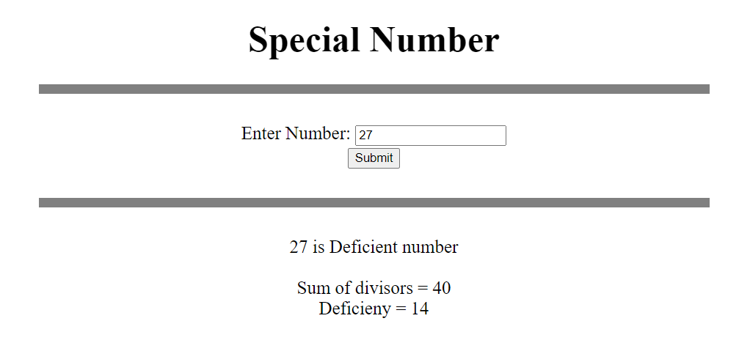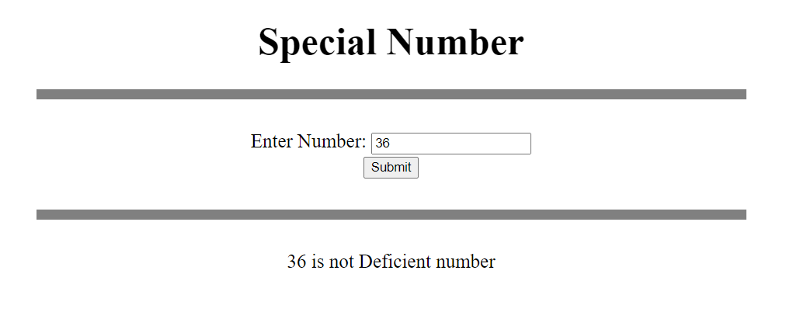

<!DOCTYPE html>

<html>

<body>

<center><h1>Special Number</h1></center>

<hr width="50%" size='10' noshade><br>

<center>

<form method="post" action="<?php echo $_SERVER['PHP_SELF'];?>">

Enter Number: <input type="number" name="num"><br>

<input type="submit"><br><br>

<hr width="50%" size='10' noshade><br>

</form>

<?php

if($_SERVER["REQUEST_METHOD"] == "POST") {

// taking input and storing it in variable

$n = htmlspecialchars($_REQUEST['num']);

if(empty($n)) {

echo "Please fill the input!<br>";

}

else {

// finding sum of all divisors of number

$suma = 0;

for($i=1; $i<=sqrt($n); ++$i) {

if($n%$i==0) {

if($i!=($n/$i))

$suma += $i+($n/$i);

else

$suma += $i;

}

}

// checking condition of deficient number

if($suma<2*$n) {

echo "$n is Deficient number<br><br>Sum of divisors = $suma<br>Deficieny = ".(2*$n-$suma)."<br>";

}

else {

echo "$n is not Deficient number<br>";

}

}

unset($n);

}

?>

<script>

if ( window.history.replaceState ) {

window.history.replaceState( null, null, window.location.href );

}

</script>

</center>

</body>

</html>

Conclusion: -

From this practical, I have learnt how to define variables, loops in PHP, conditions in PHP, implement user defined functions in PHP, etc. and performed certain programs like checking whether the number taken as input from user has certain property or not.