**ML Assignment- 6**

**Name: Parth Arora**

**Roll No.: 2018IMT-063**

1. **Considering the IRIS dataset discussed in the previous assignment, apply the EM algorithm to cluster the data (without considering the output labels) Use the same dataset for clustering using the K-means algorithm. Compare the results of these two algorithms.**

## We are actually adjusting the number of clusters (K) in the Elbow approach from 1 to 10. We calculate WCSS for each value of K. ( Within-Cluster Sum of Square ). WCSS is the sum of squared distances between each point and the centroid in a cluster. When we plot the WCSS with the K value, the plot looks like an Elbow. As the number of clusters

increases, the WCSS value will decrease. When K = 1, the WCSS value is the highest. When we examine the graph, we can see that it will shift rapidly at a point, forming an elbow shape. The graph begins to travel practically parallel to the X-axis at this point.

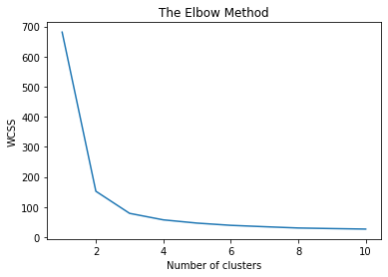

Since the elbow lies at approximately 3 on the x-axis. We can conclude the number of clusters is 3.

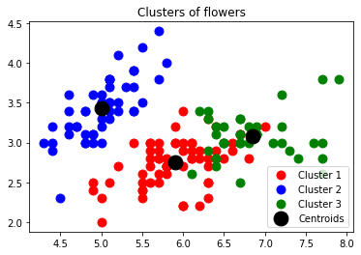

An insight we can get from the scatterplot is the model’s accuracy in determining Cluster 2 is comparatively more to Cluster 1 and Cluster 3.

1. **Apply PCA algorithm to obtain the ﬁrst two principal components and perform the clustering using both algorithms on the resultant data. Compare the results of these two algorithms.**



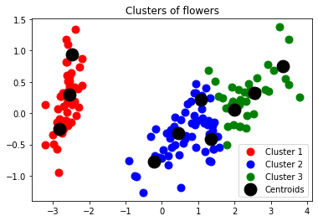

An insight we can get from the scatterplot is the model’s accuracy in determining Cluster 1 is comparatively more to Cluster 2 and Cluster 3.

### Accuracy of K-means and EM models

1. The accuracy of K-Mean model is: **0.24**
2. The accuracy of EM model is: **0.3333333333333333**

### Accuracy of K-means and EM models on applying PCA

1. The accuracy of K-Mean model with PCA is: **0.8866666666666667**
2. The accuracy of EM model is: **0.98**

**Inference:**

It can be observed that in both raw data and PCA data (dimensionally reduced data), the EM algorithm seems to behave and perform better as compared to the K-means model. EM Algorithm is a solid alternative to traditional k-means clustering on semi-supervised learning. It produces stable solutions by finding multivariate Gaussian distributions for each cluster.

Code:<https://github.com/parth-arora/ITIT-4103-2021/blob/main/ML_Assignment_6%5B2018IMT_063%5D.ipynb>