Submission of lab class assignments 27-09-25 (B45) and 30-09-2025 (B46) ARRAYS & STRINGS

PARTH DOGRA
SAP ID - 590023018

Q1.WAP to manipulate strings using arrays :
Using standard library functions of string
Define user-defined functions for copy, length, concatenation and string comparison. OR Write a C program to implement your own versions of string handling functions—copying a string, finding the length of a string, concatenating two strings, and comparing two strings—without using the standard library functions. Define and use user-defined functions copy(), length(), concatenate(), and String_Comparison() to perform these operations on strings , and demonstrate these functions in the main() function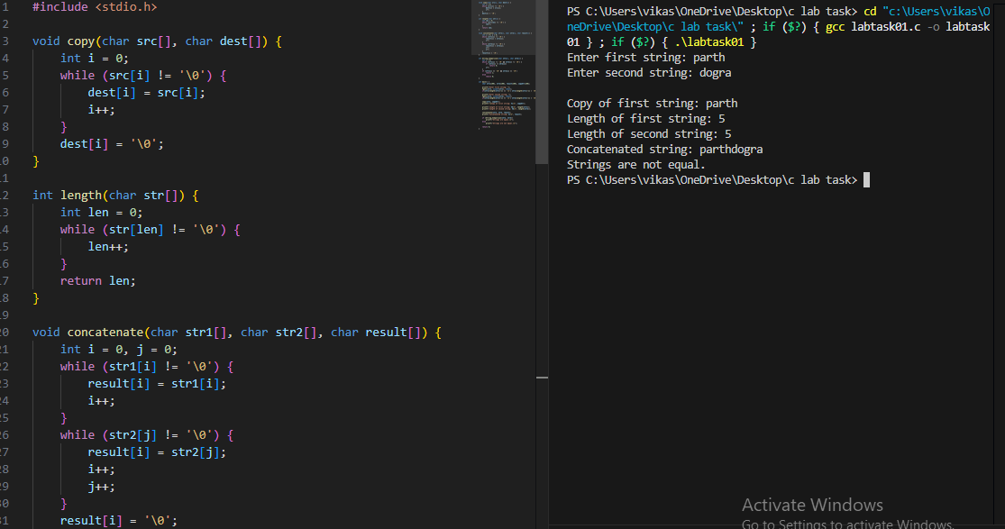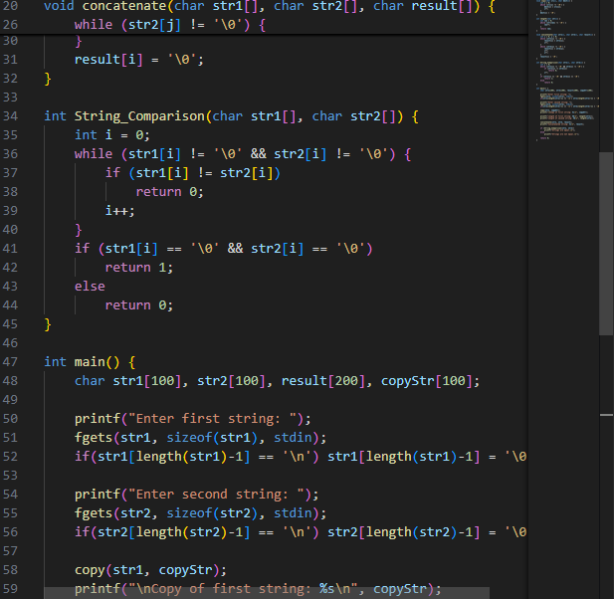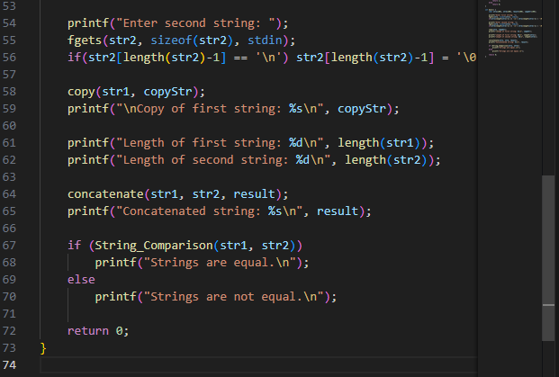
Q2.WAP to find the average of n = 40 numbers using arrays. Convert the type of array using type conversion.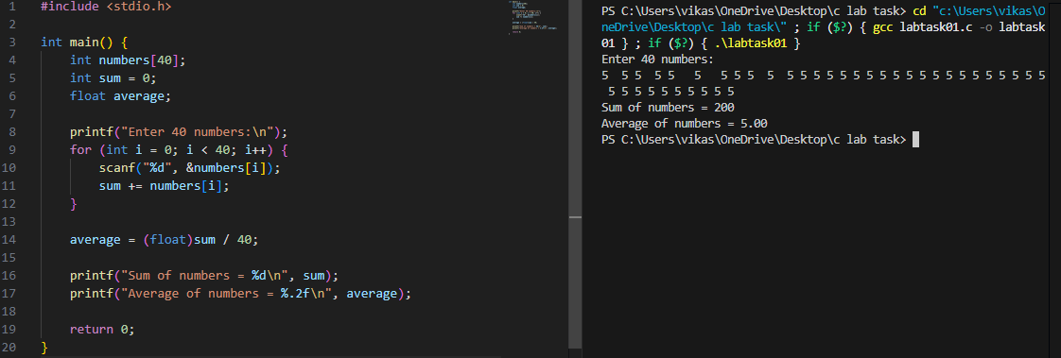

Q3. Write a C program to demonstrate basic string operations such as copying one string to another, concatenating strings with spaces, finding the length of strings, and comparing two strings using string functions like strcpy(), strcat(), strlen(), and strcmp(). Print the results of concatenation, length, and string comparison.

strcpy(), strcat(), strlen(), and strcmp().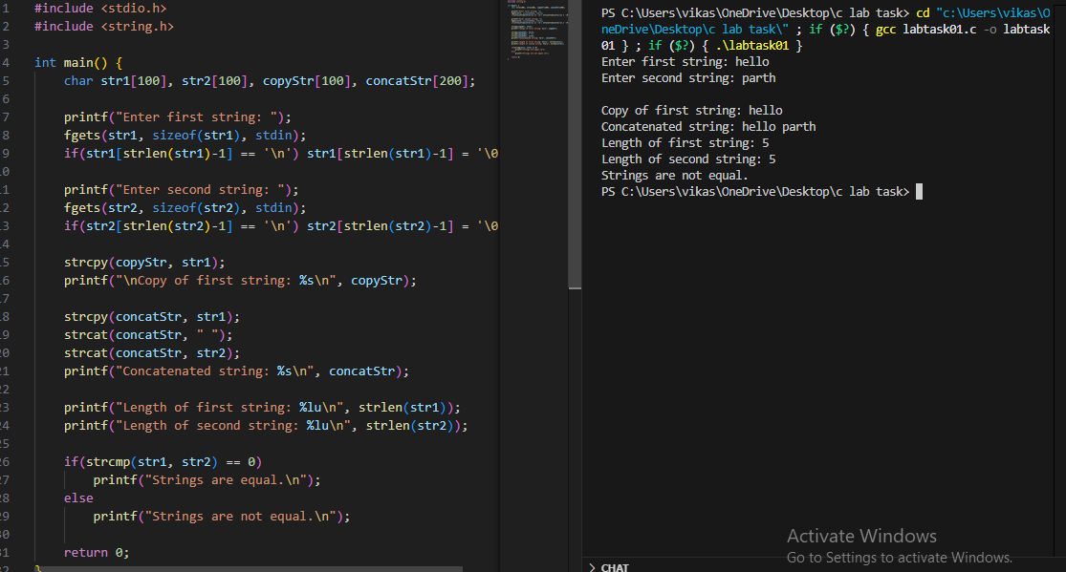

Q4.WAP to read a list of integers and store it in a single dimensional array. Write a C program to find the frequency of a particular number in a list of integers.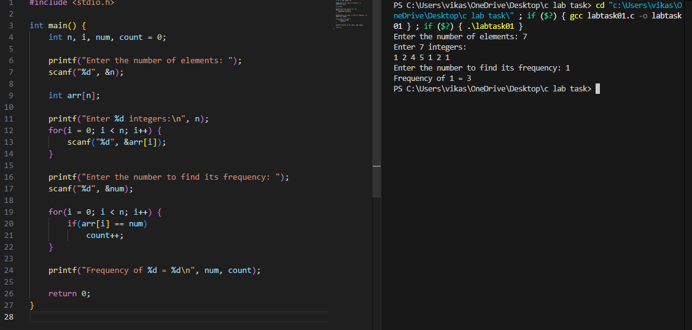

Q5.WAP that reads two matrices A (m x n) and B (p x q) and computes the (a) sum (b) product (c) determinant of A and B. Read matrix A and matrix B in row major order respectively. Print both the input matrices and resultant matrix with suitable headings and output should be in matrix format only. Program must check the compatibility of orders of the matrices for multiplication. Report appropriate message in case of incompatibility.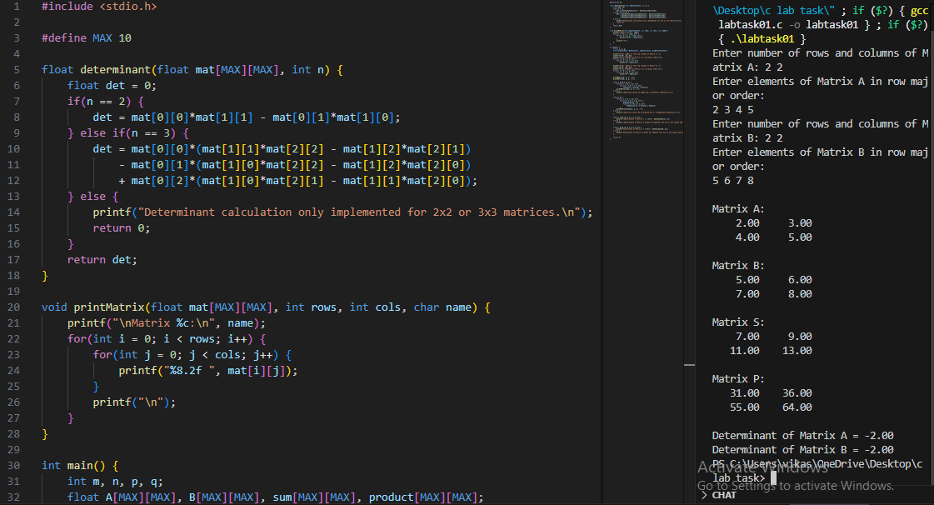
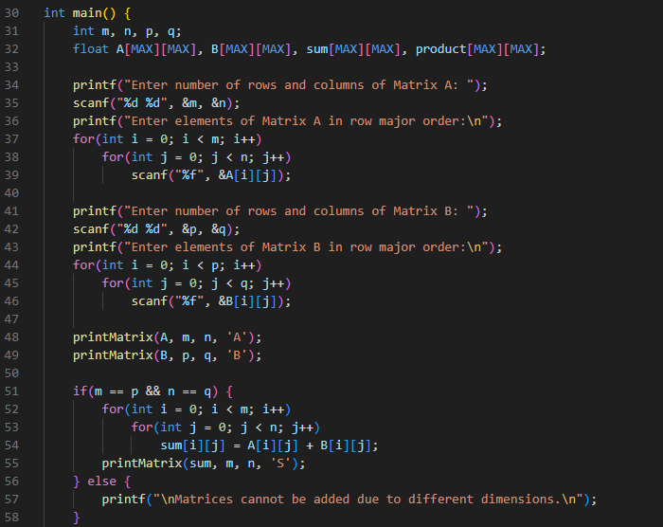
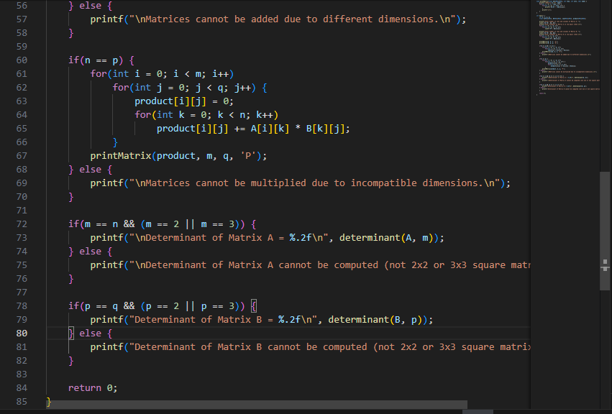

Q6.WAP to take 10 values from the user and store them in an array name numbers. Print the elements stored in the array.