C Programming ASSIGNMENT

PARTH DOGRA
SAP ID: 590023018

- Take input and print name roll no. (Sap id) and address.
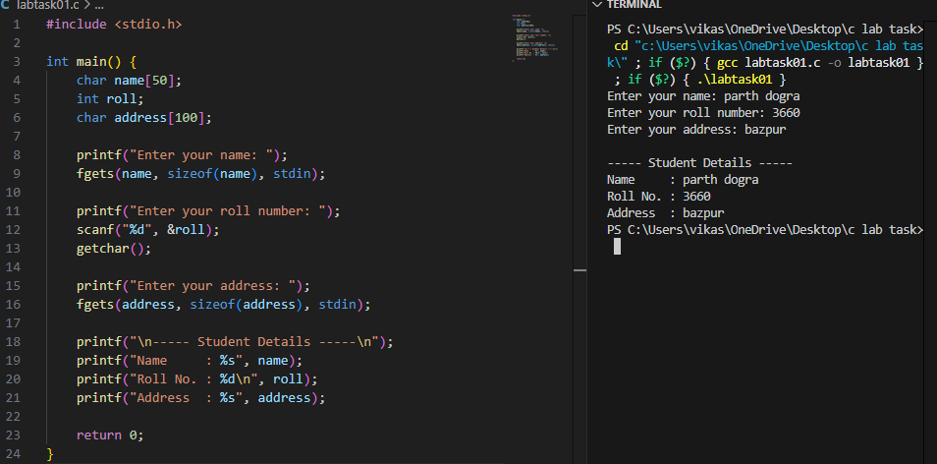

- Celsius to Fahrenheit converter
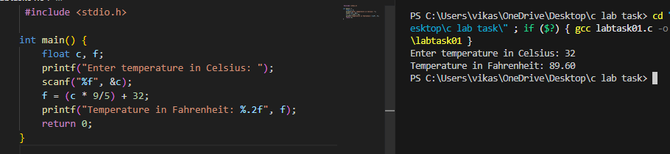

- Find out if a year is a leap year or not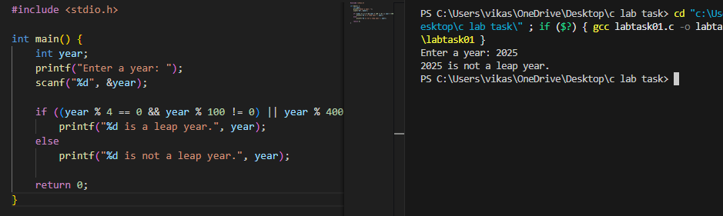
- Armstrong number checker
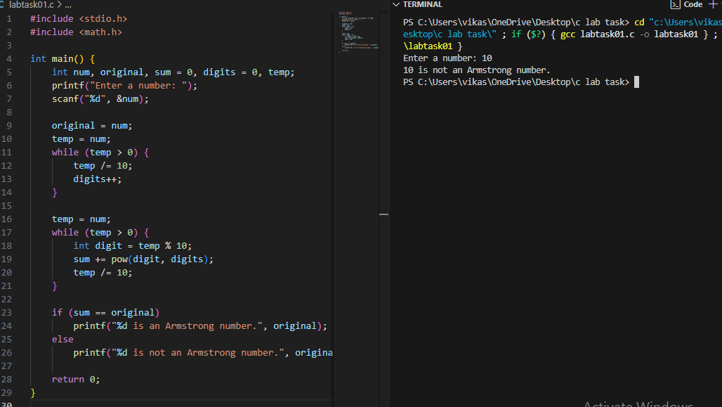

- Write a program to print all number from 1to 100 using for, while, do while.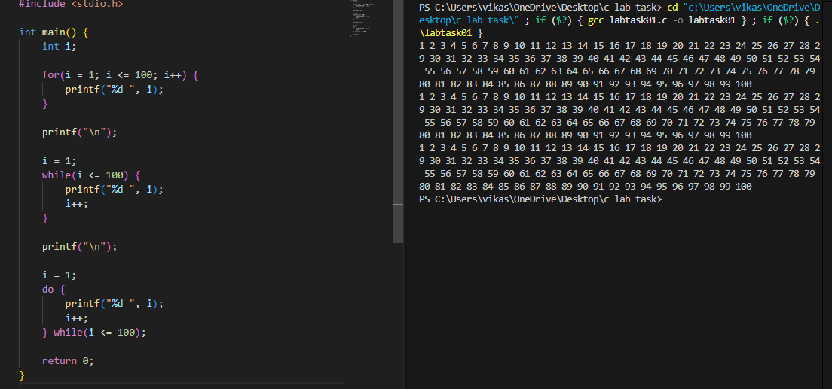

- Wap to print all even and odd numbers between 1 to 100.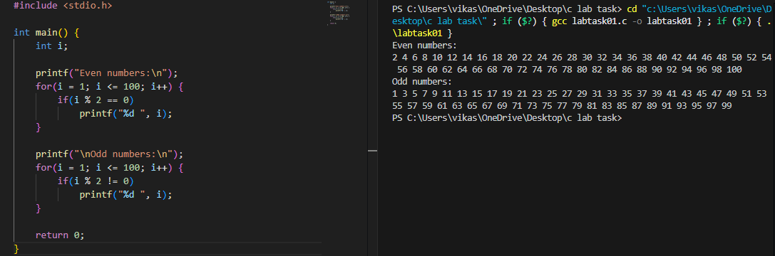
- WAP to find sum of series up to n terms.

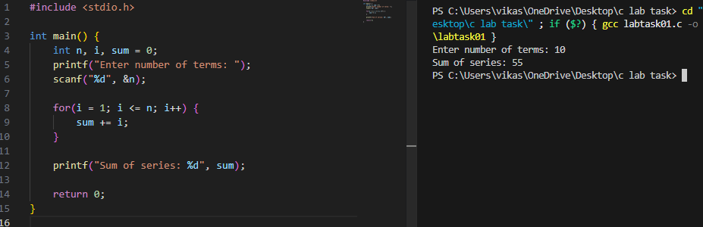
- Write a program to generate the Fibonacci sequence. 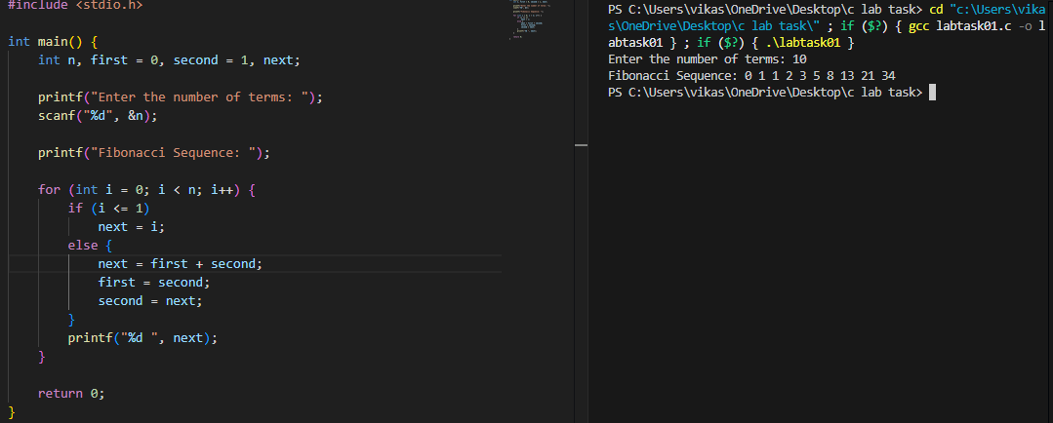
- WAP to find if given point are collinear. 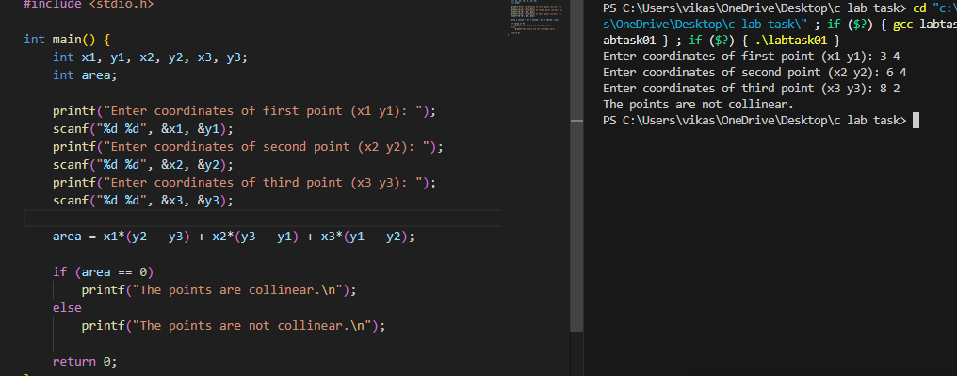

- WAP to print grades obtained by a student using.
1: - if else
2: - switch case. 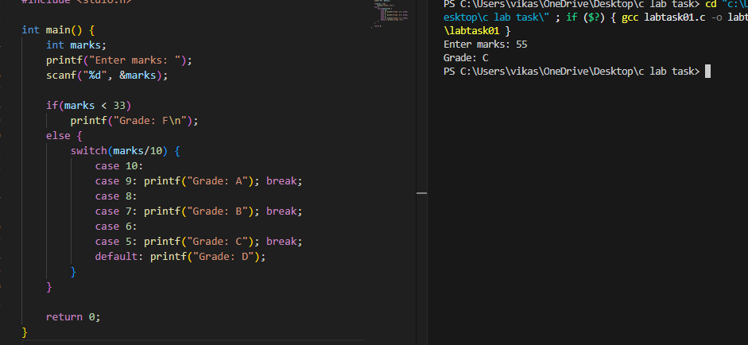
- WAP to illustrate the use of -- 1 return statement, 2 break statement, 3 continue statement 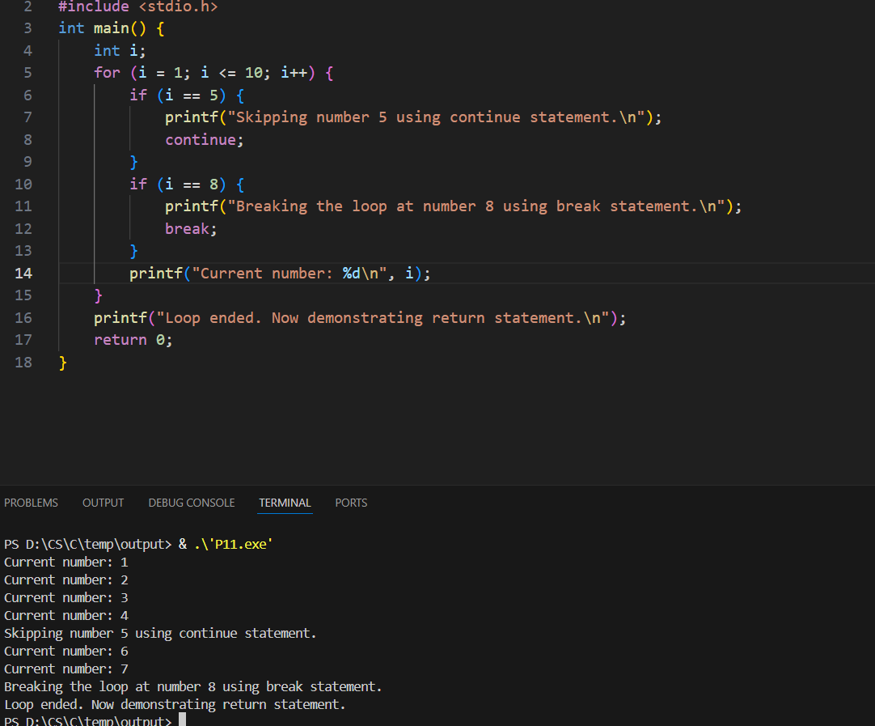

- Wap to convert - :
1. decimal to binary
2. decimal to octal
3. decimal to hexadecimal
4. binary to decimal
5. binary to octal
6. binary to hexadecimal
7. octal to binary
8. octal to decimal
9. octal to hexadecimal
10. hexadecimal to octal
11. hexadecimal to binary
12. hexadecimal to decimal 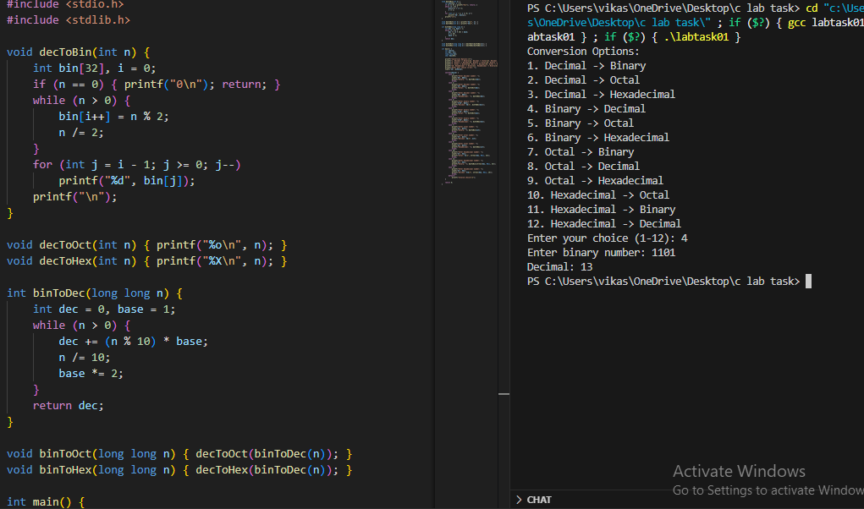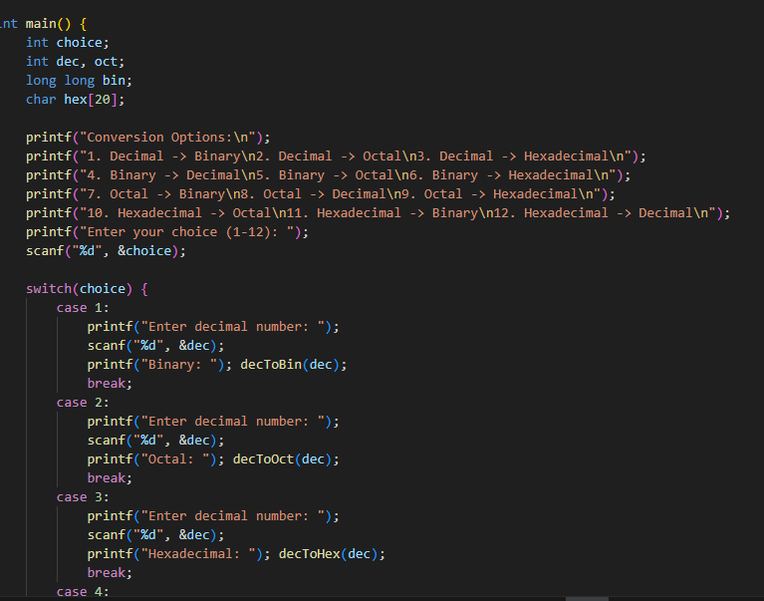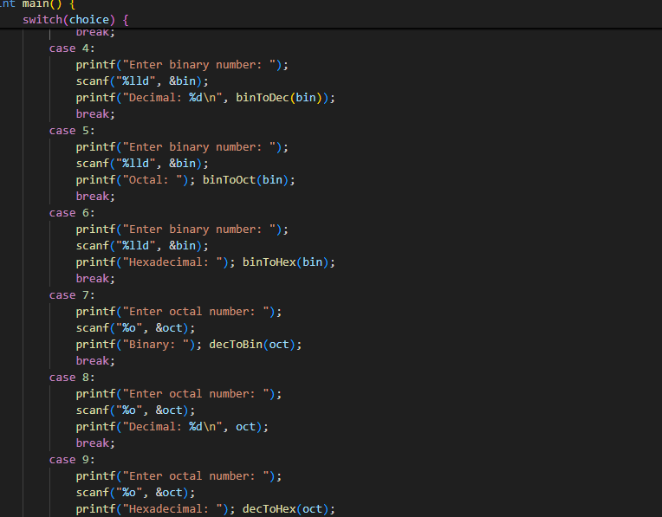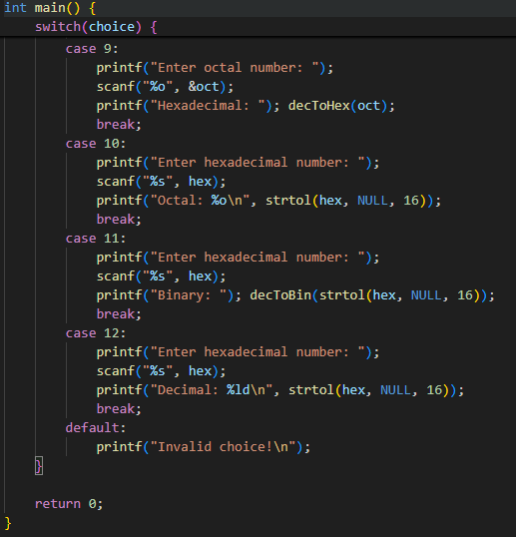
- Wap to understand the usage of operators in C 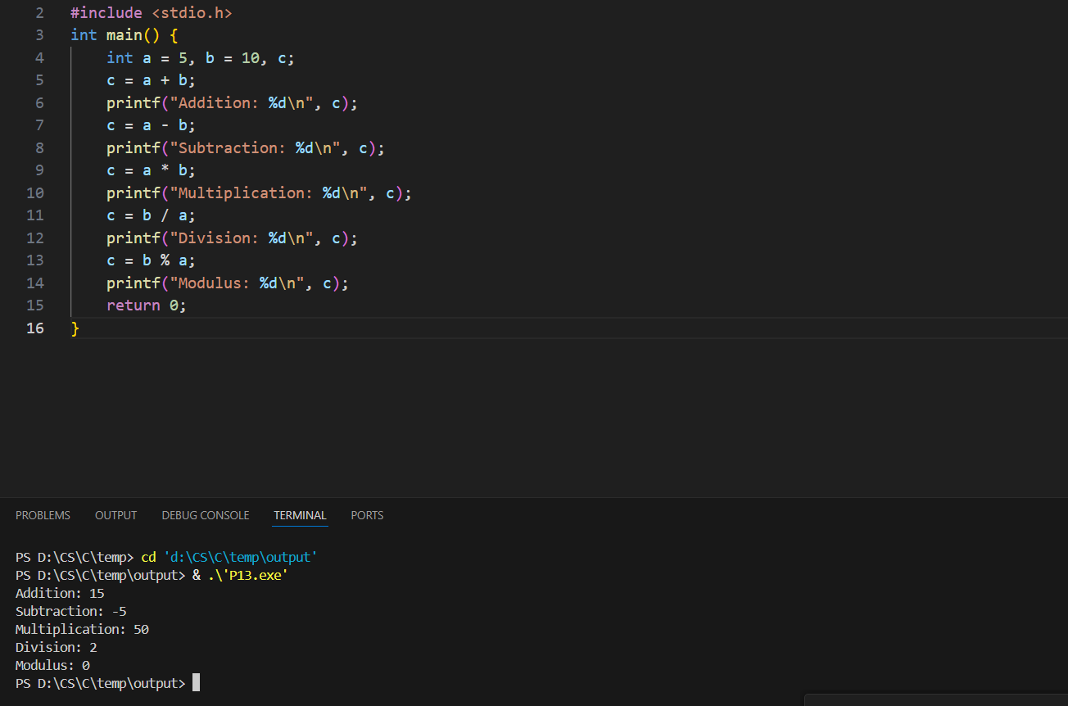
- Wap to compute positive , negative and zeroes from input of n numbers 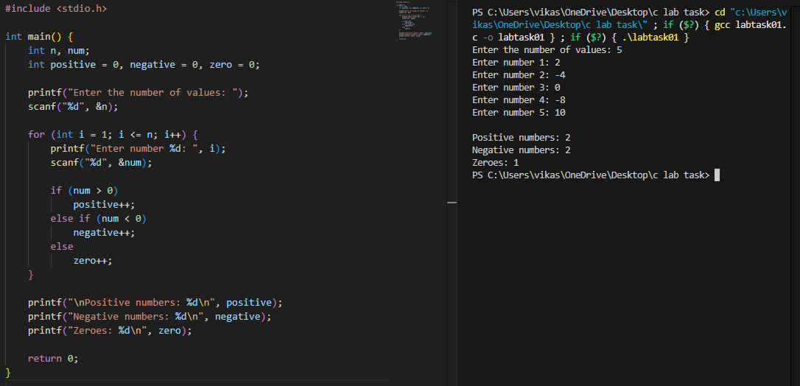

- Wap to compute if the given number is a prime number or not 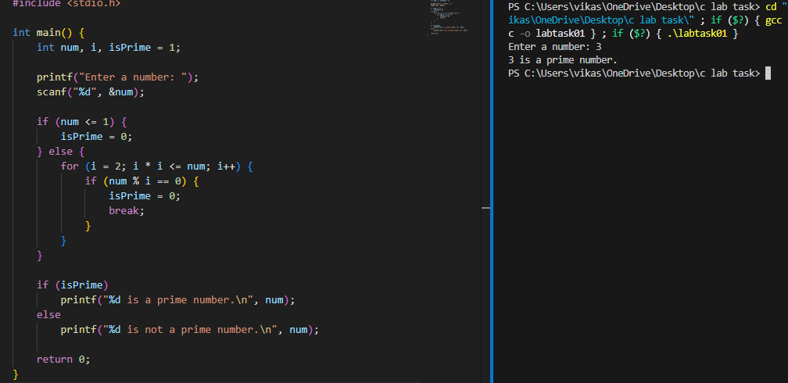

Q17. Wap to convert no. of days into years, months and days 