Submission of lab class assignments 20-09-25 (B45) and 23-09-2025 (B46) FUNCTIONS

Submitted by - Parth Dogra
Sap id - 590023018

Q 1.Functions: WAP to select a candidate based on height and age. Define a user defined function and set conditions where age is <25 and height > 5 foot.

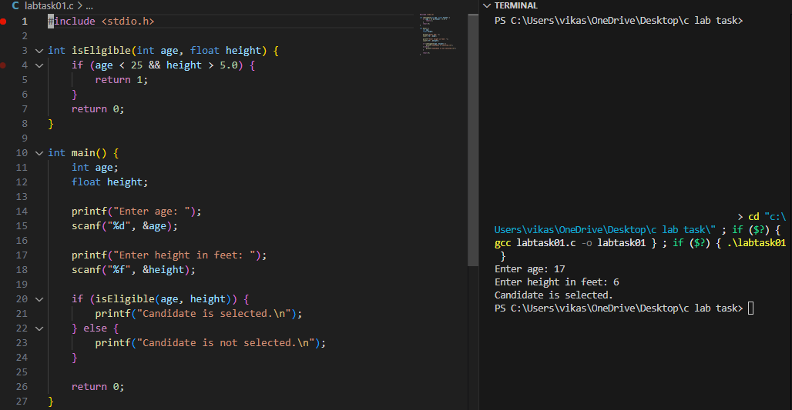

Q2.WAP program to raise a floating point number to an integer power. use user defined function such as power

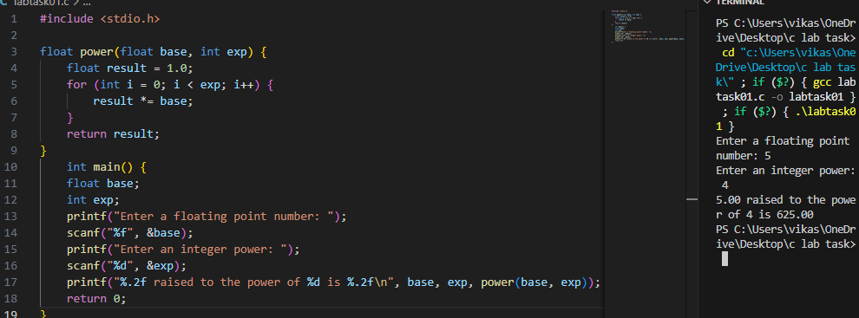

Q3.WAP to find if a given number is a palindrome (reverse). Use function palindrome or reverse.

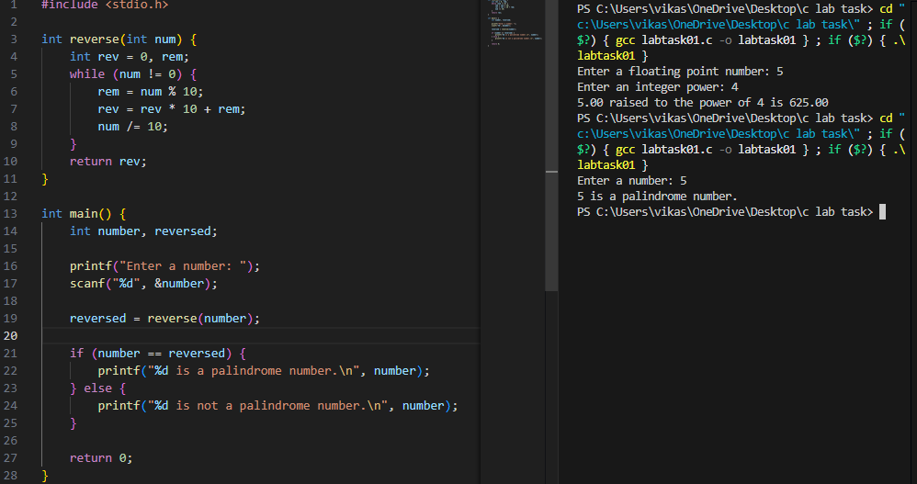

Q4.WAP to find the type and area of a triangle.

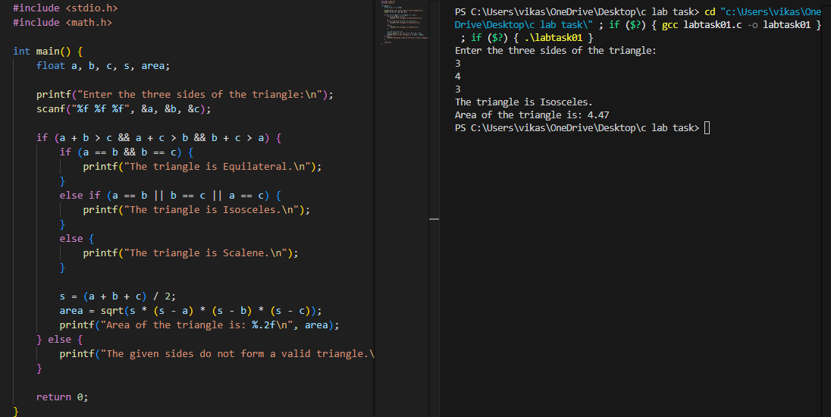

Q5.Develop a recursive and non-recursive function FACT(num) to find the factorial of a number, n!, defined by FACT(n) = 1, if n = 0. Otherwise, FACT(n) = n * FACT(n-1). Using this function, write a C program to compute the binomial coefficient. Tabulate the results for different values of n and r with suitable messages.

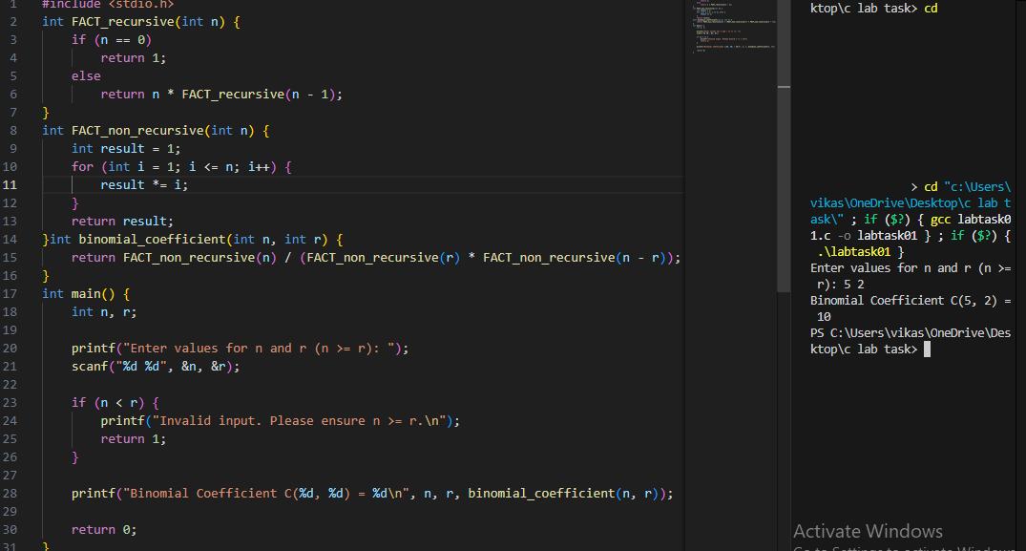

Q6.Develop a recursive function GCD (num1, num2) that accepts two integer arguments. Write a C program that invokes this function to find the greatest common divisor of two given integers.
Develop a recursive function FIBO (num) that accepts an integer argument. Write a C program that invokes this function to generate the Fibonacci sequence up to num.

