AI Usage DISCLOSURE FORM

1. Team Details
Team Name: Commit Happens
Project / Product Name: TroubleIR - Smart Guided Troubleshooting Engine
Organization / Institution (if any): Vellore Institute of Engineering
Submission Date: 30th September 2026

2. AI Usage Declaration
Did your team use any Artificial Intelligence (AI) in developing this project? Yes / No YES
Claude Code (Anthropic) was used as the primary AI coding assistant throughout development.

3. Purpose of AI Usage ( Brief Details)
Idea generation / brainstorming Pipeline architecture: polarity-aware semantic cache, IDF-weighted grounding validator, deeplink binding via SettingsGraph.
Code generation or assistance Backend (FastAPI, pipeline orchestration, Pydantic schema, BM25+dense retrieval, grounding validator, lint rules, security hardening) and frontend (GSAP scroll-driven demo, Settings navigation tree, score bar chart).
UI / UX design Scroll-driven single-page demo with GSAP ScrollTrigger and Lenis smooth scrolling; two-column layout, Settings navigation tree with traversal highlighting, relevance score chart.
Content creation README documentation, pipeline walkthrough copy.
Data analysis Deeplink catalog audit: verified 578 official voiceassist:// URIs against Samsung One UI namespace conventions.
Testing / debugging Unit test scaffolding for schema, cache, lint, and grounding validator; debugging pipeline error handling and schema validation.
Other N/A

4. Feature Origin Classification ( Please add/delete based on the number of the feature)
1. Feature Name IDF-Weighted Grounding Validator
2. Self-Generated/AI-Generated/Both Both
3. Description Tool: Claude Code (Anthropic). Prompt: 'implement a grounding validator that rejects LLM-extracted steps not supported by SIIS evidence, using IDF-weighted token overlap'. Output: grounding.py with per-step scoring and coverage threshold. Modification: threshold values tuned manually via test scenarios.

1. Feature Name Polarity-Aware Semantic Cache
2. Self-Generated/AI-Generated/Both Both
3. Description Tool: Claude Code (Anthropic). Prompt: 'add a semantic cache with cosine similarity lookup and polarity guard so opposite-sentiment queries never share a cache slot'. Output: cache.py with embedding-based lookup and polarity extraction. Modification: similarity threshold set to 0.85 after manual testing.
…

5. Ethical & Compliance Confirmation
AI usage complies with guidelines and policies. Yes
No proprietary or copyrighted data misused. I Agree

6. Declaration & Sign-Off
Name of Team Representative: Parth Garg
Role: Team Representative
Signature: 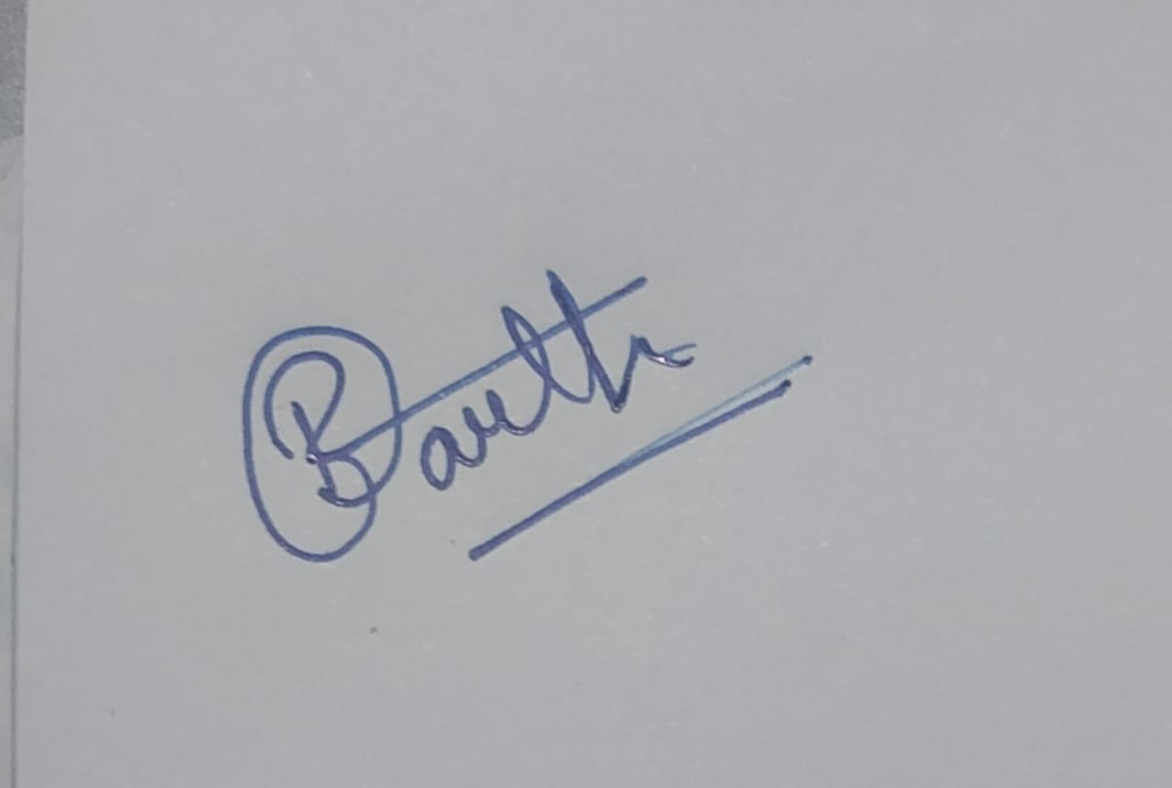
Date: 30th September 2026

