Undergraduate Project Report

On

Deep Learning Application in Fluid Mechanics


Submitted by
Parth Gautam(160478)
Senior Undergraduate Student
Department of Aerospace Engineering, IIT Kanpur

Submission Date: 13 Nov,2019

Certificate
It is certified that the work completed in this report entitled Deep Learning Application in Fluid Mechanics jointly by Parth Gautam and Ravi Prakash Tripathi has been carried out under my supervision and this work has not been submitted elsewhere for a degree.

Signature of Supervisor
Prof. Navrose
Department of Aerospace Engineering
Indian Institute of Technology, Kanpur

1. Acknowledgment
I would like to thank my guide Dr. Navrose under whose canopy this project prospered and flourished. He not only helped us in achieving the objectives of this project but also supported emotionally whenever I felt low and down.
I would also like to thank Prof. Alakesh Mandal who provided us the high-resolution data set on which I was able to carry out our undergraduate project.

2. Introduction
Machine learning and Deep learning has many applications in very diverse fields. Its nature of flexibility to learn various problems and predict further with good accuracy makes it widely exploited in many fields. As computers are strict logic machines things should be explicitly coded to automate computer processing but with the introduction of machine learning computer’s are now able to learn and understand the behaviour and patterns inside the data and give results without being explicitly coded.

This project is focussed to exploit this nature of Deep Learning in classical aerospace fields
like fluid mechanics. This project incorporates the applications of Deep learning models for flow field generation and predicting the pressure in flow field. Deep learning is used in this project for finding patterns inside the data by learning the essence of data using a fully- connected Neural Network architecture with suitable hyper-parameters on Keras and Tensorflow (Google’s Neural Network libraries). At last this project further highlights the future work that can be done using Deep Learning techniques in the field of fluid mechanics.

3. Objective of work
Objectives of this project is to develop a model which can be used for flow field generation from low resolution data to make it high resolution one. And further highlights the future work that can be done using this model

4. Method:
I was given PIV data for the velocity field of the wake region of flow past a flat plate for Re 1800. Data contains U and V velocities for the grid of 100 X 100 in space(X,Y) and for 800
timeframes with a time resolution of $2.74 ×{{10^{-3}}_{}^{}}^{}$ seconds. To start, I just took the flow field data of 1st-time frame and build the deep neural network with inputs (X, Y) and output(U, V) as shown below.

4.a Network Architecture:
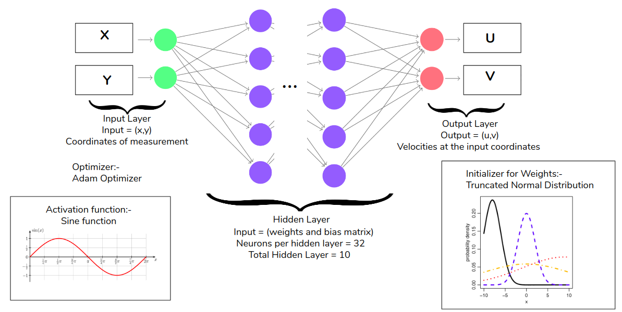

The network had 10 hidden layers with 32 neurons per hidden layer with sine activation function and weight initializers as truncated normal distribution and built-in Keras.

4.b Preliminary Loss Function:
The Initial loss function for the network is the root mean squared error(RMSE) which is defined as
Loss = mean(sqrt((U-U_{pred})² + (V-V_{pred})²))
4.c Sampling:
For training and testing the model, I divided the data into training and testing set with a ratio of 68:32. I trained the first model on random sampling of space data
Random Sampling
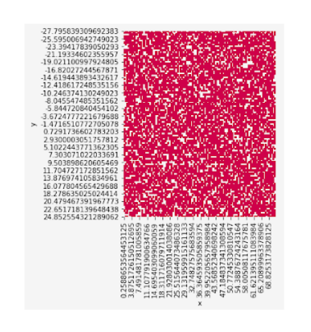

This is a basic model with no physics information, after implementing this I tried to add our understanding of flow and moved on biased sampling of data as I know that major flow variance is along the centre line and major traits and pattern can be captured from that region.

4.d Hypothesis - 1 :-
Changing sampling distribution will lead to improvise the model accuracy.

Biased Sampling(Bell Shaped)
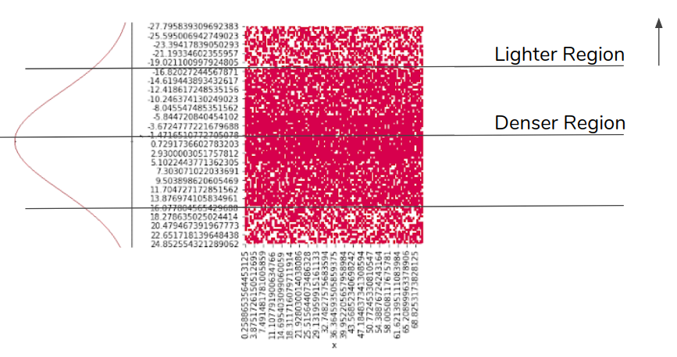
In biased sampling data for training is chosen with a gaussian look a like distribution along Y-direction as in the figure above.

4.e Governing Equations:
The governing equations of fluid motion are incompressible continuity and momentum equations.
U_{x}+V_{y} = 0 E - 1
and,
U_{t} + U*U_{x} + V*U_{y} + P_{x}= (1/Re)(U_{xx} + U_{yy}) E - 2

V_{t} + U*V_{x} + V*V_{y} + P_{y}= (1/Re)(V_{xx} + V_{yy}) E - 3

So the predicted flow field must respect the governing equations and should be considered in our model.
After this step I again tried to add our knowledge for flow that flow must satisfy the continuity equation and I involved fluid mechanics constraint of continuity equation in the loss function.
For E -1 I needed the gradients of U and V wrt x and y respectively but derivative operator in keras was not further differentiable in Keras loss. So I moved the model on Tensorflow which offers all mathematical flexibility.
Computation graph for the model is mentioned further.

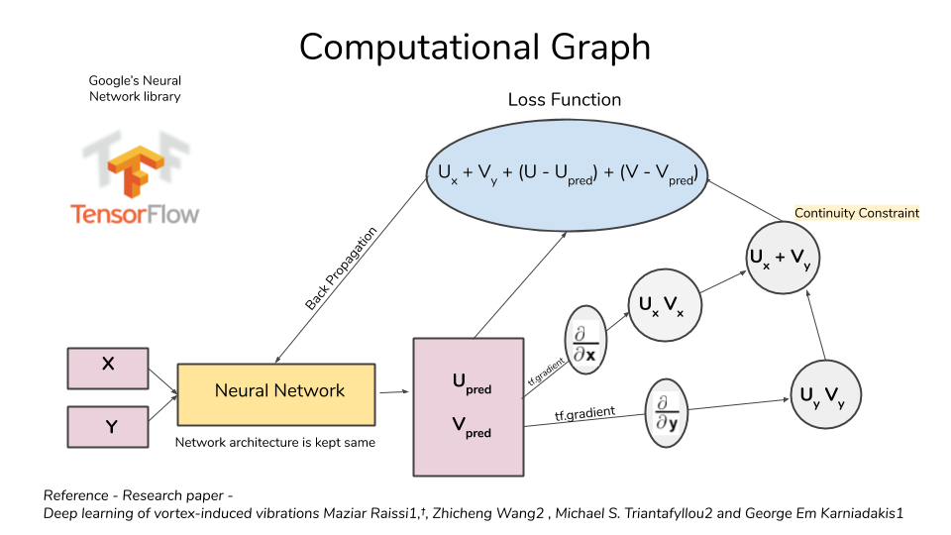

4.f Hypothesis - 2
Adding continuity constraint will help in improvising the model performance

Loss Function incorporating Governing Equation:
The loss function for the hypothesis - 2
Loss = mean(sqrt((U-U_{pred})² + (V-V_{pred})²) + U_{x} + V_{y})

4.g Hypothesis - 3
Loss has 3 components which is rmse in U, rmse in V, continuity constraint and all have equal weights initially but I can tweak the weights of all the three components and it might help model to increase accuracy in the component with higher weight.

Loss Function with varying weights:
Then I included weights w_{u} , w_{v} and w_{c} to the error in U, V and continuity equation(e1).
Loss = w_{u}*mean(sqrt(U-U_{pred})² )+ w_{v}*mean(sqrt(V-V_{pred})²) + w_{c}*mean(sqrt(e1))

Analysed different combinations and picked the best sets to increase the prediction accuracy.

4.h Hypothesis - 4

Including momentum equation constraints in loss function with rmse error and continuity constraints will further improve the model

The loss function for the hypothesis - 4
Loss = mean(sqrt((U-U_{pred})² + (V-V_{pred})²) + U_{x} + V_{y} + Momentum_{x} + Momentum_{y})

where,
Momentum_{x} = U_{t} + U*U_{x} + V*U_{y} + P_{x}= (1/Re)(U_{xx} + U_{yy})

Momentum_{y} = V_{t} + U*V_{x} + V*V_{y} + P_{y}= (1/Re)(V_{xx} + V_{yy})

5.Results:
5.a Random Sampling (Basic model)
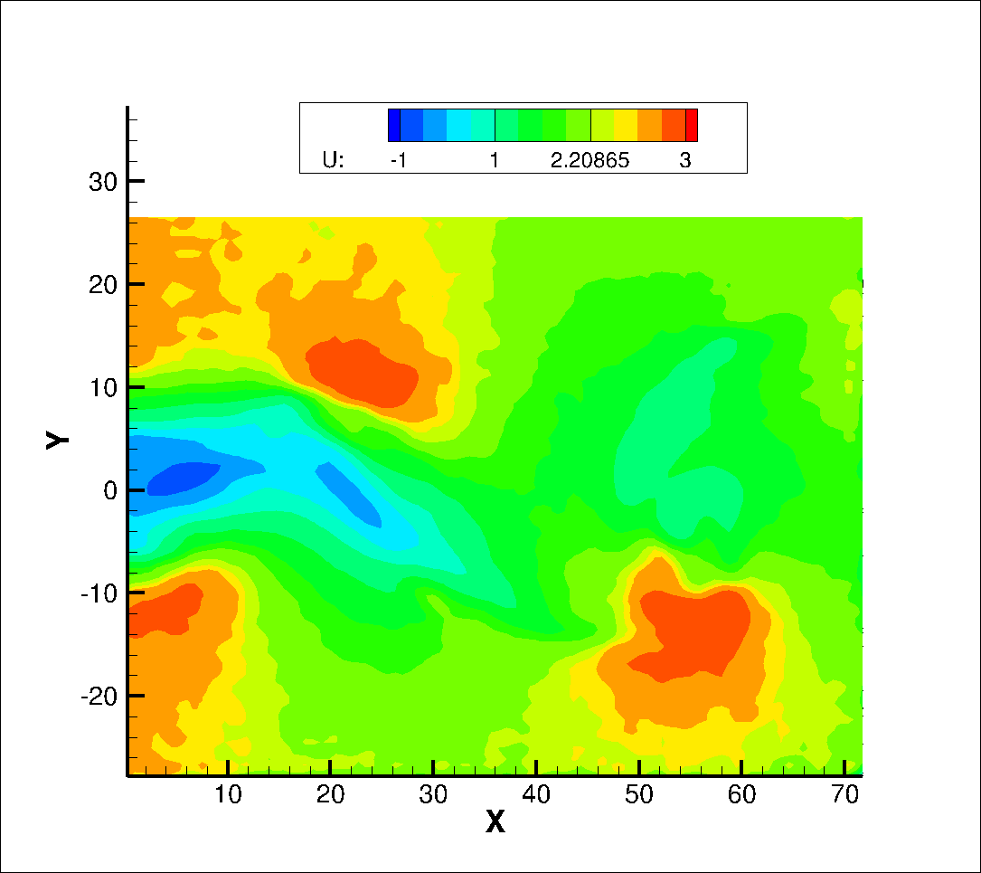
Figure:5.1 U velocity contours developed from Tecplot

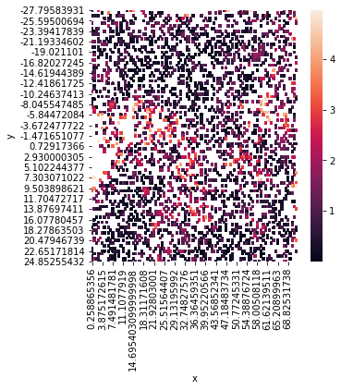
Figure:5.2 Heat map showing %error in U_{pred} and U_{actual} in range [0,5]
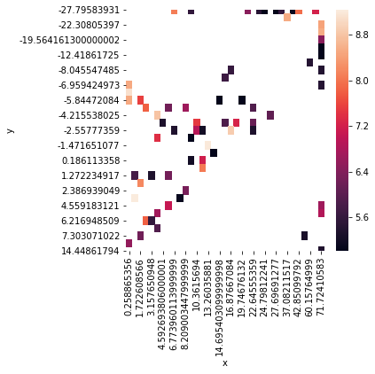
Figure:5.3 Heat map showing %error in U_{pred} and U_{actual} in range (5,10]

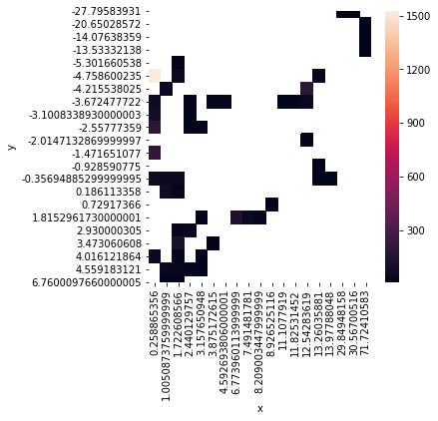
Figure:5.4 Heat map showing %error in U_{pred} and U_{actual} in range (10,error_{max}]
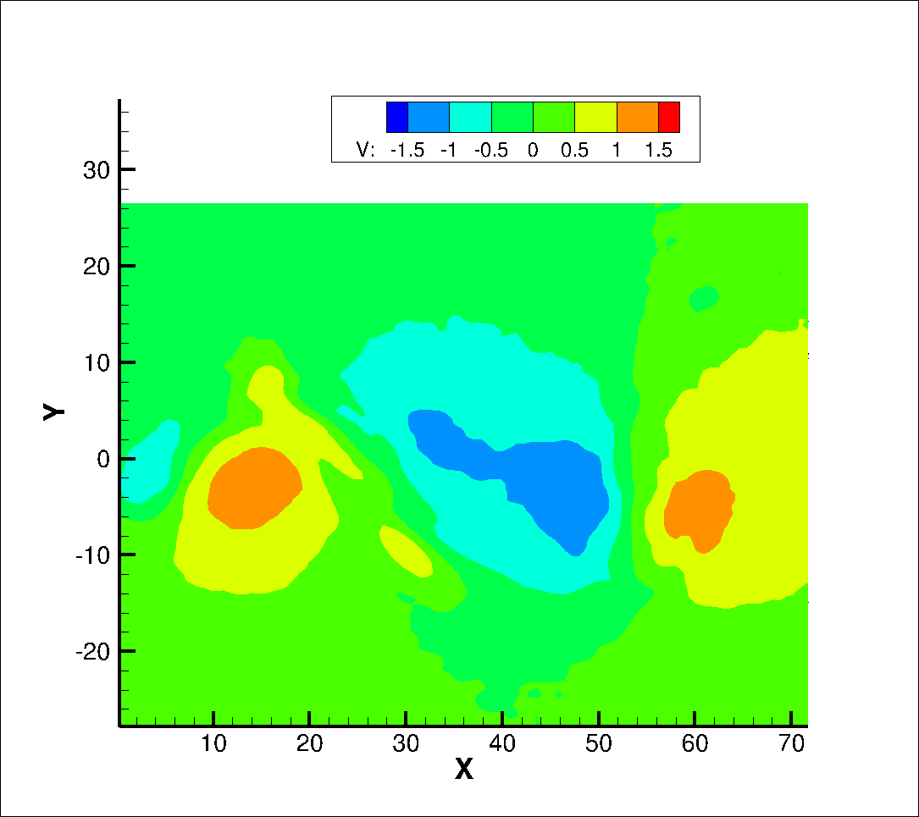
Figure:5.5 V velocity contours developed from Tecplot

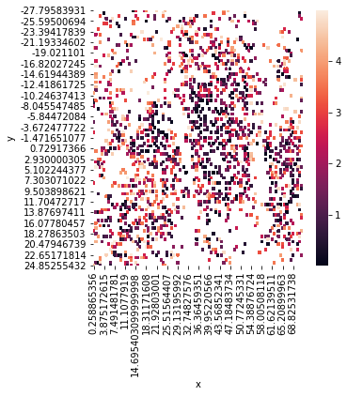
Figure:5.6 Heat map showing %error in V_{pred} and V_{actual} in range [0,5]

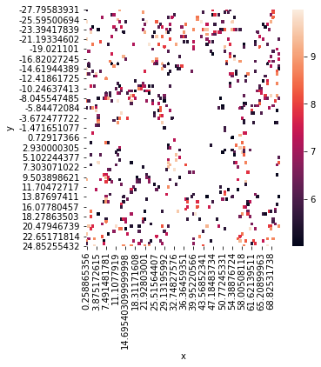
Figure:5.7 Heat map showing %error in V_{pred} and V_{actual} in range (5,10]
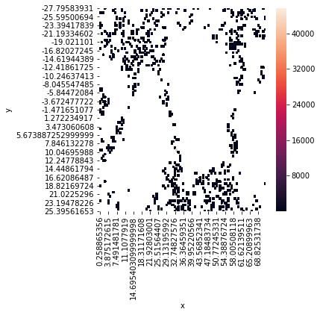
Figure:5.8 Heat map showing %error in V_{pred} and V_{actual} in range (10,err_{max}]

Table 5.1:Error in U_{pred}

Sampling Type | %data points in error range[0,5] | %data points in error range(5,10] | %data points in error range(10,err_{max}]
Random | 94.25 | 3.15 | 2.59

Table 5.2:Error in V_{pred}

Sampling Type | %data points in range[0,5] | %data points in range(5,10] | %data points in range(10,err_{max}]
Random | 55.72 | 18.66 | 25.62

5.b Result of hypothesis - 1
Biased Sampling
Figure:5.9 U velocity contours developed from Tecplot

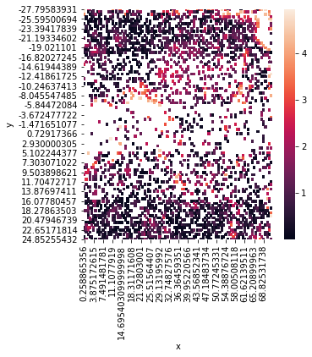
Figure:5.10 Heat map showing %error in U_{pred} and U_{actual} in range [0,5]
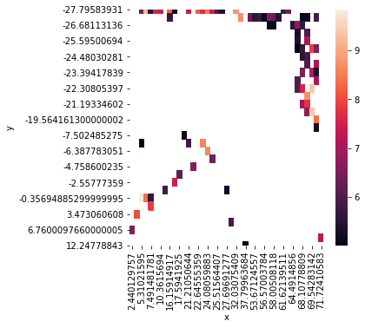
Figure:5.11 Heat map showing %error in U_{pred} and U_{actual} in range (5,10]

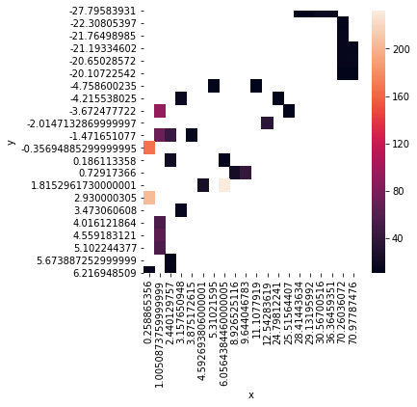
Figure:5.12 Heat map showing %error in U_{pred} and U_{actual} in range (10,err_{max}]

Figure:5.13 V velocity contours developed from Tecplot

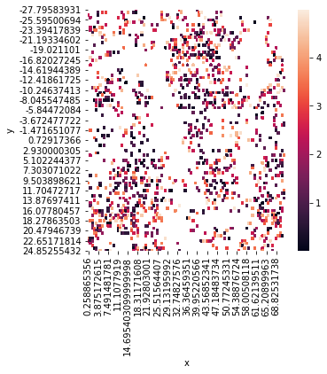
Figure:5.14 Heat map showing %error in V_{pred} and V_{actual} in range [0,5]

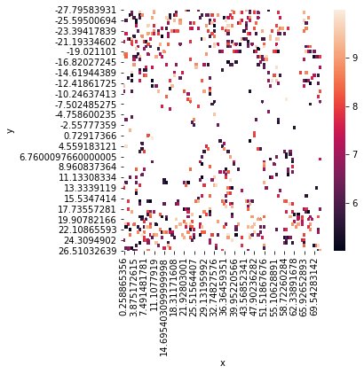
Figure:5.15 Heat map showing %error in V_{pred} and V_{actual} in range (5,10]

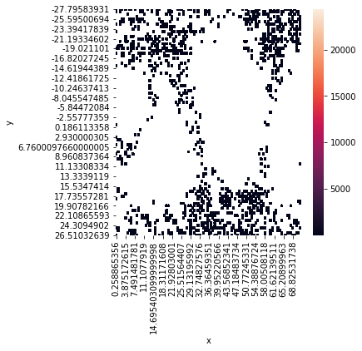
Figure:5.16 Heat map showing %error in V_{pred} and V_{actual} in range (10,error_{max}]

Table 5.3:Error in U_{pred}

Sampling Type | %data points in error range[0,5] | %data points in error range(5,10] | %data points in error range(10,err_{max}]
Random | 94.25 | 3.15 | 2.59
Biased | 96.28 | 2.56 | 1.16

Table 5.4:Error in V_{pred}

Sampling Type | %data points in error range[0,5] | %data points in error range(5,10] | %data points in error range(10,err_{max}]
Random | 55.72 | 18.66 | 25.62
Biased | 42.09 | 20.66 | 37.25

It can be inferred from the Table 5.3 that biased sampling improves model performance in predicting U (94.25% to 96.28%) and degrades in predicting V (55.72% to 42.09%)

5.c Result of hypothesis - 2
Random Distribution(with Continuity Constraint in Loss Function)

Figure:5.17 U velocity contours developed from Tecplot
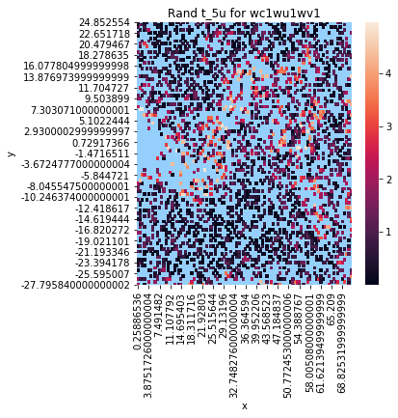
Figure:5.18 Heat map showing %error in U_{pred} and U_{actual} in range [0,5]
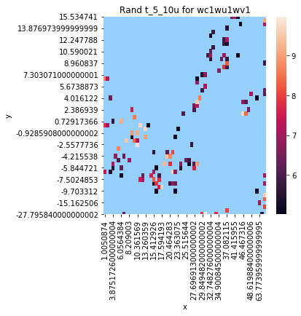
Figure:5.19 Heat map showing %error in U_{pred} and U_{actual} in range (0,10]

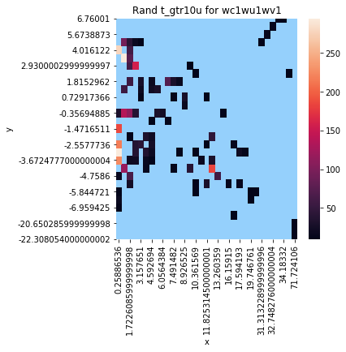
Figure:5.20 Heat map showing %error in U_{pred} and U_{actual} in range (10,err_{max}]
Figure:5.21 V velocity contours developed from Tecplot

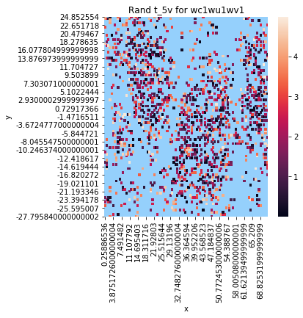

Figure:5.22 Heat map showing %error in V_{pred} and V_{actual} in range [0,5]

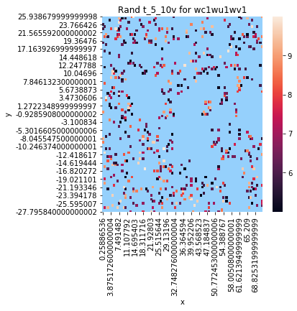
Figure:5.23 Heat map showing %error in V_{pred} and V_{actual} in range (5,10]

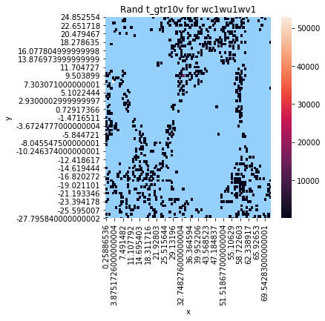
Figure:5.24 Heat map showing %error in V_{pred} and V_{actual} in range (10,err_{max}]

Biased Distribution(with Continuity Constraint in Loss Function)

Figure:5.25 U velocity contours developed from Tecplot
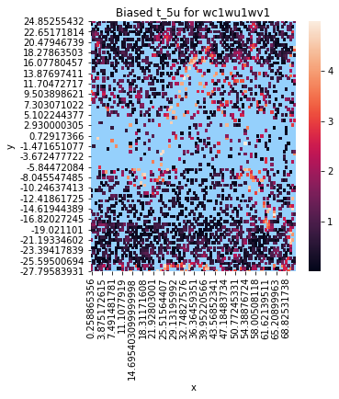
Figure:5.26 Heat map showing %error in U_{pred} and U_{actual} in range [0,5]
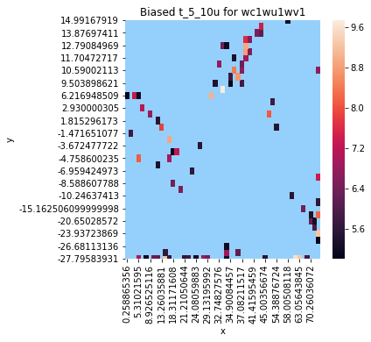
Figure:5.27 Heat map showing %error in U_{pred} and U_{actual} in range (0,10]

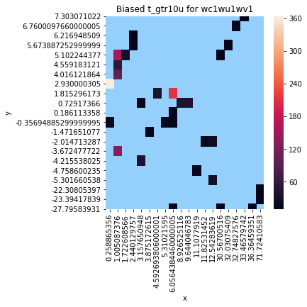
Figure:5.28 Heat map showing %error in U_{pred} and U_{actual} in range (10,err_{max}]
Figure:5.29 V velocity contours developed from Tecplot

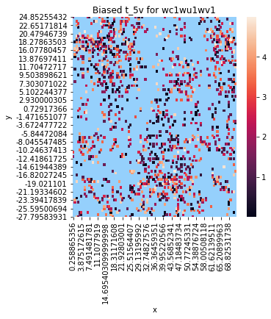

Figure:5.22 Heat map showing %error in V_{pred} and V_{actual} in range [0,5]
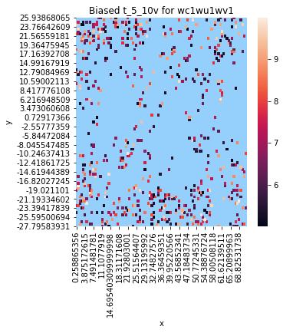
Figure:5.23 Heat map showing %error in V_{pred} and V_{actual} in range (5,10]

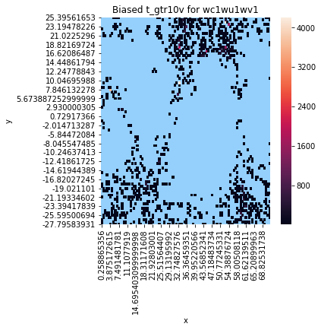
Figure:5.24 Heat map showing %error in V_{pred} and V_{actual} in range (10,err_{max}]
Table 5.5:Error in U_{pred}

Sampling Type | %data points in error range[0,5] | %data points in error range(5,10] | %data points in error range(10,err_{max}]
Random | 94.25 | 3.15 | 2.59
Random(with Continuity Constraint) | 95.7 | 2.5 | 1.8
Biased | 96.28 | 2.56 | 1.16
Biased(with Continuity Constraint) | 96.5 | 2.5 | 1.0

Table 5.6:Error in V_{pred}

Sampling Type | %data points in error range[0,5] | %data points in error range(5,10] | %data points in error range(10,err_{max}]
Random | 55.72 | 18.66 | 25.62
Random(with Continuity Constraint) | 57.75 | 20.5 | 21.75
Biased | 42.09 | 20.66 | 37.25
Biased(with Continuity Constraint) | 43.91 | 20.125 | 35.97

It can be inferred from the above Table 5.5 and Table 5.6 that indeed there is improvement in model performance (from 96.28 to 96.5%) in U and (42.09 to 43.91%) in V for Bell Shaped Sampling and also improvement for Random Sampling (from 94.25 to 95.7%) in U and (from 55.72 to 57.75%) in V.

5.d Result of hypothesis - 3
Table 5.7
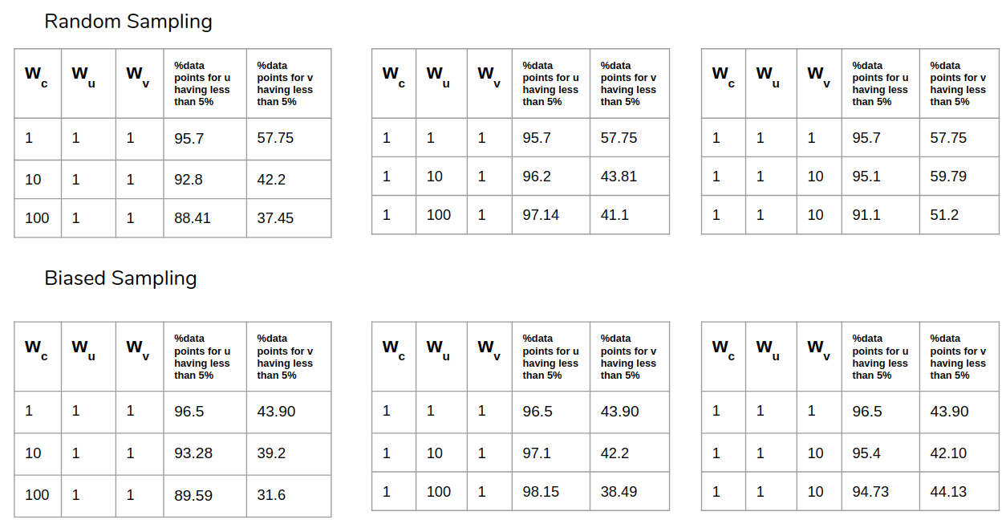
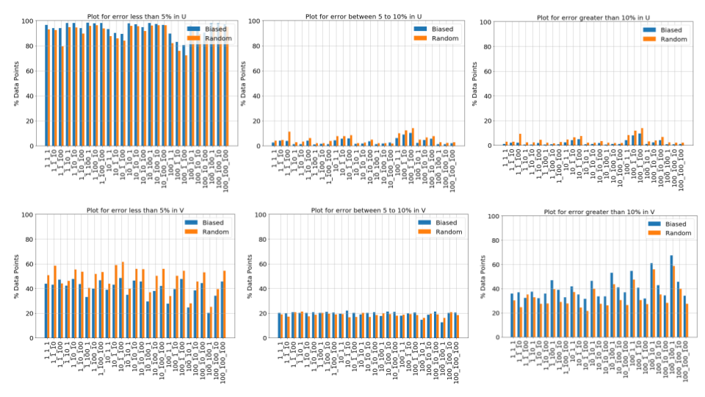
In the above plot % of Data points have been plotted for different combination of weights for both types of sampling. X-axis has notation of w_{c}_w_{u}_w_{v}.

Points to infer:
- For Random sampling as w_{c} is increased keeping w_{u} and w_{v} constant, %data points for U and V both decreases for error range[0,5] and hence the performance of model decreases. Similar trend is observed for biased distribution.
- For Random sampling as w_{u} is increased keeping w_{c} and w_{v} constant, %data points for U increases for error range[0,5] and decreases for V and hence the performance of model increases for U and decreases for V. Similar trend is observed for biased distribution.
- For Random sampling as w_{v} is increased keeping w_{u} and w_{c} constant, %data points for U increases for error range[0,5] and hence the performance of model increases for U. Similar trend is observed for biased distribution.
- From the above bar plot it is clear that Biased(Bell Shaped) distribution sampling is performing better than Random Sampling in predicting U accurately for all combinations of weights.
- Random Sampling performs better than Biased sampling in predicting V accurately for all combinations of weights
- As the weightage of error in the V direction is increased in loss function, accuracy in V prediction increases considerably for both types of sampling but there is decrement in U for both samplings.
- As we have tried to for 27 combinations of w_{c}, w_{u} and w_{v} each belongs to set {1,10,100}, we can try for larger combination of weights. At present stage, it would be naive to comment on optimum combination of weight for best model performance.

6. Code Snippets

- Keras Model
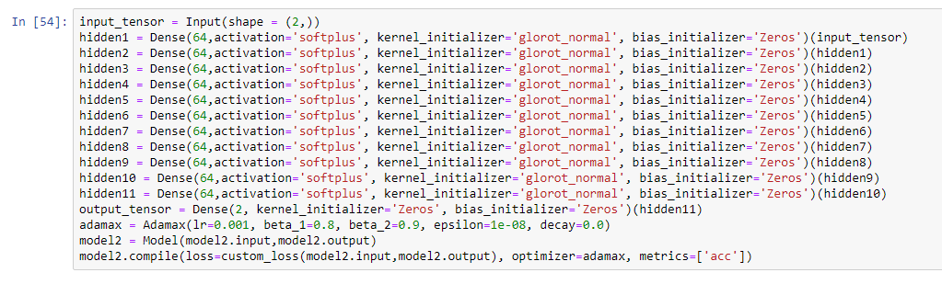
- Tensorflow Model
Model building and initialization code
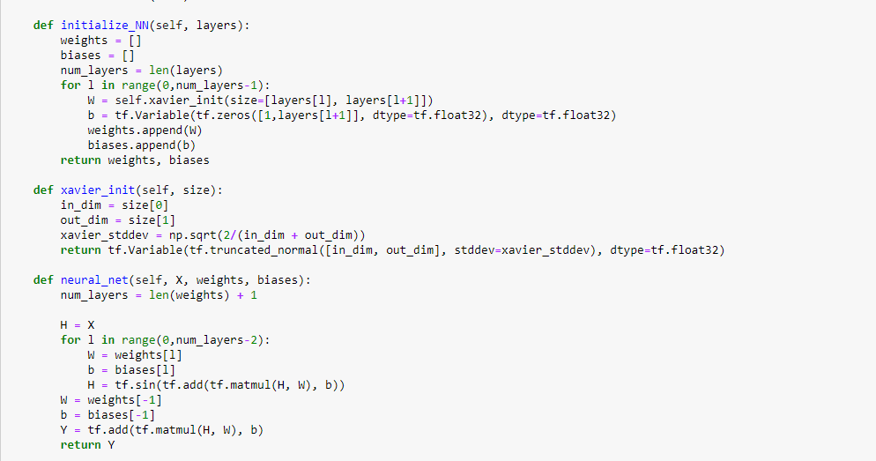

Custom Loss Tensorflow
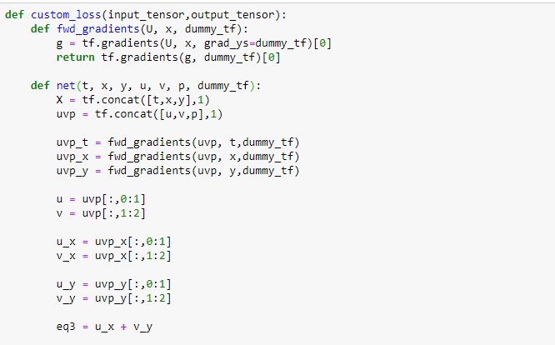

7.Future work
- Modeling the weights of loss of the model with time and space varying data with different sampling methods to find an optimum model for generating flow field from a lower resolution time and space data.
- Predicting lift and drag on a test body present in a flow field by getting Pressure distribution from Deep learning model.
- Shape optimization of a test body inside a flow field for reducing drag or increasing lift on the body.
- Shape optimization for maximizing or minimizing vortex-induced vibration of a test body present inside a flow field.

8.References
- https://www.tensorflow.org/guide
- https://keras.io/
- M. Raissi, Z. Wang, M. S. Triantafyllou and G. E. Karniadakis,2018,Deep learning of vortex-induced vibrations

