Setup JENKINS

NOTE: Install jenkins on a fresh machine

1. Install jenkins

# wget -q -O - https://jenkins-ci.org/debian/jenkins-ci.org.key | sudo apt-key add -  
# sudo sh -c 'echo deb http://pkg.jenkins-ci.org/debian binary/ > /etc/apt/sources.list.d/jenkins.list'  
# sudo apt-get update  
# sudo apt-get install jenkins

2. start the jenkins service

# service jenkins start

2. access jenkins on browser and create a new job

access the eth1 ip address of the jenkins machine from your host machine’s web browser.

url: http://192.168.56.107:8080

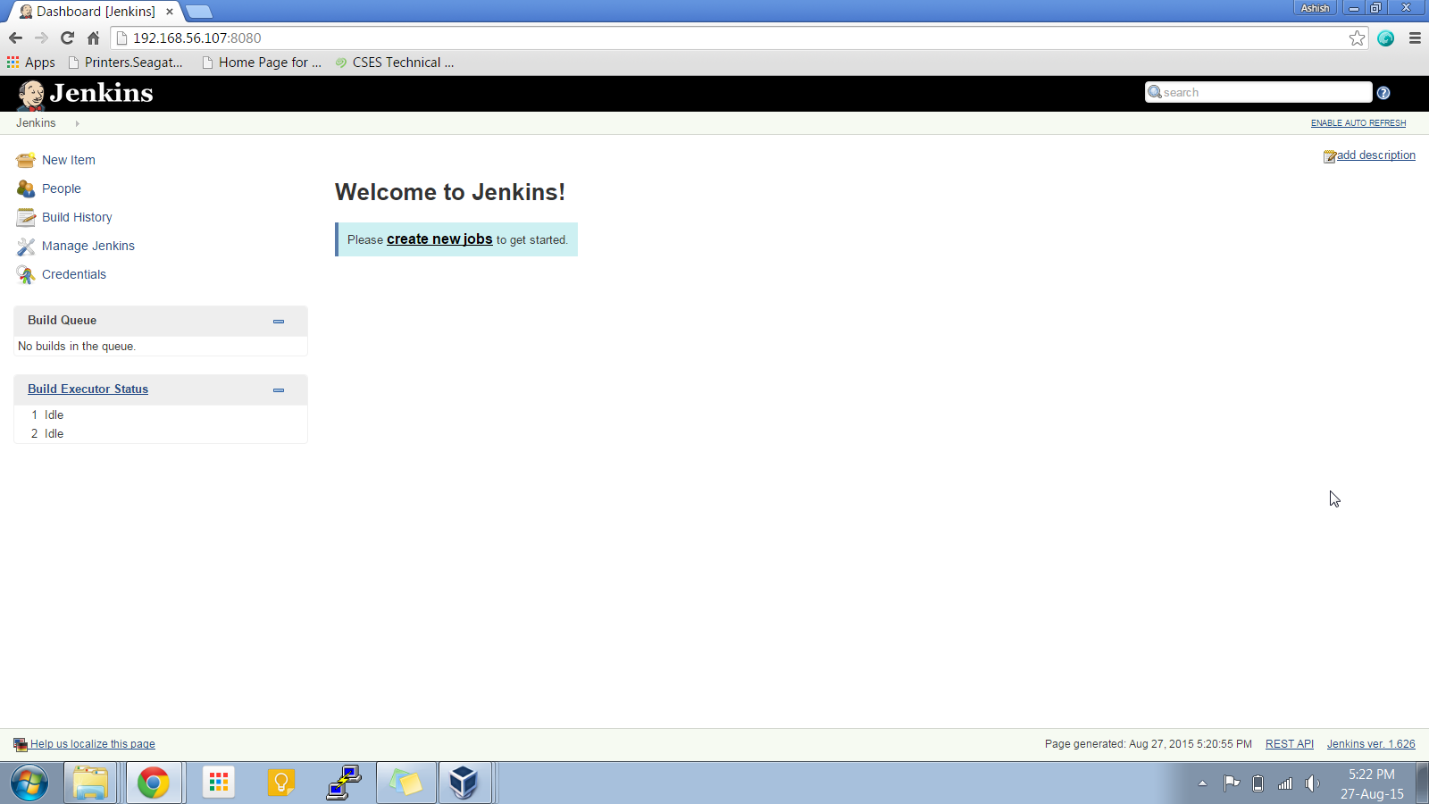

3. create a job named test_job

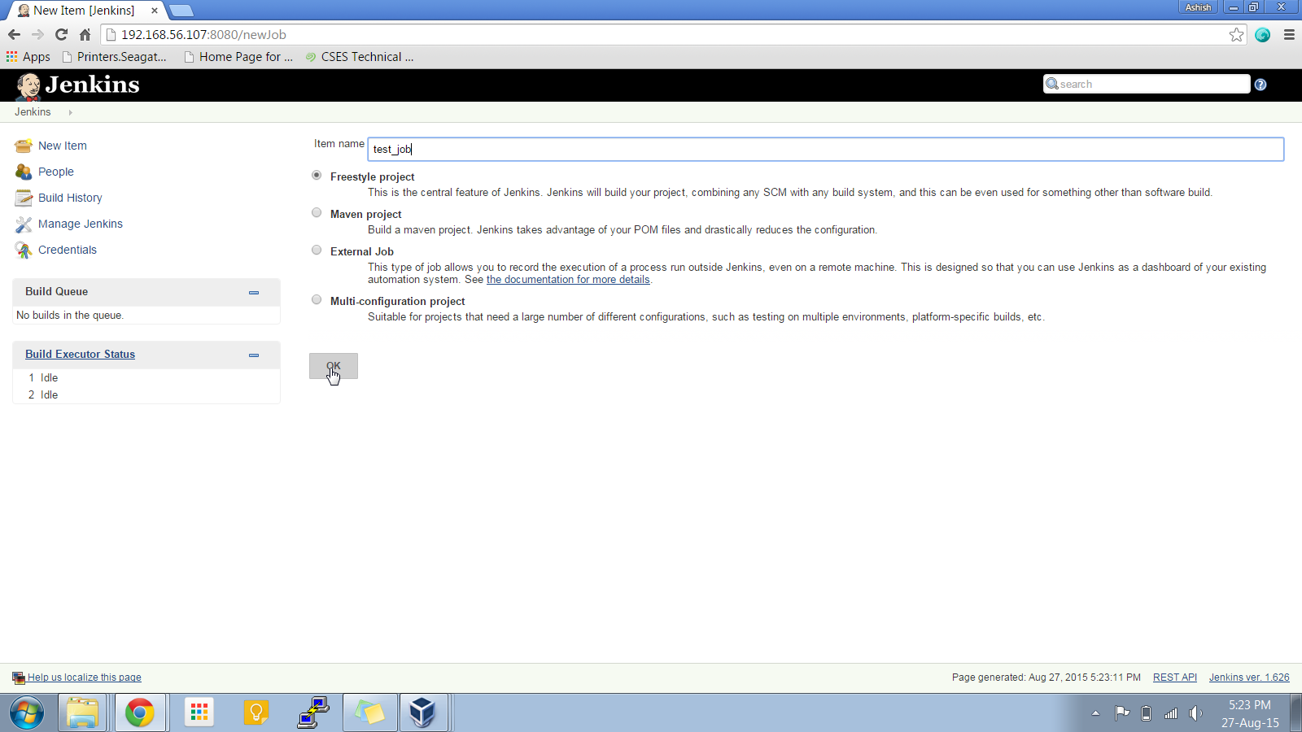

4. configure the job to echo “HELLO WORLD”

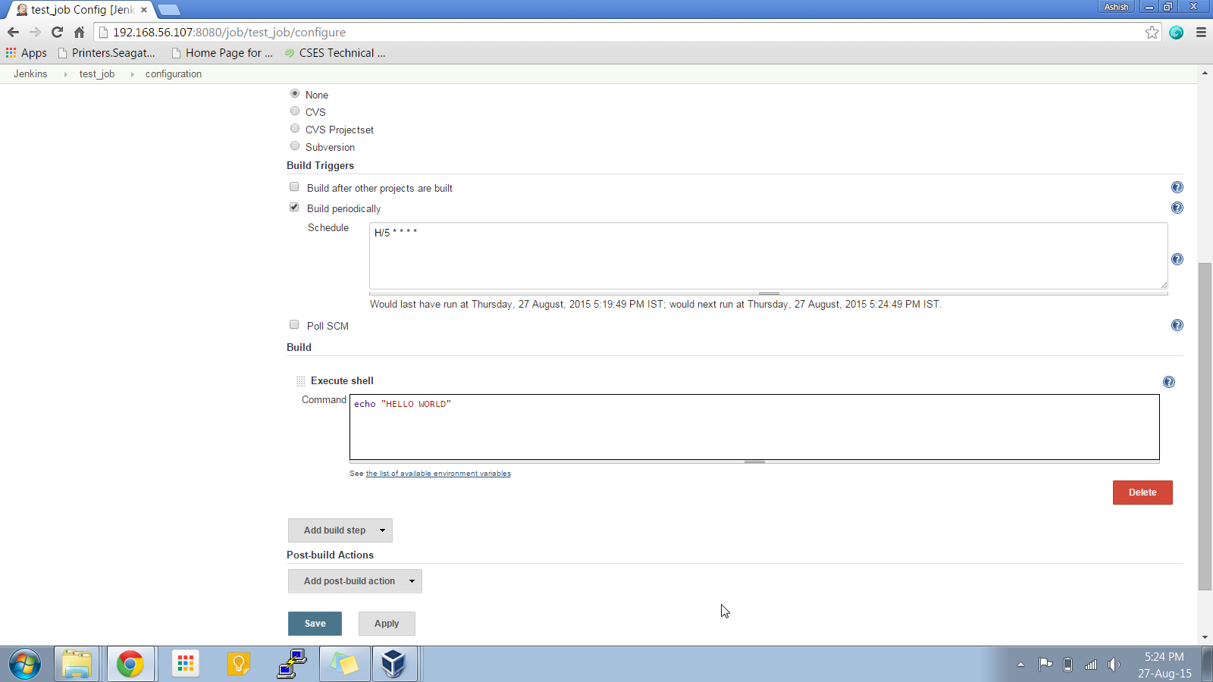

5. build the job manually first time

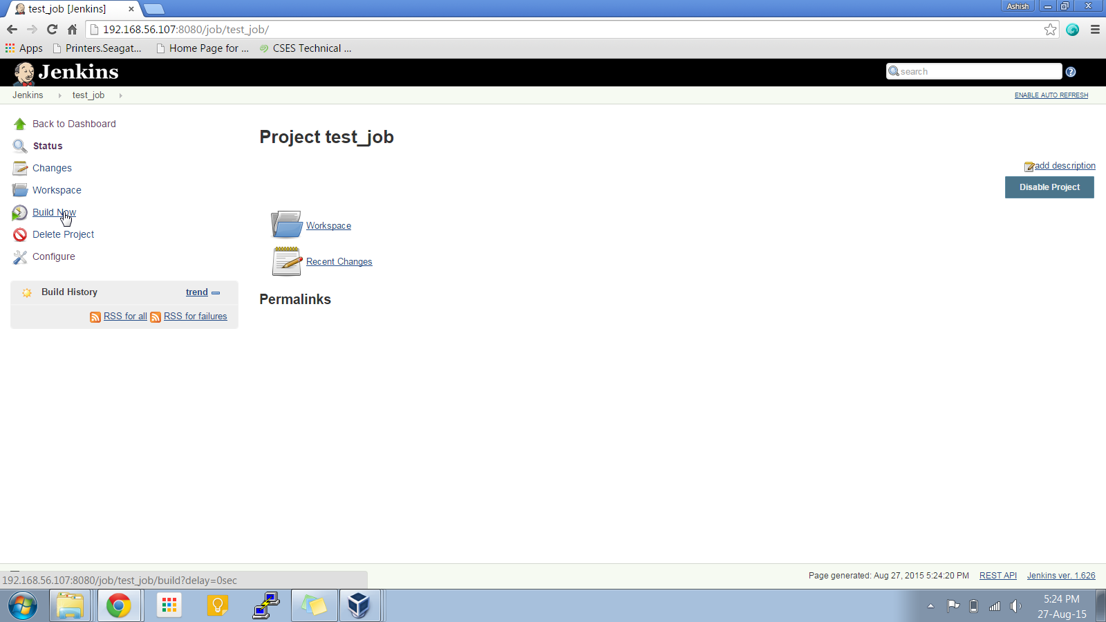

6. check the output

