Setup PXE server

1. install packages

#apt-get install apache2 tftpd-hpa inetuutils-inetd

2. Configure PXE server

edit and add the following lines to /etc/default/tftpd-hpa

[...]  
RUN_DAEMON="yes"  
OPTIONS="-l -s /var/lib/tftpboot"

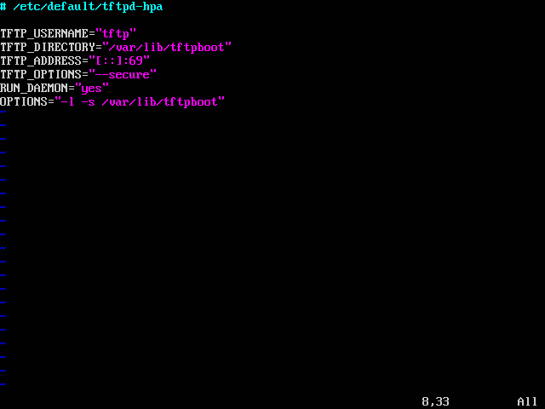

edit and add the following line to /etc/inetd.conf

tftp dgram udp wait root /usr/sbin/in.tftpd /usr/sbin/in.tftpd -s /var/lib/tftpboot

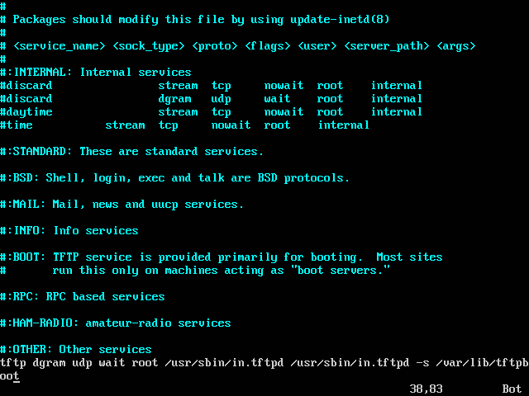

3. Restart the service

#service tftpd-hpa restart

4. Download ubuntu iso or mount one in the virtual CD drive of your VM.

http://mirrors.koehn.com/ubuntureleases/14.04.3/ubuntu-14.04.3-server-i386.iso

#mount /dev/cdrom /media/cdrom

5. copy boot files:

#cp -fr /media/cdrom/install/netboot/* /var/lib/tftpboot/

6. create a directory in apache root folder

#mkdir /var/www/html/ubuntu

7. copy installation code to ubuntu folder

#cp -fr /media/cdrom/* /var/www/html/ubuntu/

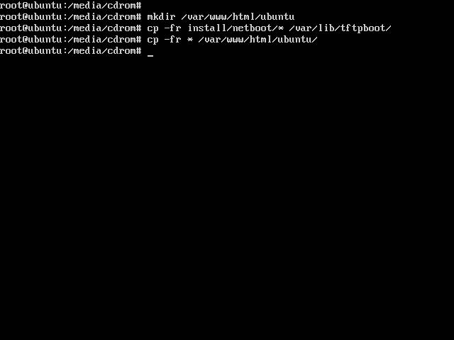

8. Edit the pxelinux.cfg/default

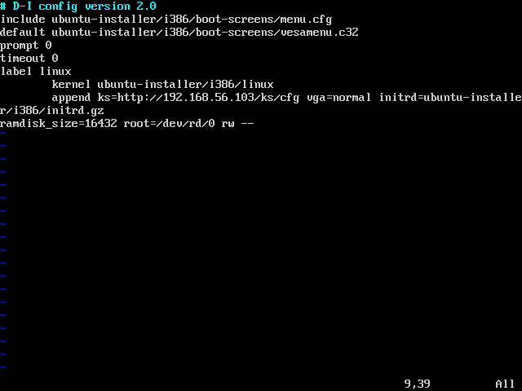

Setup DHCP server

9. Configure the DHCP server.

NOTE: use the DHCP server configured in practical # 2

edit /etc/dhcp/dhcpd.conf file and add the following lines

allow booting;  
allow bootp;  
option option-128 code 128 = string;  
option option-129 code 129 = text;  
next-server 192.168.1.101;  
filename "pxelinux.0";

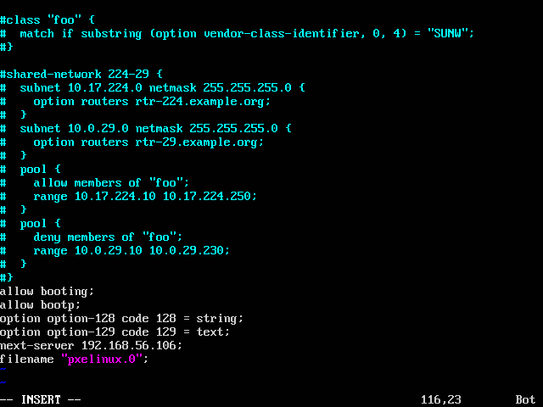

Setup fresh machine

10. Create a new machine following the steps in practical #1

NOTE: Do not install the operating system from ISO.

NOTE: Boot order should be set in system tab and network to be kept on the top. Remember to allow boot using network and make it a priority.

11. Verification: you should see the following screen on machine start up.

