ECE 50024

Homework 1

Parth Sagar Hasabnis [phasabni@purdue.edu](mailto:phasabni@purdue.edu)

## Exercise 1:

Mean of the distribution is: 0.026005414594233493.

Standard Deviation of the distribution is: 0.9907009680534483.

Optimal number of bins = 15

## Exercise 2:

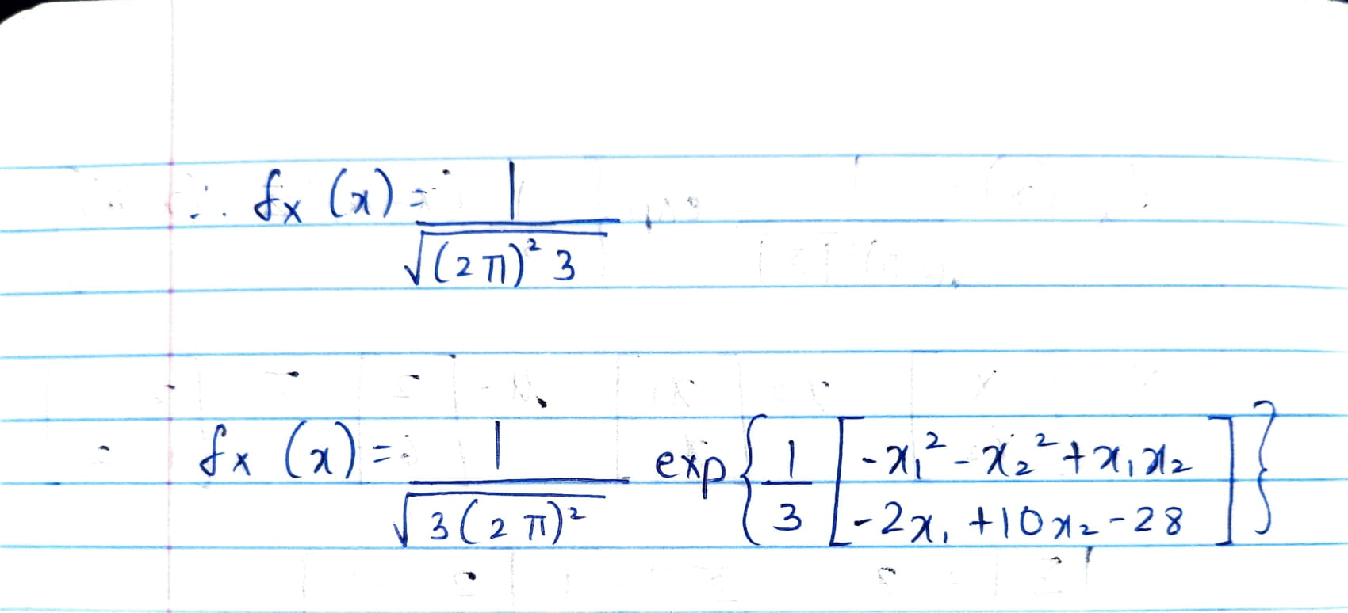

## b)

## c)

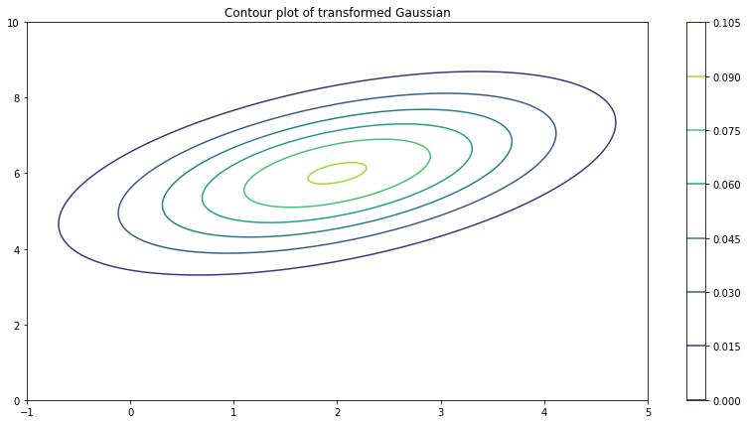

The results from parts (c)(i) and (ii) are in line with the theoritical findings. The plot of (c)(ii) represents a 2D transformed gaussian quite effectively. Similarly, the A matrix calculated from the transformed samples matches with its hand-calculated counterpart.

## Exercise 3:

## Scatter plot of data

## Least squares solution

## Presence of Outliers

Observation: The existence of outliers has severely impacted the performance of Least Square regression. The fitted curve has experienced a positive offset, and no longer is representative of the data.

## Linear Programming Problem

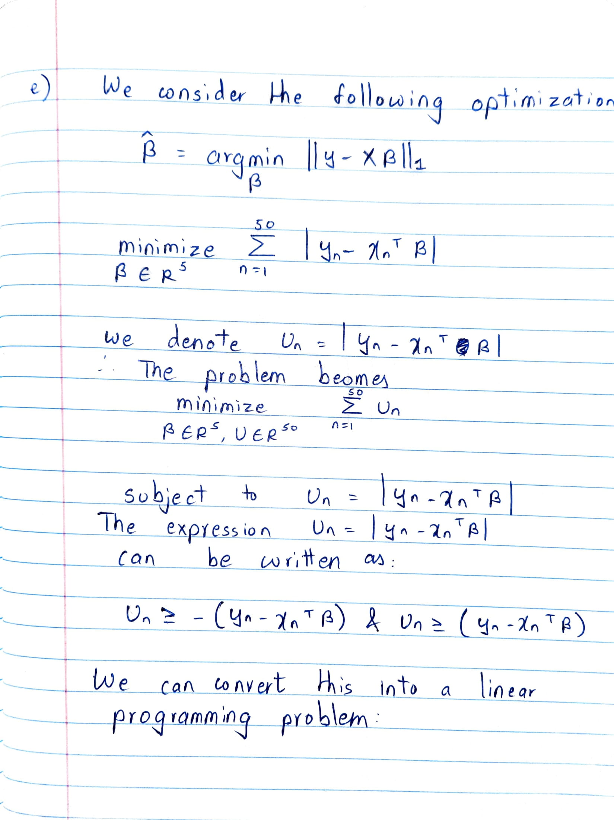

# APPENDIX