ECE 50024

Homework 6

Parth Sagar Hasabnis [phasabni@purdue.edu](mailto:phasabni@purdue.edu)

## Exercise 1:

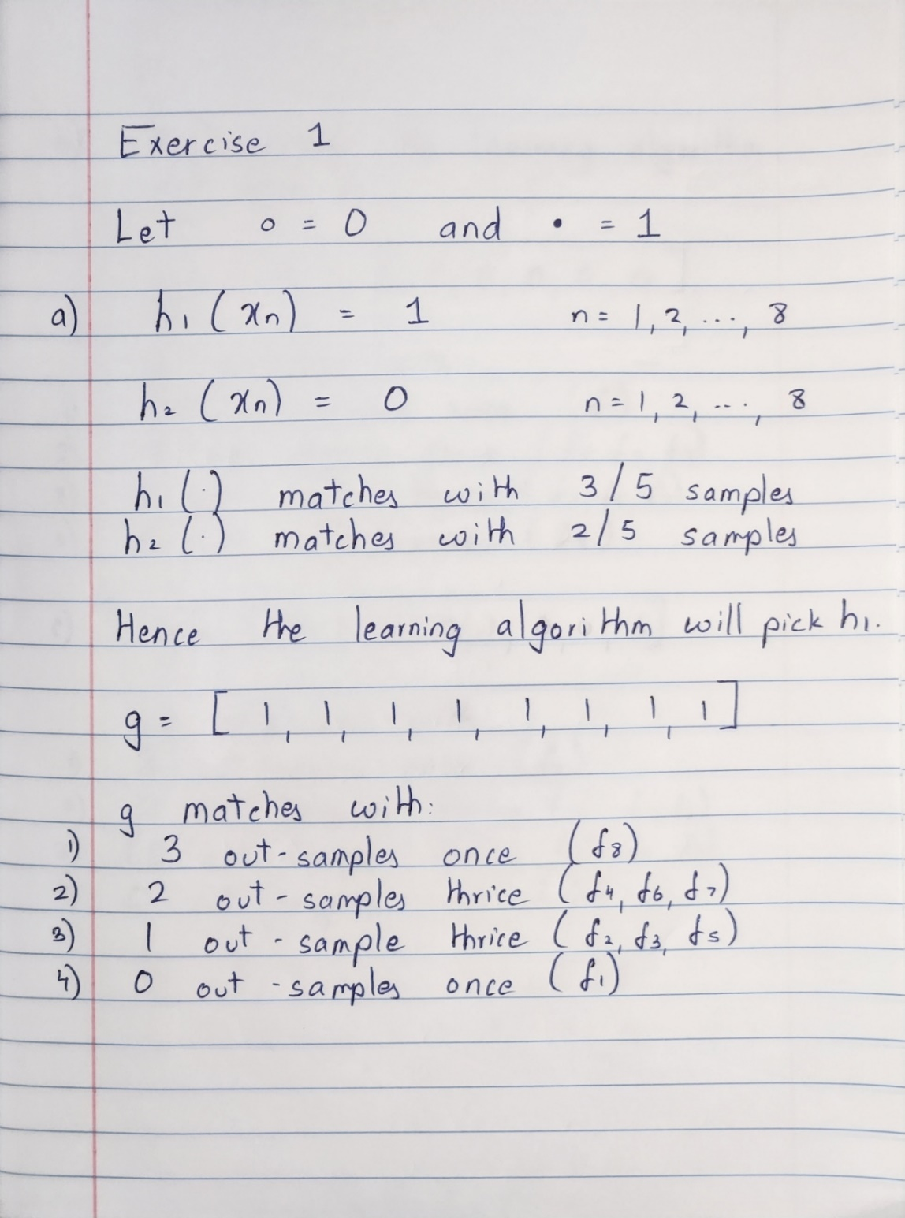

## Exercise 2:

1. As all the three coins we pick are fair coins, the probability that we get a head on each of them is same and is equal to 0.5.
$$μ_{1 }=0.5$$

$$μ_{rand}=0.5$$

$$μ_{min }=0.5$$

2. Histograms of the random variables

1. Hoeffding’s inequality for the 3 coins

Note: The curves for $V_{1}$ and $V_{rand}$ coincide.

1. The coins ${coin}_{1}$ and ${coin}_{rand}$ follow the Hoeffding bound, while ${coin}_{min}$ does not. This is because the coins ${coin}_{1}$ and ${coin}_{rand}$ are selected before we look at the data, while ${coin}_{min}$ is selected after we have the data. Hoeffding inequality is valid only if we apply it before we look at the data.

# 

# APPENDIX