**Name : Kachhadiya Parth A.**

**Semester : 7th**

**Division : A**

**Roll no : 40**

**Practical Assignment – 1**

1 . 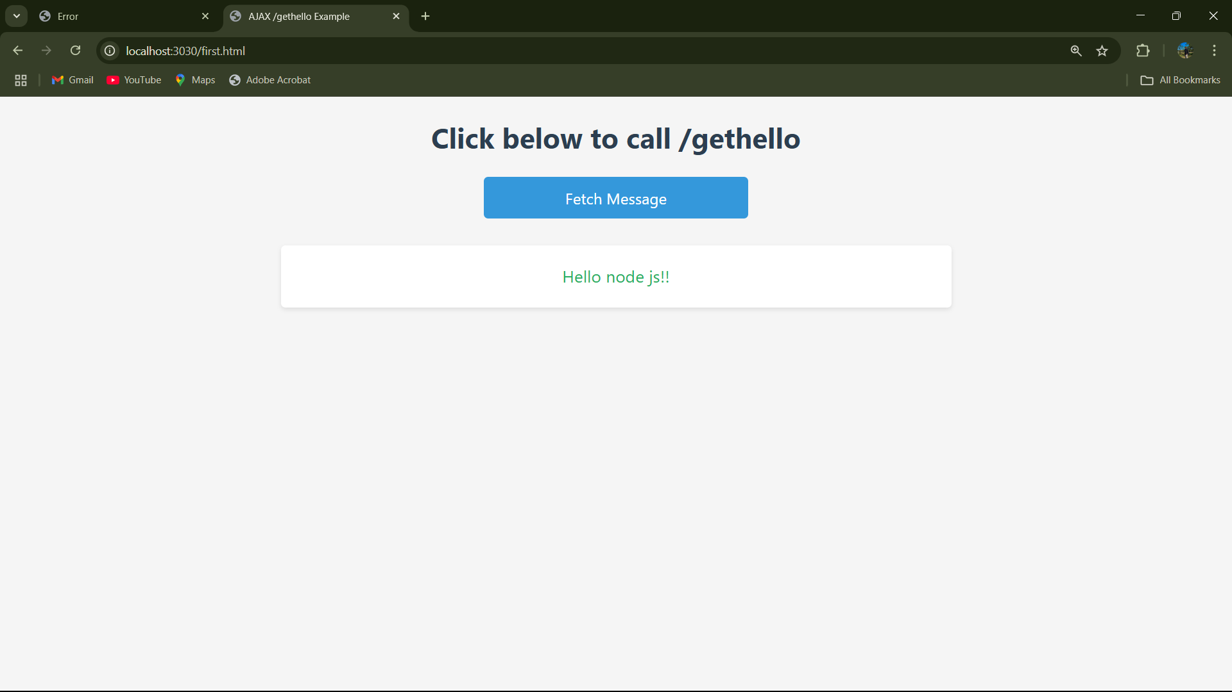

2. 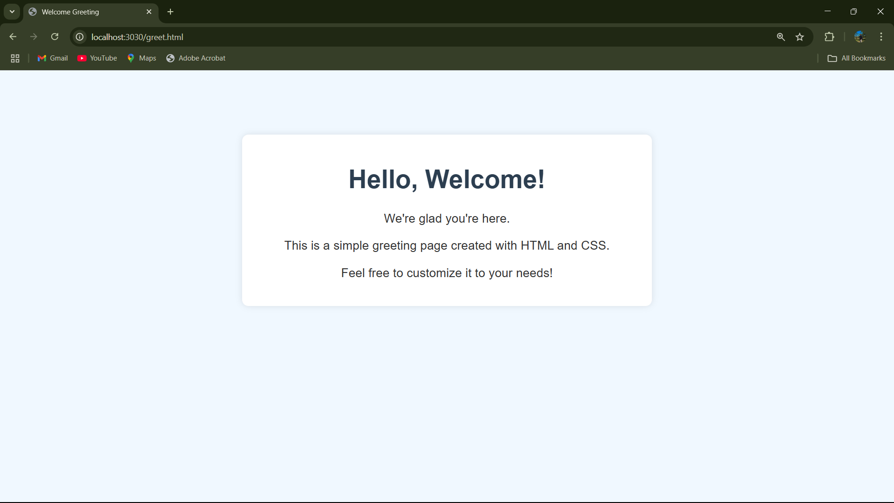

3. 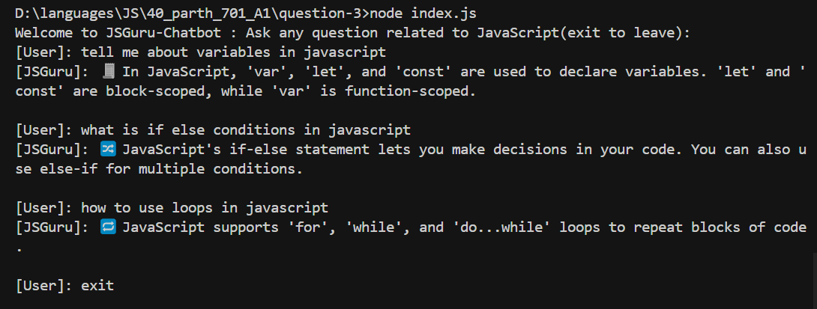

4. 

5. 

6. 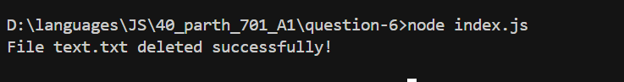

7. 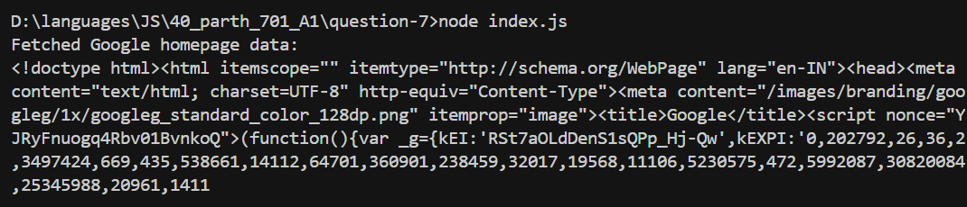

8. 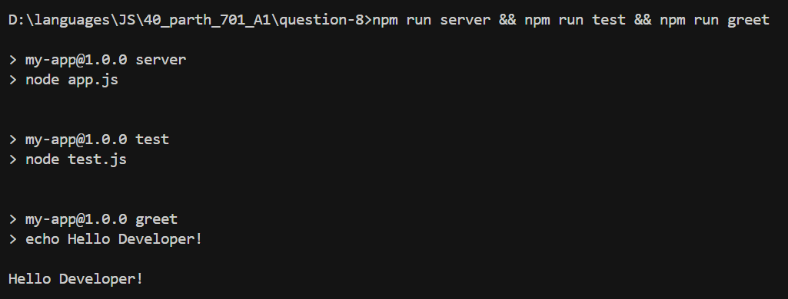

9. 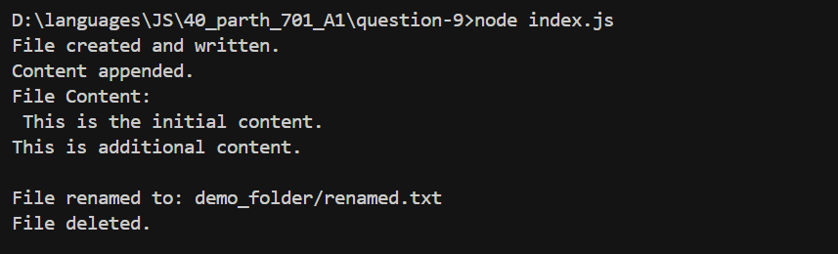

10. 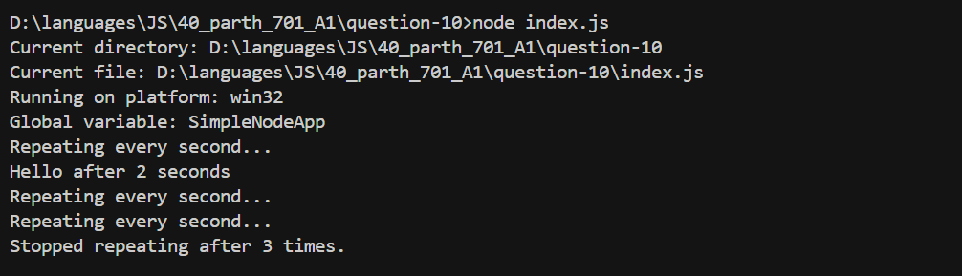

11. 