Experiment 10: MLOps Deployment of the Task-Automation Agent

Name: Parth Ladage
Roll N0: DS63 PRN: 2324001218
Course: Generative AI & Agentic AI

1. Tools and hosting platform
- Python & Streamlit: Developed the web application.
- DuckDuckGo & Groq API: Retrieved web information and generated summaries.
- Git & GitHub: Managed and stored source code.
- Docker: Containerized the application.
- GitHub Actions: Automated syntax checks and Docker builds.
- Streamlit Community Cloud: Hosted the application publicly for free.

2. Procedure followed
Step 1: Application development
Created app.py to accept a research topic, search the web, and generate a summary of exactly three bullet points.
Step 2: Docker deployment
Created a Dockerfile, built the Docker image, and ran the container locally with the Groq API key configured securely.
Step 3: GitHub repository
Uploaded the project files to GitHub and pushed changes to the main branch.
Screenshot : GitHub repository showing project files.
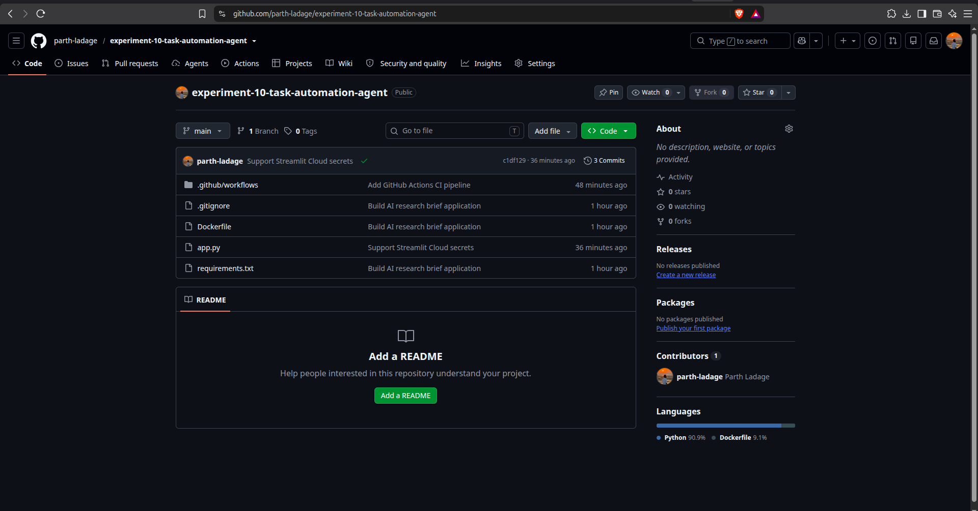
Step 4: Continuous Integration
Configured GitHub Actions to install dependencies, check Python syntax, and build the Docker image. The workflow completed successfully.
Screenshot : Successful GitHub Actions run.
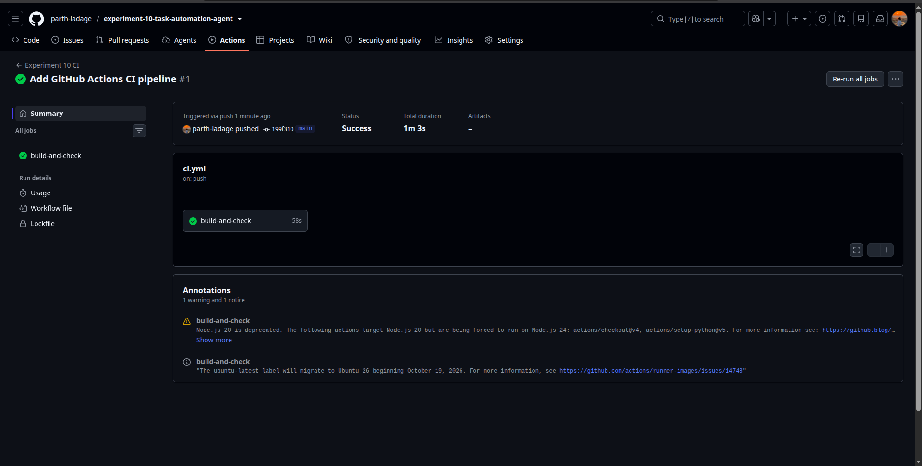
Step 5: Secrets configuration
Configured GROQ_API_KEY in the hosting platform's Secrets settings instead of exposing it in the source code.
Step 6: Cloud deployment and logging
Deployed the Streamlit application using Streamlit Community Cloud and checked its logs for execution details and errors.
Screenshot : Public application and cloud logs.
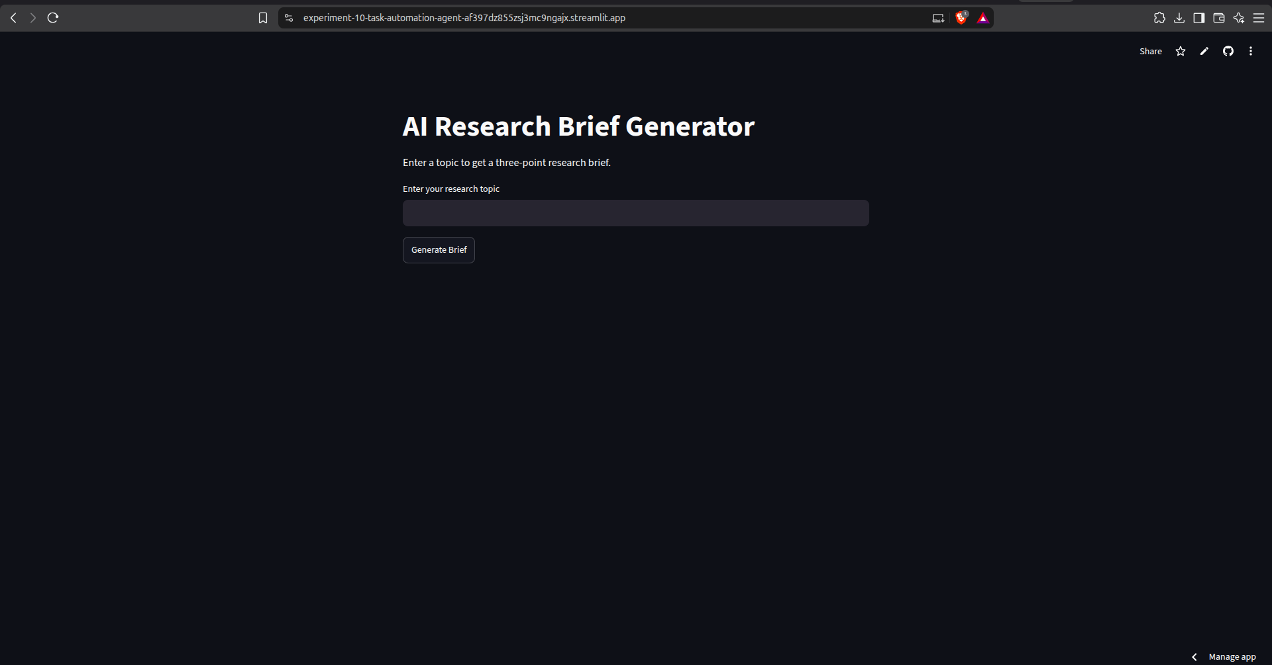
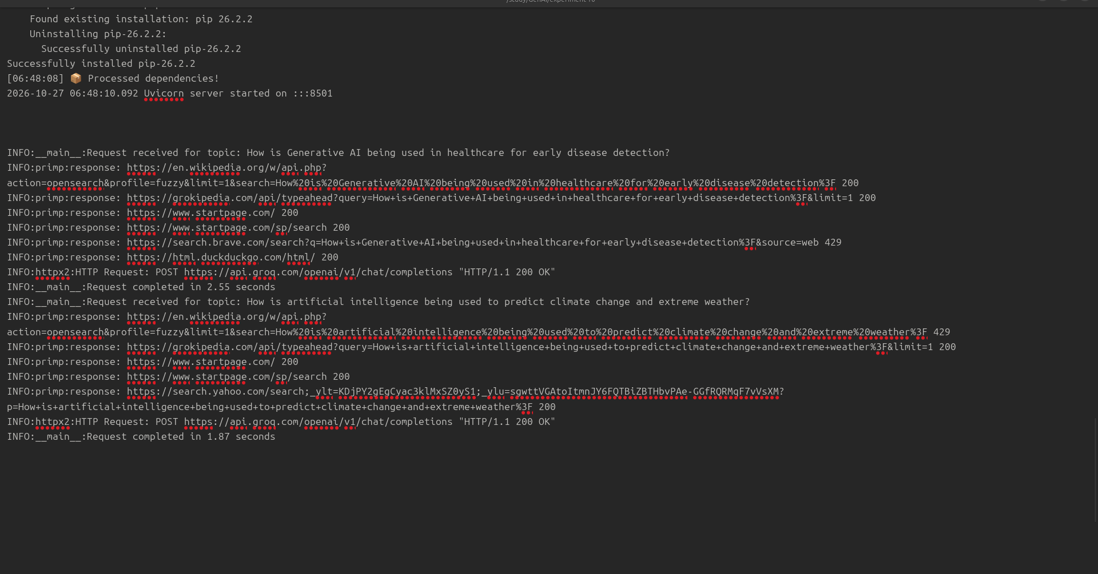

3. Pipeline diagram
Code development
↓
GitHub repository
↓
GitHub Actions: syntax check + Docker build
↓
Streamlit Community Cloud deployment
↓
Live application + logs

4. Application output
The deployed application was tested using two research topics:
- Generative AI in healthcare for early disease detection.
- AI for climate change prediction and extreme weather.
Screenshots : Generated summaries for both topics.
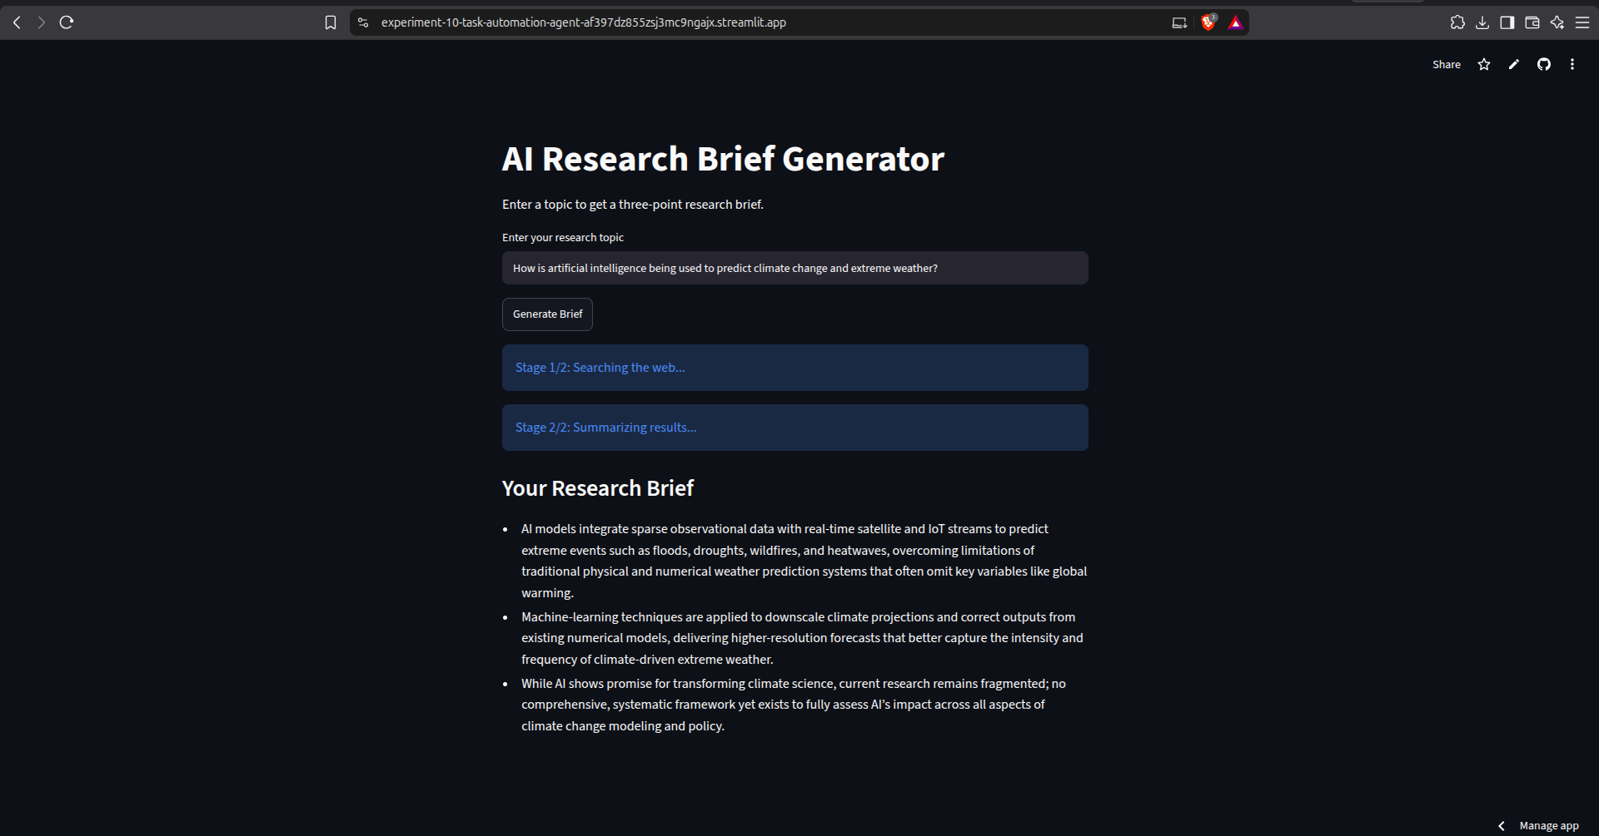
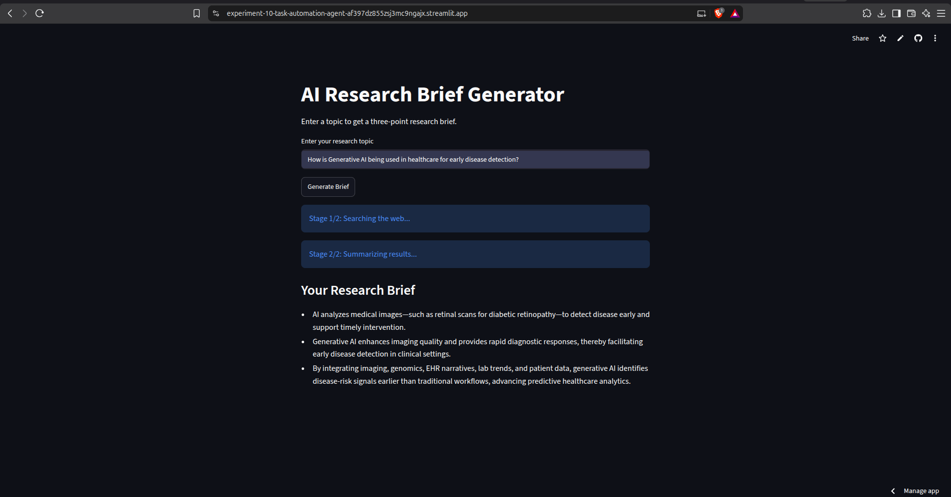

Public application link: https://experiment-10-task-automation-agent-af397dz855zsj3mc9ngajx.streamlit.app/

5. Problems faced and solutions
- Docker API key issue: The environment variable was not passed correctly through sudo. Resolved it using sudo --preserve-env=GROQ_API_KEY.
- Hosting limitation: Docker hosting on Hugging Face Spaces required a paid option. Selected Streamlit Community Cloud as a free alternative.
- API key security: Configured the key through deployment secrets instead of committing it to GitHub.

6. Conclusion
This experiment demonstrated how Docker, GitHub, and GitHub Actions improve consistency and automate application checks. Cloud hosting made the application publicly accessible, while logging helped monitor execution and troubleshoot errors. Pushing code changes to GitHub also simplified application updates compared with manual deployment.

