**Assignment-11**

**Aim:Implementation of Speech-to-Text Conversion in an Android Application.**

**.xml file code:**

<?xml version="1.0" encoding="utf-8"?>

<LinearLayout xmlns:android="http://schemas.android.com/apk/res/android"

android:layout_width="match_parent"

android:layout_height="match_parent"

xmlns:tools="http://schemas.android.com/tools"

android:id="@+id/main"

android:orientation="vertical"

android:gravity="center"

android:padding="20dp"

tools:context=".speechtext">

<TextView

android:id="@+id/tv_Speech_to_text"

android:layout_width="wrap_content"

android:layout_height="wrap_content"

android:text="Your speech will appear here"

android:textSize="18sp"

android:textStyle="bold"

android:layout_marginBottom="20dp" />

<Button

android:id="@+id/iv_mic"

android:layout_width="wrap_content"

android:layout_height="wrap_content"

android:text="Tap to Speak"

android:textSize="16sp"

android:padding="10dp"/>

</LinearLayout>

**.java file:**

package com.example.myapplication;

import android.content.Intent;

import android.os.Bundle;

import android.speech.RecognizerIntent;

import android.view.View;

import android.widget.Button;

import android.widget.TextView;

import android.widget.Toast;

import androidx.annotation.Nullable;

import androidx.appcompat.app.AppCompatActivity;

import androidx.core.graphics.Insets;

import androidx.core.view.ViewCompat;

import androidx.core.view.WindowInsetsCompat;

import java.util.ArrayList;

import java.util.Locale;

import java.util.Objects;

public class speechtext extends AppCompatActivity {

private static final int REQUEST_CODE_SPEECH_INPUT = 1;

private TextView tv_Speech_to_text;

private Button iv_mic;

@Override

protected void onCreate(Bundle savedInstanceState) {

super.onCreate(savedInstanceState);

setContentView(R.layout.activity_speechtext);

// Edge-to-Edge support

ViewCompat.setOnApplyWindowInsetsListener(findViewById(R.id.main), (v, insets) -> {

Insets systemBars = insets.getInsets(WindowInsetsCompat.Type.systemBars());

v.setPadding(systemBars.left, systemBars.top, systemBars.right, systemBars.bottom);

return insets;

});

// Initializing UI elements

iv_mic = findViewById(R.id.iv_mic);

tv_Speech_to_text = findViewById(R.id.tv_Speech_to_text);

iv_mic.setOnClickListener(new View.OnClickListener() {

@Override

public void onClick(View v) {

startSpeechToText();

}

});

}

private void startSpeechToText() {

Intent intent = new Intent(RecognizerIntent.ACTION_RECOGNIZE_SPEECH);

intent.putExtra(RecognizerIntent.EXTRA_LANGUAGE_MODEL, RecognizerIntent.LANGUAGE_MODEL_FREE_FORM);

intent.putExtra(RecognizerIntent.EXTRA_LANGUAGE, Locale.getDefault());

intent.putExtra(RecognizerIntent.EXTRA_PROMPT, "Speak to convert into text");

try {

startActivityForResult(intent, REQUEST_CODE_SPEECH_INPUT);

} catch (Exception e) {

Toast.makeText(this, "Error: " + e.getMessage(), Toast.LENGTH_SHORT).show();

}

}

@Override

protected void onActivityResult(int requestCode, int resultCode, @Nullable Intent data) {

super.onActivityResult(requestCode, resultCode, data);

if (requestCode == REQUEST_CODE_SPEECH_INPUT) {

if (resultCode == RESULT_OK && data != null) {

ArrayList<String> result = data.getStringArrayListExtra(RecognizerIntent.EXTRA_RESULTS);

tv_Speech_to_text.setText(Objects.requireNonNull(result).get(0));

}

}

}

}

**OUTPUT:**

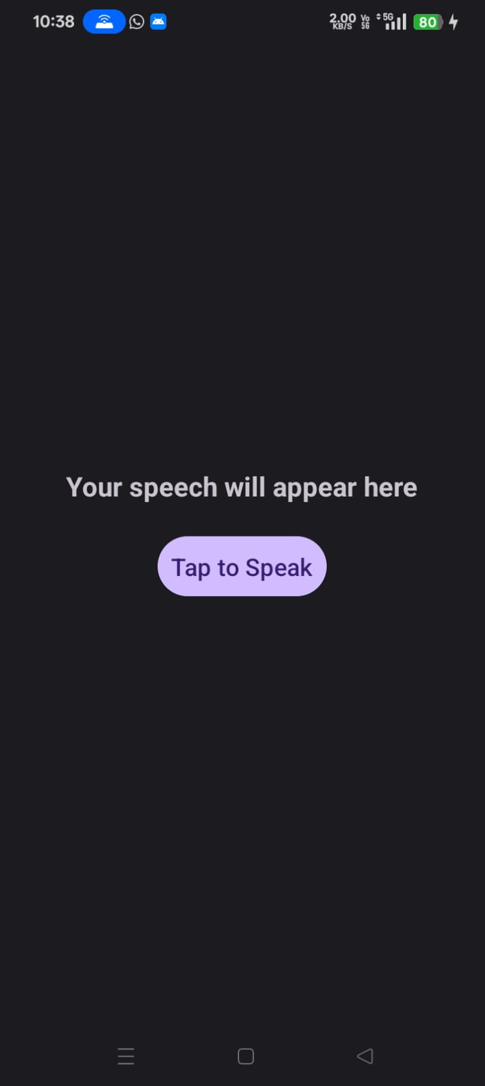

**After speech:**

