**Assignment-6**

**Aim:1.Create an android application to print a toast of all the selected values from checkbox. 2. Create an android application to Print the value of selected radio button in a toat.**

**.java file code:**

package com.example.myapplication;

import android.content.Intent;

import android.os.Bundle;

import android.view.View;

import android.widget.Button;

import androidx.appcompat.app.AppCompatActivity;

public class MainActivity extends AppCompatActivity {

Button btnCheckBox, btnRadioButton;

@Override

protected void onCreate(Bundle savedInstanceState) {

super.onCreate(savedInstanceState);

setContentView(R.layout.activity_main);

// Initialize Buttons

btnCheckBox = findViewById(R.id.button);

btnRadioButton = findViewById(R.id.button2);

// Navigate to CheckBox Activity

btnCheckBox.setOnClickListener(new View.OnClickListener() {

@Override

public void onClick(View v) {

Intent intent = new Intent(MainActivity.this, checkbox.class);

startActivity(intent);

}

});

// Navigate to RadioButton Activity

btnRadioButton.setOnClickListener(new View.OnClickListener() {

@Override

public void onClick(View v) {

Intent intent = new Intent(MainActivity.this, radiobtn.class);

startActivity(intent);

}

});

}

}

**.xml file code:**

<?xml version="1.0" encoding="utf-8"?>

<LinearLayout xmlns:android="http://schemas.android.com/apk/res/android"

xmlns:app="http://schemas.android.com/apk/res-auto"

xmlns:tools="http://schemas.android.com/tools"

android:id="@+id/main"

android:layout_width="match_parent"

android:layout_height="match_parent"

android:orientation="vertical"

android:gravity="center"

tools:context=".checkRadio">

<Button

android:id="@+id/button"

android:layout_width="150dp"

android:layout_height="wrap_content"

android:text="CheckBox" />

<Button

android:id="@+id/button2"

android:layout_width="150dp"

android:layout_height="wrap_content"

android:text="RadioButton"

android:layout_marginTop="5dp"/>

</LinearLayout>

**OUTPUT:**

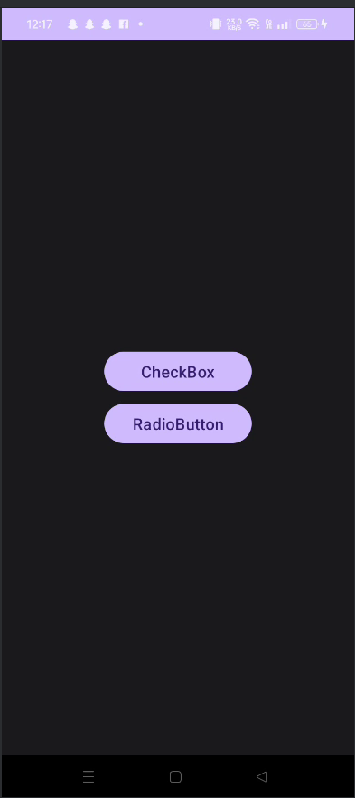

**checkbox.java:**

package com.example.myapplication;

import android.os.Bundle;

import android.view.View;

import android.widget.Button;

import android.widget.CheckBox;

import android.widget.Toast;

import androidx.activity.EdgeToEdge;

import androidx.appcompat.app.AppCompatActivity;

import androidx.core.graphics.Insets;

import androidx.core.view.ViewCompat;

import androidx.core.view.WindowInsetsCompat;

public class checkbox extends AppCompatActivity {

CheckBox ch, ch1, ch2,ch3;

Button btn;

@Override

protected void onCreate(Bundle savedInstanceState) {

super.onCreate(savedInstanceState);

EdgeToEdge.enable(this);

setContentView(R.layout.activity_checkbox);

//Finding checkbox by its unique ID

ch=(CheckBox)findViewById(R.id.checkBox);

ch1=(CheckBox)findViewById(R.id.checkBox2);

ch2=(CheckBox)findViewById(R.id.checkBox3);

ch3=(CheckBox)findViewById(R.id.checkBox4);

btn = findViewById(R.id.button3);

btn.setOnClickListener(new View.OnClickListener() {

@Override

public void onClick(View v) {

String msg="";

if(ch.isChecked())

msg = msg + "Printing ";

if(ch1.isChecked())

msg = msg + "Reading ";

if(ch2.isChecked())

msg = msg + "Writing ";

if(ch3.isChecked())

msg = msg + "Eating ";

Toast.makeText(checkbox.this, msg + " are Selected",Toast.LENGTH_LONG).show();

}

});

}

}

**activity_checkbox.xml:**

<?xml version="1.0" encoding="utf-8"?>

<LinearLayout xmlns:android="http://schemas.android.com/apk/res/android"

xmlns:app="http://schemas.android.com/apk/res-auto"

xmlns:tools="http://schemas.android.com/tools"

android:id="@+id/main"

android:layout_width="match_parent"

android:layout_height="match_parent"

android:orientation="vertical"

android:gravity="start"

tools:context=".checkbox">

<EditText

android:id="@+id/editTextText"

android:layout_width="match_parent"

android:layout_height="wrap_content"

android:inputType="text"

android:layout_marginTop="50dp"

android:textSize="25dp"

android:text="Choose Your Activity:" />

<CheckBox

android:id="@+id/checkBox"

android:layout_width="wrap_content"

android:layout_height="wrap_content"

android:textSize="20dp"

android:text="Printing" />

<CheckBox

android:id="@+id/checkBox2"

android:layout_width="wrap_content"

android:layout_height="wrap_content"

android:textSize="20dp"

android:text="Reading" />

<CheckBox

android:id="@+id/checkBox3"

android:layout_width="match_parent"

android:layout_height="wrap_content"

android:textSize="20dp"

android:text="Writing" />

<CheckBox

android:id="@+id/checkBox4"

android:layout_width="match_parent"

android:layout_height="wrap_content"

android:textSize="20dp"

android:text="Eating" />

<Button

android:id="@+id/button3"

android:layout_width="match_parent"

android:layout_height="wrap_content"

android:layout_marginTop="20dp"

android:textSize="20dp"

android:text="Submit" />

</LinearLayout>

**OUTPUT:**

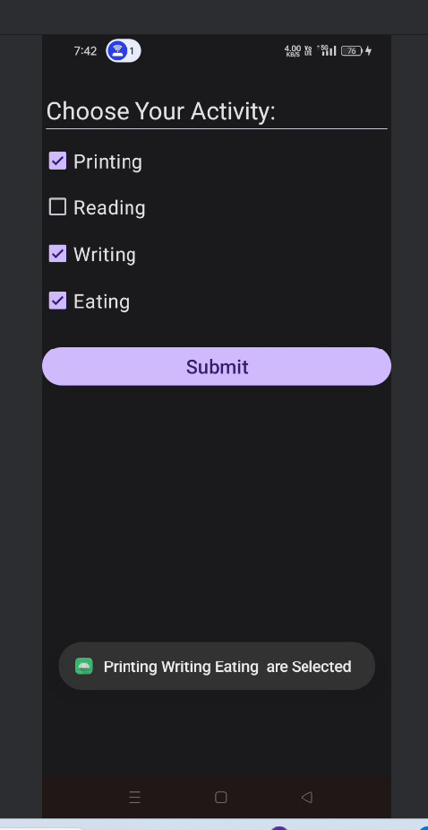

**radiobtn.java:**

package com.example.myapplication;

import android.annotation.SuppressLint;

import android.os.Bundle;

import android.view.View;

import android.widget.Button;

import android.widget.RadioButton;

import android.widget.Toast;

import androidx.appcompat.app.AppCompatActivity;

import com.example.myapplication.R;

public class radiobtn extends AppCompatActivity {

private RadioButton johnCena, randyOrton, goldberg, romanReigns, sheamus;

private Button submit;

@SuppressLint("MissingInflatedId")

@Override

protected void onCreate(Bundle savedInstanceState) {

super.onCreate(savedInstanceState);

setContentView(R.layout.activity_radiobtn);

// Initialize UI elements

johnCena =(RadioButton) findViewById(R.id.johnCena);

randyOrton =(RadioButton) findViewById(R.id.randyOrton);

goldberg =(RadioButton) findViewById(R.id.goldBerg);

romanReigns =(RadioButton) findViewById(R.id.romanReigns);

sheamus = (RadioButton)findViewById(R.id.sheamus);

submit = (Button) findViewById(R.id.button);

// Set up button click listener

submit.setOnClickListener(new View.OnClickListener() {

@Override

public void onClick(View v) {

String selectedSuperStar = "";

if (randyOrton.isChecked()) {

selectedSuperStar = randyOrton.getText().toString();

} else if (sheamus.isChecked()) {

selectedSuperStar = sheamus.getText().toString();

} else if (johnCena.isChecked()) {

selectedSuperStar = johnCena.getText().toString();

} else if (romanReigns.isChecked()) {

selectedSuperStar = romanReigns.getText().toString();

} else if (goldberg.isChecked()) {

selectedSuperStar = goldberg.getText().toString();

}

Toast.makeText(getApplicationContext(), selectedSuperStar + " is selected" ,Toast.LENGTH_LONG).show();

}

});

}

}

**activity_radiobtn.xml:**

<?xml version="1.0" encoding="utf-8"?>

<LinearLayout xmlns:android="http://schemas.android.com/apk/res/android"

xmlns:app="http://schemas.android.com/apk/res-auto"

xmlns:tools="http://schemas.android.com/tools"

android:id="@+id/main"

android:layout_width="match_parent"

android:layout_height="match_parent"

android:orientation="vertical"

tools:context=".radiobtn">

<EditText

android:id="@+id/editTextText"

android:layout_width="match_parent"

android:layout_height="wrap_content"

android:layout_marginTop="50dp"

android:inputType="text"

android:text="Choose Your Activity:"

android:textSize="25dp" />

<RadioButton

android:id="@+id/johnCena"

android:layout_width="match_parent"

android:layout_height="wrap_content"

android:text="John cena" />

<RadioButton

android:id="@+id/randyOrton"

android:layout_width="match_parent"

android:layout_height="wrap_content"

android:text="Randy Orton" />

<RadioButton

android:id="@+id/romanReigns"

android:layout_width="match_parent"

android:layout_height="wrap_content"

android:text="Roman Reigns" />

<RadioButton

android:id="@+id/goldBerg"

android:layout_width="match_parent"

android:layout_height="wrap_content"

android:text="Gold Berg" />

<RadioButton

android:id="@+id/sheamus"

android:layout_width="match_parent"

android:layout_height="wrap_content"

android:text="Sheamus" />

<Button

android:id="@+id/button"

android:layout_width="match_parent"

android:layout_height="wrap_content"

android:layout_marginTop="20dp"

android:textSize="20dp"

android:text="Submit" />

</LinearLayout>

**OUTPUT:**

