Homework 1

Due date: Sunday, 2/6/2022 by 11:59pm

Instructions:
- For each day of late submission, 10 points will be deducted.
- After two days, no more submission is allowed.
- You must submit through Canvas.
- Keep this file intact, copy your solution codes from your IDE and paste at the bottom of the file under ‘Answer’. Submit this word document with your codes. Do not change the format of the file to pdf or .rar or anything else.

Reminder: Academic Integrity policy is strictly implemented for all your submissions.

If any two submissions are similar, both will be graded zero and there will be further consequences.

Learning Objective:
- Discuss how inheritance derives new classes from existing ones.
- Classify various visibility scenarios and review method overriding process.

Write a Java program to display various courses of Computer Science department at NJIT.
Name the class ComputerScience.java - 2 points

It should contain instance data that represents the course ID, credits, course name and the semester when the course is offered. - 16 points

Define the constructor to accept and initialize all instance data. - 20 points

Include getter and setter methods for all instance data. - 20 points

Include a toString method that returns a one line description, must be full and meaningful description of the course. - 10 points

Write a driver class called ComputerScienceTest.java - 2 points
The main method instantiates three Computer Science courses. – 16 points.
Show the use of one getter method and one setter method. - 4 points.

Print all three courses using toString. - 10 points.

Your solutions will be in two files. Copy and paste as instructed below:

Answer:

ComputerScience.java:
package parthexplore;

public class ComputerScience {
// Name the class ComputerScience.java

//instance data that represents
String course_id;
String course_name;
int course_credits;
String course_semester;

//the constructor to accept and initialize all instance data

public ComputerScience(String ecourse_id, String ecourse_name, int ecourse_credits, String ecourse_semester) {

course_id = ecourse_id;
course_name = ecourse_name;
course_credits=ecourse_credits;
course_semester=ecourse_semester;
}

// getter and setter methods for all instance data

public void setCourse_id(String value) {

this.course_id= value;
}

public void setCourse_name(String value) {

this.course_name= value;
}

public void setCourse_credits(int value) {

this.course_credits= value;
}

public void setCourse_semester(String value) {
this.course_semester =value;

}

public String getCourse_id() {
return course_id;

}

public String getcourse_name() {
return course_name;

}
public int getCourse_credits() {
return course_credits;

}
public String getCourse_semester() {
return course_semester;
}
//a toString method that returns a one line description

public String toString() {
String result = "Course Id: " + course_id + " Course Name: " + course_name + " Course Credits: " + course_credits + " ,Course Semester: " + course_semester;
return result;
}

}

ComputerScienceTest.java:

package parthexplore;

public class ComputerScienceTest {
// driver class called ComputerScienceTest.java and instantiate three courses of computer science

public static void main(String[]args) {

ComputerScience course1 = new ComputerScience( "CS 280, " ,"Programming Language Concepts, " ,3 , "Spring " );
ComputerScience course2 = new ComputerScience( "CS 602, " ,"Java Programming, " ,3 , "Spring " );
ComputerScience course3 = new ComputerScience( "CS 610, " ,"Data Structures and Algorithms, " ,3 , "Spring " );

//Use of setter and getter method in driver class and printing
course1.setCourse_semester("Spring and Summer");

//Print all three courses using toString

System.out.println("Description of three Computer Science courses are as: ");
System.out.println(course1);
System.out.println(course2);
System.out.println(course3);
System.out.println();
System.out.println( "NOTE:- The Course ID 'CS 280' will be offered in two semester: " + course1.getCourse_semester());
}
}
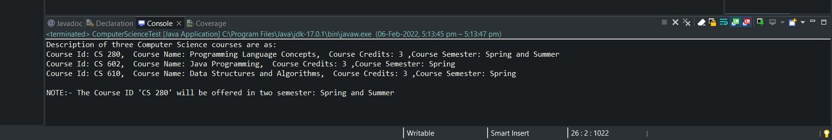
// Screenshot of console

