A project report on

# Smart AI Polymorphic System

### by

**Parth Shah (202202100410014)**

**Harpreet Singh Lohia (202202100410012)**

**Paramjeet Singh Lohia (202202100410040)**

**Prince Unadkat (202202100410053)**

in Partial Fulfilment of the Requirements for the Degree of

### Diploma

in

### Computer Engineering

at

**UKA TARSADIA UNIVERSITY**

### Under the guidance of Mr. Sandip Patel



#### Department of Diploma CE

**Chhotubhai Gopalbhai Patel Institute of Technology Bardoli, Surat**

#### May-2025

This is to certify that the project report entitled “**Smart AI Polymorphic System**” has been carried out by **Parth Shah(202202100410014)**, **Prince unadkat (202202100410053),**  **Harpreet Singh Lohia(202202100410012), Paramjeet Singh Lohia (202202100410040)** at **Chhotubhai Gopalbhai Patel Institute of Technology** for the partial fulfillment of Diploma in Computer Engineering degree to be awarded by **Uka Tarsadia University**.

#### Date:

**Place:** Bardoli, Surat

Mr. Sandip Patel Dr. Vibha Patel Prof. B. M. Vadher

Guide, Head, Director,

Department of CE , Diploma Studies , CGPIT

CGPIT CGPIT Uka Tardsadia University

Examiner’s Signature

ii

We have put effort into this project. However, it would not have been possible. without the kind support and help of many individuals. We would like to extend our sincere thanks to all of them.

We are highly indebted to **Mr. Sandip Patel** for his guidance and constant supervi- sion, as well as for providing necessary information regarding the project work.

We would like to express our gratitude towards our parents and members of our family for their kind cooperation and encouragement, which helped us in the completion of this project. Our thanks and appreciation also go to people who have willingly helped us out with their abilities.

#### Parth Shah

#### Harpreet Singh Lohia

#### Paramjeet Singh Lohia

#### Prince Unadkat

iii

*Smart AI Polymorphic System is an advanced solution designed to streamline and optimize waste collection and management processes in urban areas. The system incorporates key features such as real-time monitoring of waste levels in bins, automated notifications for waste collection, and dynamic route optimization for waste collection vehicles. Using IoT-enabled sensors, the system detects the fill level of bins, helping to prevent overflow and ensuring timely pickups.*

*In addition to these core functions, Smart Waste Management System provides data analytics and reporting capabilities, allowing municipalities to analyze waste patterns and make informed decisions for sustainability initiatives. The system also offers user-friendly dashboards for waste collectors and administrators to monitor operations efficiently. With a focus on reducing operational costs, enhancing cleanliness, and promoting environmental responsibility, Smart Waste Management System delivers a comprehensive, scalable solution for modern cities.*

iv

|  |  |
| --- | --- |
| **CERTIFICATE** | **ii** |
| **ACKNOWLEDGEMENT** | **iii** |
| **ABSTRACT** | **iv** |
| **LIST OF TABLES** | **vii** |
| **LIST OF FIGURES** | **viii** |
| **LIST OF ABBREVIATIONS** | **ix** |
| **1 Introduction** | **1** |
| 1.1 Introduction : . . . . . . . . . . . . . . . . . . . . . . . . . . . . . . . . | 1 |
| 1.2 Motivation : . . . . . . . . . . . . . . . . . . . . . . . . . . . . . . . . . | 1 |
| 1.3 Objective : . . . . . . . . . . . . . . . . . . . . . . . . . . . . . . . . . . | 1 |
| 1.4 OverView : . . . . . . . . . . . . . . . . . . . . . . . . . . . . . . . . . | 1 |
| **2 System Planning** | **3** |
| 2.1 Project development approach . . . . . . . . . . . . . . . . . . . . . . . | 3 |
| 2.2 System Modules . . . . . . . . . . . . . . . . . . . . . . . . . . . . . . . | 3 |
| 2.2.1 User . . . . . . . . . . . . . . . . . . . . . . . . . . . . . . . . . | 3 |
| 2.2.2 Database . . . . . . . . . . . . . . . . . . . . . . . . . . . . . . | 3 |
| 2.3 Functional Requirements . . . . . . . . . . . . . . . . . . . . . . . . . . | 4 |
| 2.4 Non-Functional Requirements . . . . . . . . . . . . . . . . . . . . . . . | 5 |
| 2.4.1 Performance . . . . . . . . . . . . . . . . . . . . . . . . . . . . . | 5 |
| 2.4.2 Security . . . . . . . . . . . . . . . . . . . . . . . . . . . . . . . | 5 |
| 2.4.3 Usability . . . . . . . . . . . . . . . . . . . . . . . . . . . . . . . | 5 |
| 2.4.4 Compatibility . . . . . . . . . . . . . . . . . . . . . . . . . . . . | 5 |

v

2.5 Hardware and Software Requirements . . . . . . . . . . . . . . . . . . . 5 2.5.1 Hardware Requirements: . . . . . . . . . . . . . . . . . . . . . . 5 2.5.2 Software Requirements: . . . . . . . . . . . . . . . . . . . . . . . 6

1. System Design 7

3.1 ER Diagram . . . . . . . . . . . . . . . . . . . . . . . . . . . . . . . . . 7

3.2 Class Diagram . . . . . . . . . . . . . . . . . . . . . . . . . . . . . . . . 8

3.3 Sequence Diagram . . . . . . . . . . . . . . . . . . . . . . . . . . . . . 9

* 1. Use Case Diagram 10
  2. Activity Diagram 11
  3. Data Flow Diagram 12
  4. Database Schema Diagram 13

1. Implementation, Languages and Wireframes 14
   1. Languages/Platform used for development : 14
      1. Frontend Languages : 14
      2. Backend Languages : 14
      3. Platform : 14
   2. Wireframes 15
   3. Implementation : 17
      1. Registration page 17
      2. Login page 17
      3. Color penal or user profile 18
      4. Chat page 18
2. Future Works 19
3. Conclusion 20

vi

vii

**LIST OF FIGURES**

3.1 Entity-Relationship Diagram . . . . . . . . . . . . . . . . . . . . . . . 7 ( 3.1) Class Diagram . . . . . . . . . . . . . . . . . . . . . . . . . . . . . . . . 8( 3.2) Sequence Diagram . . . . . . . . . . . . . . . . . . . . . . . . . . . . . 9 ( 3.3) Use Case Diagram. . . . . . . . . . . . . . . . . . . . . . . . . . . . . . . . .10 ( 3 . 4 )

* 1. Activity Diagram. . . . . . . . . . . . . . . . . . . . . . . . . . . . . . . . .11(3.5)
  2. Data Flow Diagram. . . . . . . . . . . . . . . . . . . . . . . . . . . . . . . 12(3.6)
  3. Database Schema Diagram. . . . . . . . . . . . . . . . . . . . . . . . . . .13(3.7)
  4. Wire Frame - org.Home 15
  5. Wire Frame - Controls 15
  6. Wire Frame - Location and details 16
  7. Wire Frame - Private.Home 16
  8. Implementation - Components 17
  9. Implementation - Firebase 17
  10. Implementation - Control Dashboard 18
  11. Implementation - Model 18

viii

IOT Internet of Things.

GPS Global Positioning System.

Automation Route Adjustment.

Real-Time Monitoring Database Dashboard.

Mobile App Control Dashboard.

ix

# Introduction

## Introduction :

The benefits of using a Smart Waste Management System include improving waste collection efficiency, reducing operational costs, and promoting environmental sustainability. The system enables real-time monitoring of waste levels in bins, allowing for timely waste collection and minimizing overflow issues. It also helps optimize collection routes, saving fuel and reducing carbon emissions.

The project focuses on smart bin monitoring and optimized waste collection. The system automatically tracks bin fill levels and sends alerts when they are ready to be emptied, just like other smart waste management solutions. It also provides a platform to share analytics and reports, making it easier for municipalities to collaborate on improving waste management efforts.

## Motivation :

Sometimes data and sensor issues can’t be maintained in waste management systems..

## Objective :

A Smart Waste Management System aims to facilitate real-time waste monitoring for residential, commercial, or municipal use, promoting efficient and sustainable waste management for cities.

## OverView :

The Smart Waste Management System represents an exciting evolution in the field of urban development, aimed at reshaping the way we approach waste management. the system offers a dynamic and comprehensive platform where a diverse range of essential functionalities are seamlessly integrated to create an efficient and sustainable waste management ecosystem.

1

Whether it’s monitoring waste levels in real time or optimizing collection routes, the system empowers users to manage waste collection effectively and prevent overflow. The customizable alert feature allows for timely notifications when bins are full, ensuring swift responses and preventing environmental hazards.

Navigating the system is made effortless with its search capabilities, enabling users to quickly locate specific bins or review historical data, enhancing the overall waste management experience. The real-time tracking feature provides a dynamic interface for coordinating waste collection vehicles, allowing seamless communication between teams to handle the fast-paced demands of urban waste management.

Furthermore, the system offers flexibility by allowing users to make data-driven adjustments to collection routes and schedules. With the integration of smart sensors and automated alerts, administrators can ensure waste collection remains efficient and sustainable.

The inclusion of detailed reports and data analytics adds an extra layer of insight, helping municipalities make informed decisions about resource allocation and improving waste management strategies. This comprehensive system promotes sustainability and operational efficiency, providing a modern solution to urban waste challenges.

# System Planning

## Project development approach

The benefits of using a Smart Waste Management System include improving waste collection efficiency, enhancing environmental sustainability, and providing real-time data insights for better decision-making. The project focuses on optimizing waste collection processes in urban areas. Monitor waste levels in bins and receive alerts for timely pickups, just like any modern waste management solution. Share analytics reports to collaborate on sustainability initiatives and ensure a cleaner, greener environment for communities.

## System Modules

## The Smart Waste Management System comprises several key modules, each designed to

## enhance the efficiency of waste management processes. The User Management Module handles

## user registration, authentication, and role-based access, ensuring secure entry for administrators

## and waste collectors. Central to the system is the Waste Bin Monitoring Module, which utilizes

## IoT sensors to provide real-time data on fill levels, sending automated alerts when bins are

## nearing capacity.

### User

Users can monitor waste levels and receive alerts to ensure timely collections.

### Database

Databases can authenticate users, store waste data efficiently, and manage historical collection records.

3

## Functional Requirements

|  |  |
| --- | --- |
| **ID** | **Description** |
| FR1 | **Title :** Sensor Registration  **Description :** Users can register their waste bins and sensors within the system, providing necessary details like bin location and sensor type. |
| FR2 | **Title :** Device Configuration  **Description :** Users can configure connected devices such as motors, GPS modules, and sensors for optimal waste management functionality. |
| FR3 | **Title :** Data Input  **Description :** Users can input initial data, including bin capacity and type, to help the system manage waste collection effectively. |
| FR4 | **Title :** Location Setup  **Description :** Users can set up the GPS coordinates for each waste bin, enabling accurate tracking and monitoring of collection routes. |
| FR5 | **Title :** Connectivity Test  **Description :** Users can run tests to ensure all sensors and devices are properly connected and communicating with the Blynk IoT platform. |
| FR6 | **Title :** SIM Module Configuration  **Description :** Users can configure the SIM module settings to enable cellular connectivity for remote monitoring and alerts. |
| FR7 | **Title :** Solar Panel Setup  **Description :** Users can input solar panel specifications to optimize power consumption and ensure operation of the waste management system. |
| FR8 | **Title :** Data Sync  **Description :** The system allows users to synchronize data between Firebase and connected devices for real-time updates and monitoring. |

*CHAPTER 2. SYSTEM PLANNING* 5

|  |  |
| --- | --- |
| FR9 | **Title :** Operational Parameters  **Description :** Users can define operational parameters, such as waste collection frequency and alert thresholds for bin fill levels. |
| FR10 | **Title :** User Instructions  **Description :** Users receive guidelines on how to operate the sensors and devices, ensuring effective use of the Smart Waste Management System. |

## Non-Functional Requirements

### Performance

The system should support a large number of concurrent devices and provide real-time data transmission, ensuring efficient waste management processes.

### Security

Device data must be securely stored and transmitted with encryption. Strong authentication and authorization mechanisms should be in place to protect device configurations and data.

### Usability

The interface should be intuitive, user-friendly, and responsive to enhance the user experience for monitoring and managing waste collection.

### Compatibility

The system should be compatible with major mobile platforms and various IoT devices to reach a broad user base in waste management.

## Hardware and Software Requirements

### Hardware Requirements:

**Processor:** A multi-core processor with a clock speed of at least 2.0 GHz.

**Storage:** A minimum of 100 GB of high-speed storage for data and application files.

**RAM:** At least 8 GB of RAM to ensure smooth system performance, but the actual requirement may vary based on the expected user load. For a heavily used system, consider 16 GB or more.

### Software Requirements:

**Operating System**: The system should run on a 64-bit Linux distribution or Windows 10/11 to ensure optimal performance, security, and compatibility with various applications and devices.

# Chapter 3 System Design

## ER Diagram

ER diagrams visually represent a system’s data structure, highlighting entities (e.g., database tables) and their relationships. They serve as a foundation for designing database schemas, showing how data is organized and connected.

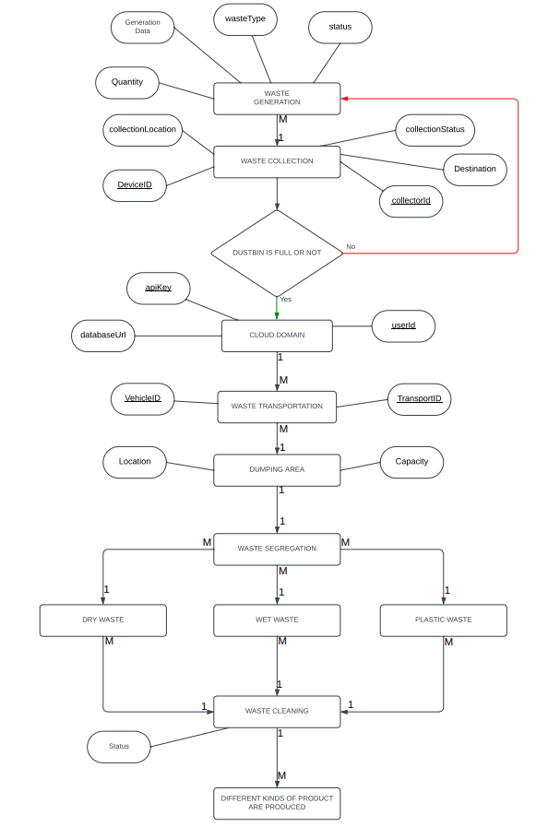

Figure 3.1: Entity-Relationship Diagram

7

## Class Diagram

Class diagrams provide a static view of a system by depicting classes, their attributes, methods, and the relationships between them. They are essential for designing the structure and hierarchy of classes in an object-oriented system.

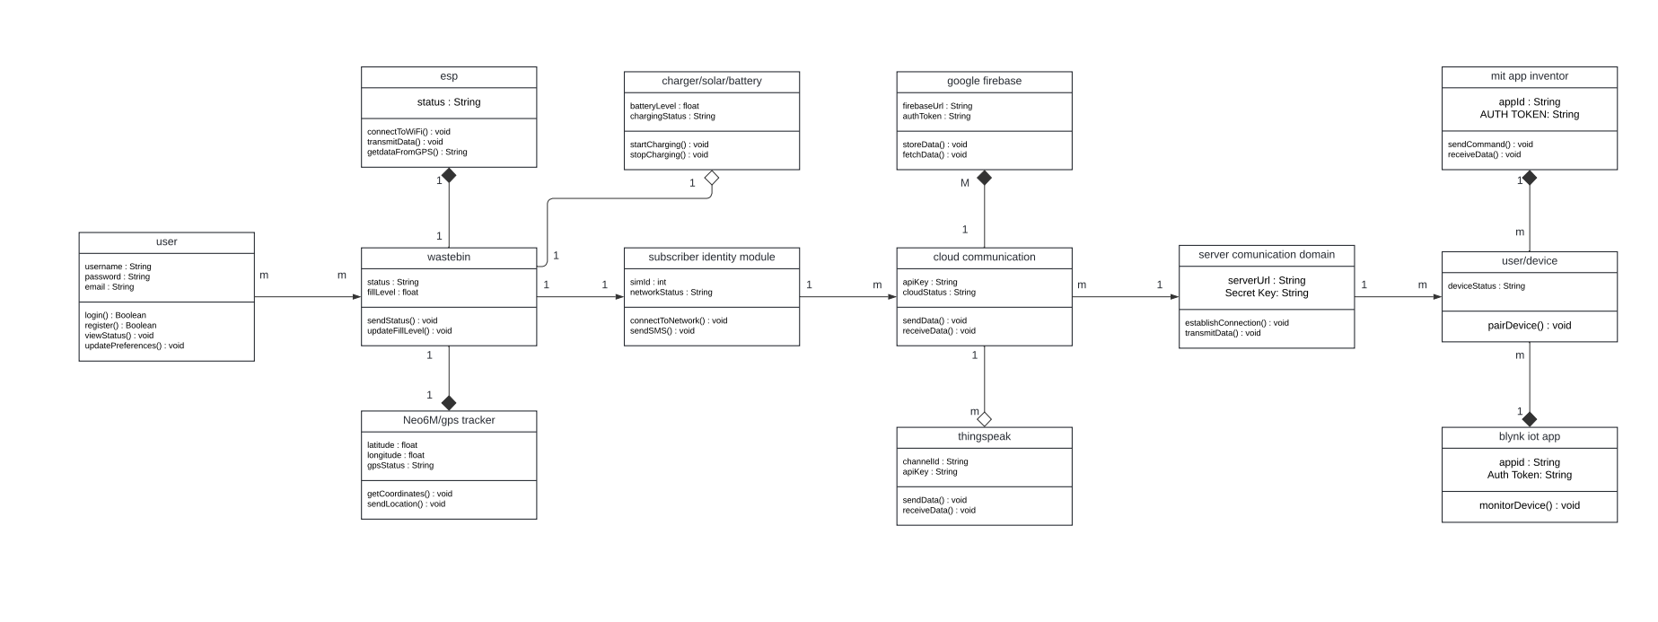

Figure 3.2: Class Diagram

## Sequence Diagram

Sequence diagrams illustrate the dynamic interactions between objects or components in a system over time. They help in visualizing the order of actions and how different elements collaborate to achieve specific functionalities.

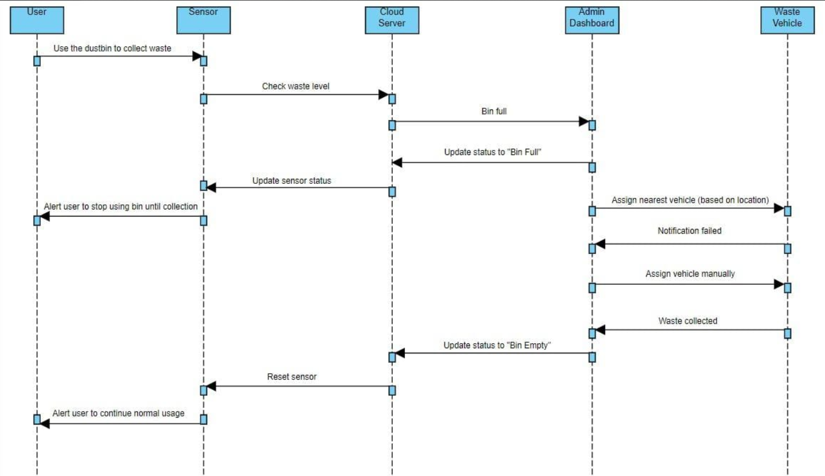

Figure 3.3: Sequence Diagram

## Use Case Diagram

Use case diagrams focus on the interactions between external actors (users or systems) and a software application. They define the system’s external behavior, showing how users interact with it and what functions are available.

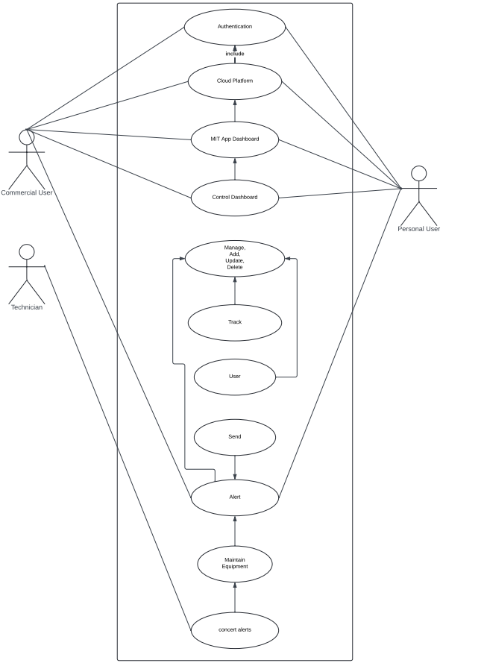

Figure 3.4: Use Case Diagram

## Activity Diagram

Activity diagrams model the flow of tasks and actions within a system, providing a clear picture of process workflows. They are particularly useful for understanding business processes and system behavior.

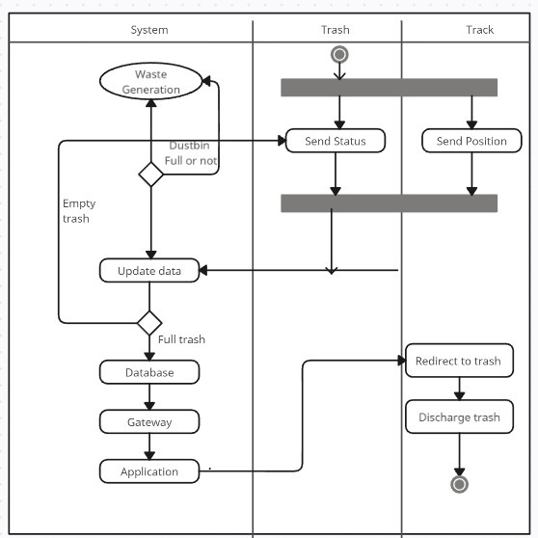

Figure 3.5: Activity Diagram

## Data Flow Diagram

A Data Flow Diagram is a crucial tool for visualizing and documenting how data moves within a system. It provides a clear representation of processes, data storage, data sources, and data destinations, emphasizing the flow of information. DFDs are instrumental in system analysis and design, helping stakeholders understand data in- teractions, identify inefficiencies, and improve data processing within a system.

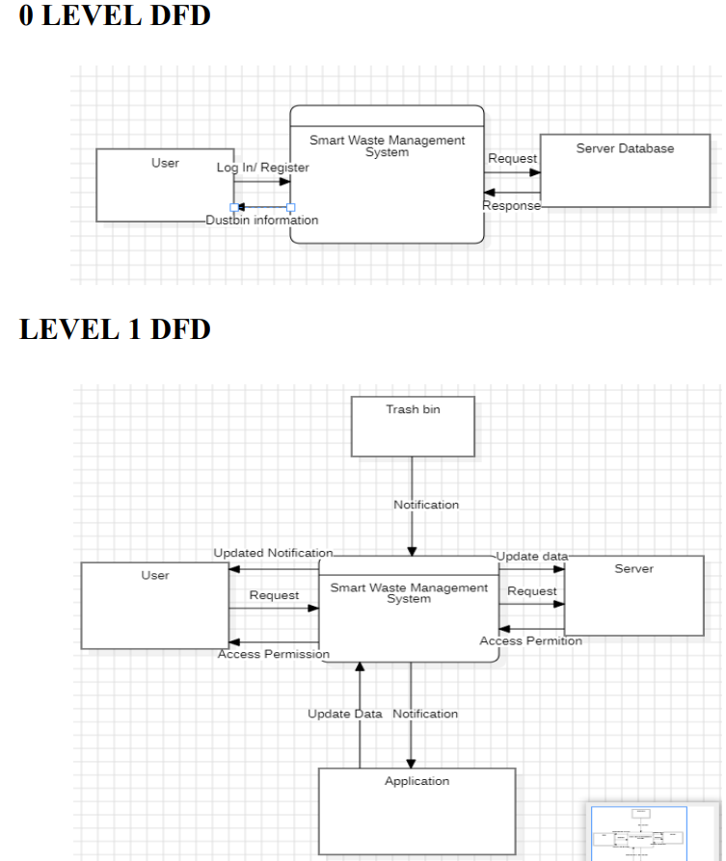

Figure 3.6: Data Flow Diagram

## Database Schema Diagram

Schema diagrams are critical in database design. They represent the structure of a database schema, including tables, columns, keys, and relationships, helping in the organization and understanding of data within a database system.

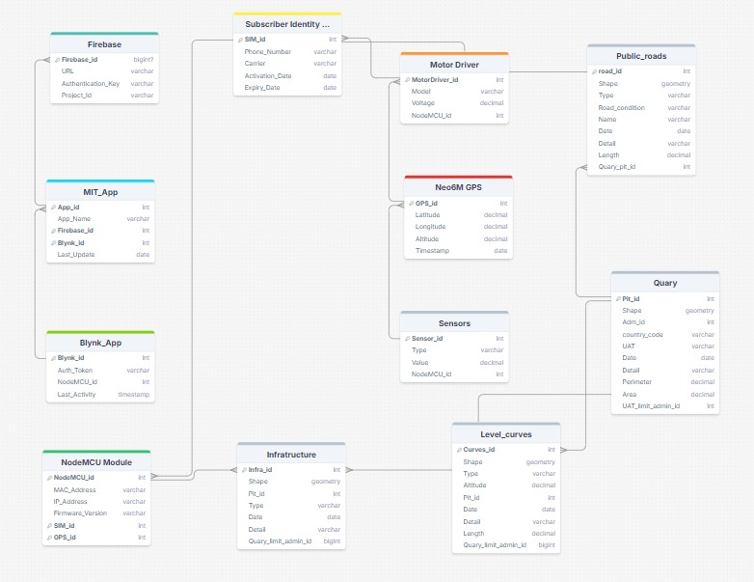

Figure 3.7: Database Schema Diagram

# Chapter 4

**Implementation, Languages and**

# Wireframes

## Languages/Platform used for development :

### Technologies :

* + - 1. Firebase
      2. MIT App Inventor
      3. Blynk IoT
      4. JSON
      5. Arduino/Coding for IoT

### Backend Technologies :

* + - 1. Javascript
      2. Firebase

### Platform :

* + - 1. Arduino IDE
      2. MIT app inventor
      3. Blynk IOT

14

## Wireframes :

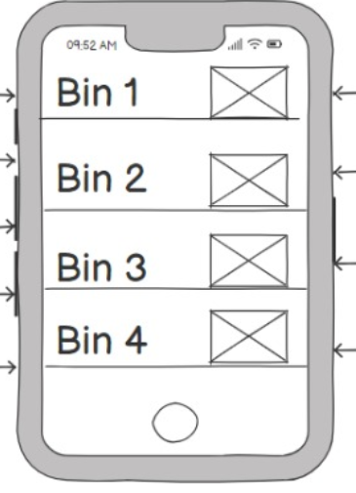

Figure 4.1: Wire Frame - org.Home

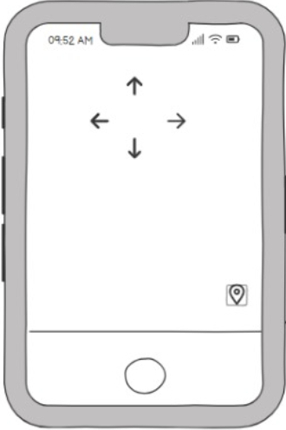

Figure 4.2: Wire Frame - Controls

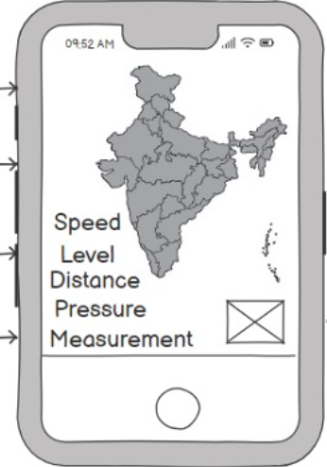

Figure 4.3: Wire Frame - Location and details

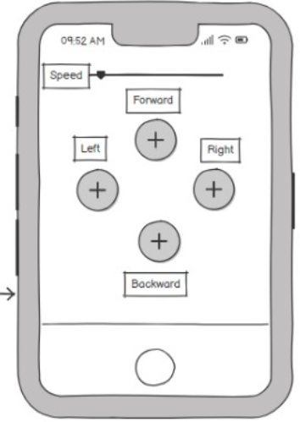

Figure 4.4: Wire Frame - Private.Home

## Implementation :

### Components

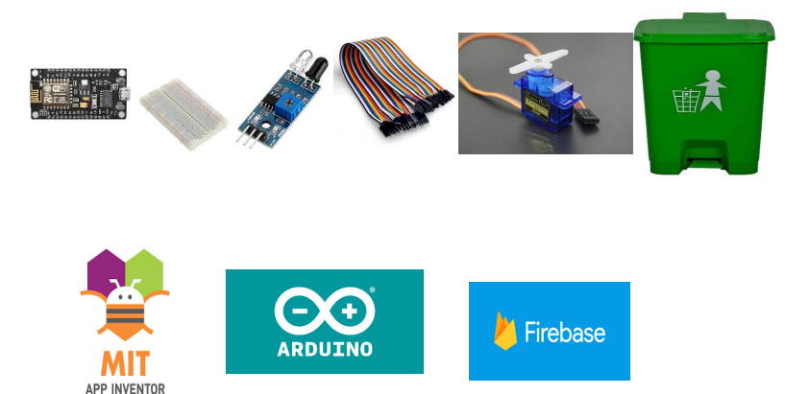

Figure 4.5: Implementation - Components

### Firebase

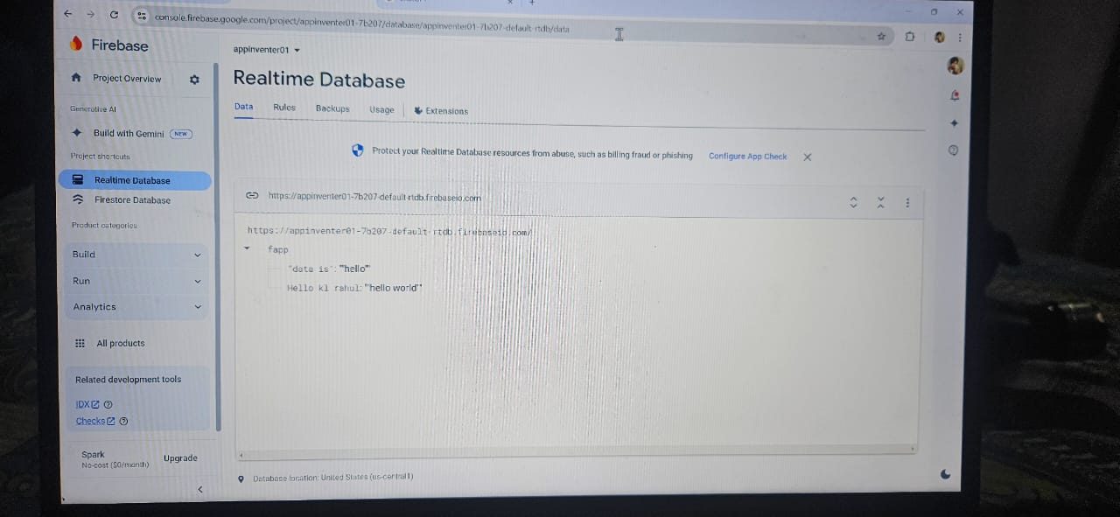

Figure 4.6: Implementation - Firebase

### Control Dashboard

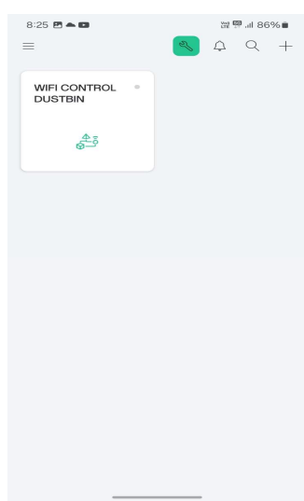-----------------------------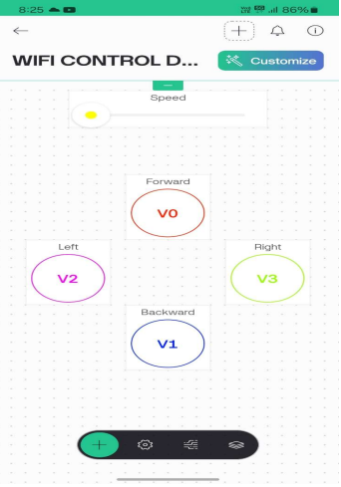

Figure 4.7: Implementation – Control Dashboard

### Model

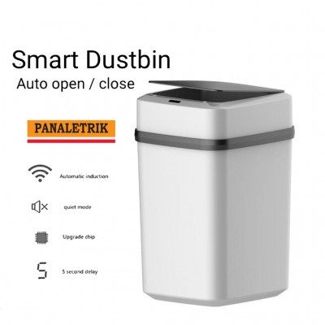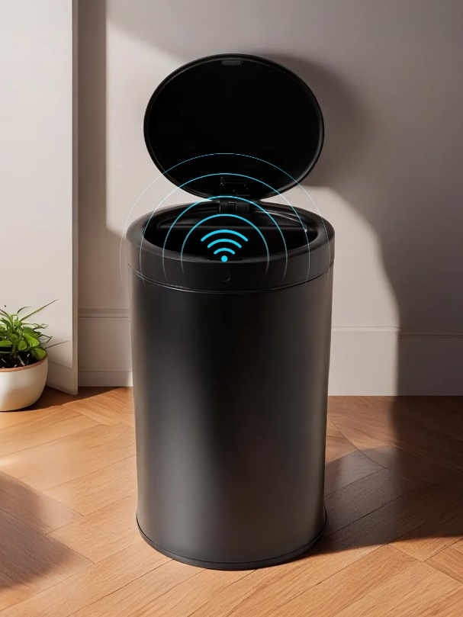

Figure 4.8: Implementation - Model

# Chapter 5 Future Works

* In the upcoming phase of the Smart Waste Management System, our focus is on optimizing functionality and improving user experience. We are enhancing the integration of Firebase for real-time data storage and monitoring, allowing users to access waste level data remotely through a mobile app built with MIT App Inventor. The Blynk IoT platform will provide seamless communication between the system's components and the user interface, ensuring smooth operation of the waste management process.
* To further enhance operational efficiency, the system will incorporate advanced sensor technology to detect waste levels accurately. The Neo-6M GPS module will be used for precise tracking of the waste bins, enabling better route planning for waste collection. We are also focusing on integrating the motor driver for automatic waste disposal, triggered by sensor data, ensuring that the system operates autonomously.
* Additionally, the SIM module and solar panel integration will ensure that the system remains operational even in remote areas with limited power and network connectivity. These updates aim to make waste collection more efficient and environmentally friendly, while providing accurate, real-time data to users and municipal waste management teams.

19

# Chapter 6 Conclusion

* Smart Waste Management Systems are like vital hubs in modern cities, helping keep environments clean and sustainable. Just as we aim to maintain a clean planet, it’s important to use these systems responsibly and efficiently. By taking care of waste and using technology wisely, we can contribute to healthier and greener communities. Together, we can ensure that our surroundings are kept clean and pollution-free, creating a better, more sustainable future for everyone. As we continue to refine these features, the Smart Waste Management System will become a powerful tool for cities and municipalities seeking to implement smart, eco-friendly waste management solutions.

20