Air-Quality Prediction for Nashik Monitoring Stations Using KNN Imputation and a CNN-LSTM Network
Academic Project Report

[Student name] · [Roll number]
[Department, Institution]
[Course / guide]
[Submission date]

Abstract
Hourly concentrations of seven pollutants (PM2.5, PM10, NO2, SO2, CO, O3 and NH3) from four continuous monitoring stations in Nashik, India (MIDC Ambad, Gangapur Road, Pandav Nagari and Hirwadi) were used to build a one-hour-ahead prediction model. After rule-based cleaning, missing inputs were filled with a K-nearest-neighbours imputer fitted on training-period data only. A separate convolutional-LSTM (CNN-LSTM) network was trained for each station on 24-hour input windows, with the latest calendar year of each station held out for testing: January-August 2026 for three stations (July 2026 is absent from the files) and 2025 for Pandav Nagari, whose record ends on 31 December 2025. Predictions were scored in original units with MSE, RMSE, MAE and R² against observed values only, and compared with a persistence baseline on identical test hours. Pooled over stations, with four flagged sensor series excluded, the CNN-LSTM reached test R² between 0.46 (NH3) and 0.85 (PM10), and reduced RMSE relative to persistence by: PM2.5 5.3%, PM10 8.6%, NO2 9.9%, SO2 8.3%, CO 10.6%, O3 9.7%, NH3 3.7%. A network trained to predict concentration levels directly was worse than persistence on validation data at every station; predicting the change from the last observed value was therefore selected on validation loss. The gains over persistence are consistent but modest, and four station-pollutant test series show sensor-quality problems that dominate their scores.

Keywords
air-quality prediction; CNN-LSTM; KNN imputation; time-series forecasting; persistence baseline; Nashik; particulate matter; chronological validation

1. Introduction
Short-term air-quality prediction supports public advisories and operational decisions such as traffic or industrial-emission controls. Continuous ambient monitoring stations report hourly concentrations, but their records contain gaps, instrument faults and changes in data availability, so any prediction pipeline must handle missing data without leaking information from the future.
Hybrid convolutional-recurrent networks are a common choice for such series: one-dimensional convolutions extract short local patterns, and Long Short-Term Memory (LSTM) layers model longer dependencies [1], [3], [4]. This project applies that design to data from four Nashik stations and evaluates it against the simplest competitive forecast, persistence.

2. Problem Statement
Given the hourly pollutant observations of a Nashik monitoring station up to hour t, predict the concentrations of seven pollutants at hour t+1, and quantify the accuracy of those predictions over the latest calendar year in the data, which is excluded from model fitting and model selection.

3. Objectives
- Inspect the Nashik dataset and document its schema, coverage and quality problems.
- Build a reproducible cleaning pipeline and KNN imputation fitted without temporal leakage.
- Design, train and validate a CNN-LSTM model for next-hour prediction at each station.
- Evaluate predictions with MSE, RMSE, MAE and R² in original units per station and pollutant, and compare them with a persistence baseline on identical test hours.
- Report limitations, including data-quality issues that affect the evaluation.

4. Dataset Description
The dataset consists of four CSV files, one per station. Station identity is given only by the file name; no column identifies the station. All files share the same 25 columns: a Timestamp plus 24 measurements (criteria pollutants, volatile organic compounds and meteorological variables). The Hirwadi file has a 26th column, Source_File, whose labels do not match the timestamps (rows labelled '2023.csv.csv' carry 2026 timestamps), so it was dropped and the timestamps were treated as authoritative. Hirwadi rows are also stored out of chronological order and were sorted. The column naming matches the export format of India's Central Pollution Control Board continuous-monitoring portal; the provenance should be confirmed with the data provider before publication.
Table 1. Raw files as delivered.
Station | Rows | First timestamp | Last timestamp | Duplicate times | Sorted | Step | Years present | Rows with no pollutant
MIDC Ambad | 40152 | 2017-01-01 | 2026-08-31 23:00:00 | 0 | True | 1 hour | 2017, 2023, 2024, 2025, 2026 | 14377
Gangapur Road | 81024 | 2017-01-01 | 2026-08-31 23:00:00 | 0 | True | 1 hour | 2017, 2018, 2019, 2020, 2021, 2022, 2023, 2024, 2025, 2026 | 4945
Pandav Nagari | 35064 | 2017-01-01 | 2025-12-31 23:00:00 | 0 | True | 1 hour | 2017, 2023, 2024, 2025 | 12761
Hirwadi | 40152 | 2017-01-01 | 2026-08-31 23:00:00 | 0 | False | 1 hour | 2017, 2023, 2024, 2025, 2026 | 13873

One observation is one hourly average. Three files begin with a full year of empty 2017 placeholder rows and resume in mid-2023 (the first observation is on 14 June 2023 at MIDC Ambad, 22 May 2023 at Pandav Nagari and 23 May 2023 at Hirwadi). Gangapur Road has the longest record, starting in 2017 with a 123-day gap in that year. In all files that reach 2026, July 2026 is missing entirely. The latest calendar year is therefore 2026, covering 1 January-30 June and 1-31 August (5,088 of 8,760 hours); it is incomplete. Pandav Nagari has no 2026 rows; its latest year, 2025, is complete.
Seven pollutants were selected as prediction targets: the pollutants of the Indian National AQI that are present in the data (PM2.5, PM10, NO2, SO2, CO, O3, NH3). The aromatic VOCs (benzene, toluene, xylenes) were not used. Xylene, BP and VWS are empty in every file. Meteorological variables were not used as inputs: air temperature and relative humidity are absent at Gangapur Road before 2026, and wind speed shows level shifts that look like sensor changes (for example, a median of 0.0 m/s at MIDC Ambad in 2026 against about 0.5 m/s before, and isolated values above 20 m/s at Gangapur Road and Hirwadi). The full data dictionary, with per-station missing percentages, is exported as outputs/tables/data_dictionary.csv.
Table 2. Data dictionary for the columns used by the model.
Column (standardised) | Original column | Unit | Role
Timestamp | Timestamp | - | Time index (hourly)
PM2.5 | PM2.5 (µg/m³) | µg/m³ | Model input and prediction target
PM10 | PM10 (µg/m³) | µg/m³ | Model input and prediction target
NO2 | NO2 (µg/m³) | µg/m³ | Model input and prediction target
SO2 | SO2 (µg/m³) | µg/m³ | Model input and prediction target
CO | CO (mg/m³) | mg/m³ | Model input and prediction target
O3 | Ozone (µg/m³) | µg/m³ | Model input and prediction target
NH3 | NH3 (µg/m³) | µg/m³ | Model input and prediction target

5. Data Preprocessing and KNN Imputation

5.1 Cleaning rules
- Timestamps parsed and sorted; duplicate timestamps would keep the first row (none were found).
- Rows before a station's first pollutant observation removed (the empty 2017 placeholder blocks): 12,710 rows at MIDC Ambad, 12,161 at Pandav Nagari and 12,184 at Hirwadi.
- Negative concentrations set to missing (none occurred).
- PM2.5 or PM10 values of 999 or more set to missing, because that is the analyser ceiling, not a measurement (21 values, all at Gangapur Road).
- Any value repeated unchanged for 12 or more consecutive hours set to missing as a stuck-sensor reading. This removed 13,921 values, mostly CO readings of exactly 0.00 mg/m³ and long flat NO2 stretches at Gangapur Road.
- No interpolation, aggregation or resampling. Hours absent from the files (the 2017 gap at Gangapur Road and July 2026) were not filled, and no input window spans them.
Table 3. Values removed by the stuck-sensor rule (12 or more identical consecutive hours).
Station | PM2.5 | PM10 | NO2 | SO2 | CO | O3 | NH3
MIDC Ambad | 22 | 0 | 0 | 0 | 3059 | 14 | 12
Gangapur Road | 346 | 124 | 2853 | 193 | 4005 | 155 | 806
Pandav Nagari | 0 | 0 | 0 | 0 | 0 | 0 | 0
Hirwadi | 13 | 13 | 59 | 0 | 2247 | 0 | 0

5.2 Missing values
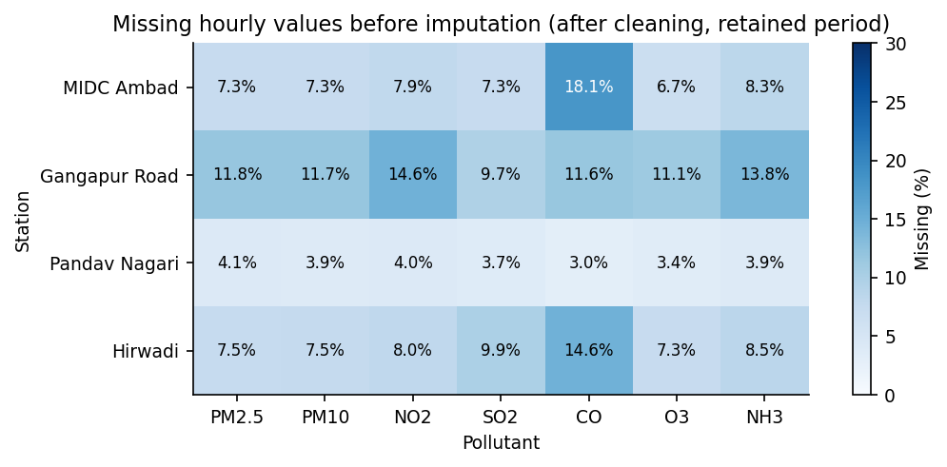
Figure 1. Missing hourly values per station and pollutant before imputation, after cleaning, over each station's retained period.

5.3 KNN imputation
K-nearest-neighbours imputation fills a missing value with a weighted average of that variable in the k most similar records [2], [5]. Similarity is measured by the NaN-Euclidean distance, which compares two hours over the variables both have observed and rescales for the missing ones. Here k = 5 and neighbours are weighted by inverse distance (scikit-learn KNNImputer [6]).
- Features: the seven standardised pollutant concentrations of the same hour. Station identifiers and timestamps are not used in the distance.
- One StandardScaler and one KNNImputer per station, fitted on that station's training rows only and then applied to validation and test rows. Neighbours (donors) are therefore always training-period hours. Scaling is needed because units and ranges differ widely, for example CO in mg/m³ against PM10 in hundreds of µg/m³.
- Each station is imputed from its own history, preserving station-specific pollutant relationships. Stations never donate to each other.
- Imputed values are used only as model inputs. A missing value at hour s is filled from other pollutants observed at hour s, which are known when a prediction for any later hour is issued. Prediction targets are never imputed: training loss and every evaluation metric use observed values only.
- Hours with every pollutant missing receive the training mean (no distance can be computed). Input windows in which more than half of the pollutant cells are imputed are discarded (Section 9).
Table 4. Missing pollutant cells before and after KNN imputation (7 pollutants).
Station | Split | Missing cells before | Missing cells after
MIDC Ambad | train | 9802 | 0
MIDC Ambad | val | 1664 | 0
MIDC Ambad | test | 5818 | 0
Gangapur Road | train | 58622 | 0
Gangapur Road | val | 1423 | 0
Gangapur Road | test | 8310 | 0
Pandav Nagari | train | 1898 | 0
Pandav Nagari | val | 1121 | 0
Pandav Nagari | test | 2936 | 0
Hirwadi | train | 11641 | 0
Hirwadi | val | 1014 | 0
Hirwadi | test | 5052 | 0

6. Exploratory Data Analysis
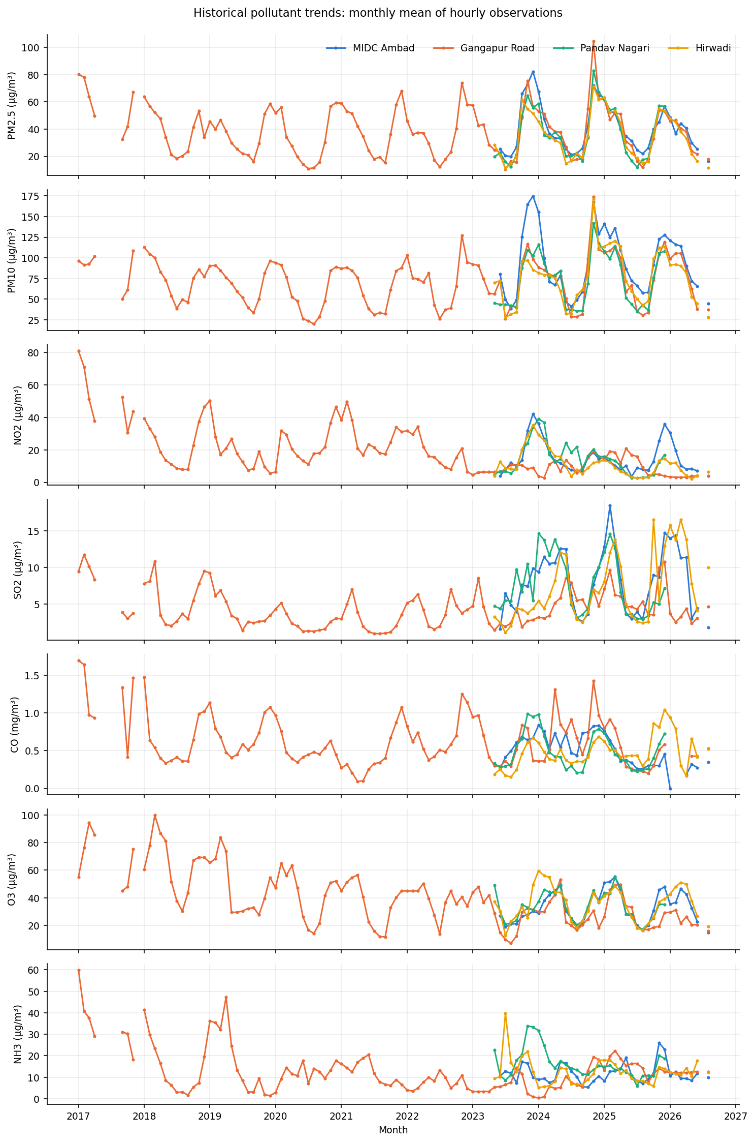
Figure 2. Monthly means of hourly observations per pollutant and station. Gaps are periods with no observations.
Particulate matter shows a seasonal cycle at all stations, with lower concentrations in the monsoon months (June-September) and higher concentrations in winter. Gangapur Road is the only station with history before 2023. Its NO2, CO and NH3 series change character in 2026: NO2 settles near 3 µg/m³ in 0.25 steps and CO near 0 mg/m³, consistent with an instrument or calibration change rather than a real drop in pollution.
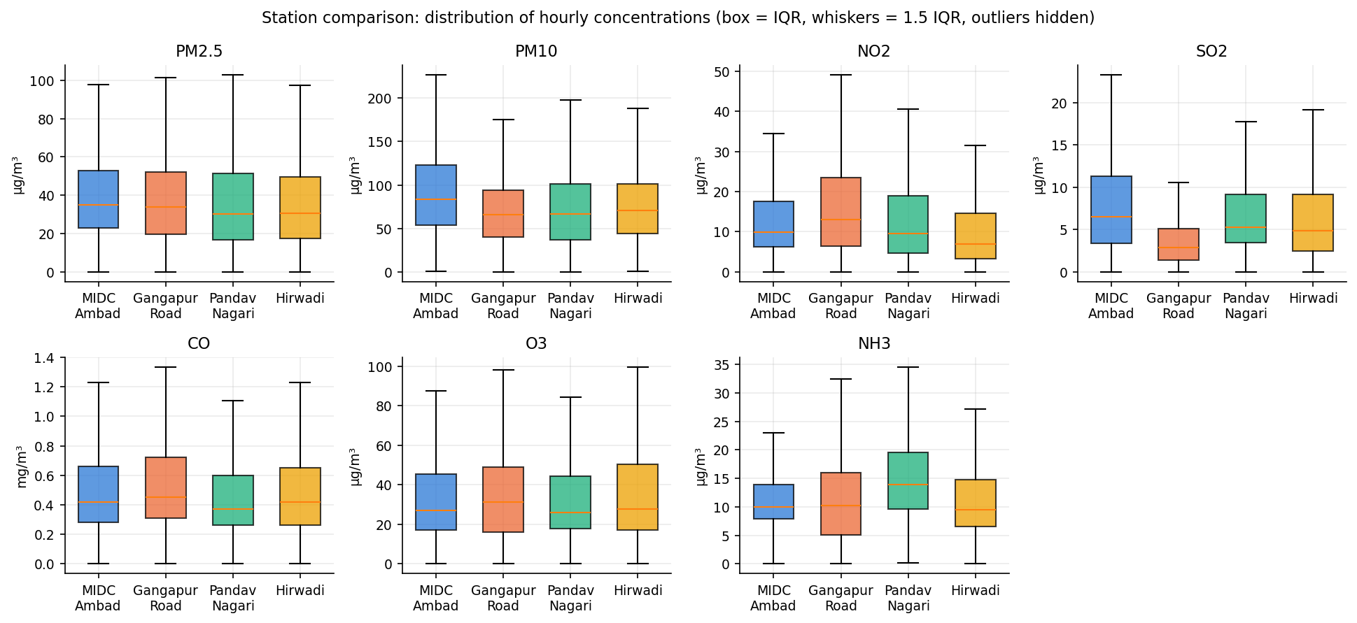
Figure 3. Distribution of hourly concentrations by station (box: interquartile range; whiskers: 1.5 IQR; outliers hidden).
Table 5. Percentage of missing hourly values before imputation (retained period).
Station | PM2.5 | PM10 | NO2 | SO2 | CO | O3 | NH3
MIDC Ambad | 7.3 | 7.3 | 7.9 | 7.3 | 18.1 | 6.8 | 8.3
Gangapur Road | 11.8 | 11.7 | 14.6 | 9.7 | 11.6 | 11.2 | 13.8
Pandav Nagari | 4.1 | 3.9 | 4.0 | 3.7 | 3.0 | 3.4 | 3.9
Hirwadi | 7.5 | 7.5 | 8.0 | 9.9 | 14.6 | 7.3 | 8.5

7. Proposed CNN-LSTM Architecture
A one-dimensional convolution slides a small learned filter along the time axis. With kernel size 3, each output step combines three consecutive hours of all input features, so a filter can respond to a local motif such as a sharp morning rise in NO2 [7]. Stacking two such layers widens the receptive field to five hours. Causal padding ensures that no output step depends on later steps. Max-pooling then halves the sequence, keeping the strongest response in each pair of steps.
An LSTM layer [1] reads the pooled sequence step by step. Its cell state is updated through input, forget and output gates, which lets it carry information across the whole window without the vanishing gradients of a plain recurrent network. The final hidden state summarises the 24-hour history; dropout [9] regularises it, and two dense layers map it to the seven outputs.
Table 6. CNN-LSTM layers (50,247 trainable parameters per station model).
Layer | Output shape | Configuration | Parameters
Input | (24, 13) | 24 hours x 13 features | 0
Conv1D | (24, 64) | 64 filters, kernel 3, causal padding, ReLU | 2,560
Conv1D | (24, 64) | 64 filters, kernel 3, causal padding, ReLU | 12,352
MaxPooling1D | (12, 64) | pool size 2 | 0
LSTM | (64) | 64 units, final hidden state | 33,024
Dropout | (64) | rate 0.2 | 0
Dense | (32) | ReLU | 2,080
Dense (output) | (7) | linear, one unit per pollutant | 231

Inputs per hour: the seven standardised, KNN-imputed pollutant concentrations plus sine and cosine encodings of hour-of-day, day-of-week and month (13 features). Calendar encodings are deterministic and known in advance. The model is multi-output: one network predicts all seven pollutants of a station, and each pollutant is evaluated separately.

8. Methodology and Experimental Setup

8.1 Forecasting design
The task is one-step-ahead (next-hour) prediction. To predict hour t+1, the model receives the 24 hours t-23 ... t of observed (and, where missing, imputed) inputs. In the test year the inputs are the real observations preceding each predicted hour, exactly as they would be available to an operational system that updates every hour. No prediction is fed back as an input, so this is not a recursive forecast. The test year is a held-out historical year with known measurements. The work does not forecast genuinely future hours, for which no measurements exist, and its accuracy says nothing about predicting more than one hour ahead.

8.2 Station-specific models
Each station has its own model, scaler and imputer. A shared model was not used because the stations' histories differ sharply (Gangapur Road from 2017; the others from mid-2023) and their test years differ (Pandav Nagari ends in 2025). In a shared model, Pandav Nagari's 2025 test year would coincide with training data from the other stations, and correlated regional weather would leak across stations. Independent models avoid that and keep sequences from crossing station boundaries by construction.

8.3 Sequence construction
- Lookback 24 hours (one diurnal cycle); horizon 1 hour.
- A window is kept only if its 25 timestamps are consecutive hours, so no window spans a gap in the file.
- At least one of the seven targets must be observed at the predicted hour.
- At most 50% of the window's input pollutant cells may be imputed.
- Every pollutant must have an earlier observation (needed by the baseline).

8.4 Training configuration and target design
Table 7. Training configuration (identical for all stations; no hyperparameter search).
Setting | Value
Loss | Masked MSE on standardised targets (missing targets excluded)
Optimiser | Adam [8], learning rate 0.001
Batch size / maximum epochs | 256 / 60
Early stopping | validation loss, patience 6, best weights restored
Random seed | 42 (Python, NumPy, TensorFlow)
Software | Python 3.12.14, TensorFlow 2.19.0, scikit-learn 1.6.1, pandas 2.2.2, NumPy 2.0.2

Two parameterisations of the same network were trained per station, and the one with the lower validation loss was selected. In the level design, the network predicts the standardised concentration at t+1. In the change design, it predicts the difference between the concentration at t+1 and the last observed value, which is then added back. Because both are scored in the same standardised units, their validation losses are directly comparable with each other and with persistence.
Table 8. Model selection on the validation period (masked MSE, standardised units). The test year played no part.
Station | Train seq. | Val seq. | Val loss: persistence | Val loss: level | Val loss: change | Best epoch (change) | Selected
MIDC Ambad | 16498 | 4178 | 0.1625 | 0.1817 | 0.1387 | 13 | change
Gangapur Road | 64835 | 4223 | 0.1109 | 0.1293 | 0.09261 | 9 | change
Pandav Nagari | 9499 | 4264 | 0.216 | 0.2312 | 0.1756 | 16 | change
Hirwadi | 16951 | 4303 | 0.3727 | 0.412 | 0.3065 | 5 | change

The level design was worse than persistence on validation at all four stations. The change design beat persistence at all four, so it was selected everywhere. For transparency: the first version of the pipeline used only the level design. Its test-year results were computed before the change design was added, and they were worse than persistence. The switch is justified by the validation evidence above, which was available without the test year. Test RMSE for both designs is kept in outputs/metrics/station_pollutant_metrics.csv.
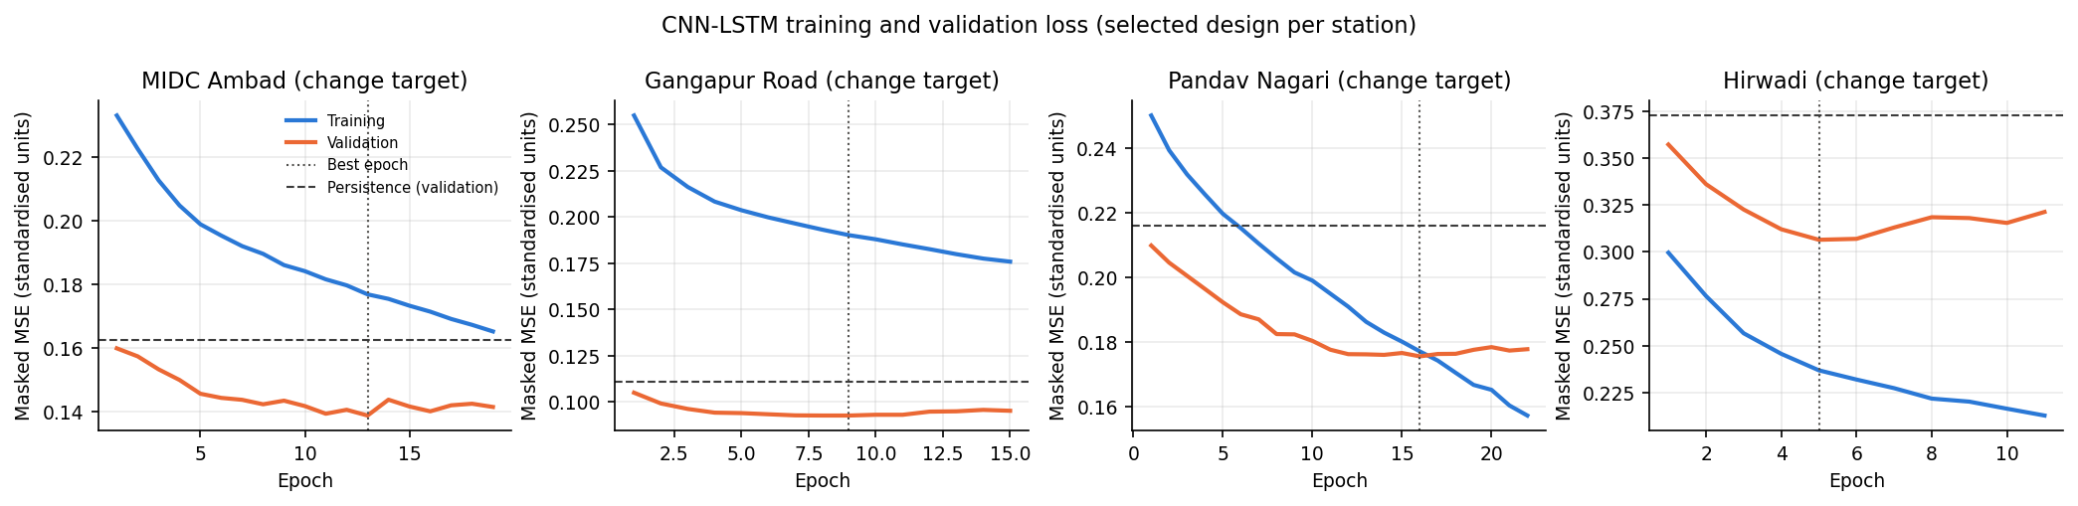
Figure 4. Training and validation loss of the selected (change) design per station. The dashed line is persistence on the validation period.
Validation loss is below training loss at three stations. This is expected rather than suspicious: dropout is active only during training, and the validation half-year (July-December) includes the monsoon months, when concentrations are low and smooth. Hirwadi is the exception: validation loss is higher and rises after epoch 5, showing early overfitting, which early stopping caught.

9. Train-Validation-Test Strategy
Random splitting would put hours from the same day into both training and test sets. Because neighbouring hours are highly correlated, the model would be scored on near-copies of its training data, and it would also learn from the future of the period it is tested on [10]. A chronological split avoids both problems. For each station, the test set is its latest calendar year, validation is the six months before it, and training is everything earlier. Windows are assigned to a split by the timestamp of the predicted hour. Scaler and imputer statistics come from training rows only.
Table 9. Chronological splits per station.
Station | Split | Start | End | Hourly rows | Months | PM2.5 observed
MIDC Ambad | train | 2023-06-14 14:00:00 | 2025-06-30 23:00:00 | 17938 | 25 | 16560
MIDC Ambad | val | 2025-07-01 00:00:00 | 2025-12-31 23:00:00 | 4416 | 6 | 4175
MIDC Ambad | test | 2026-01-01 00:00:00 | 2026-08-31 23:00:00 | 5088 | 7 | 4708
Gangapur Road | train | 2017-01-01 00:00:00 | 2025-06-30 23:00:00 | 71520 | 98 | 62415
Gangapur Road | val | 2025-07-01 00:00:00 | 2025-12-31 23:00:00 | 4416 | 6 | 4197
Gangapur Road | test | 2026-01-01 00:00:00 | 2026-08-31 23:00:00 | 5088 | 7 | 4876
Pandav Nagari | train | 2023-05-22 17:00:00 | 2024-06-30 23:00:00 | 9727 | 14 | 9439
Pandav Nagari | val | 2024-07-01 00:00:00 | 2024-12-31 23:00:00 | 4416 | 6 | 4251
Pandav Nagari | test | 2025-01-01 00:00:00 | 2025-12-31 23:00:00 | 8760 | 12 | 8277
Hirwadi | train | 2023-05-23 16:00:00 | 2025-06-30 23:00:00 | 18464 | 26 | 16799
Hirwadi | val | 2025-07-01 00:00:00 | 2025-12-31 23:00:00 | 4416 | 6 | 4306
Hirwadi | test | 2026-01-01 00:00:00 | 2026-08-31 23:00:00 | 5088 | 7 | 4769

10. Evaluation Metrics: MSE, RMSE, MAE and R²
For n test hours with observed values yᵢ, predictions ŷᵢ and observed mean ȳ:
MSE = (1/n) Σ (yᵢ − ŷᵢ)²
RMSE = √MSE
MAE = (1/n) Σ |yᵢ − ŷᵢ|
R² = 1 − Σ (yᵢ − ŷᵢ)² / Σ (yᵢ − ȳ)²
- MSE is in squared units (for example (µg/m³)²). It penalises large errors heavily, so pollution spikes dominate it.
- RMSE is in the pollutant's own unit and is the typical size of an error, weighted towards large errors.
- MAE is in the pollutant's unit and is the average absolute error. It is less sensitive to spikes than RMSE.
- R² is unitless: the share of the test-period variance explained by the predictions. 1 is perfect; 0 equals always predicting the test mean. It is negative when predictions are worse than that, which is possible on test data, and undefined when the test values are constant or there are fewer than two of them (reported as missing in that case).
- RMSE skill = 1 − RMSE_model / RMSE_persistence. Positive values mean the CNN-LSTM beats persistence; 0.05 means a 5% lower RMSE.
All metrics are computed with scikit-learn in original units, after inverse transformation and only on hours with an observed value. Pollutants are never pooled into one score because their units and scales differ. The overall summary is computed per pollutant by concatenating the test hours of all stations whose series is not quality-flagged.

11. Experimental Results
Table 10. CNN-LSTM test results per station and pollutant, in original units (µg/m³; CO in mg/m³, MSE in squared units). * = quality-flagged test series (fewer than 100 distinct values; see Section 14).
Station | Pollutant | Evaluation Period | Number of Test Observations | MSE | RMSE | MAE | R²
MIDC Ambad | PM2.5 | 2026-01-01 to 2026-08-31 | 4542 | 35.71 | 5.976 | 3.981 | 0.8656
MIDC Ambad | PM10 | 2026-01-01 to 2026-08-31 | 4544 | 238.6 | 15.45 | 8.786 | 0.8544
MIDC Ambad | NO2 | 2026-01-01 to 2026-08-31 | 4467 | 25.87 | 5.086 | 2.794 | 0.8402
MIDC Ambad | SO2 | 2026-01-01 to 2026-08-31 | 4542 | 5.725 | 2.393 | 1.278 | 0.8637
MIDC Ambad | CO * | 2026-04-21 to 2026-08-31 | 1574 | 0.007139 | 0.08449 | 0.05104 | 0.4433
MIDC Ambad | O3 | 2026-01-01 to 2026-08-31 | 4552 | 41.55 | 6.446 | 4.464 | 0.8903
MIDC Ambad | NH3 | 2026-01-01 to 2026-08-31 | 4489 | 1.908 | 1.381 | 0.8995 | 0.7476
Gangapur Road | PM2.5 | 2026-01-01 to 2026-08-31 | 4800 | 135.4 | 11.64 | 5.337 | 0.7073
Gangapur Road | PM10 | 2026-01-01 to 2026-08-31 | 4780 | 350.1 | 18.71 | 10.8 | 0.8108
Gangapur Road | NO2 * | 2026-01-02 to 2026-08-31 | 2190 | 1.426 | 1.194 | 0.4078 | -1.101
Gangapur Road | SO2 | 2026-01-01 to 2026-08-31 | 4259 | 7.392 | 2.719 | 1.263 | 0.2832
Gangapur Road | CO * | 2026-05-15 to 2026-08-31 | 1705 | 0.003825 | 0.06184 | 0.05053 | -0.5708
Gangapur Road | O3 | 2026-01-01 to 2026-08-31 | 4905 | 53.51 | 7.315 | 3.199 | 0.687
Gangapur Road | NH3 * | 2026-01-01 to 2026-08-31 | 4198 | 3.911 | 1.978 | 0.3034 | -0.8288
Pandav Nagari | PM2.5 | 2025-01-02 to 2025-12-31 | 8135 | 93.15 | 9.652 | 3.762 | 0.8659
Pandav Nagari | PM10 | 2025-01-02 to 2025-12-31 | 8161 | 220.7 | 14.86 | 7.161 | 0.8919
Pandav Nagari | NO2 | 2025-01-02 to 2025-12-31 | 8199 | 15.57 | 3.945 | 2.081 | 0.7819
Pandav Nagari | SO2 | 2025-01-02 to 2025-12-31 | 8177 | 34.22 | 5.85 | 1.999 | 0.6176
Pandav Nagari | CO | 2025-01-02 to 2025-12-31 | 8266 | 0.01912 | 0.1383 | 0.07446 | 0.8104
Pandav Nagari | O3 | 2025-01-02 to 2025-12-31 | 8202 | 49.97 | 7.069 | 4.604 | 0.8857
Pandav Nagari | NH3 | 2025-01-02 to 2025-12-31 | 8216 | 22.02 | 4.692 | 2.044 | 0.6167
Hirwadi | PM2.5 | 2026-01-01 to 2026-08-31 | 4632 | 20.22 | 4.497 | 3.079 | 0.9311
Hirwadi | PM10 | 2026-01-01 to 2026-08-31 | 4628 | 305.6 | 17.48 | 7.233 | 0.765
Hirwadi | NO2 | 2026-01-01 to 2026-08-31 | 4402 | 11.66 | 3.414 | 2.091 | 0.7002
Hirwadi | SO2 | 2026-01-01 to 2026-08-31 | 4436 | 64.96 | 8.06 | 2.881 | 0.5709
Hirwadi | CO | 2026-01-02 to 2026-08-31 | 2407 | 0.03036 | 0.1742 | 0.08154 | 0.773
Hirwadi | O3 | 2026-01-01 to 2026-08-31 | 4642 | 159.5 | 12.63 | 6.087 | 0.7411
Hirwadi | NH3 | 2026-01-01 to 2026-08-31 | 4508 | 64.75 | 8.047 | 3.561 | 0.2009

Table 11. Overall summary per pollutant: test hours of all unflagged stations pooled. Test periods: 2025 (Pandav Nagari) and January-August 2026 (others).
Pollutant | Unit | Test obs. | MSE | RMSE | MAE | R² | Stations included
PM2.5 | µg/m³ | 22109 | 75.24 | 8.674 | 4.006 | 0.8423 | MIDC Ambad, Gangapur Road, Pandav Nagari, Hirwadi
PM10 | µg/m³ | 22113 | 270.1 | 16.44 | 8.296 | 0.8512 | MIDC Ambad, Gangapur Road, Pandav Nagari, Hirwadi
NO2 | µg/m³ | 17068 | 17.25 | 4.154 | 2.27 | 0.8123 | MIDC Ambad, Pandav Nagari, Hirwadi
SO2 | µg/m³ | 21414 | 29.21 | 5.404 | 1.883 | 0.6538 | MIDC Ambad, Gangapur Road, Pandav Nagari, Hirwadi
CO | mg/m³ | 10673 | 0.02165 | 0.1471 | 0.07605 | 0.8062 | Pandav Nagari, Hirwadi
O3 | µg/m³ | 22301 | 71.83 | 8.475 | 4.575 | 0.8339 | MIDC Ambad, Gangapur Road, Pandav Nagari, Hirwadi
NH3 | µg/m³ | 17213 | 27.97 | 5.288 | 2.143 | 0.4613 | MIDC Ambad, Pandav Nagari, Hirwadi

11.1 Station-wise interpretation
MIDC Ambad. Test period 2026-01-01 to 2026-08-31 (2026), 1,574-4,552 observed hours per pollutant. R² ranges from 0.44 (CO) to 0.89 (O3). The model beats persistence on RMSE for 5 of 6 unflagged pollutants, with a mean RMSE skill of 8.5%. Flagged series: CO (skill -0%).
Gangapur Road. Test period 2026-01-01 to 2026-08-31 (2026), 1,705-4,905 observed hours per pollutant. R² ranges from -1.10 (NO2) to 0.81 (PM10). The model beats persistence on RMSE for 4 of 4 unflagged pollutants, with a mean RMSE skill of 4.6%. Flagged series: NO2, CO, NH3 (skill -9%, -420%, 3%).
Pandav Nagari. Test period 2025-01-02 to 2025-12-31 (2025), 8,135-8,266 observed hours per pollutant. R² ranges from 0.62 (NH3) to 0.89 (PM10). The model beats persistence on RMSE for 7 of 7 unflagged pollutants, with a mean RMSE skill of 9.3%.
Hirwadi. Test period 2026-01-01 to 2026-08-31 (2026), 2,407-4,642 observed hours per pollutant. R² ranges from 0.20 (NH3) to 0.93 (PM2.5). The model beats persistence on RMSE for 7 of 7 unflagged pollutants, with a mean RMSE skill of 5.3%.
Pandav Nagari and MIDC Ambad gain most over persistence (mean skill 9.3% and 8.5%), with the largest gains for O3 at both stations and for NO2 and PM10 at MIDC Ambad; these pollutants have strong diurnal cycles that a 24-hour window captures. Gangapur Road has the most training data but the weakest test behaviour, because three of its seven test series changed character in 2026. Hirwadi's NH3 and Gangapur Road's SO2 have low R² for both the model and persistence: these series are dominated by short, isolated spikes that no next-hour method anticipates.

12. Baseline Comparison
The persistence baseline predicts each pollutant at hour t+1 as its most recent observed value at or before hour t. It is evaluated on exactly the same station, hour and pollutant rows as the CNN-LSTM.
Table 12. CNN-LSTM against persistence on identical test hours (original units). * = quality-flagged series.
Station | Pollutant | n | RMSE CNN-LSTM | RMSE persist. | MAE CNN-LSTM | MAE persist. | R² CNN-LSTM | R² persist. | RMSE skill
MIDC Ambad | PM2.5 | 4542 | 5.976 | 6.106 | 3.981 | 3.954 | 0.8656 | 0.8597 | 0.02138
MIDC Ambad | PM10 | 4544 | 15.45 | 17.98 | 8.786 | 9.564 | 0.8544 | 0.8027 | 0.1407
MIDC Ambad | NO2 | 4467 | 5.086 | 5.958 | 2.794 | 3.139 | 0.8402 | 0.7807 | 0.1463
MIDC Ambad | SO2 | 4542 | 2.393 | 2.496 | 1.278 | 1.18 | 0.8637 | 0.8516 | 0.04153
MIDC Ambad | CO * | 1574 | 0.08449 | 0.08424 | 0.05104 | 0.04811 | 0.4433 | 0.4466 | -0.002942
MIDC Ambad | O3 | 4552 | 6.446 | 7.68 | 4.464 | 5.207 | 0.8903 | 0.8443 | 0.1606
MIDC Ambad | NH3 | 4489 | 1.381 | 1.378 | 0.8995 | 0.8446 | 0.7476 | 0.7489 | -0.0026
Gangapur Road | PM2.5 | 4800 | 11.64 | 12.26 | 5.337 | 5.598 | 0.7073 | 0.6753 | 0.05065
Gangapur Road | PM10 | 4780 | 18.71 | 20.07 | 10.8 | 11.72 | 0.8108 | 0.7823 | 0.06767
Gangapur Road | NO2 * | 2190 | 1.194 | 1.095 | 0.4078 | 0.08097 | -1.101 | -0.7663 | -0.09071
Gangapur Road | SO2 | 4259 | 2.719 | 2.898 | 1.263 | 1.266 | 0.2832 | 0.1856 | 0.06186
Gangapur Road | CO * | 1705 | 0.06184 | 0.0119 | 0.05053 | 0.007349 | -0.5708 | 0.9418 | -4.196
Gangapur Road | O3 | 4905 | 7.315 | 7.344 | 3.199 | 2.526 | 0.687 | 0.6845 | 0.003936
Gangapur Road | NH3 * | 4198 | 1.978 | 2.038 | 0.3034 | 0.161 | -0.8288 | -0.9419 | 0.02957
Pandav Nagari | PM2.5 | 8135 | 9.652 | 10.26 | 3.762 | 3.95 | 0.8659 | 0.8484 | 0.05936
Pandav Nagari | PM10 | 8161 | 14.86 | 16.38 | 7.161 | 7.72 | 0.8919 | 0.8686 | 0.09281
Pandav Nagari | NO2 | 8199 | 3.945 | 4.29 | 2.081 | 2.129 | 0.7819 | 0.7421 | 0.08038
Pandav Nagari | SO2 | 8177 | 5.85 | 6.486 | 1.999 | 2.023 | 0.6176 | 0.5298 | 0.09812
Pandav Nagari | CO | 8266 | 0.1383 | 0.1584 | 0.07446 | 0.0832 | 0.8104 | 0.7511 | 0.1274
Pandav Nagari | O3 | 8202 | 7.069 | 8.28 | 4.604 | 5.251 | 0.8857 | 0.8432 | 0.1462
Pandav Nagari | NH3 | 8216 | 4.692 | 4.915 | 2.044 | 1.787 | 0.6167 | 0.5795 | 0.04524
Hirwadi | PM2.5 | 4632 | 4.497 | 4.789 | 3.079 | 3.238 | 0.9311 | 0.9219 | 0.06101
Hirwadi | PM10 | 4628 | 17.48 | 18.45 | 7.233 | 7.993 | 0.765 | 0.7383 | 0.05241
Hirwadi | NO2 | 4402 | 3.414 | 3.489 | 2.091 | 1.944 | 0.7002 | 0.6869 | 0.02148
Hirwadi | SO2 | 4436 | 8.06 | 8.695 | 2.881 | 2.836 | 0.5709 | 0.5005 | 0.07307
Hirwadi | CO | 2407 | 0.1742 | 0.1842 | 0.08154 | 0.06864 | 0.773 | 0.7462 | 0.05419
Hirwadi | O3 | 4642 | 12.63 | 13.68 | 6.087 | 7.027 | 0.7411 | 0.696 | 0.07715
Hirwadi | NH3 | 4508 | 8.047 | 8.327 | 3.561 | 3.516 | 0.2009 | 0.1443 | 0.03363

Table 13. Pooled comparison per pollutant (unflagged stations). The level-design column shows the rejected design for reference.
Pollutant | RMSE CNN-LSTM | RMSE persist. | RMSE level design | MAE CNN-LSTM | MAE persist. | R² CNN-LSTM | R² persist. | RMSE skill
PM2.5 | 8.674 | 9.155 | 10.24 | 4.006 | 4.16 | 0.8423 | 0.8243 | 0.05253
PM10 | 16.44 | 17.99 | 19.72 | 8.296 | 9.022 | 0.8512 | 0.8217 | 0.08646
NO2 | 4.154 | 4.612 | 5.173 | 2.27 | 2.345 | 0.8123 | 0.7686 | 0.09937
SO2 | 5.404 | 5.892 | 6.033 | 1.883 | 1.862 | 0.6538 | 0.5885 | 0.08279
CO | 0.1471 | 0.1646 | 0.1827 | 0.07605 | 0.07992 | 0.8062 | 0.7575 | 0.1061
O3 | 8.475 | 9.386 | 10.23 | 4.575 | 5.012 | 0.8339 | 0.7963 | 0.09704
NH3 | 5.288 | 5.494 | 5.394 | 2.143 | 1.994 | 0.4613 | 0.4186 | 0.03744

On unflagged series the CNN-LSTM has lower RMSE than persistence in 23 of 24 station-pollutant pairs. Pooled RMSE skill ranges from 3.7% (NH3) to 10.6% (CO). The improvement is consistent but small. Persistence is a strong baseline at a one-hour horizon because consecutive hourly averages are highly correlated. On MAE the picture is mixed: the CNN-LSTM has a higher MAE than persistence in 9 of the 24 unflagged pairs. The network reduces large errors around rapid changes (which dominate RMSE) but adds small errors during calm periods, where repeating the last value is already almost exact. The level design, which predicts concentrations directly, was worse than persistence for 6 of 7 pollutants on pooled test RMSE. Model complexity alone did not produce better predictions; the gain came from framing the task as a correction to persistence.

13. Graphs and Interpretation
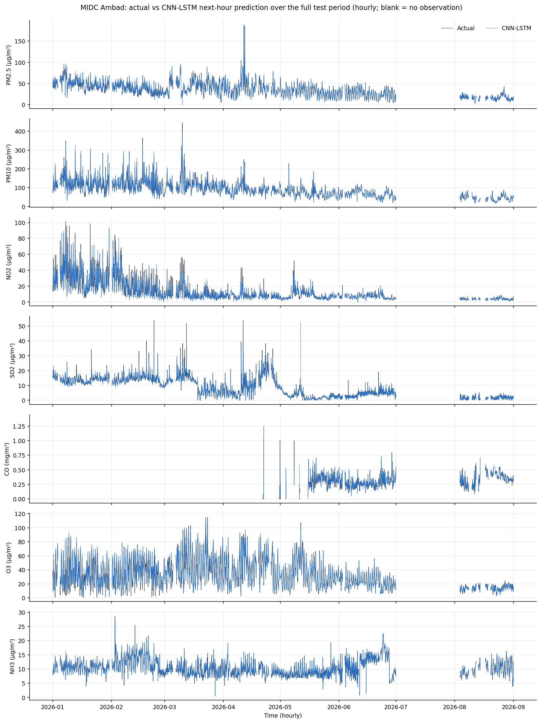
Figure 5. MIDC Ambad: hourly actual and CNN-LSTM predicted concentrations over the whole test period. Blank stretches have no observation (including July 2026).
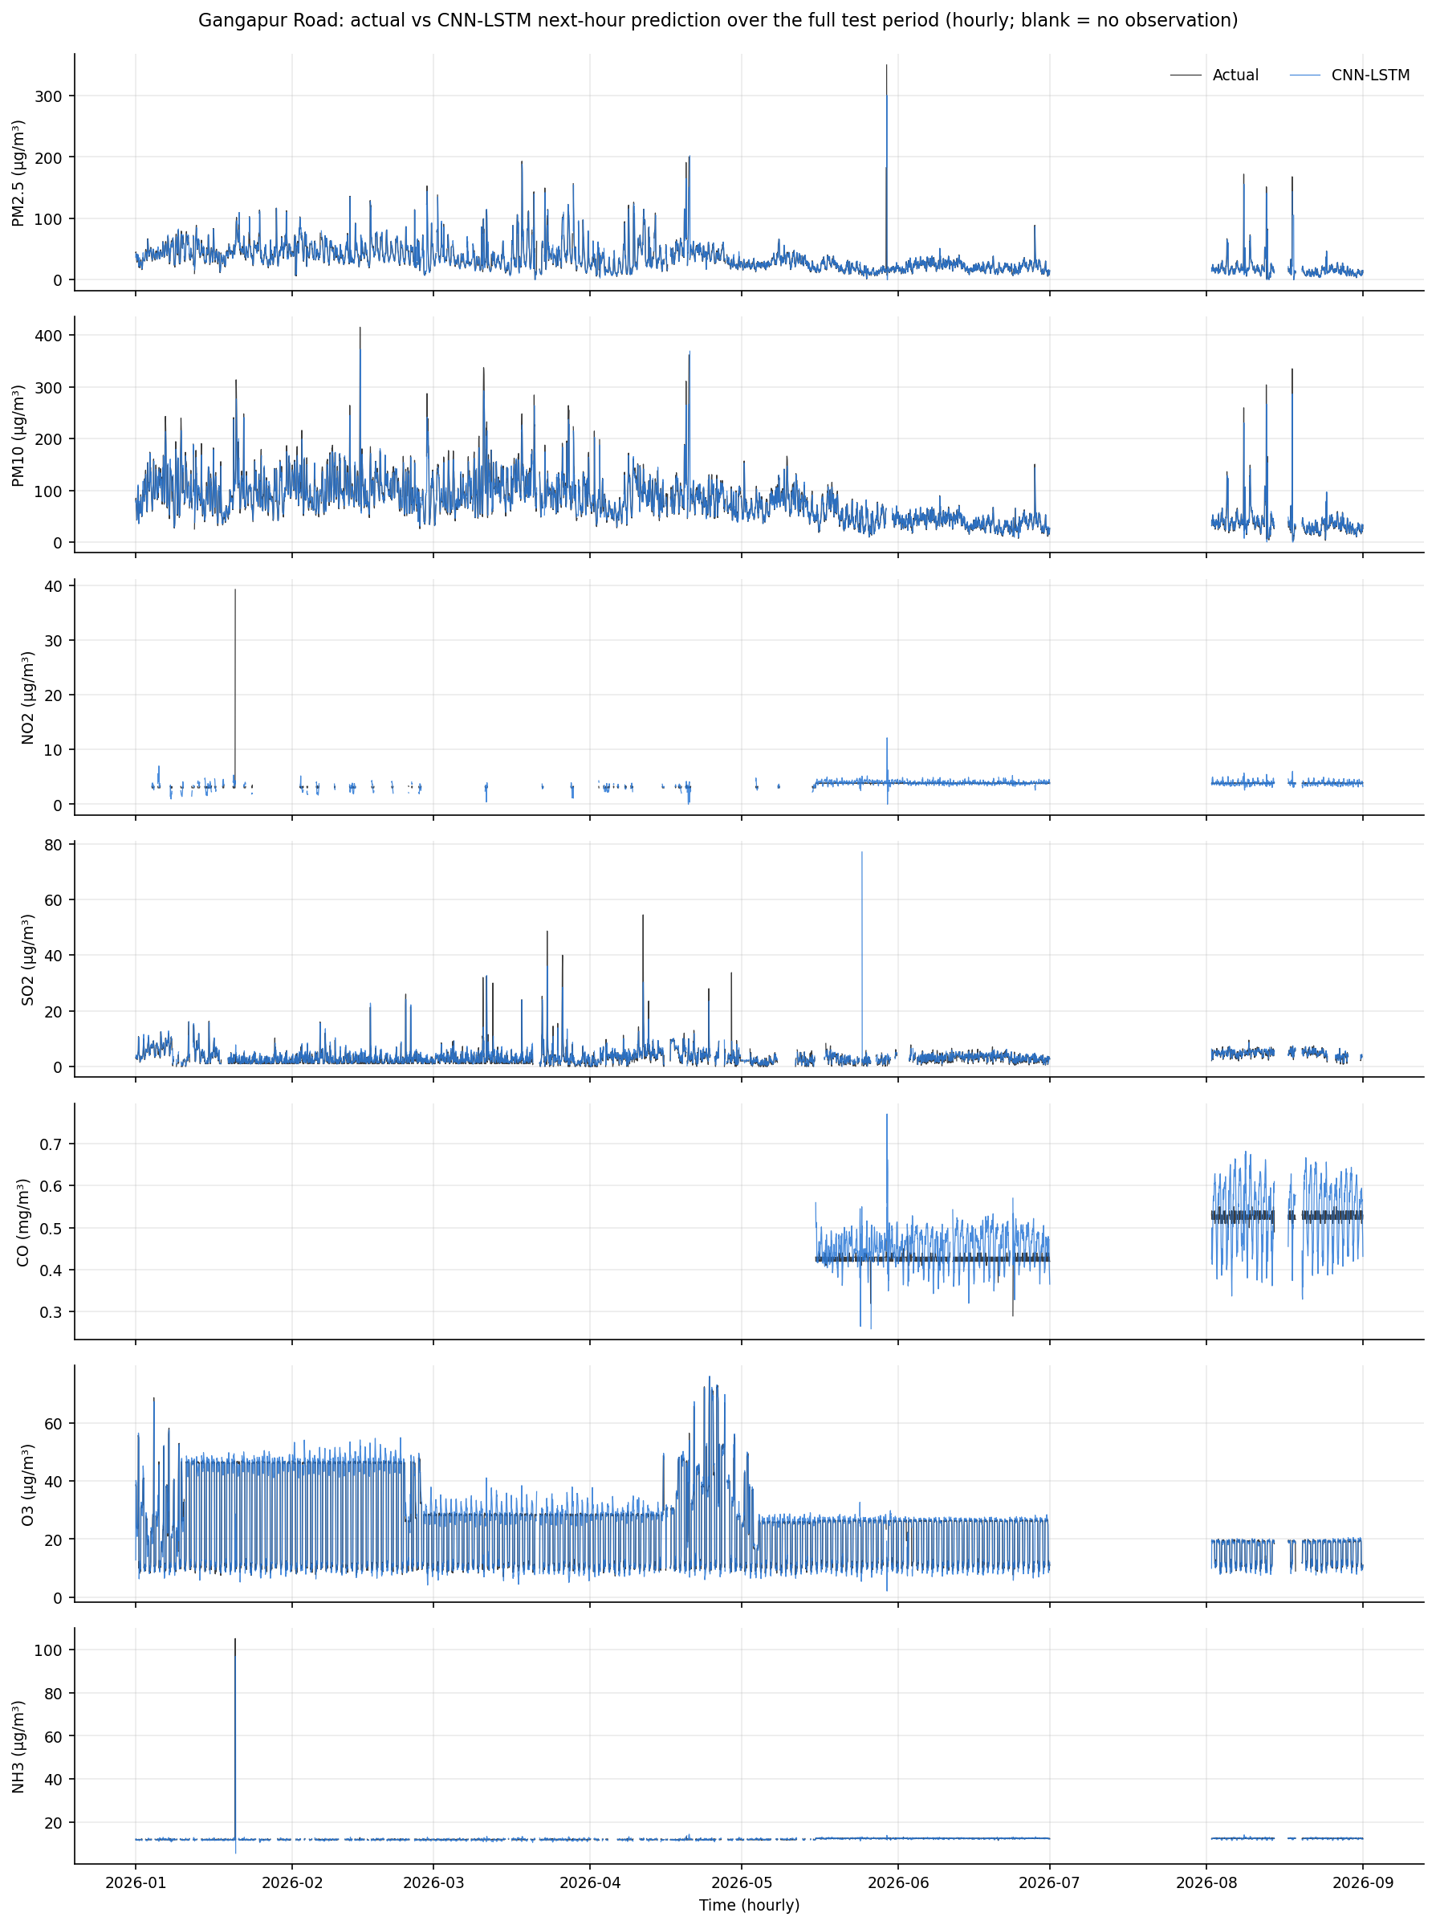
Figure 6. Gangapur Road: hourly actual and CNN-LSTM predicted concentrations over the whole test period. Blank stretches have no observation (including July 2026).
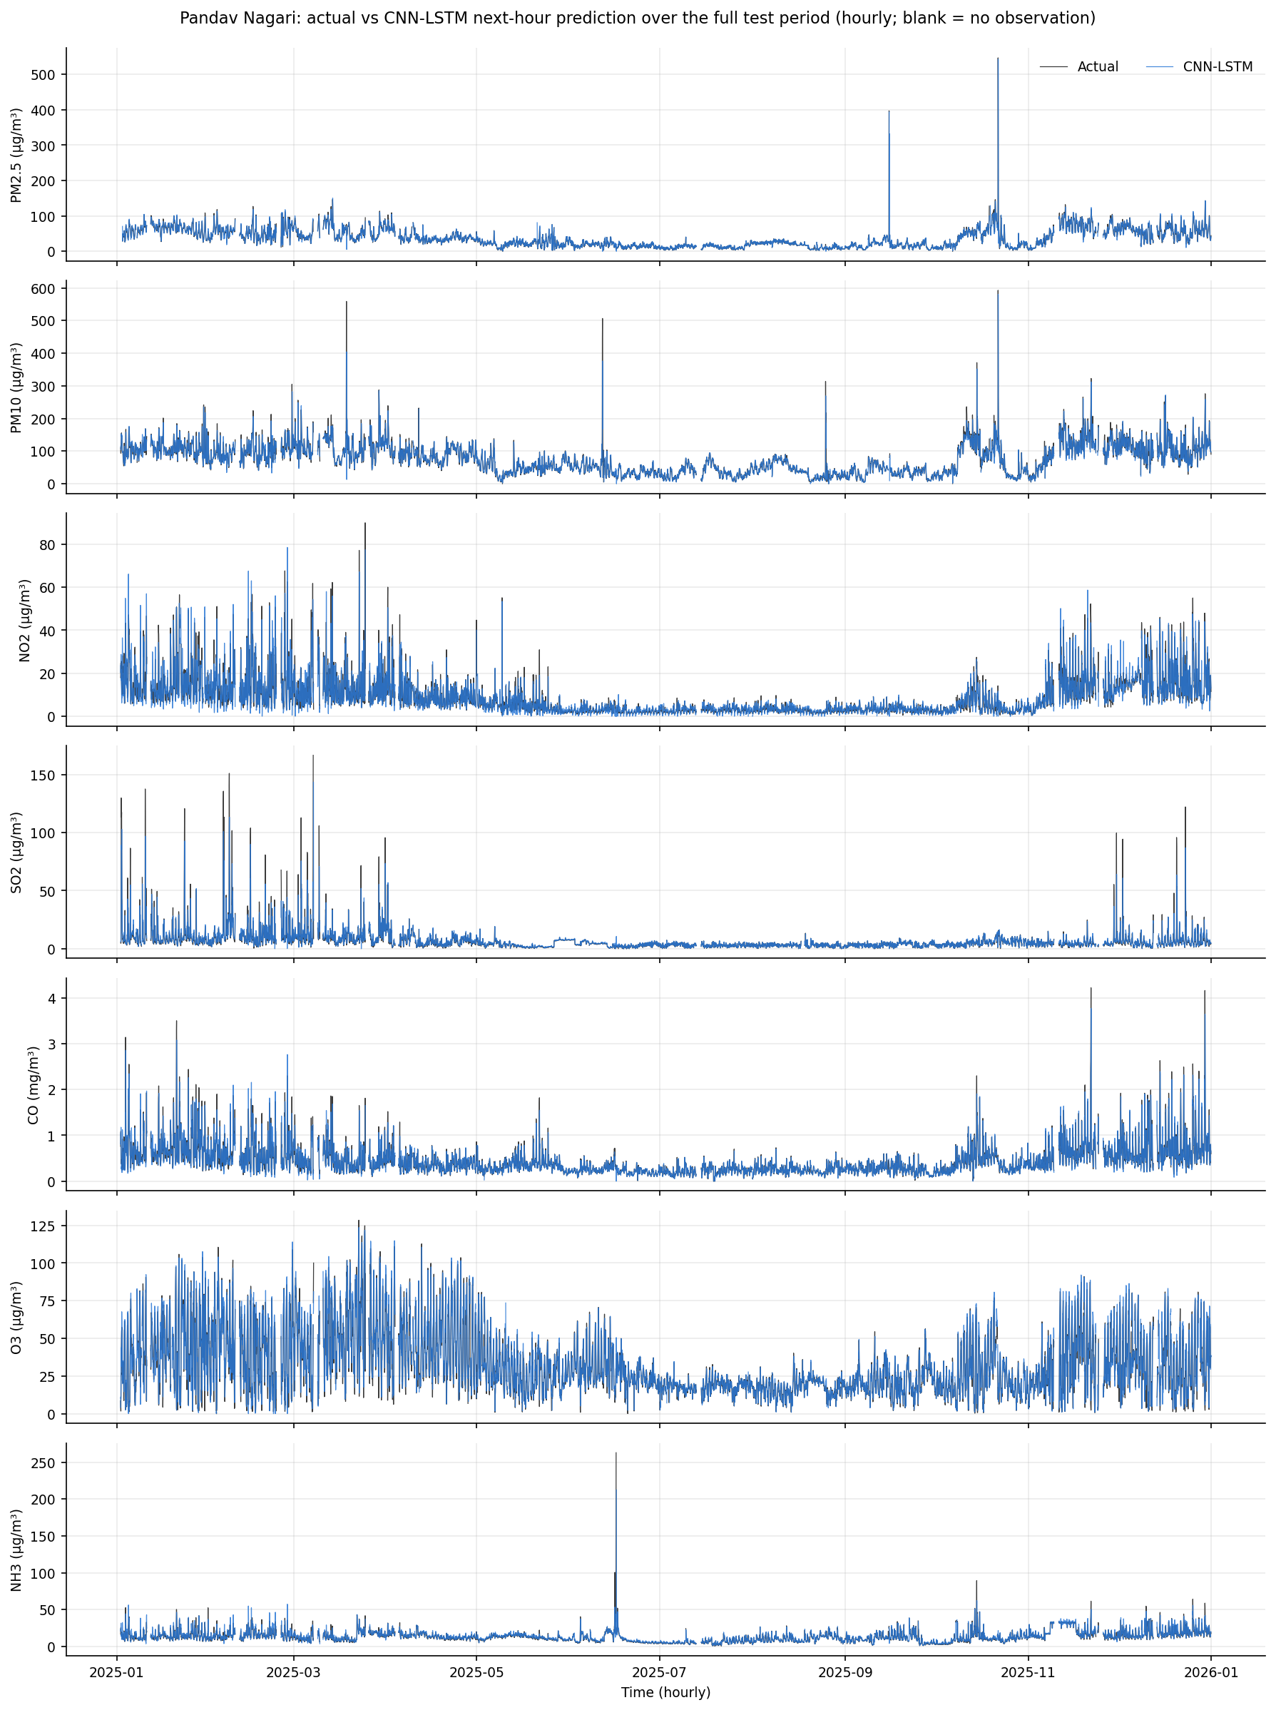
Figure 7. Pandav Nagari: hourly actual and CNN-LSTM predicted concentrations over the whole test period. Blank stretches have no observation (including July 2026).
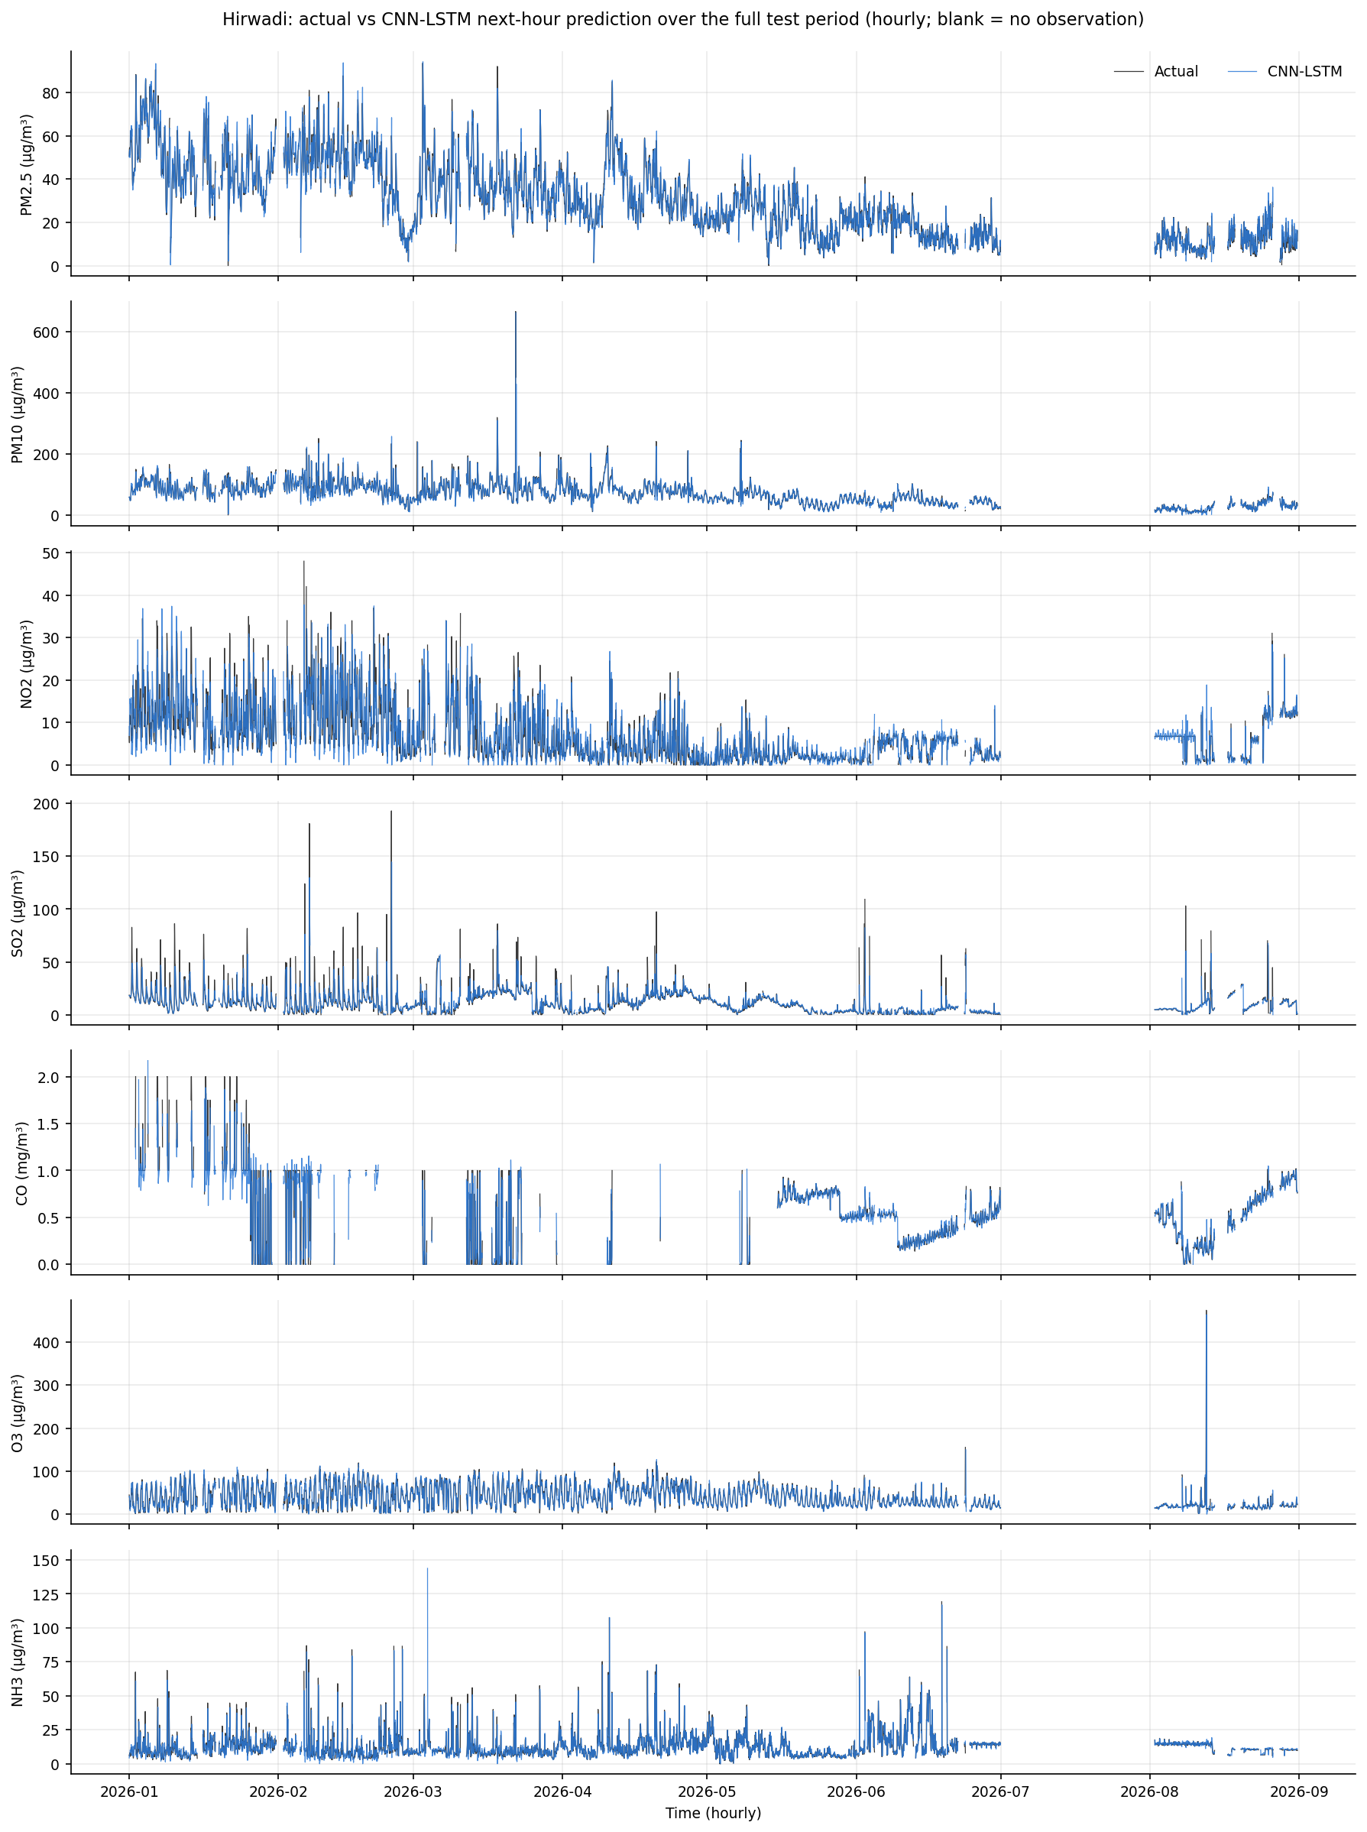
Figure 8. Hirwadi: hourly actual and CNN-LSTM predicted concentrations over the whole test period. Blank stretches have no observation (including July 2026).
Across the test period the predictions track the observed series closely at all stations, including the seasonal decline in particulate matter from winter to the monsoon. At hourly resolution the two lines overlap for most of the period, which is expected for a one-hour horizon. Visible departures are at isolated spikes (for example SO2 and NH3 bursts). For 28 of 28 series the predictions correlate more strongly with the previous hour's observation than with the current one: the model largely follows the series one hour late, as persistence does, and adds a small correction.
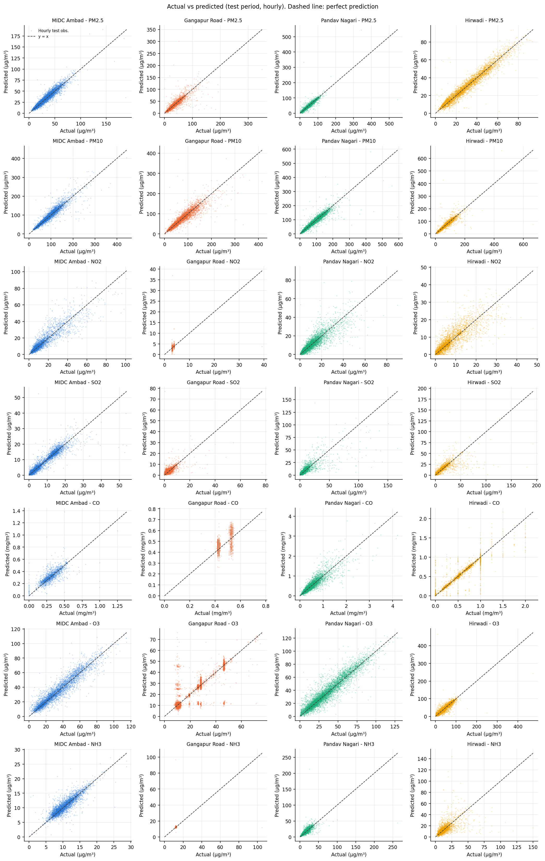
Figure 9. Predicted against actual hourly concentration per station (columns) and pollutant (rows). Dashed line: perfect prediction.
Points cluster along the 1:1 line for particulate matter and O3. The flagged Gangapur Road CO panel shows vertical bands and its NO2 panel a tight cluster, because the observed values take only a few discrete levels. The highest values fall below the line: within the top 1% of observed hours of each series, the prediction is lower than the observation in a median of 82% of hours (range 35-98% across the 28 series).
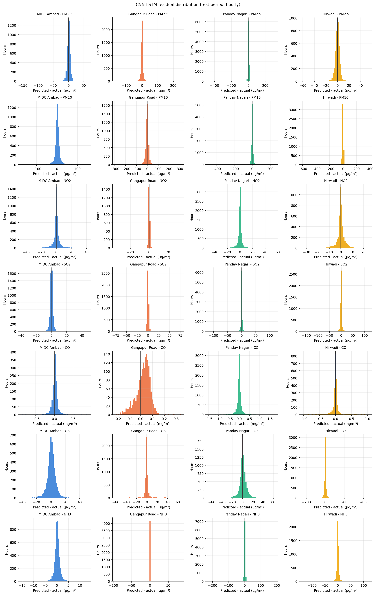
Figure 10. Distribution of CNN-LSTM residuals (predicted minus actual) per station and pollutant over the test period.
Residuals are centred near zero with long tails in both directions. The tails come from abrupt changes: in the hours with the sharpest rises, residuals are negative (the rise is under-predicted), and in the hours with the sharpest falls they are positive.
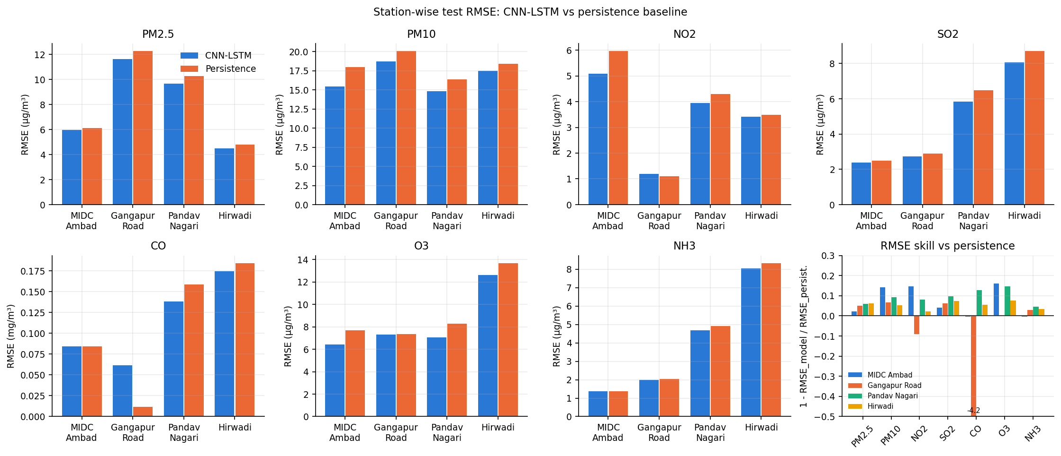
Figure 11. Test RMSE of the CNN-LSTM and persistence per station and pollutant, and RMSE skill (bottom right; bars below the axis limit are labelled with their value).

14. Discussion
Leakage checks. The scaler and imputer of each station were fitted on training rows only. A separate verification script recomputes the scaler means from the raw training rows, re-derives every test actual value and every persistence prediction from the raw CSV files, confirms that every evaluated hour lies in the test year, and recomputes MSE, RMSE, MAE and R² by hand from the exported predictions. The script was itself tested by injecting a leaked baseline, a one-hour timestamp shift and corrupted predictions; it rejected all three.
Quality-flagged series. Four test series take fewer than 100 distinct values over thousands of hours: Gangapur Road NO2, CO and NH3, and MIDC Ambad CO. At Gangapur Road in 2026, NO2 reads mostly 3.00 µg/m³ in 0.25 steps (34 distinct values, against about 2,400 per year before) and CO mostly 0.00 mg/m³ (17 values). The model was trained on the earlier, continuous behaviour, so its predictions are poor there (Gangapur Road CO skill -420%). These series measure an instrument change, not the model's ability to predict air quality. They are reported in every table but excluded from the pooled summary.
Overfitting and data availability. Early stopping ended training after 11-22 epochs. Hirwadi shows the clearest overfitting (validation loss rising after epoch 5). Training data is unbalanced: Gangapur Road has about 65,000 training windows, while Pandav Nagari has about 9,500. Despite that, Pandav Nagari has the best skill, which suggests that recent, consistent data matters more here than volume. Gangapur Road's long history includes years whose behaviour differs from 2026.
Comparison with other studies. Studies such as [3] and [4] report CNN-LSTM models outperforming other neural networks for PM2.5 prediction. The results here neither confirm nor contradict them. The experiment shows that, for next-hour prediction on these stations, a CNN-LSTM gives a small but consistent improvement over persistence when trained to predict the change from the last value, but not when trained to predict the level.

15. Limitations
- The latest year is incomplete: 2026 covers January-June and August (5,088 hours); July is absent. Results for 2026 do not represent a full seasonal cycle.
- Pandav Nagari is evaluated on 2025, not 2026, so station results cover different periods and are not strictly comparable.
- Three stations have only about two years of training data (mid-2023 to June 2025), and 2023 is partially covered.
- Meteorological inputs were excluded because of missing or inconsistent sensors. Wind, temperature and humidity are known drivers of pollutant concentration, and their absence limits accuracy, especially at spikes.
- One hour ahead only. Skill at longer horizons, where persistence degrades, was not measured.
- Single training run per model (seed 42); no confidence intervals or multiple-seed variance are reported. Differences of a few per cent in skill may be within run-to-run variation.
- The quality flag (fewer than 100 distinct test values) and the 12-hour stuck rule are simple heuristics; some degraded readings may remain (for example, Hirwadi CO alternates between about 0 and 1 mg/m³ in February-April 2026).
- KNN imputation assumes hours with similar pollutant profiles are interchangeable. Long all-missing stretches receive the training mean.

16. Conclusion and Future Scope
A reproducible pipeline was built for next-hour prediction of seven pollutants at four Nashik stations, using leakage-free KNN imputation, per-station CNN-LSTM models and a chronological hold-out of each station's latest year. On quality-checked series, the selected model explains 0.46-0.85 of the pooled test variance and reduces RMSE relative to persistence by 3.7-10.6% depending on the pollutant. The improvement is modest, and a model that predicted levels directly did not beat persistence on validation data at any station. The experiment also exposed sensor problems in the 2026 data that should be resolved with the data provider.
Future work: add quality-controlled meteorological inputs; evaluate horizons of 6-24 hours, where persistence is weaker; report variance over several seeds; compare with simpler learned baselines (for example, gradient-boosted trees on lag features) to establish whether the recurrent architecture is necessary; and re-evaluate on a complete 2026 once the data is available.

17. References
[1] S. Hochreiter and J. Schmidhuber, "Long Short-Term Memory," Neural Computation, vol. 9, no. 8, pp. 1735-1780, 1997, doi: 10.1162/neco.1997.9.8.1735.
[2] O. Troyanskaya, M. Cantor, G. Sherlock, P. Brown, T. Hastie, R. Tibshirani, D. Botstein and R. B. Altman, "Missing value estimation methods for DNA microarrays," Bioinformatics, vol. 17, no. 6, pp. 520-525, 2001, doi: 10.1093/bioinformatics/17.6.520.
[3] C.-J. Huang and P.-H. Kuo, "A Deep CNN-LSTM Model for Particulate Matter (PM2.5) Forecasting in Smart Cities," Sensors, vol. 18, no. 7, art. 2220, 2018, doi: 10.3390/s18072220.
[4] D. Qin, J. Yu, G. Zou, R. Yong, Q. Zhao and B. Zhang, "A Novel Combined Prediction Scheme Based on CNN and LSTM for Urban PM2.5 Concentration," IEEE Access, vol. 7, pp. 20050-20059, 2019, doi: 10.1109/ACCESS.2019.2897028.
[5] H. Junninen, H. Niska, K. Tuppurainen, J. Ruuskanen and M. Kolehmainen, "Methods for imputation of missing values in air quality data sets," Atmospheric Environment, vol. 38, no. 18, pp. 2895-2907, 2004, doi: 10.1016/j.atmosenv.2004.02.026.
[6] F. Pedregosa et al., "Scikit-learn: Machine Learning in Python," Journal of Machine Learning Research, vol. 12, pp. 2825-2830, 2011.
[7] Y. LeCun, L. Bottou, Y. Bengio and P. Haffner, "Gradient-based learning applied to document recognition," Proceedings of the IEEE, vol. 86, no. 11, pp. 2278-2324, 1998, doi: 10.1109/5.726791.
[8] D. P. Kingma and J. Ba, "Adam: A Method for Stochastic Optimization," arXiv:1412.6980, 2014 (ICLR 2015).
[9] N. Srivastava, G. Hinton, A. Krizhevsky, I. Sutskever and R. Salakhutdinov, "Dropout: A Simple Way to Prevent Neural Networks from Overfitting," Journal of Machine Learning Research, vol. 15, pp. 1929-1958, 2014.
[10] C. Bergmeir and J. M. Benítez, "On the use of cross-validation for time series predictor evaluation," Information Sciences, vol. 191, pp. 192-213, 2012, doi: 10.1016/j.ins.2011.12.028.

