Hourly Air-Quality Forecasting for Nashik Monitoring Stations with KNN Imputation and a CNN-LSTM Network: 2025 Backtest and Partial 2026 Evaluation
Academic Project Report

[Student name] · [Roll number]
[Department, Institution]
[Course / guide]
[Submission date]

Abstract
Hourly concentrations of seven pollutants (PM2.5, PM10, NO2, SO2, CO, O3 and NH3) from four continuous monitoring stations in Nashik, India (MIDC Ambad, Gangapur Road, Pandav Nagari and Hirwadi) were used to train one convolutional-LSTM (CNN-LSTM) network per station that predicts the next hour from the previous 24. Missing inputs were filled with a K-nearest-neighbours imputer fitted on training data only. The pipeline runs in two separate modes. The 2025 backtest uses data up to 31 December 2024 (network fitted to 30 June 2024, validated on July-December 2024) and is scored on 2025, which is measured at all stations. The 2026 run uses data up to 31 December 2025 in the same way and forecasts all 8,760 hours of 2026 at all four stations; measurements exist only for January-June and August 2026 at three stations and not at all at Pandav Nagari. Two kinds of prediction are scored separately on measured hours: a recursive forecast of the whole year from the forecast origin, which uses no later measurement, and a rolling one-step evaluation, in which the frozen model predicts each measured hour from the measured previous 24 hours. Faulty sensor readings (stuck values, CO zeros and near-constant 'flatline' days) are removed before training and are never scored. Pooled over stations, with quality-flagged sensor series excluded, the recursive forecast changed RMSE relative to a month-by-hour climatology by -223.0% (PM2.5) to -20.9% (PM10) in 2025 and -211.8% (PM10) to 10.6% (CO) in 2026 (negative = worse than climatology): fed its own predictions for a year, the network is a worse year-ahead estimate than climatology for every pollutant in 2025 and 6 of 7 pollutants in 2026. The one-step predictions changed RMSE relative to persistence by -3.7% (NO2) to 8.1% (SO2) in 2025 and -5.8% (CO) to 10.4% (PM10) in 2026: a small, mostly consistent gain when fresh measurements are available every hour. Daily CPCB AQI values were derived from the predicted concentrations; they are model estimates, not official AQI bulletins.

Keywords
air-quality forecasting; CNN-LSTM; KNN imputation; recursive forecasting; backtest; CPCB AQI; Nashik; chronological validation

Key Findings in Plain Language
This page states the conclusions first. The rest of the report gives the evidence.
- What the model does. For each station, a neural network reads the last 24 hours of seven pollutant measurements and predicts the next hour.
- Next-hour prediction works, modestly. The simplest possible guess is persistence: 'next hour = the latest measured value'. One hour ahead, the CNN-LSTM is more accurate than persistence for 22 of 28 station-pollutant series in 2025 and 12 of 17 in 2026. The typical (median) error reduction is 5.8% in 2025 and 4.4% in 2026. That is a real but small improvement.
- A high R² is not proof of a good model. Hourly pollution changes slowly, so persistence already reaches a high R². Every R² in this report is shown next to a baseline scored on exactly the same hours.
- A full-year forecast does not work with this model. Feeding the model its own predictions for a whole year lets errors pile up. Against climatology (the average for that month and hour of day), the recursive CNN-LSTM is better for only 3 of 28 series in 2025 and 2 of 17 in 2026. For months ahead, climatology is the better estimate.
- Faulty sensor readings were removed before training and scoring. Examples are Gangapur Road NO2 stuck near 3.85 µg/m³ from late August 2025, Gangapur Road NH3 stuck near 12 µg/m³ in 2026, and CO reading 0.00 mg/m³ for months in 2026. Every removed hour is counted and labelled; pollution peaks are never removed.
- 2026 is only a partial test: January-June and August at three stations. July is missing from all files, September-December have not happened in the data, and Pandav Nagari has no 2026 data at all.

Glossary
- Station-pollutant series: the hourly record of one pollutant at one station (4 stations x 7 pollutants = 28 series).
- Persistence baseline: predict that the next hour equals the latest measured value.
- Climatology baseline: predict the historical average for that calendar month and hour of day.
- RMSE / MAE: typical size of the prediction error, in µg/m³ (mg/m³ for CO). Lower is better.
- Skill: 1 - RMSE(model) / RMSE(baseline). Positive means the model beats the baseline; 0.05 means 5% lower error.
- Rolling one-step prediction: each hour is predicted from the real measurements of the previous 24 hours.
- Recursive forecast: the model's own predictions are fed back as inputs, so it can run for a whole year without any future measurement.
- Imputation: filling a missing input value with an estimate. Missing target values are never filled; they are simply not scored.

1. Introduction
Short-term air-quality prediction supports public advisories and operational decisions such as traffic or industrial-emission controls. Continuous ambient monitoring stations report hourly concentrations, but their records contain gaps, instrument faults and changes in data availability, so any forecasting pipeline must handle missing data without using information from after the forecast origin.
Hybrid convolutional-recurrent networks are a common choice for such series: one-dimensional convolutions extract short local patterns, and Long Short-Term Memory (LSTM) layers model longer dependencies [1], [3], [4]. This project applies that design to four Nashik stations, produces an hourly forecast of 2026, and tests the same procedure on 2025, where the full year was measured.

2. Problem Statement
Using only the hourly observations of a station available before 1 January 2026, forecast the concentrations of seven pollutants for every hour of 2026, and measure the accuracy of the same procedure where the answer is known: on 2025, with data up to 31 December 2024, and on the hours of 2026 that have since been measured.

3. Objectives
- Document the dataset's schema, coverage and quality problems per station.
- Build reproducible cleaning and KNN imputation fitted without temporal leakage.
- Train one CNN-LSTM per station on data before each forecast origin.
- Export a continuous hourly 2026 forecast for all four stations, including hours and stations without measurements, without fabricating ground truth.
- Score recursive and one-step predictions separately with MSE, RMSE, MAE and R² in original units, against climatology, same-hour-last-year and persistence baselines.
- Derive daily CPCB AQI from the predicted concentrations, clearly separated from measured AQI.

4. Dataset Description
The dataset consists of four CSV files, one per station. Station identity is given only by the file name. All files share 25 columns: a Timestamp plus 24 measurements (criteria pollutants, volatile organic compounds and meteorological variables). The Hirwadi file has an extra Source_File column whose labels do not match the timestamps, so it was dropped and the timestamps were treated as authoritative. Hirwadi rows are stored out of order and were sorted. No file contains duplicate timestamps.
Table 1. Raw files as delivered.
Station | Rows | First timestamp | Last timestamp | Duplicate times | Sorted | Years present | Rows with no pollutant
MIDC Ambad | 40152 | 2017-01-01 | 2026-08-31 23:00:00 | 0 | True | 2017, 2023, 2024, 2025, 2026 | 14377
Gangapur Road | 81024 | 2017-01-01 | 2026-08-31 23:00:00 | 0 | True | 2017, 2018, 2019, 2020, 2021, 2022, 2023, 2024, 2025, 2026 | 4945
Pandav Nagari | 35064 | 2017-01-01 | 2025-12-31 23:00:00 | 0 | True | 2017, 2023, 2024, 2025 | 12761
Hirwadi | 40152 | 2017-01-01 | 2026-08-31 23:00:00 | 0 | False | 2017, 2023, 2024, 2025, 2026 | 13873

Table 2. Coverage of each forecast horizon in the station files.
Station | Horizon | Rows in file (of 8,760) | Hours with a measurement | First measured | Last measured | Months with no rows
MIDC Ambad | 2025 | 8760 | 8456 | 2025-01-01 00:00:00 | 2025-12-31 23:00:00 | none
Gangapur Road | 2025 | 8760 | 8511 | 2025-01-01 00:00:00 | 2025-12-31 23:00:00 | none
Pandav Nagari | 2025 | 8760 | 8435 | 2025-01-01 16:00:00 | 2025-12-31 23:00:00 | none
Hirwadi | 2025 | 8760 | 8550 | 2025-01-01 00:00:00 | 2025-12-31 23:00:00 | none
MIDC Ambad | 2026 | 5088 | 4739 | 2026-01-01 | 2026-08-31 23:00:00 | Jul, Sep, Oct, Nov, Dec
Gangapur Road | 2026 | 5088 | 4989 | 2026-01-01 | 2026-08-31 23:00:00 | Jul, Sep, Oct, Nov, Dec
Pandav Nagari | 2026 | 0 | 0 | - | - | Jan, Feb, Mar, Apr, May, Jun, Jul, Aug, Sep, Oct, Nov, Dec
Hirwadi | 2026 | 5088 | 4844 | 2026-01-01 | 2026-08-31 15:00:00 | Jul, Sep, Oct, Nov, Dec

Three files begin with an empty 2017 block and resume in mid-2023; Gangapur Road has data from 2017 onwards. In 2026, every file that has 2026 rows covers 1 January-30 June and 1-31 August (5,088 of 8,760 hours); July and September-December are absent. Pandav Nagari's file ends on 31 December 2025. Its 2026 forecast is produced like the others but cannot be scored.
Seven pollutants are the prediction targets: the pollutants of the Indian National AQI present in the data (PM2.5, PM10, NO2, SO2, CO, O3, NH3). The model uses no weather inputs. The files do contain weather columns, which are measured for about 93-97% of hours at MIDC Ambad, Pandav Nagari and Hirwadi. At Gangapur Road, temperature and humidity cover only about 5% of hours. Weather was left out to keep one consistent input set for all stations.
In January-May 2026 many values at the three stations with 2026 data are reported as whole numbers (25-50% of values, against about 1% before). This looks like a change in reporting precision, not a sensor fault, and these values are kept.

5. Data Preprocessing and KNN Imputation

5.1 Cleaning rules
- Timestamps parsed and sorted; a duplicate timestamp would keep its first row (none occur).
- Rows before a station's first pollutant observation removed (the empty 2017 blocks).
- Negative concentrations set to missing (none occur).
- PM2.5 or PM10 of 999 or more set to missing: the analyser ceiling (21 values). The true value is unknown above the ceiling; one such hour is Diwali night 2024 at Gangapur Road.
- Any value repeated unchanged for 12 or more consecutive hours set to missing as a stuck-sensor reading (13,921 values).
- CO of exactly 0.00 mg/m³ set to missing. Outdoor CO never falls to zero (the clean-air background is about 0.1 mg/m³), and the zeros come in long blocks when the analyser is off (1,645 further values after the stuck rule). Zeros of other pollutants are kept.
- Flatline days set to missing. A failed sensor can jitter around a fixed level instead of repeating one value exactly. For each station, pollutant and calendar day with at least 12 measured hours, the day is removed when the spread of its values (90th minus 10th percentile) is below 5% of its median (40,356 values). Real pollution varies far more within a day, so this rule only removes near-constant days and can never remove a pollution peak.
- No interpolation or resampling. Hours absent from a file are not filled, and no input window spans them.
Table 3. Hourly values removed by each cleaning rule, whole file (all pollutants).
Station | PM ceiling | Stuck 12 h | CO zero | Flatline days
MIDC Ambad | 0 | 3107 | 84 | 391
Gangapur Road | 21 | 8482 | 1241 | 38626
Pandav Nagari | 0 | 0 | 9 | 829
Hirwadi | 0 | 2332 | 311 | 510

Table 4. Hourly values removed by the flatline rule, per pollutant (whole file). Gangapur Road dominates: its NO2, NH3, O3 and CO analysers have long near-constant periods (e.g. O3 at 45.0 µg/m³ in December 2021-March 2022, NO2 at 6.28 µg/m³ in March-June 2023, NO2 at 3.85 µg/m³ from late August 2025).
Station | PM2.5 | PM10 | NO2 | SO2 | CO | O3 | NH3
MIDC Ambad | 0 | 0 | 0 | 91 | 72 | 85 | 143
Gangapur Road | 14 | 0 | 13223 | 12 | 5153 | 5227 | 14997
Pandav Nagari | 48 | 48 | 0 | 168 | 48 | 72 | 445
Hirwadi | 0 | 0 | 168 | 111 | 147 | 0 | 84

Detected sensor faults that remain uncertain are reported, not hidden: in mid-2025 CO at Gangapur Road and MIDC Ambad varies only within a few 0.01 mg/m³ steps. These months pass the flatline rule and are kept.

5.2 Missing values
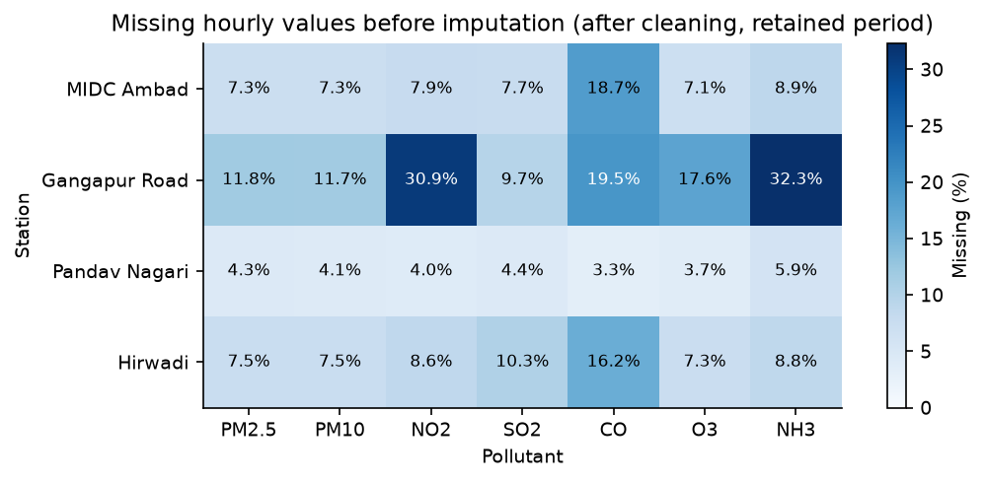
Figure 1. Missing hourly values per station and pollutant before imputation (all data up to the end of the 2026 horizon).
Table 5. Percentage of missing hourly values before imputation.
Station | PM2.5 | PM10 | NO2 | SO2 | CO | O3 | NH3
MIDC Ambad | 7.3 | 7.3 | 7.9 | 7.7 | 18.7 | 7.0 | 8.9
Gangapur Road | 11.8 | 11.7 | 30.9 | 9.7 | 19.5 | 17.6 | 32.3
Pandav Nagari | 4.3 | 4.1 | 4.0 | 4.4 | 3.3 | 3.7 | 5.9
Hirwadi | 7.5 | 7.5 | 8.6 | 10.3 | 16.2 | 7.3 | 8.8

5.3 KNN imputation
The pollutants are first standardised, then imputed. A missing value is filled with the inverse-distance-weighted mean of that variable in the k = 5 most similar hours, using the NaN-Euclidean distance over the seven standardised pollutants of the same hour [2], [5], [6].
- One StandardScaler and one KNNImputer per station and mode, fitted on that station's training rows only, then applied unchanged to validation, test and forecast inputs. Every training row is a candidate donor; no sub-sample is drawn.
- Many missing values occur in hours where all seven pollutants are missing (a whole-station outage). KNN has nothing to compare such an hour with, so it receives the training mean of each pollutant.
- Imputed values are model inputs only. Training targets are never imputed (the loss is masked) and every metric uses measured values only.
- Hours with every pollutant missing get the training mean; windows with more than half of their pollutant cells imputed are discarded.
Table 6. Missing pollutant cells before and after KNN imputation, 2026-forecast mode.
Station | Split | Missing cells before | Missing cells after
MIDC Ambad | train | 10148 | 0
MIDC Ambad | val | 1760 | 0
MIDC Ambad | test | 5851 | 0
Gangapur Road | train | 84261 | 0
Gangapur Road | val | 8178 | 0
Gangapur Road | test | 15783 | 0
Pandav Nagari | train | 5178 | 0
Pandav Nagari | val | 1615 | 0
Pandav Nagari | test | 0 | 0
Hirwadi | train | 11734 | 0
Hirwadi | val | 1041 | 0
Hirwadi | test | 5753 | 0

6. Exploratory Data Analysis
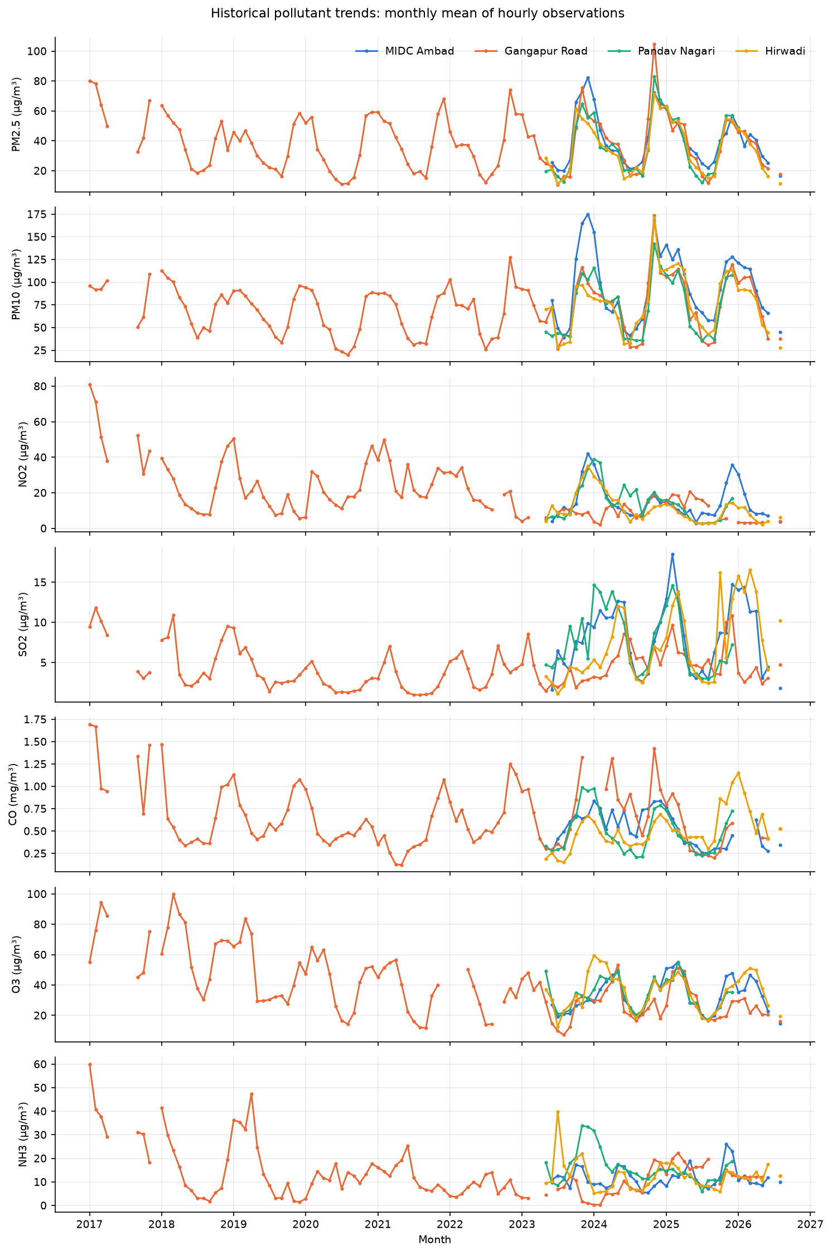
Figure 2. Monthly means of hourly observations per pollutant and station. Gaps are periods with no observations.
Particulate matter follows a seasonal cycle at all stations: low during the monsoon (June-September) and high in winter. This cycle is what a year-ahead forecast can realistically capture. Gangapur Road's gas analysers (NO2, NH3, O3, CO) have long near-constant periods, removed by the flatline rule, and their levels shift between years, so its older history is a weaker guide to 2025-2026.
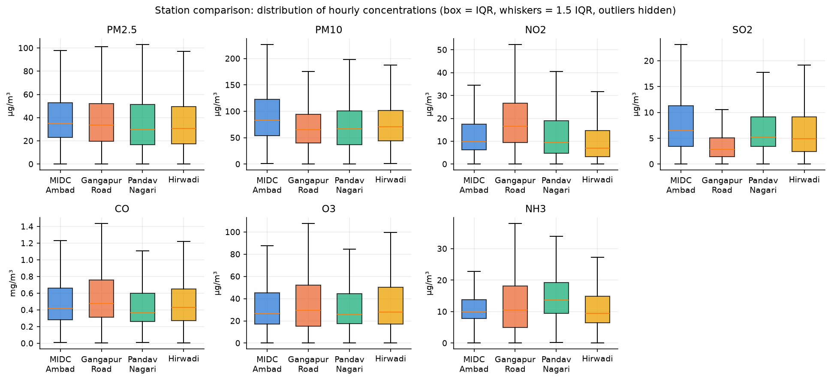
Figure 3. Distribution of hourly concentrations by station (box: interquartile range; whiskers: 1.5 IQR; outliers hidden).

7. CNN-LSTM Architecture
Two causal one-dimensional convolutions (64 filters, kernel 3) extract local temporal motifs from the 24-hour window; max-pooling halves the sequence; an LSTM [1] with 64 units summarises it; dropout [9] regularises; two dense layers output the seven pollutants. Inputs per hour: the seven standardised, KNN-imputed pollutants plus sine and cosine encodings of hour-of-day, day-of-week and month (13 features). Calendar encodings are known for any future hour.
Table 7. CNN-LSTM layers (50,247 trainable parameters per station model).
Layer | Output shape | Configuration | Parameters
Input | (24, 13) | 24 hours x 13 features | 0
Conv1D | (24, 64) | 64 filters, kernel 3, causal padding, ReLU | 2,560
Conv1D | (24, 64) | 64 filters, kernel 3, causal padding, ReLU | 12,352
MaxPooling1D | (12, 64) | pool size 2 | 0
LSTM | (64) | 64 units, final hidden state | 33,024
Dropout | (64) | rate 0.2 | 0
Dense | (32) | ReLU | 2,080
Dense (output) | (7) | linear, one unit per pollutant | 231

8. Methodology

8.1 Two modes
Table 8. Run configuration. Each mode trains its own models, scalers and imputers and writes to its own output folder.
Mode | Training cutoff | Horizon start | Horizon end | Horizon hours
2025 backtest | 2024-12-31 23:00:00 | 2025-01-01 00:00:00 | 2025-12-31 23:00:00 | 8760
2026 forecast | 2025-12-31 23:00:00 | 2026-01-01 00:00:00 | 2026-12-31 23:00:00 | 8760

Within each mode, validation is the six months before the forecast origin and training is everything earlier: the 2025 backtest fits the network on data up to 30 June 2024 and validates on July-December 2024; the 2026 run fits on data up to 30 June 2025 and validates on July-December 2025. Scaler, imputer, network weights, early stopping and the choice of target design use only data up to the training cutoff. Horizon rows are used for two things only: as ground truth, and as inputs to the one-step evaluation.

8.2 Two kinds of prediction
- Recursive forecast (the 2026 forecast proper). The model starts from the 24 hours before the origin, predicts the next hour, appends that prediction (with the known calendar features) to its input window, drops the oldest hour and repeats for all 8,760 hours. Only the starting window is real data, so errors accumulate and, beyond the first days, the forecast can only carry the seasonal and diurnal pattern the model has learned. It is compared with three baselines that use the same information: hour-of-day by month climatology, the same hour 52 weeks earlier, and the last value before the origin.
- Rolling one-step evaluation (the task the network was trained for). For each measured horizon hour with a valid window, the frozen model predicts it from the measured previous 24 hours. This needs measurements up to the previous hour, so it exists only where the data exist. It is compared with persistence (the last observed value) on the same rows.
Predicted concentrations are clipped at zero, both before being fed back and on output; a pollutant concentration cannot be negative. Every horizon hour is exported. Each row records whether a measurement exists (observed), a value was rejected by the cleaning rules (removed_by_quality_check), the station file has the hour but no value (missing_value), or the file has no row for the hour (no_row_in_file). Ground truth is never imputed or interpolated, and only observed hours are scored.

8.3 Training and target design
Table 9. Training configuration (same for all stations and modes; no hyperparameter search).
Setting | Value
Loss | Masked MSE on standardised targets (missing targets excluded)
Optimiser | Adam [8], learning rate 0.001
Batch size / maximum epochs | 256 / 60
Early stopping | validation loss, patience 6, best weights
Random seed | 42 (Python, NumPy, TensorFlow)
Software | Python 3.12.14, TensorFlow 2.19.1, scikit-learn 1.9.1, pandas 3.0.6, NumPy 2.1.3

Two parameterisations of the same network are trained per station: level (predict the standardised concentration) and change (predict the difference from the last hour of the input window, then add it back). Training, one-step and recursive prediction all use that same base value; in the recursive forecast it is the previous prediction. The design for the recursive forecast is chosen by a recursive forecast of the validation half-year. The design for the one-step evaluation is chosen by one-step validation loss. Neither choice sees the horizon.
Table 10. 2025 backtest: model selection on validation data (MSE, standardised units).
Station | 1-step val: persistence | 1-step val: level | 1-step val: change | Recursive val: level | Recursive val: change | Recursive design | One-step design
MIDC Ambad | 0.1928 | 0.2358 | 0.1763 | 2.71 | 1.615 | change | change
Gangapur Road | 0.3141 | 0.2659 | 0.265 | 2.915 | 3.467 | level | change
Pandav Nagari | 0.2147 | 0.2356 | 0.1734 | 1.325 | 60.74 | level | change
Hirwadi | 0.2096 | 0.2532 | 0.1694 | 1.822 | 3.333 | level | change

Table 11. 2026 forecast: model selection on validation data (MSE, standardised units).
Station | 1-step val: persistence | 1-step val: level | 1-step val: change | Recursive val: level | Recursive val: change | Recursive design | One-step design
MIDC Ambad | 0.1629 | 0.1893 | 0.1369 | 1.586 | 2.829 | level | change
Gangapur Road | 0.143 | 0.1659 | 0.1288 | 2.942 | 1.484 | change | change
Pandav Nagari | 0.1219 | 0.1191 | 0.09565 | 1.672 | 1.742 | level | change
Hirwadi | 0.3723 | 0.3762 | 0.3361 | 2.683 | 1.95 | change | change

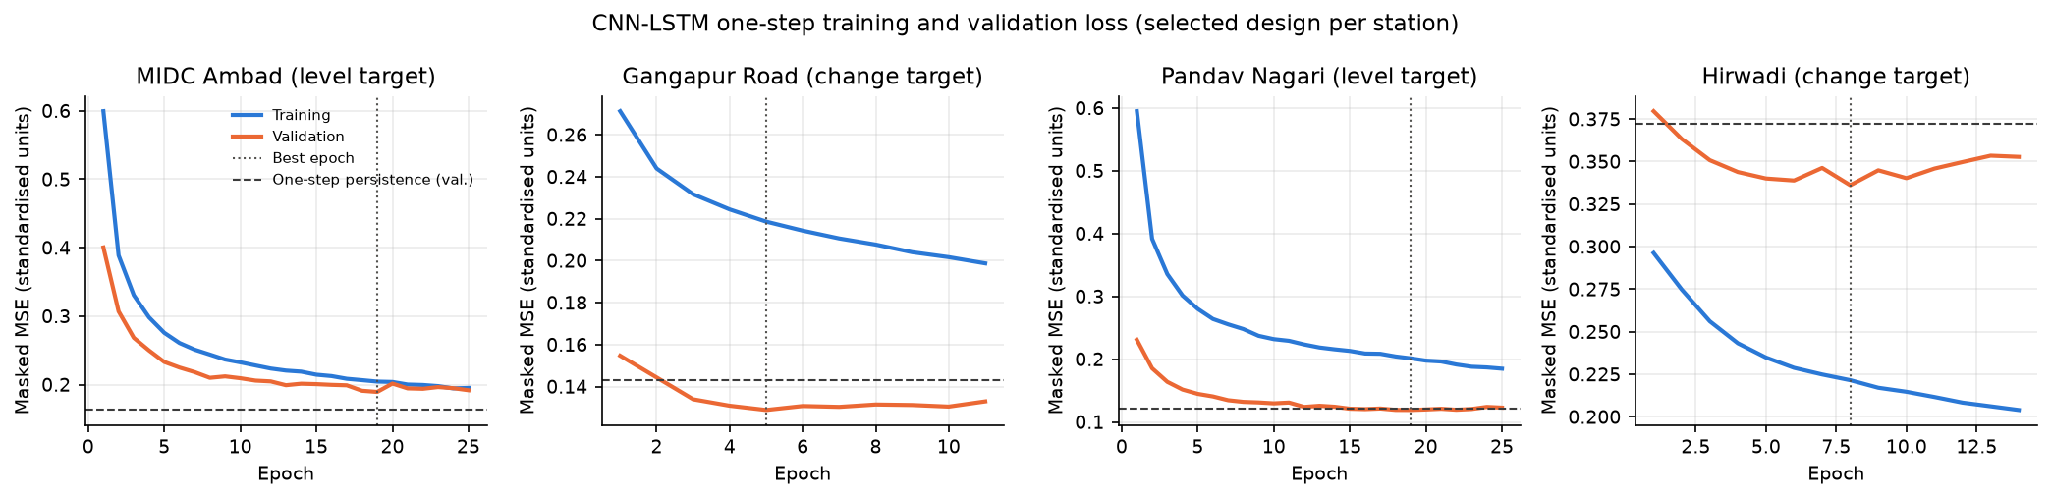
Figure 4. 2026-forecast mode: training and validation loss of the recursively selected design per station.

9. Chronological Splits
Random splitting would score the model on near-copies of its training hours and let it learn from the period it is tested on [10]. Every split here is chronological, and windows are assigned by the timestamp of the predicted hour.
Table 12. Splits per mode and station. Test = the horizon rows present in the file.
Mode | Station | Split | Start | End | Hourly rows | PM2.5 observed
2025 backtest | MIDC Ambad | train | 2023-06-14 14:00:00 | 2024-06-30 23:00:00 | 9178 | 8371
2025 backtest | MIDC Ambad | val | 2024-07-01 00:00:00 | 2024-12-31 23:00:00 | 4416 | 4054
2025 backtest | MIDC Ambad | test | 2025-01-01 00:00:00 | 2025-12-31 23:00:00 | 8760 | 8310
2025 backtest | Gangapur Road | train | 2017-01-01 00:00:00 | 2024-06-30 23:00:00 | 62760 | 54175
2025 backtest | Gangapur Road | val | 2024-07-01 00:00:00 | 2024-12-31 23:00:00 | 4416 | 4106
2025 backtest | Gangapur Road | test | 2025-01-01 00:00:00 | 2025-12-31 23:00:00 | 8760 | 8317
2025 backtest | Pandav Nagari | train | 2023-05-22 17:00:00 | 2024-06-30 23:00:00 | 9727 | 9391
2025 backtest | Pandav Nagari | val | 2024-07-01 00:00:00 | 2024-12-31 23:00:00 | 4416 | 4251
2025 backtest | Pandav Nagari | test | 2025-01-01 00:00:00 | 2025-12-31 23:00:00 | 8760 | 8277
2025 backtest | Hirwadi | train | 2023-05-23 16:00:00 | 2024-06-30 23:00:00 | 9704 | 8308
2025 backtest | Hirwadi | val | 2024-07-01 00:00:00 | 2024-12-31 23:00:00 | 4416 | 4291
2025 backtest | Hirwadi | test | 2025-01-01 00:00:00 | 2025-12-31 23:00:00 | 8760 | 8506
2026 forecast | MIDC Ambad | train | 2023-06-14 14:00:00 | 2025-06-30 23:00:00 | 17938 | 16560
2026 forecast | MIDC Ambad | val | 2025-07-01 00:00:00 | 2025-12-31 23:00:00 | 4416 | 4175
2026 forecast | MIDC Ambad | test | 2026-01-01 00:00:00 | 2026-08-31 23:00:00 | 5088 | 4708
2026 forecast | Gangapur Road | train | 2017-01-01 00:00:00 | 2025-06-30 23:00:00 | 71520 | 62401
2026 forecast | Gangapur Road | val | 2025-07-01 00:00:00 | 2025-12-31 23:00:00 | 4416 | 4197
2026 forecast | Gangapur Road | test | 2026-01-01 00:00:00 | 2026-08-31 23:00:00 | 5088 | 4876
2026 forecast | Pandav Nagari | train | 2023-05-22 17:00:00 | 2025-06-30 23:00:00 | 18487 | 17736
2026 forecast | Pandav Nagari | val | 2025-07-01 00:00:00 | 2025-12-31 23:00:00 | 4416 | 4183
2026 forecast | Pandav Nagari | test | - | - | 0 | 0
2026 forecast | Hirwadi | train | 2023-05-23 16:00:00 | 2025-06-30 23:00:00 | 18464 | 16799
2026 forecast | Hirwadi | val | 2025-07-01 00:00:00 | 2025-12-31 23:00:00 | 4416 | 4306
2026 forecast | Hirwadi | test | 2026-01-01 00:00:00 | 2026-08-31 23:00:00 | 5088 | 4769

10. Evaluation Metrics
For n measured hours with values yᵢ, predictions ŷᵢ and measured mean ȳ:
MSE = (1/n) Σ (yᵢ − ŷᵢ)²
RMSE = √MSE
MAE = (1/n) Σ |yᵢ − ŷᵢ|
R² = 1 − Σ (yᵢ − ŷᵢ)² / Σ (yᵢ − ȳ)²
- All metrics are in original units, after inverse scaling, on measured hours only. Every method is scored on exactly the same hours.
- n_valid is the number of measured hours scored. Coverage is n_valid as a share of the 8,760 horizon hours.
- R² is reported as undefined with fewer than two hours or zero variance, and flagged unreliable with fewer than 168 hours (one week).
- Recursive skill = 1 − RMSE_CNN-LSTM / RMSE_climatology; one-step skill = 1 − RMSE_CNN-LSTM / RMSE_persistence. Positive means the CNN-LSTM is better.
- Hours removed by the cleaning rules are never scored, for any method.
- As a second safeguard, a series whose remaining measured horizon values take fewer than 100 distinct values is quality-flagged. It is reported but left out of the pooled per-pollutant summary and the win counts. Pollutants are never pooled together.
- R² is never read on its own: hourly pollution is persistent, so even the persistence baseline reaches a high R². The skill against a baseline is the number that shows whether the model adds anything.

11. Results: 2025 Backtest
Models trained on data up to 31 December 2024 forecast every hour of 2025, which is measured at all four stations. This is the fair test of how the procedure behaves on a year it has never seen.

11.1 Recursive year-ahead forecast
Table 13. 2025: recursive forecast per station and pollutant, measured hours only (µg/m³; CO in mg/m³). * = quality-flagged series; '-' = no measured hours.
Station | Pollutant | n | Cov. % | RMSE | MAE | R² | RMSE clim. | RMSE last yr | RMSE persist. | Skill vs clim. | R² flag
MIDC Ambad | PM2.5 | 8310 | 94.86 | 125.8 | 105.4 | -30.56 | 20.92 | 26.46 | 24.06 | -5.013 | ok
MIDC Ambad | PM10 | 8327 | 95.06 | 61.53 | 47.47 | -0.3626 | 51.64 | 63.78 | 53.07 | -0.1916 | ok
MIDC Ambad | NO2 | 8267 | 94.37 | 25.63 | 20.42 | -2.976 | 11.83 | 15.85 | 12.97 | -1.166 | ok
MIDC Ambad | SO2 | 8275 | 94.46 | 17.68 | 14.66 | -3.233 | 8.281 | 10.03 | 8.887 | -1.135 | ok
MIDC Ambad | CO | 8286 | 94.59 | 0.8694 | 0.6989 | -8.762 | 0.3626 | 0.575 | 0.4218 | -1.398 | ok
MIDC Ambad | O3 | 8415 | 96.06 | 25.85 | 19.32 | -0.1983 | 19.33 | 23.47 | 24.11 | -0.3372 | ok
MIDC Ambad | NH3 | 8079 | 92.23 | 12.84 | 9.125 | -0.8606 | 9.615 | 10.79 | 12.09 | -0.3353 | ok
Gangapur Road | PM2.5 | 8317 | 94.94 | 34.79 | 28.09 | -0.6057 | 22.13 | 36.05 | 49.31 | -0.5721 | ok
Gangapur Road | PM10 | 8276 | 94.47 | 58.51 | 44.08 | -0.1657 | 43.94 | 60.57 | 76.48 | -0.3316 | ok
Gangapur Road | NO2 | 4967 | 56.7 | 24.92 | 19.8 | -9.095 | 15.07 | 13.5 | 14.04 | -0.6543 | ok
Gangapur Road | SO2 | 8438 | 96.32 | 9.191 | 6.088 | -0.7786 | 6.758 | 8.121 | 8.268 | -0.3601 | ok
Gangapur Road | CO | 8041 | 91.79 | 0.4873 | 0.3703 | -0.6611 | 0.4279 | 0.7289 | 1.358 | -0.1387 | ok
Gangapur Road | O3 | 7911 | 90.31 | 82.71 | 67.88 | -16.4 | 24.36 | 23.11 | 27.52 | -2.395 | ok
Gangapur Road | NH3 | 4984 | 56.89 | 13.09 | 9.985 | -1.992 | 9.437 | 14.56 | 9.44 | -0.3869 | ok
Pandav Nagari | PM2.5 | 8277 | 94.49 | 30.81 | 20.26 | -0.3628 | 21.18 | 30.79 | 26.42 | -0.4548 | ok
Pandav Nagari | PM10 | 8309 | 94.85 | 49.91 | 36.35 | -0.2096 | 36.13 | 53.96 | 46.26 | -0.3816 | ok
Pandav Nagari | NO2 | 8347 | 95.29 | 11.11 | 7.995 | -0.6995 | 14.2 | 19.26 | 8.618 | 0.218 | ok
Pandav Nagari | SO2 | 8301 | 94.76 | 9.574 | 4.119 | 0.008285 | 9.121 | 11.78 | 9.688 | -0.04967 | ok
Pandav Nagari | CO | 8407 | 95.97 | 0.3095 | 0.229 | 0.06024 | 0.2568 | 0.3219 | 0.3194 | -0.205 | ok
Pandav Nagari | O3 | 8350 | 95.32 | 24.23 | 18.24 | -0.3169 | 16.31 | 21.47 | 42.69 | -0.4854 | ok
Pandav Nagari | NH3 | 8205 | 93.66 | 14.17 | 10.7 | -2.806 | 9.382 | 11.85 | 7.515 | -0.5104 | ok
Hirwadi | PM2.5 | 8506 | 97.1 | 17.96 | 12.56 | 0.4253 | 19.27 | 25.78 | 27.81 | 0.06797 | ok
Hirwadi | PM10 | 8494 | 96.96 | 43.65 | 29.09 | 0.213 | 44.96 | 61.58 | 49.38 | 0.02908 | ok
Hirwadi | NO2 | 8503 | 97.07 | 18.1 | 14.33 | -5.203 | 11.41 | 13.77 | 7.868 | -0.5868 | ok
Hirwadi | SO2 | 8147 | 93 | 12.77 | 8.097 | -0.4551 | 10.91 | 11.66 | 12.53 | -0.1707 | ok
Hirwadi | CO | 8527 | 97.34 | 0.3402 | 0.2461 | -0.01539 | 0.2967 | 0.3598 | 0.3377 | -0.1466 | ok
Hirwadi | O3 | 8528 | 97.35 | 22.94 | 17.64 | -0.01753 | 15.73 | 21.27 | 22.77 | -0.4585 | ok
Hirwadi | NH3 | 8472 | 96.71 | 24.27 | 16.06 | -6.666 | 10.9 | 10.48 | 9.079 | -1.227 | ok

Table 14. 2025: recursive forecast, unflagged stations pooled per pollutant.
Pollutant | n | MSE | RMSE | MAE | R² | RMSE clim. | Skill vs clim. | Stations
PM2.5 | 33410 | 4,554 | 67.48 | 41.41 | -6.231 | 20.89 | -2.23 | MIDC Ambad, Gangapur Road, Pandav Nagari, Hirwadi
PM10 | 33406 | 2,896 | 53.82 | 39.19 | -0.09849 | 44.52 | -0.2089 | MIDC Ambad, Gangapur Road, Pandav Nagari, Hirwadi
NO2 | 30084 | 409.9 | 20.25 | 15.15 | -3.064 | 12.99 | -0.5588 | MIDC Ambad, Gangapur Road, Pandav Nagari, Hirwadi
SO2 | 33161 | 162.5 | 12.75 | 8.228 | -0.9765 | 8.876 | -0.4361 | MIDC Ambad, Gangapur Road, Pandav Nagari, Hirwadi
CO | 33261 | 0.2996 | 0.5474 | 0.3846 | -1.658 | 0.341 | -0.6052 | MIDC Ambad, Gangapur Road, Pandav Nagari, Hirwadi
O3 | 33204 | 2,082 | 45.63 | 30.19 | -3.293 | 19.14 | -1.383 | MIDC Ambad, Gangapur Road, Pandav Nagari, Hirwadi
NH3 | 29740 | 296.7 | 17.22 | 11.68 | -3.02 | 9.907 | -0.7386 | MIDC Ambad, Gangapur Road, Pandav Nagari, Hirwadi

Pooled RMSE skill against climatology ranges from -223.0% (PM2.5) to -20.9% (PM10): the CNN-LSTM beats climatology for 0 of 7 pollutants. A year-ahead recursive forecast cannot know the weather of a given day, so after the first hours its value lies in reproducing the seasonal and daily cycle, and climatology is the baseline it has to match. It does not: the CNN-LSTM beats climatology for only 3 of 28 station-pollutant series. Feeding predictions back lets the network settle on its own level, which can be far from the measurements for months. The worst series is MIDC Ambad PM2.5 (RMSE 125.8 against 20.9 for climatology).
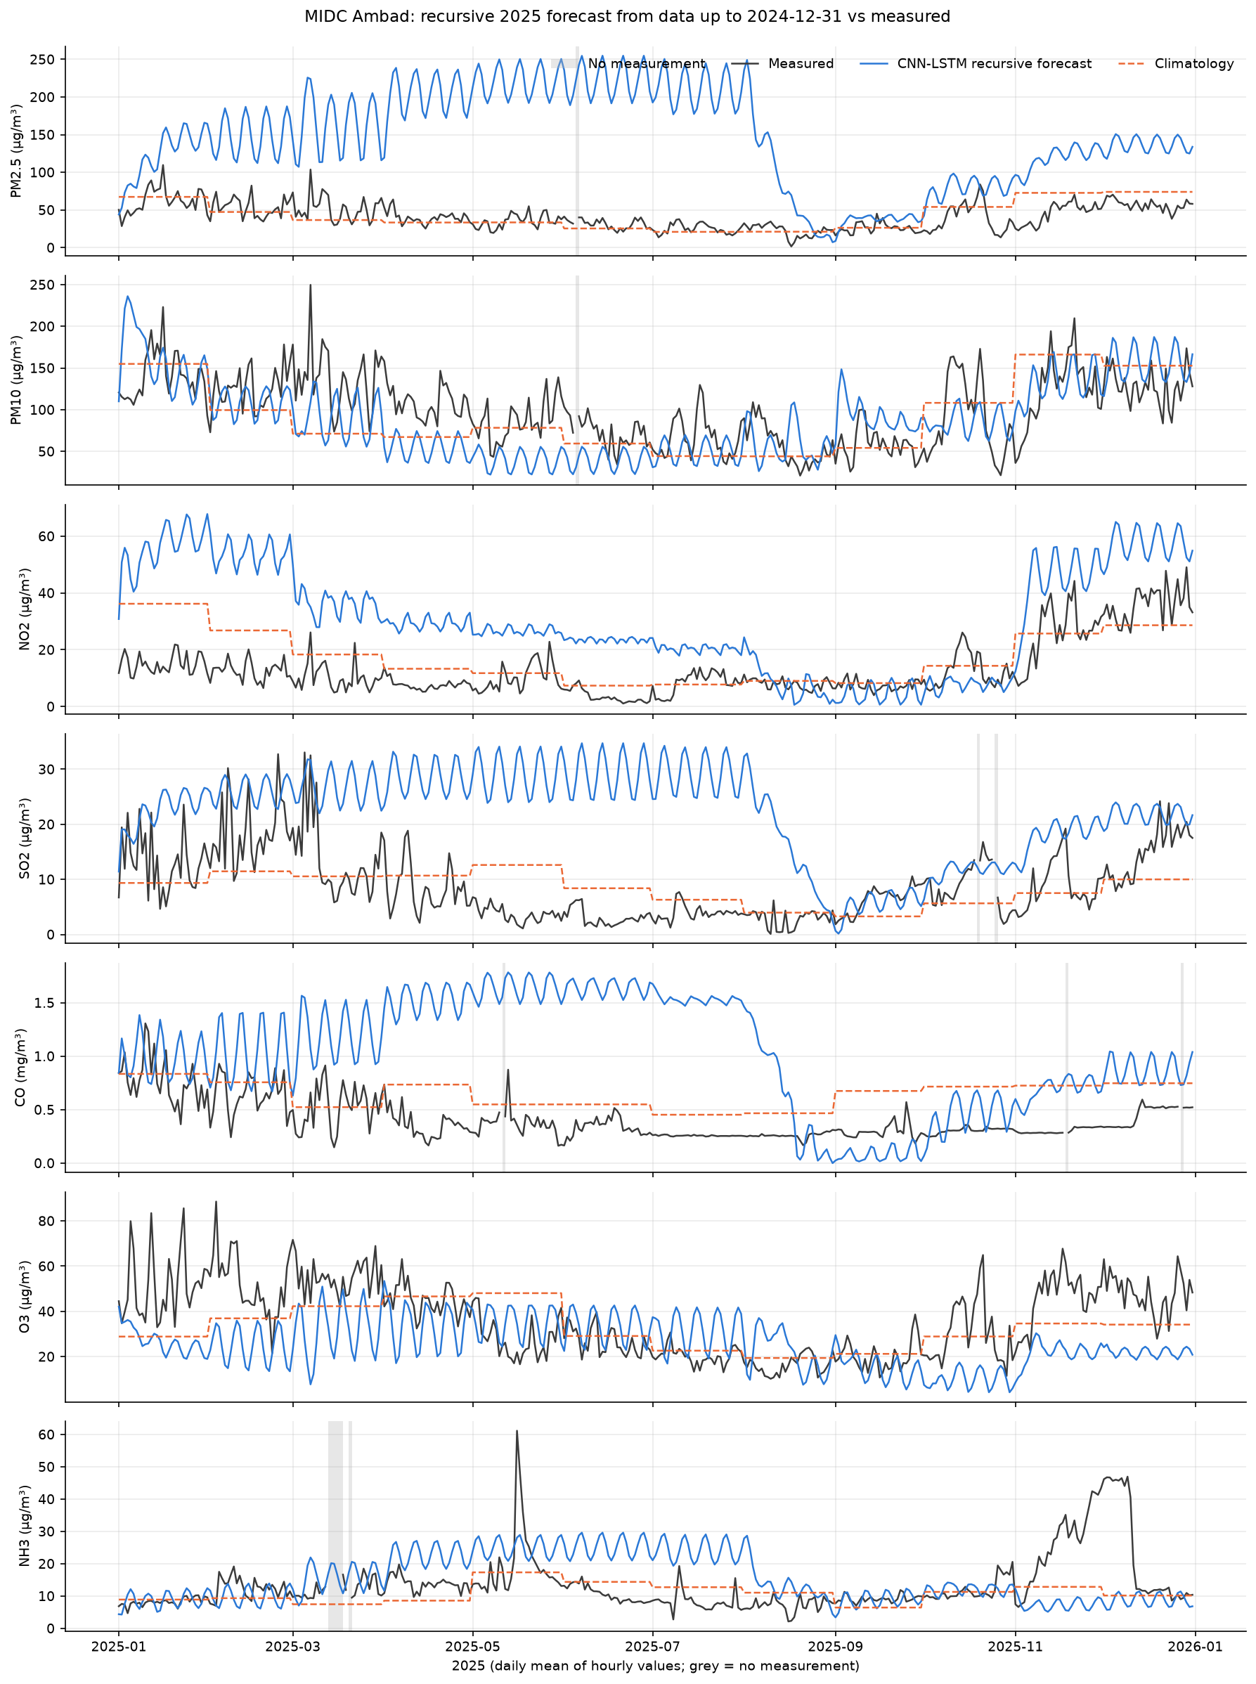
Figure 5. MIDC Ambad: 2025 recursive forecast (daily means) against measurements.
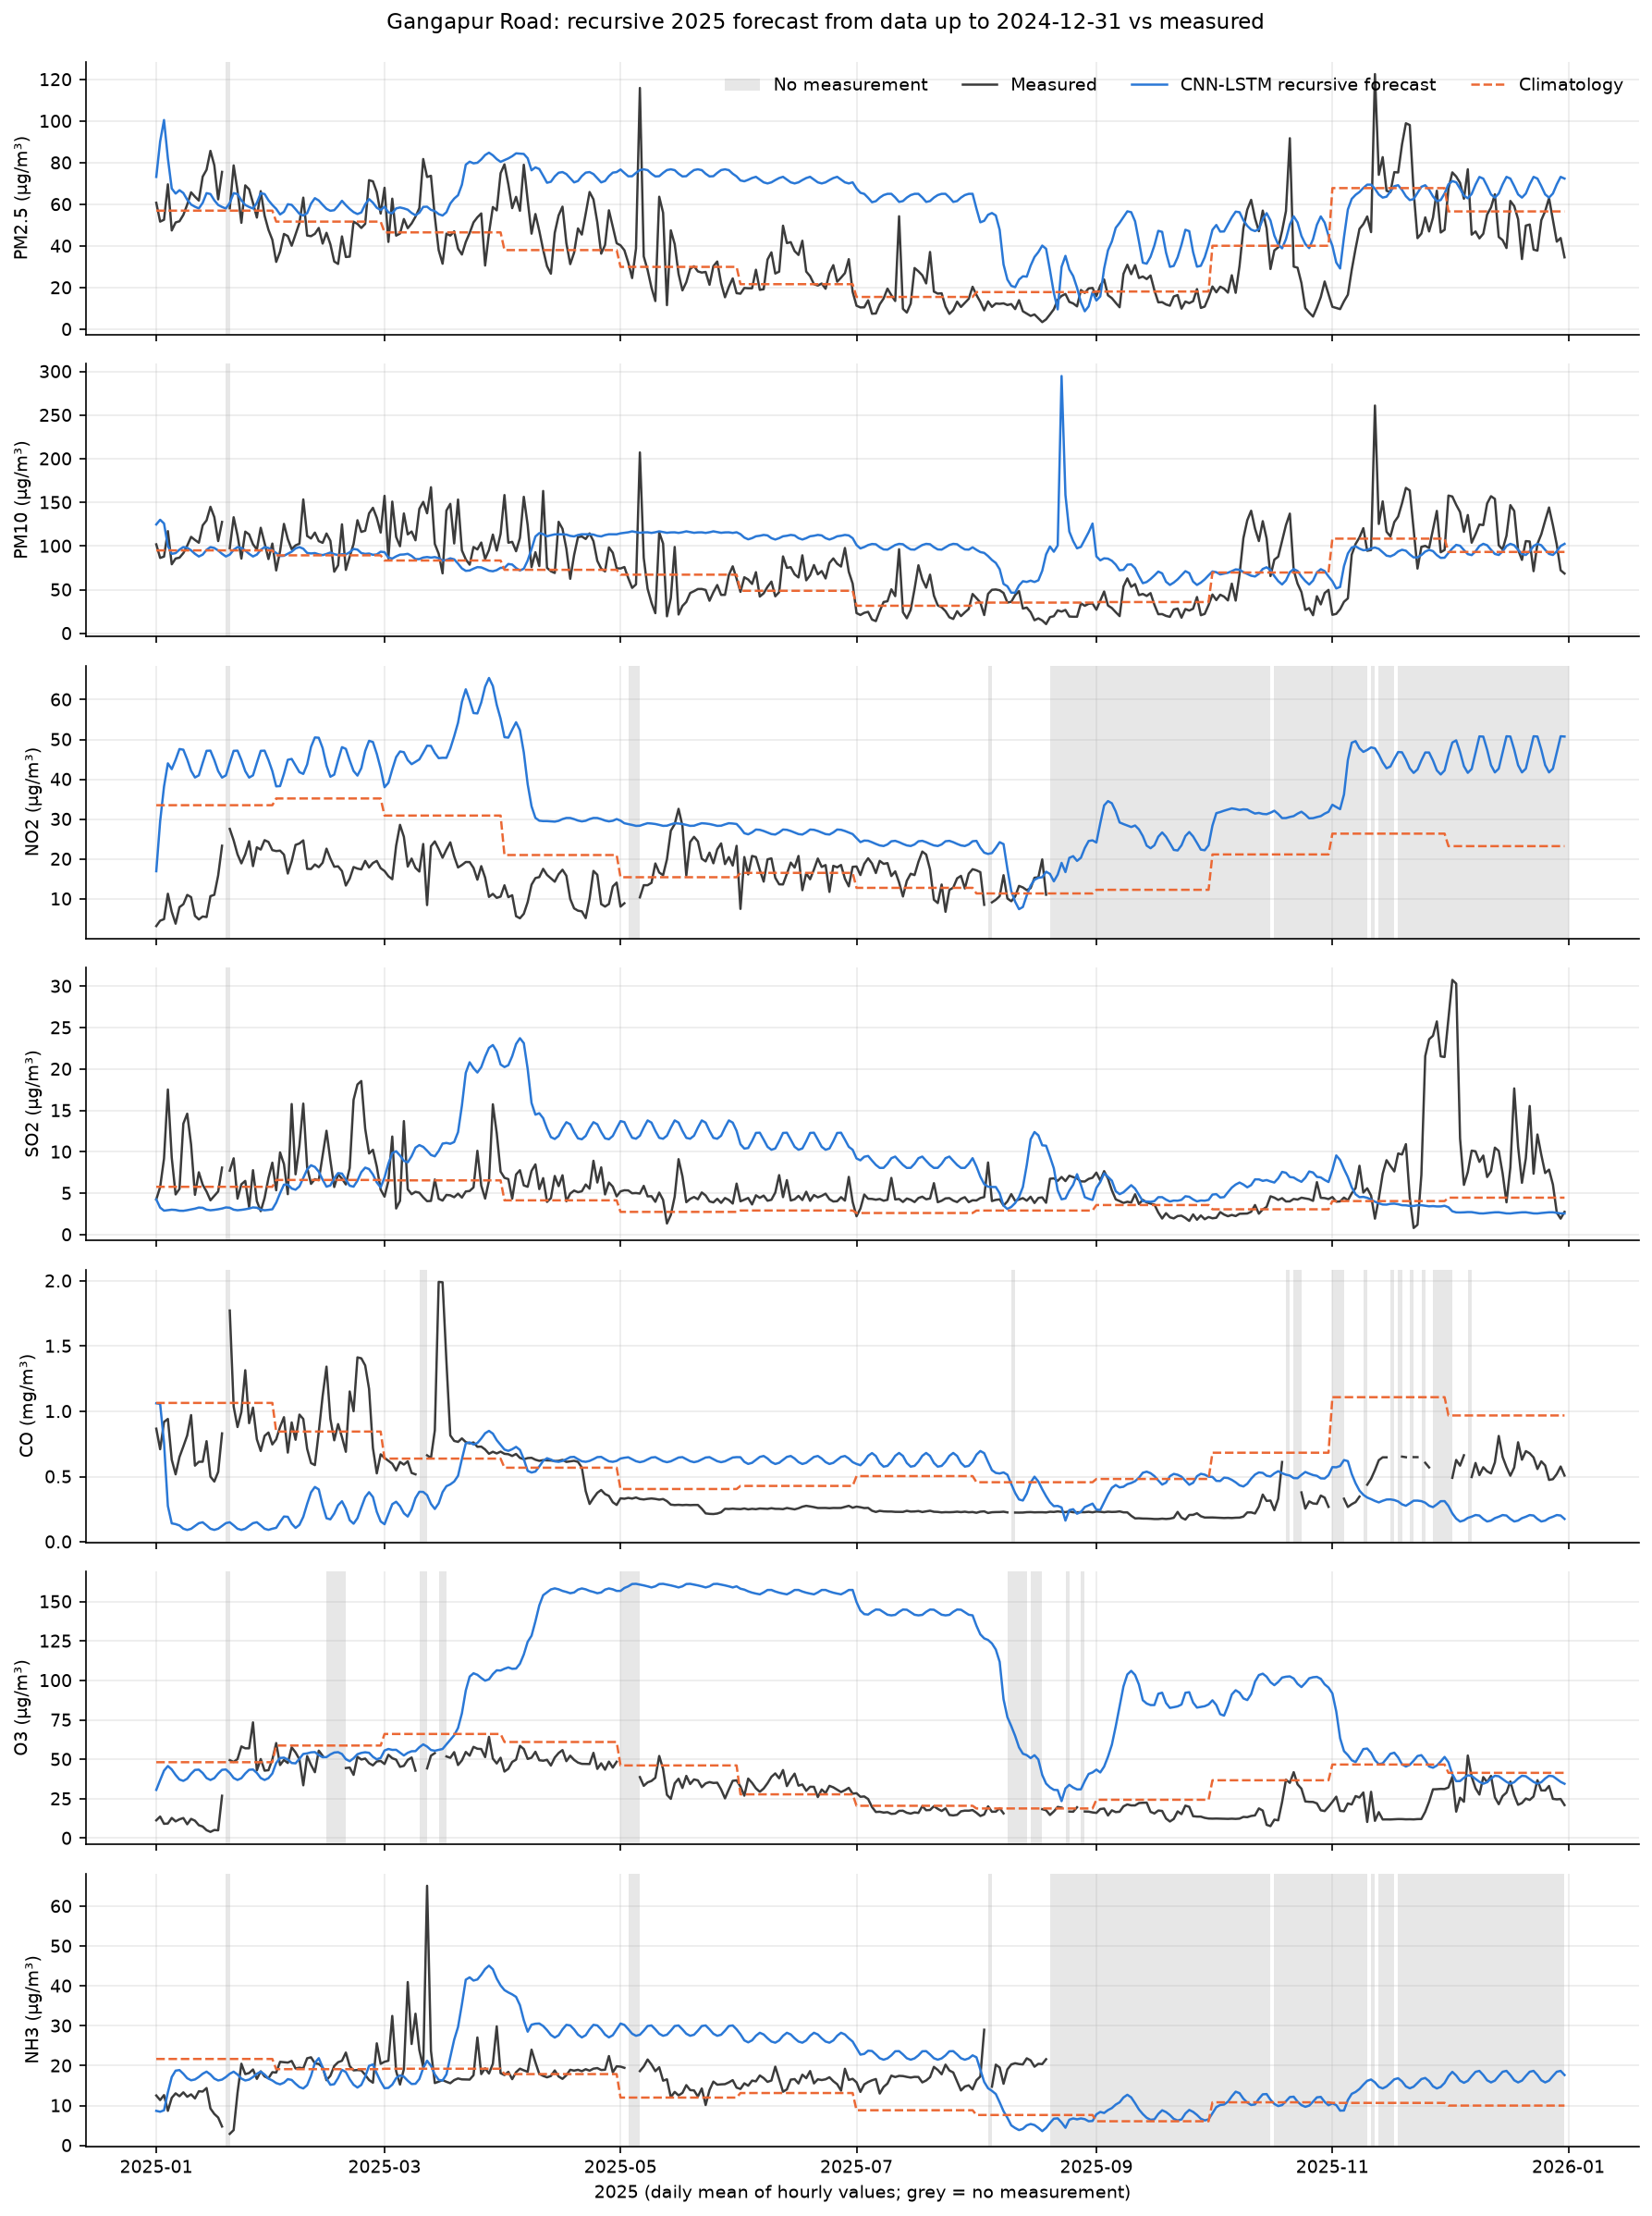
Figure 6. Gangapur Road: 2025 recursive forecast (daily means) against measurements.
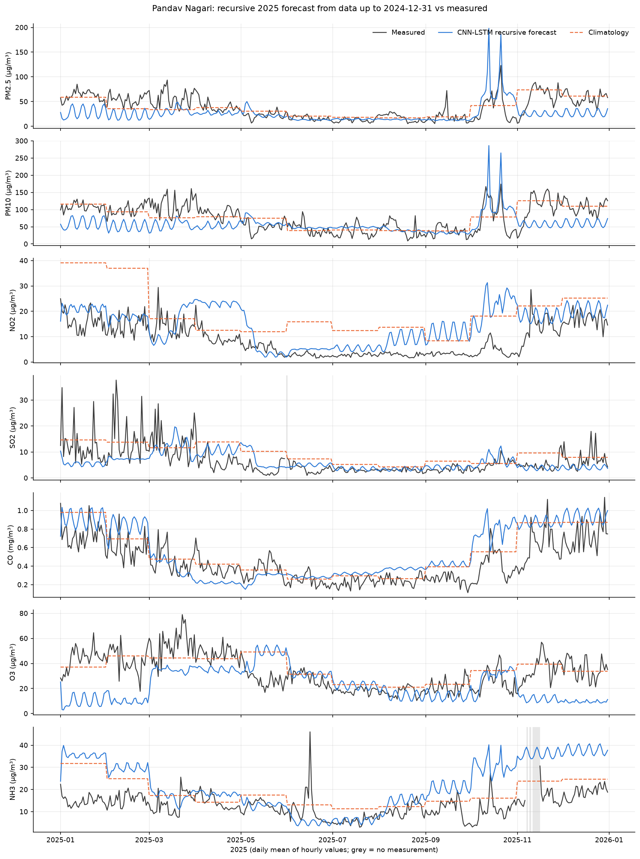
Figure 7. Pandav Nagari: 2025 recursive forecast (daily means) against measurements.
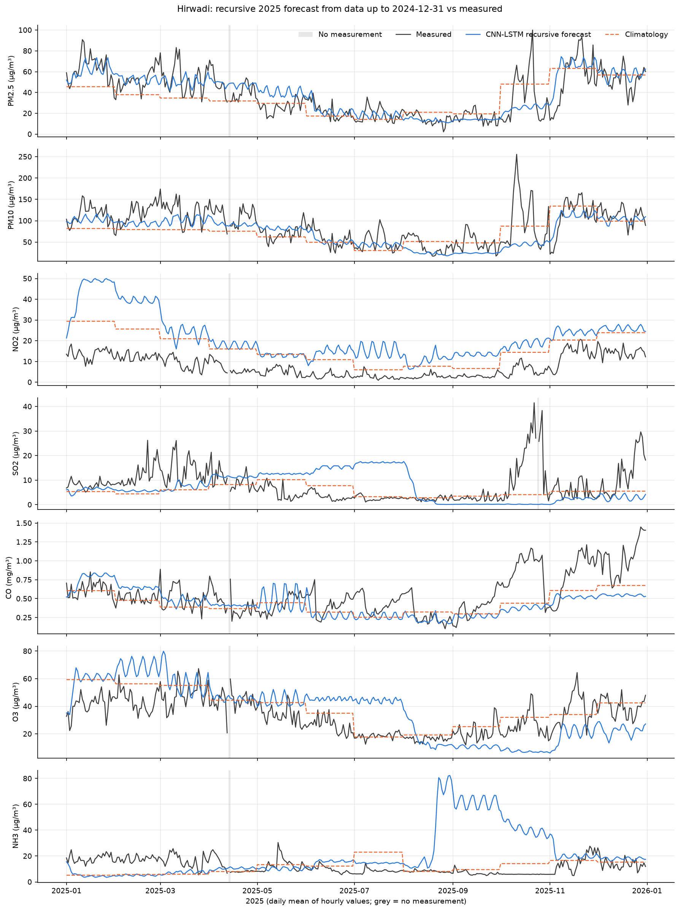
Figure 8. Hirwadi: 2025 recursive forecast (daily means) against measurements.
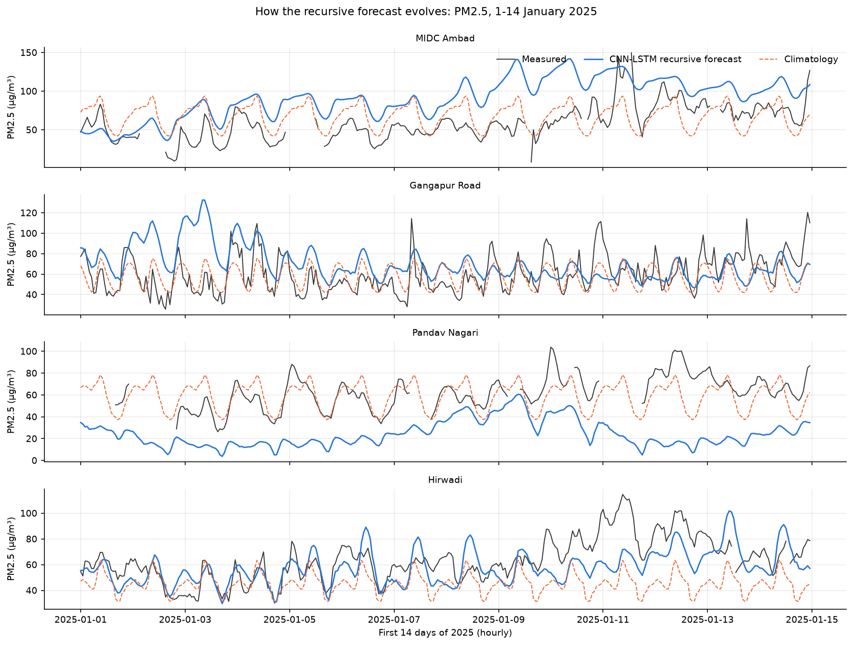
Figure 9. PM2.5 in the first 14 days of 2025: the recursive forecast drifts from the measurements within days.
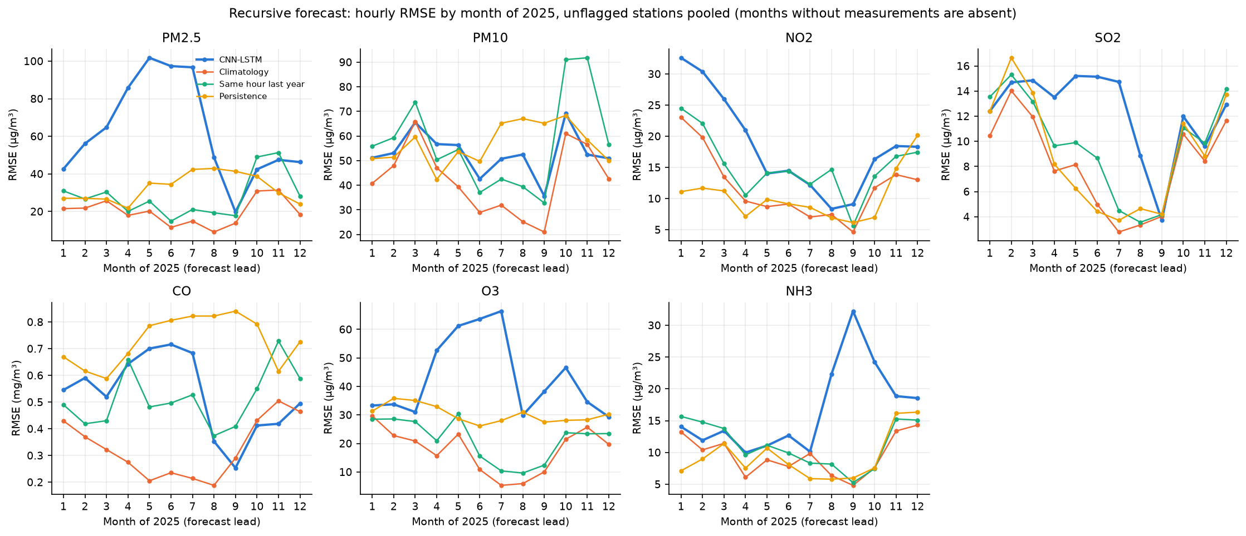
Figure 10. Recursive forecast RMSE by month of 2025 (forecast lead), unflagged stations pooled.
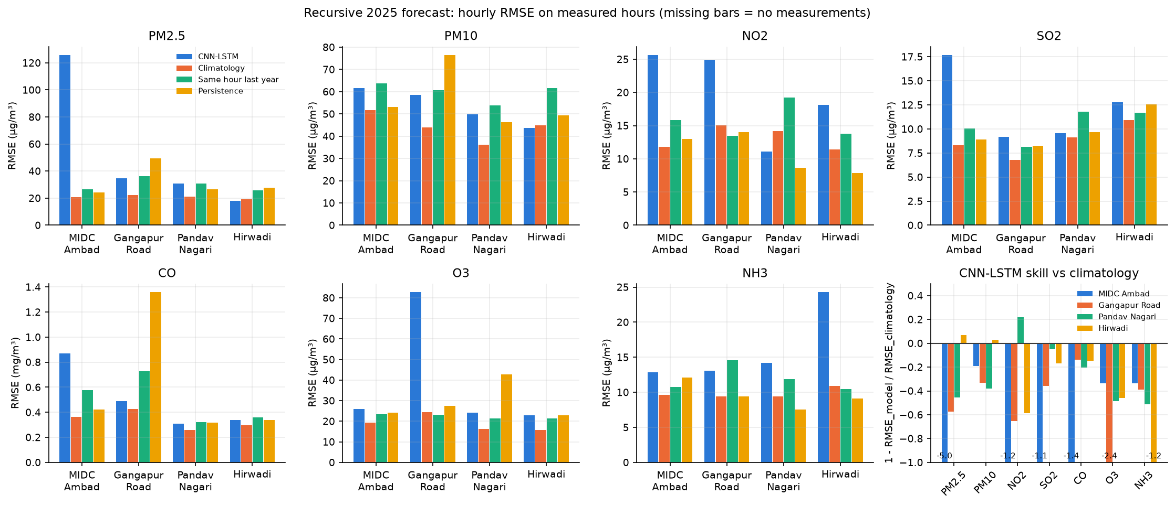
Figure 11. 2025 recursive RMSE per station and baseline, and RMSE skill against climatology.

11.2 Rolling one-step evaluation
Table 15. 2025: rolling one-step predictions per station and pollutant. * = quality-flagged series; '-' = no measured hours.
Station | Pollutant | n | MSE | RMSE | MAE | R² | RMSE persist. | Skill vs persist. | R² flag
MIDC Ambad | PM2.5 | 8231 | 69.1 | 8.313 | 5.031 | 0.8628 | 9.28 | 0.1042 | ok
MIDC Ambad | PM10 | 8248 | 541.4 | 23.27 | 11.24 | 0.8055 | 25.57 | 0.09009 | ok
MIDC Ambad | NO2 | 8196 | 37.71 | 6.141 | 3.587 | 0.7694 | 6.565 | 0.06468 | ok
MIDC Ambad | SO2 | 8197 | 26.65 | 5.163 | 1.986 | 0.6392 | 5.383 | 0.04093 | ok
MIDC Ambad | CO | 8212 | 0.03399 | 0.1844 | 0.09637 | 0.5616 | 0.1827 | -0.009157 | ok
MIDC Ambad | O3 | 8338 | 77.16 | 8.784 | 5.73 | 0.861 | 9.702 | 0.09464 | ok
MIDC Ambad | NH3 | 8009 | 7.653 | 2.766 | 1.323 | 0.9139 | 2.641 | -0.04753 | ok
Gangapur Road | PM2.5 | 8179 | 227.3 | 15.08 | 5.668 | 0.6936 | 16.05 | 0.06057 | ok
Gangapur Road | PM10 | 8145 | 683.7 | 26.15 | 12.41 | 0.7636 | 28.13 | 0.07065 | ok
Gangapur Road | NO2 | 4932 | 46.72 | 6.835 | 4.852 | 0.2345 | 6.134 | -0.1143 | ok
Gangapur Road | SO2 | 8272 | 24.89 | 4.989 | 2.212 | 0.4815 | 5.746 | 0.1318 | ok
Gangapur Road | CO | 7885 | 0.03546 | 0.1883 | 0.08974 | 0.7503 | 0.1958 | 0.03808 | ok
Gangapur Road | O3 | 7747 | 66.98 | 8.184 | 4.529 | 0.8305 | 7.12 | -0.1495 | ok
Gangapur Road | NH3 | 4953 | 37.06 | 6.088 | 3.095 | 0.3327 | 6.136 | 0.007934 | ok
Pandav Nagari | PM2.5 | 8134 | 85.51 | 9.247 | 3.989 | 0.8768 | 10.26 | 0.09884 | ok
Pandav Nagari | PM10 | 8160 | 239.7 | 15.48 | 7.733 | 0.8825 | 16.38 | 0.05471 | ok
Pandav Nagari | NO2 | 8198 | 16.6 | 4.075 | 2.25 | 0.7673 | 4.291 | 0.05029 | ok
Pandav Nagari | SO2 | 8152 | 32.81 | 5.728 | 2.096 | 0.6344 | 6.496 | 0.1182 | ok
Pandav Nagari | CO | 8258 | 0.01929 | 0.1389 | 0.07531 | 0.8086 | 0.1585 | 0.1238 | ok
Pandav Nagari | O3 | 8201 | 52.06 | 7.215 | 4.664 | 0.8809 | 8.28 | 0.1286 | ok
Pandav Nagari | NH3 | 8063 | 17.11 | 4.136 | 1.874 | 0.674 | 4.955 | 0.1652 | ok
Hirwadi | PM2.5 | 8469 | 61.72 | 7.856 | 4.437 | 0.8901 | 7.686 | -0.02218 | ok
Hirwadi | PM10 | 8457 | 560.3 | 23.67 | 9.619 | 0.7685 | 24.1 | 0.01782 | ok
Hirwadi | NO2 | 8466 | 24.08 | 4.907 | 3.173 | 0.5453 | 3.9 | -0.2584 | ok
Hirwadi | SO2 | 8111 | 66.39 | 8.148 | 3.104 | 0.4096 | 8.627 | 0.0555 | ok
Hirwadi | CO | 8490 | 0.02721 | 0.165 | 0.07528 | 0.7615 | 0.1757 | 0.06144 | ok
Hirwadi | O3 | 8491 | 94.03 | 9.697 | 5.921 | 0.8181 | 10.96 | 0.1149 | ok
Hirwadi | NH3 | 8435 | 40.77 | 6.385 | 2.564 | 0.471 | 6.542 | 0.0239 | ok

Table 16. 2025: one-step predictions, unflagged stations pooled per pollutant.
Pollutant | n | RMSE | R² | RMSE persist. | Skill vs persist. | Stations
PM2.5 | 33013 | 10.51 | 0.8238 | 11.24 | 0.06516 | MIDC Ambad, Gangapur Road, Pandav Nagari, Hirwadi
PM10 | 33010 | 22.51 | 0.807 | 23.95 | 0.06024 | MIDC Ambad, Gangapur Road, Pandav Nagari, Hirwadi
NO2 | 29792 | 5.433 | 0.705 | 5.242 | -0.03659 | MIDC Ambad, Gangapur Road, Pandav Nagari, Hirwadi
SO2 | 32732 | 6.131 | 0.5411 | 6.675 | 0.08148 | MIDC Ambad, Gangapur Road, Pandav Nagari, Hirwadi
CO | 32845 | 0.17 | 0.7427 | 0.1784 | 0.04747 | MIDC Ambad, Gangapur Road, Pandav Nagari, Hirwadi
O3 | 32777 | 8.535 | 0.8492 | 9.175 | 0.06975 | MIDC Ambad, Gangapur Road, Pandav Nagari, Hirwadi
NH3 | 29460 | 4.967 | 0.6651 | 5.215 | 0.04766 | MIDC Ambad, Gangapur Road, Pandav Nagari, Hirwadi

With the measured previous 24 hours as input, pooled RMSE skill against persistence ranges from -3.7% (NO2) to 8.1% (SO2). Persistence is a strong baseline one hour ahead because consecutive hourly averages are highly correlated.
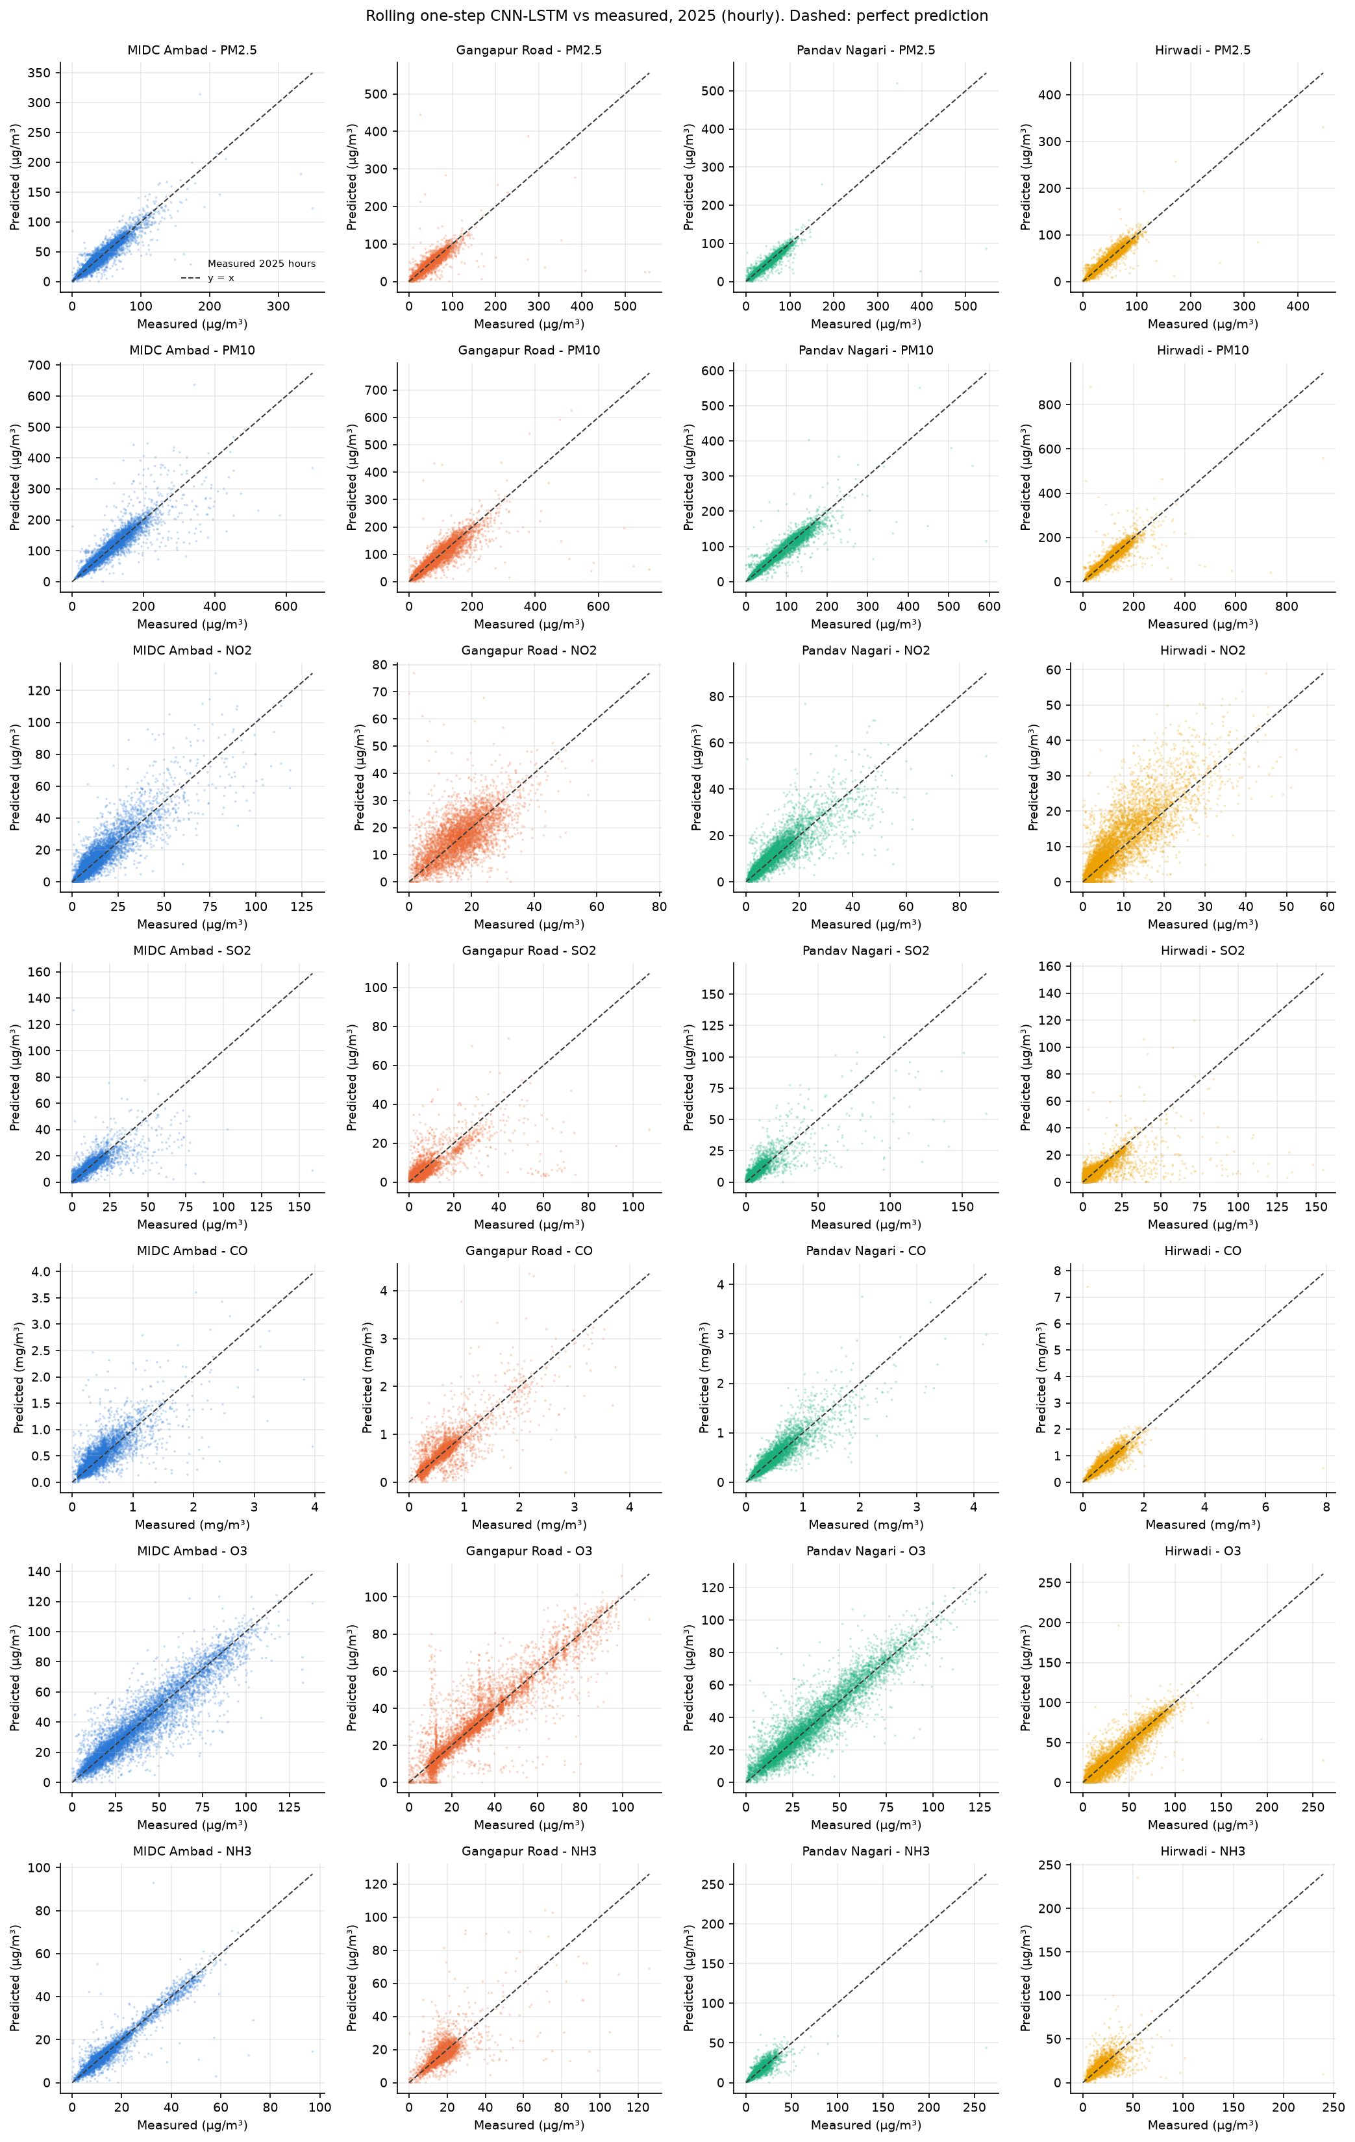
Figure 12. 2025 one-step predictions against measurements. Dashed: perfect prediction.

12. Results: 2026 (Partial-Year Evaluation)
Models trained on data up to 31 December 2025 forecast every hour of 2026 at all four stations (8,760 hours each, 1 January 00:00 to 31 December 23:00). The forecast file contains every hour. Only hours labelled observed are scored: January-June and August at MIDC Ambad, Gangapur Road and Hirwadi. July and September-December 2026, and all of 2026 at Pandav Nagari, are forecasts without ground truth. Because those months are missing, the 2026 scores do not cover a full seasonal cycle (the monsoon months July-September are mostly absent).

12.1 Plausibility of the unmeasured months
Metrics cannot judge the months without measurements, so Table 17 compares the monthly mean PM2.5 forecast with the station's climatology for every month of 2026. Large ratios in either direction mark drift of the recursive forecast rather than an expected change in air quality.
Table 17. 2026 monthly mean PM2.5 (µg/m³): recursive CNN-LSTM forecast against climatology.
Station | Series | Jan | Feb | Mar | Apr | May | Jun | Jul | Aug | Sep | Oct | Nov | Dec
MIDC Ambad | Forecast | 52 | 51 | 48 | 31 | 41 | 36 | 29 | 30 | 38 | 49 | 64 | 66
MIDC Ambad | Climatology | 65 | 50 | 44 | 37 | 34 | 28 | 22 | 21 | 26 | 50 | 63 | 68
Gangapur Road | Forecast | 68 | 60 | 60 | 56 | 42 | 11 | 3 | 4 | 4 | 11 | 21 | 13
Gangapur Road | Climatology | 58 | 51 | 47 | 40 | 30 | 23 | 16 | 17 | 18 | 39 | 66 | 56
Pandav Nagari | Forecast | 82 | 94 | 84 | 29 | 19 | 16 | 15 | 15 | 21 | 28 | 119 | 135
Pandav Nagari | Climatology | 60 | 44 | 45 | 39 | 27 | 19 | 16 | 17 | 19 | 40 | 68 | 60
Hirwadi | Forecast | 90 | 100 | 102 | 98 | 93 | 90 | 91 | 95 | 91 | 64 | 14 | 18
Hirwadi | Climatology | 56 | 45 | 44 | 38 | 28 | 19 | 16 | 18 | 18 | 44 | 60 | 56

Months where the forecast is more than twice, or less than half of, climatology: Gangapur Road (Jun, Jul, Aug, Sep, Oct, Nov, Dec; change design); Hirwadi (Feb, Mar, Apr, May, Jun, Jul, Aug, Sep, Nov, Dec; change design); Pandav Nagari (Feb, Dec; level design). The most extreme is Gangapur Road in July: 3 µg/m³ against a climatology of 16. Both target designs drift: each prediction becomes an input for the next, so small biases accumulate over thousands of steps and carry the forecast away from realistic levels. These values, and the AQI derived from them, should not be used as an estimate of 2026 air quality; the climatology column of the same file is the better year-ahead estimate.

12.2 Recursive forecast on measured hours
Table 18. 2026: recursive forecast per station and pollutant, measured hours only (µg/m³; CO in mg/m³). * = quality-flagged series; '-' = no measured hours.
Station | Pollutant | n | Cov. % | RMSE | MAE | R² | RMSE clim. | RMSE last yr | RMSE persist. | Skill vs clim. | R² flag
MIDC Ambad | PM2.5 | 4708 | 53.74 | 16.85 | 13.32 | -0.05773 | 15.78 | 23.89 | 21.07 | -0.06809 | ok
MIDC Ambad | PM10 | 4710 | 53.77 | 37.63 | 27.26 | 0.1383 | 31.89 | 50.19 | 42.71 | -0.1799 | ok
MIDC Ambad | NO2 | 4629 | 52.84 | 21.78 | 17.55 | -1.941 | 8.678 | 12 | 16.36 | -1.51 | ok
MIDC Ambad | SO2 | 4708 | 53.74 | 7.902 | 6.101 | -0.4324 | 5.131 | 9.114 | 10.74 | -0.54 | ok
MIDC Ambad | CO * | 1638 | 18.7 | 0.7627 | 0.6727 | -49.96 | 0.1734 | 0.1731 | 0.2145 | -3.4 | ok
MIDC Ambad | O3 | 4718 | 53.86 | 24.88 | 19.06 | -0.6393 | 13.97 | 21.99 | 20.21 | -0.7809 | ok
MIDC Ambad | NH3 | 4654 | 53.13 | 13.53 | 9.949 | -23.49 | 4.64 | 7.411 | 3.002 | -1.916 | ok
Gangapur Road | PM2.5 | 4876 | 55.66 | 25.22 | 20.58 | -0.3836 | 19.44 | 29.13 | 22.04 | -0.297 | ok
Gangapur Road | PM10 | 4856 | 55.43 | 38.48 | 29.89 | 0.1962 | 32.53 | 51.12 | 43.41 | -0.183 | ok
Gangapur Road | NO2 * | 490 | 5.594 | 29.35 | 26.23 | -317.6 | 25.92 | 15.43 | 1.787 | -0.1324 | ok
Gangapur Road | SO2 | 4317 | 49.28 | 5.452 | 3.811 | -1.907 | 4.519 | 8.16 | 3.226 | -0.2065 | ok
Gangapur Road | CO * | 87 | 0.9932 | 0.6562 | 0.5964 | -185.8 | 0.1186 | 0.2722 | 0.04945 | -4.532 | unreliable (n < 168)
Gangapur Road | O3 | 4971 | 56.75 | 39.62 | 31.22 | -8.208 | 36.55 | 30.51 | 18.08 | -0.08403 | ok
Gangapur Road | NH3 * | 236 | 2.694 | 11.19 | 11.1 | -2,485 | 6.585 | 6.092 | 0.4801 | -0.7 | ok
Pandav Nagari | PM2.5 | 0 | 0 | - | - | - | - | - | - | - | undefined
Pandav Nagari | PM10 | 0 | 0 | - | - | - | - | - | - | - | undefined
Pandav Nagari | NO2 | 0 | 0 | - | - | - | - | - | - | - | undefined
Pandav Nagari | SO2 | 0 | 0 | - | - | - | - | - | - | - | undefined
Pandav Nagari | CO | 0 | 0 | - | - | - | - | - | - | - | undefined
Pandav Nagari | O3 | 0 | 0 | - | - | - | - | - | - | - | undefined
Pandav Nagari | NH3 | 0 | 0 | - | - | - | - | - | - | - | undefined
Hirwadi | PM2.5 | 4769 | 54.44 | 67.05 | 64.66 | -14.15 | 12.16 | 20.42 | 23.74 | -4.516 | ok
Hirwadi | PM10 | 4767 | 54.42 | 159.1 | 156 | -18.29 | 28.6 | 47.93 | 38.32 | -4.561 | ok
Hirwadi | NO2 | 4352 | 49.68 | 7.35 | 5.828 | -0.3297 | 8.726 | 6.239 | 6.822 | 0.1577 | ok
Hirwadi | SO2 | 4549 | 51.93 | 24.81 | 22.34 | -3.087 | 12.56 | 14.42 | 13.94 | -0.9747 | ok
Hirwadi | CO | 2099 | 23.96 | 0.2942 | 0.2353 | 0.1651 | 0.3293 | 0.3813 | 0.7859 | 0.1065 | ok
Hirwadi | O3 | 4779 | 54.55 | 30.51 | 25.85 | -0.5059 | 16.94 | 20.79 | 25.13 | -0.8007 | ok
Hirwadi | NH3 | 4548 | 51.92 | 27.83 | 24.58 | -8.533 | 9.265 | 12.2 | 12.17 | -2.004 | ok

Table 19. 2026: recursive forecast, unflagged stations pooled per pollutant.
Pollutant | n | MSE | RMSE | MAE | R² | RMSE clim. | Skill vs clim. | Stations
PM2.5 | 14353 | 1,803 | 42.46 | 32.85 | -4.214 | 16.1 | -1.638 | MIDC Ambad, Gangapur Road, Hirwadi
PM10 | 14333 | 9,383 | 96.87 | 70.98 | -4.595 | 31.06 | -2.118 | MIDC Ambad, Gangapur Road, Hirwadi
NO2 | 8981 | 270.7 | 16.45 | 11.87 | -1.424 | 8.701 | -0.8907 | MIDC Ambad, Hirwadi
SO2 | 13574 | 237.4 | 15.41 | 10.81 | -1.944 | 8.278 | -0.8613 | MIDC Ambad, Gangapur Road, Hirwadi
CO | 2099 | 0.08657 | 0.2942 | 0.2353 | 0.1651 | 0.3293 | 0.1065 | Hirwadi
O3 | 14468 | 1,049 | 32.38 | 25.48 | -1.44 | 24.85 | -0.3032 | MIDC Ambad, Gangapur Road, Hirwadi
NH3 | 9202 | 475.5 | 21.81 | 17.18 | -9.46 | 7.301 | -1.986 | MIDC Ambad, Hirwadi

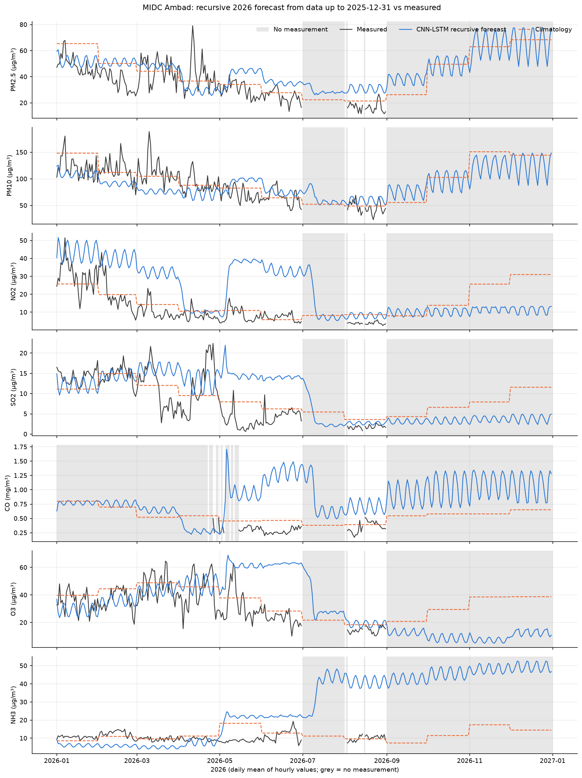
Figure 13. MIDC Ambad: 2026 recursive forecast (daily means), with measurements where they exist. Grey: no measurement.
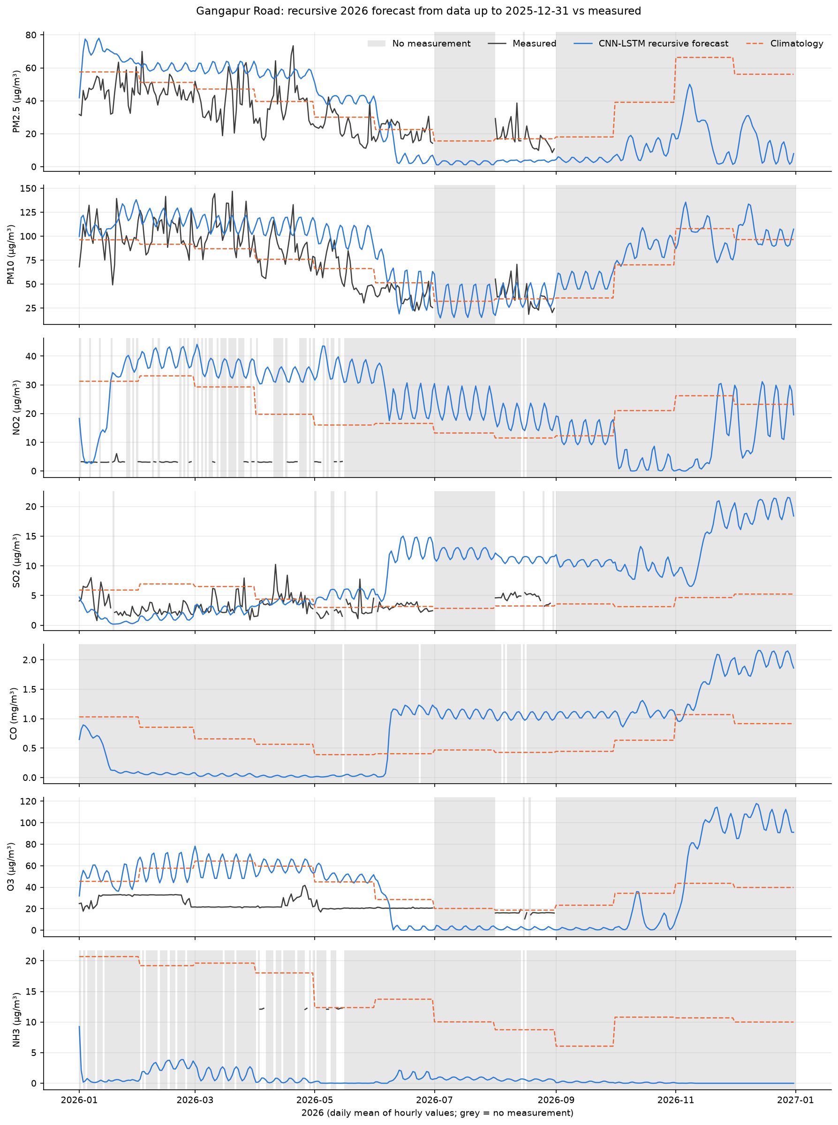
Figure 14. Gangapur Road: 2026 recursive forecast (daily means), with measurements where they exist. Grey: no measurement.
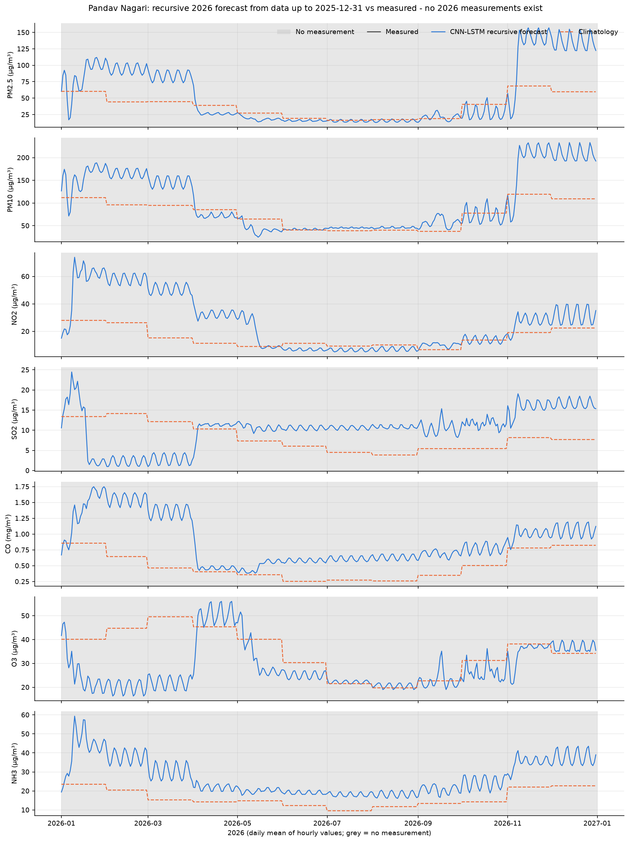
Figure 15. Pandav Nagari: 2026 recursive forecast (daily means), with measurements where they exist. Grey: no measurement.
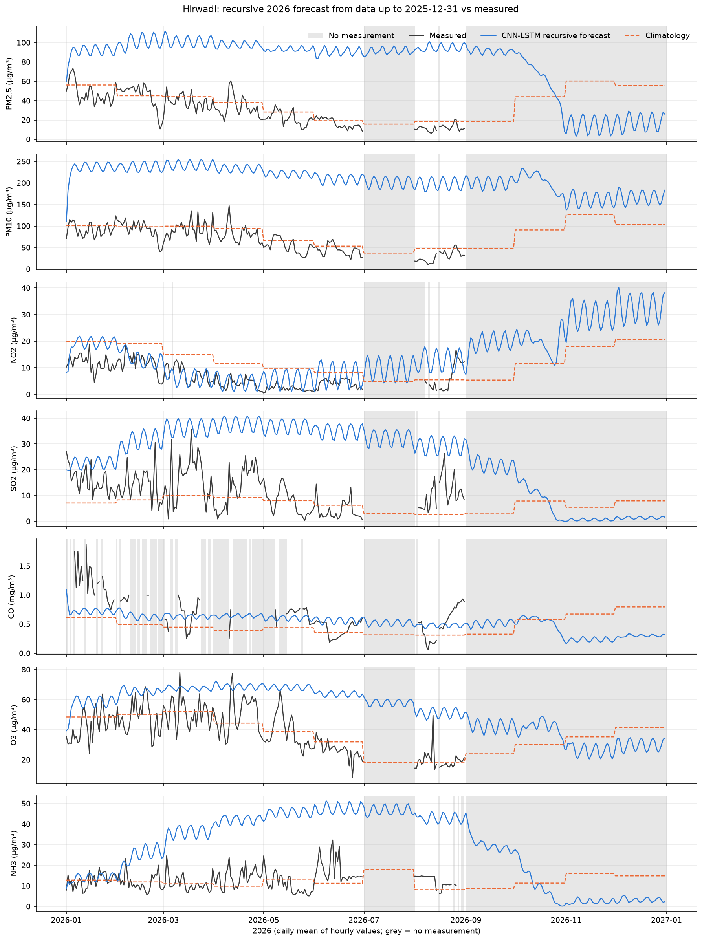
Figure 16. Hirwadi: 2026 recursive forecast (daily means), with measurements where they exist. Grey: no measurement.
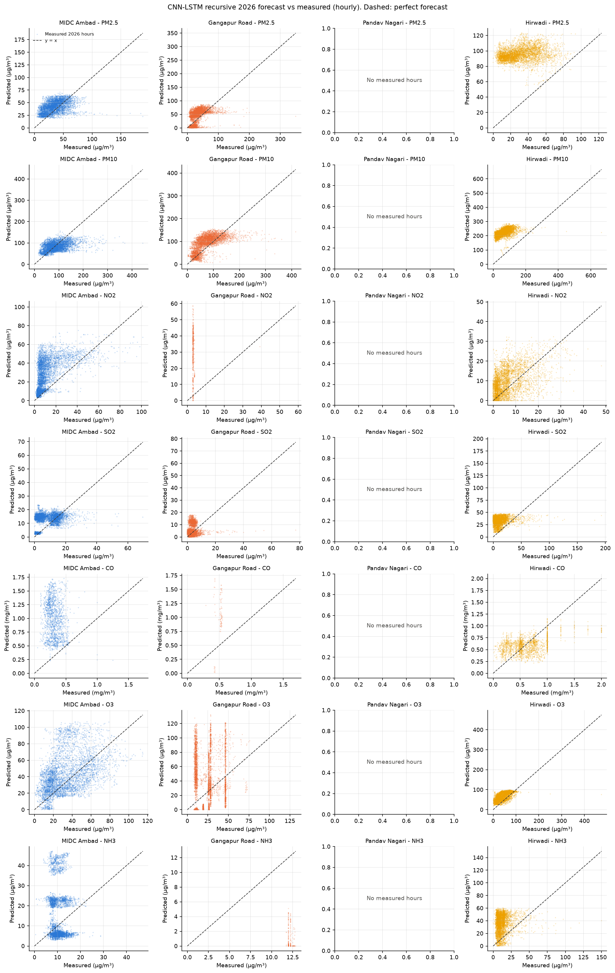
Figure 17. 2026 recursive forecast against measured hourly values.

12.3 Rolling one-step evaluation on measured hours
Table 20. 2026: rolling one-step predictions per station and pollutant. * = quality-flagged series; '-' = no measured hours.
Station | Pollutant | n | MSE | RMSE | MAE | R² | RMSE persist. | Skill vs persist. | R² flag
MIDC Ambad | PM2.5 | 4542 | 34.33 | 5.859 | 3.908 | 0.8708 | 6.106 | 0.04052 | ok
MIDC Ambad | PM10 | 4544 | 238.1 | 15.43 | 8.791 | 0.8547 | 17.98 | 0.1417 | ok
MIDC Ambad | NO2 | 4467 | 24.48 | 4.948 | 2.788 | 0.8488 | 5.958 | 0.1696 | ok
MIDC Ambad | SO2 | 4542 | 5.328 | 2.308 | 1.257 | 0.8731 | 2.496 | 0.07536 | ok
MIDC Ambad | CO * | 1543 | 0.00804 | 0.08967 | 0.05258 | 0.2773 | 0.07957 | -0.1268 | ok
MIDC Ambad | O3 | 4552 | 43.13 | 6.567 | 4.565 | 0.8861 | 7.68 | 0.1448 | ok
MIDC Ambad | NH3 | 4489 | 1.933 | 1.39 | 0.904 | 0.7443 | 1.378 | -0.009133 | ok
Gangapur Road | PM2.5 | 4267 | 159.8 | 12.64 | 5.655 | 0.6674 | 12.63 | -0.0007244 | ok
Gangapur Road | PM10 | 4267 | 367.2 | 19.16 | 11.24 | 0.805 | 20.75 | 0.07642 | ok
Gangapur Road | NO2 * | 469 | 47.71 | 6.907 | 3.419 | -15.93 | 2.364 | -1.922 | ok
Gangapur Road | SO2 | 4034 | 6.064 | 2.462 | 1.294 | 0.4193 | 2.697 | 0.08691 | ok
Gangapur Road | CO * | 79 | 0.003984 | 0.06312 | 0.04723 | -0.6252 | 0.02868 | -1.2 | unreliable (n < 168)
Gangapur Road | O3 | 4361 | 72.19 | 8.496 | 4.385 | 0.5914 | 7.437 | -0.1424 | ok
Gangapur Road | NH3 * | 214 | 25.24 | 5.024 | 1.953 | -584 | 0.1872 | -25.84 | ok
Pandav Nagari | PM2.5 | 0 | - | - | - | - | - | - | undefined
Pandav Nagari | PM10 | 0 | - | - | - | - | - | - | undefined
Pandav Nagari | NO2 | 0 | - | - | - | - | - | - | undefined
Pandav Nagari | SO2 | 0 | - | - | - | - | - | - | undefined
Pandav Nagari | CO | 0 | - | - | - | - | - | - | undefined
Pandav Nagari | O3 | 0 | - | - | - | - | - | - | undefined
Pandav Nagari | NH3 | 0 | - | - | - | - | - | - | undefined
Hirwadi | PM2.5 | 4629 | 22.31 | 4.724 | 3.213 | 0.9239 | 4.79 | 0.01381 | ok
Hirwadi | PM10 | 4624 | 274.2 | 16.56 | 7.67 | 0.7891 | 18.45 | 0.1028 | ok
Hirwadi | NO2 | 4254 | 15.45 | 3.93 | 2.42 | 0.6156 | 3.547 | -0.108 | ok
Hirwadi | SO2 | 4408 | 75.85 | 8.709 | 2.919 | 0.5011 | 8.723 | 0.001543 | ok
Hirwadi | CO | 1989 | 0.02544 | 0.1595 | 0.07564 | 0.7565 | 0.1508 | -0.05772 | ok
Hirwadi | O3 | 4638 | 161 | 12.69 | 6.185 | 0.7388 | 13.69 | 0.07313 | ok
Hirwadi | NH3 | 4432 | 64.47 | 8.029 | 3.682 | 0.2151 | 8.397 | 0.04383 | ok

Table 21. 2026: one-step predictions, unflagged stations pooled per pollutant.
Pollutant | n | RMSE | R² | RMSE persist. | Skill vs persist. | Stations
PM2.5 | 13438 | 8.368 | 0.7982 | 8.436 | 0.008069 | MIDC Ambad, Gangapur Road, Hirwadi
PM10 | 13435 | 17.07 | 0.8264 | 19.06 | 0.1042 | MIDC Ambad, Gangapur Road, Hirwadi
NO2 | 8721 | 4.48 | 0.8205 | 4.932 | 0.09148 | MIDC Ambad, Hirwadi
SO2 | 12984 | 5.431 | 0.6373 | 5.502 | 0.01283 | MIDC Ambad, Gangapur Road, Hirwadi
CO | 1989 | 0.1595 | 0.7565 | 0.1508 | -0.05772 | Hirwadi
O3 | 13551 | 9.634 | 0.7879 | 10.09 | 0.04489 | MIDC Ambad, Gangapur Road, Hirwadi
NH3 | 8921 | 5.745 | 0.2845 | 5.999 | 0.04238 | MIDC Ambad, Hirwadi

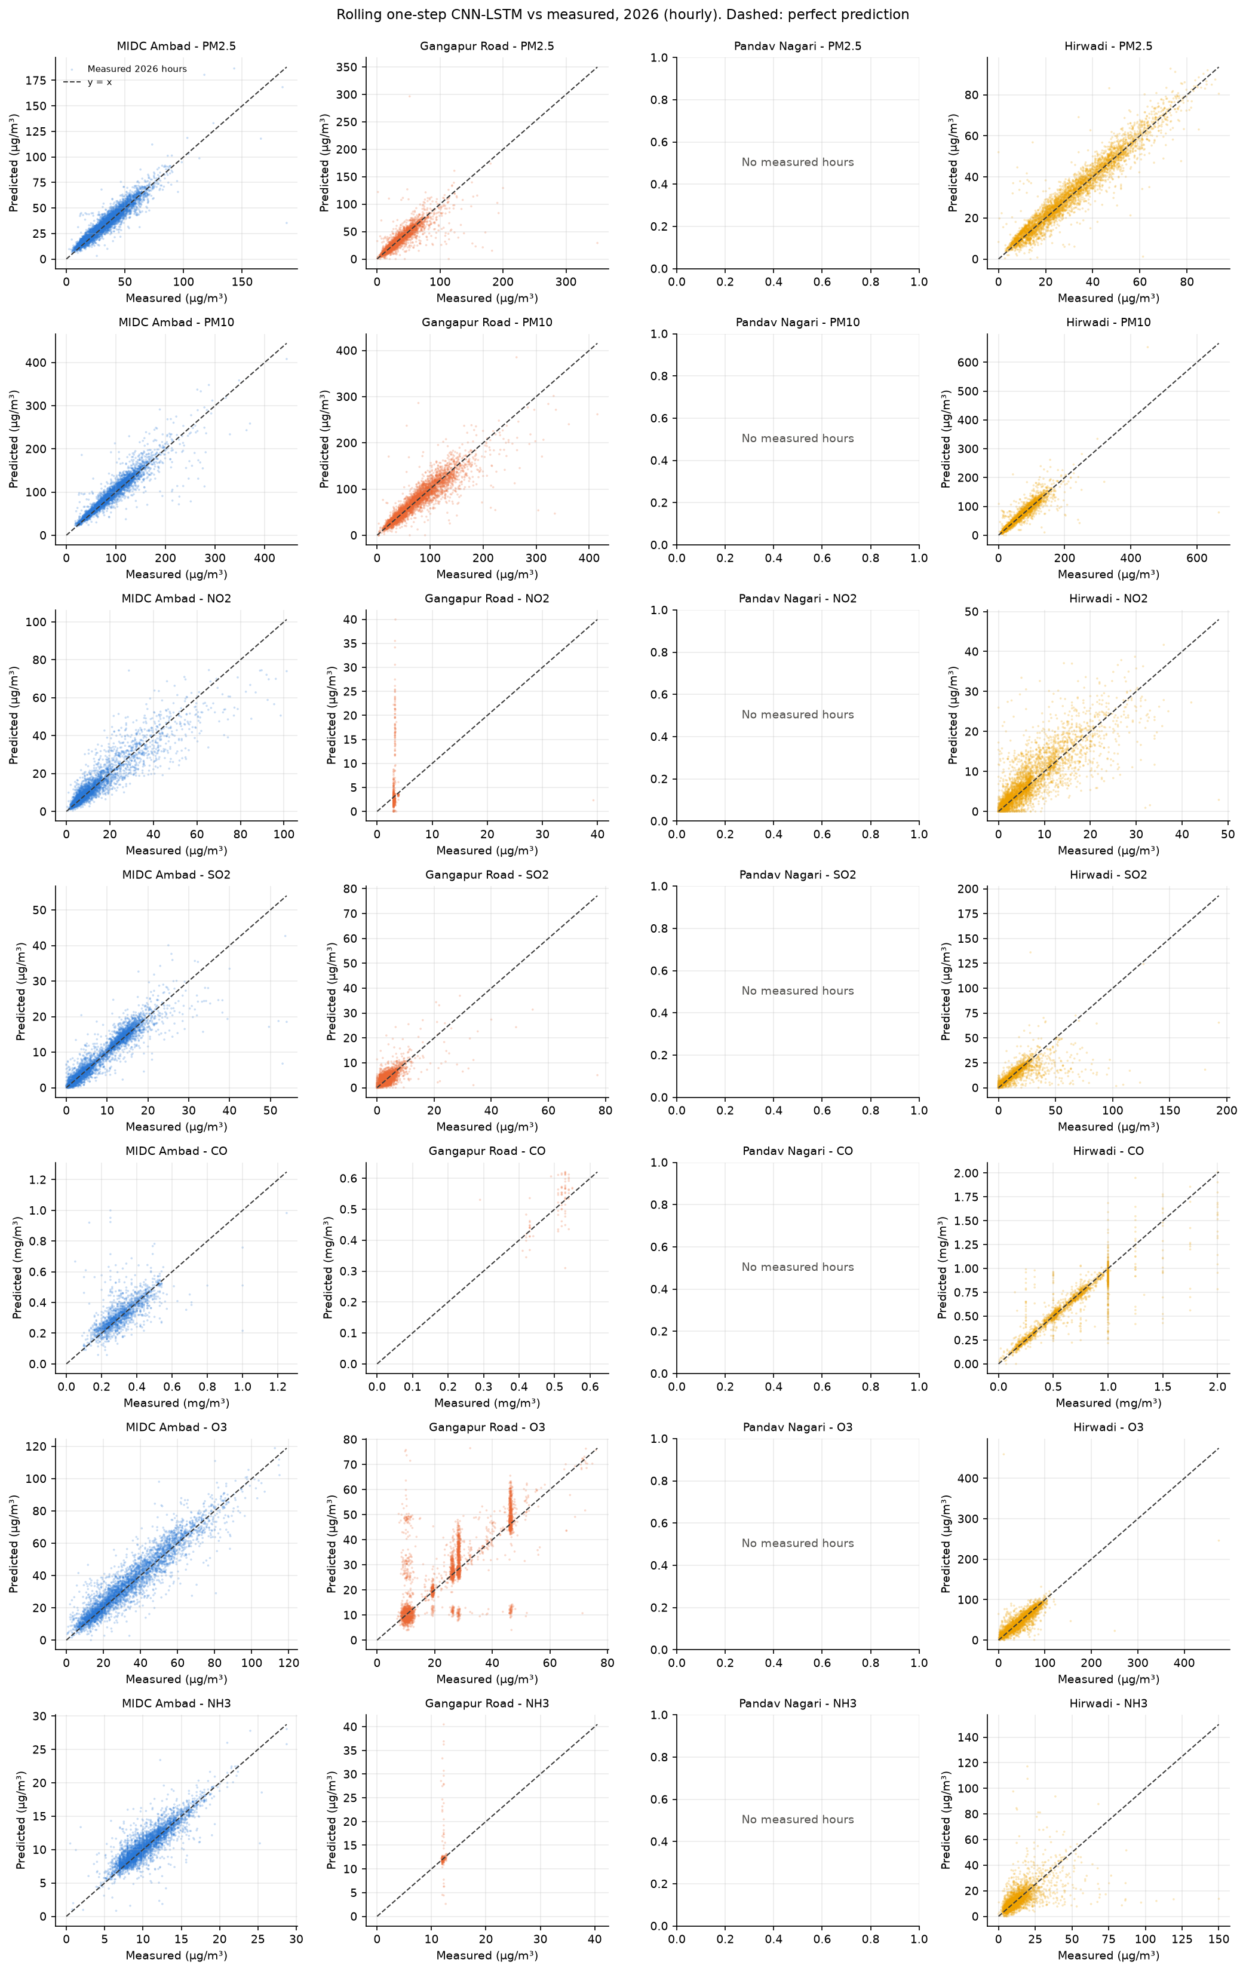
Figure 18. 2026 one-step predictions against measurements. Pandav Nagari has no 2026 measurements.

13. Predicted AQI
The model predicts pollutant concentrations; AQI is derived from them afterwards with the CPCB National AQI method [11]. Sub-indices use 24-hour means for PM2.5, PM10, NO2, SO2 and NH3 and the maximum 8-hour mean for CO and O3. The AQI is the largest sub-index and is computed only when at least three sub-indices, including PM2.5 or PM10, are available. A measured daily mean needs at least 16 measured hours. The Severe band has no published upper concentration, so it is extended linearly with the width of the Very Poor band and capped at 500. Predicted AQI is a model estimate from the recursive forecast. Measured AQI is computed from the station data with the same rules, not taken from an official bulletin.
Table 22. 2025 backtest: daily AQI from the recursive forecast against measured AQI.
Station | Forecast days | Days with measured AQI | Category agreement % | AQI RMSE | Mean predicted AQI | Mean measured AQI
MIDC Ambad | 365 | 349 | 10.03 | 212.9 | 286.3 | 95.66
Gangapur Road | 365 | 352 | 25.85 | 106.1 | 155.9 | 79.58
Pandav Nagari | 365 | 347 | 48.41 | 47 | 60.81 | 79.27
Hirwadi | 365 | 358 | 60.89 | 32.74 | 78.82 | 88.42

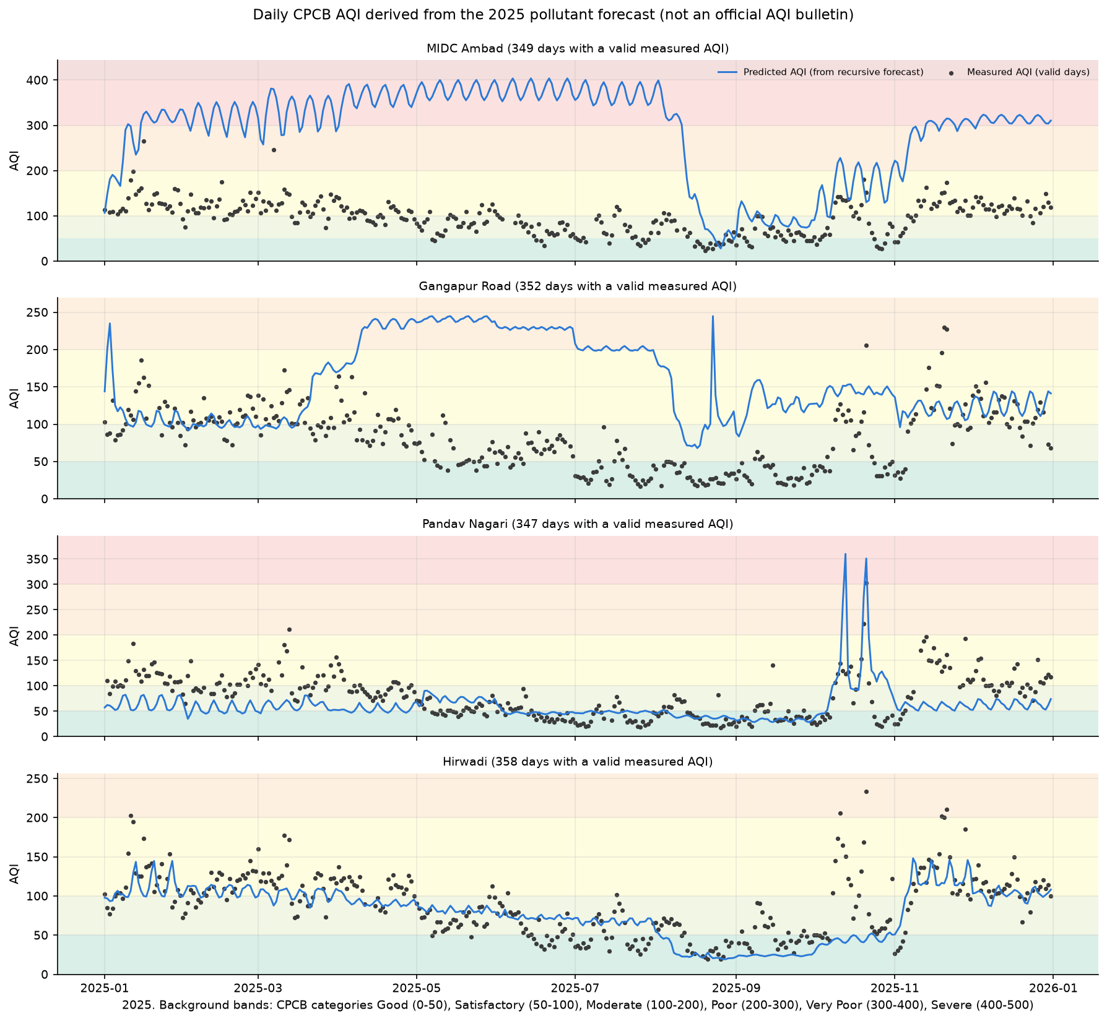
Figure 19. 2025 backtest: daily AQI derived from the forecast, with measured AQI on valid days. Bands: CPCB categories.
Table 23. 2026 forecast: daily AQI from the recursive forecast against measured AQI.
Station | Forecast days | Days with measured AQI | Category agreement % | AQI RMSE | Mean predicted AQI | Mean measured AQI
MIDC Ambad | 365 | 196 | 53.57 | 25.95 | 90.43 | 88.26
Gangapur Road | 365 | 206 | 35.44 | 31.73 | 96.24 | 76.01
Pandav Nagari | 365 | 0 | - | - | 128.4 | -
Hirwadi | 365 | 198 | 1.515 | 148.6 | 199.2 | 72.98

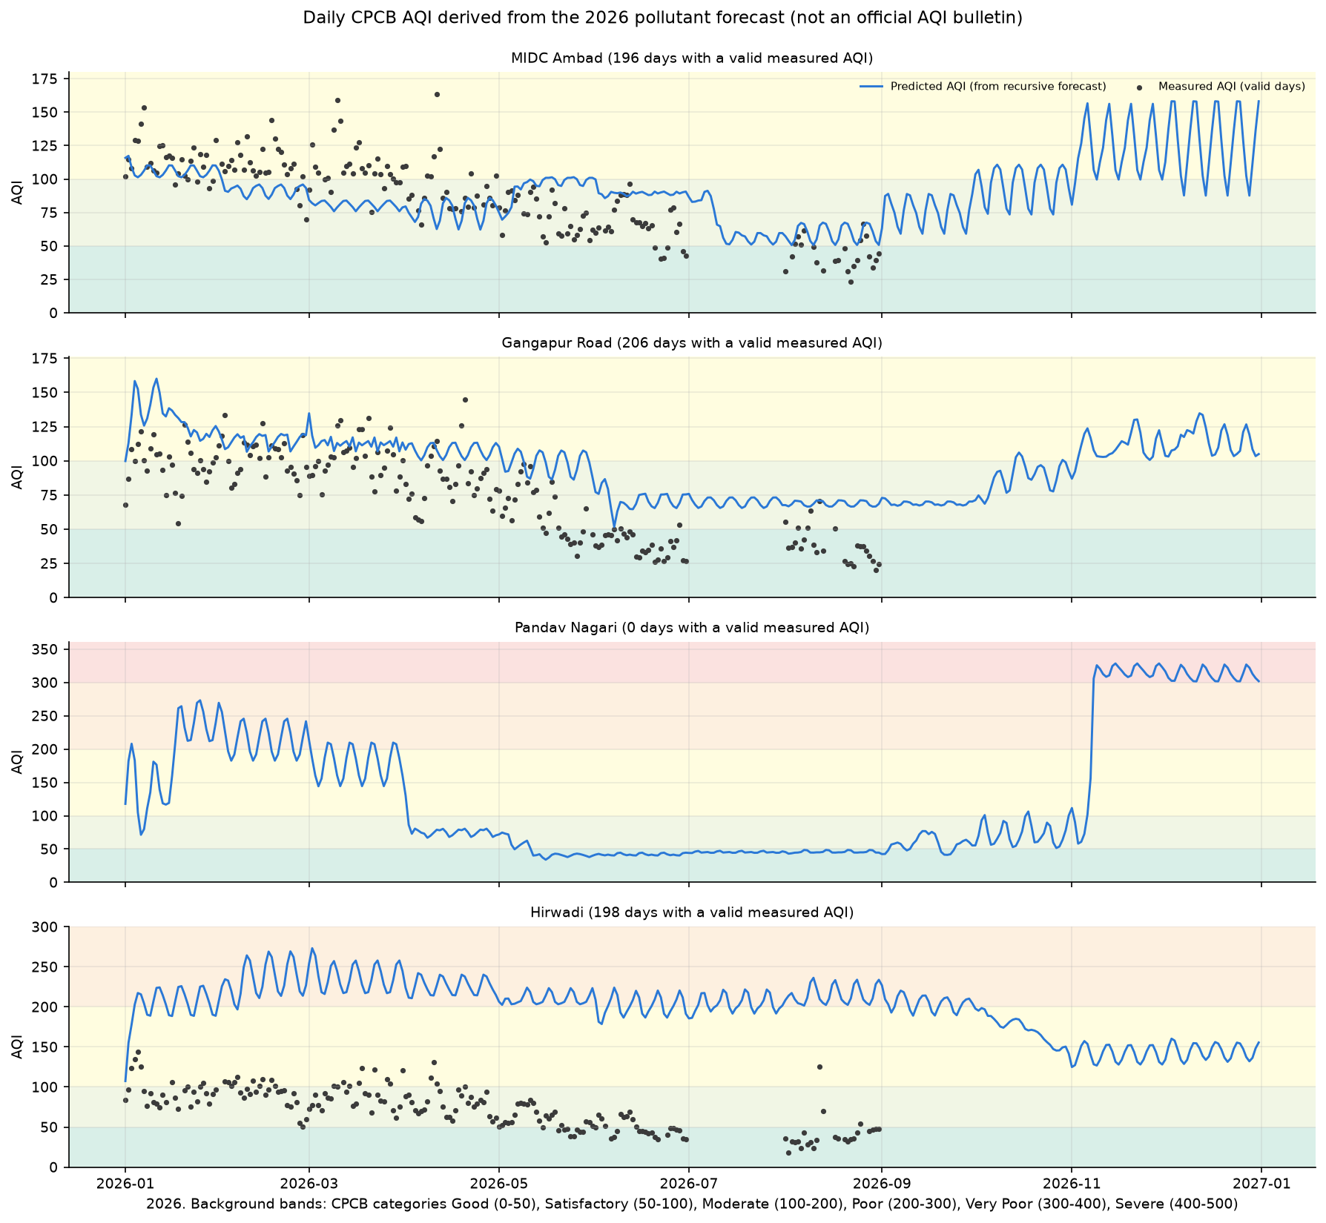
Figure 20. 2026 forecast: daily AQI derived from the forecast, with measured AQI on valid days. Bands: CPCB categories.

14. Discussion
Leakage checks. A separate script (scripts/verify_outputs.py) runs for each mode and re-derives the results from the raw CSV files and the saved models. It replays the first 48 hours of every station's recursive forecast from raw data truncated at the cutoff and reproduces the export, so the forecast does not depend on any later measurement. It rebuilds 20 random one-step input windows per station from the raw files, confirming that each prediction uses exactly the 24 preceding hours. It also checks that the scaler means equal the training-period means, that every horizon hour is present once, that missing hours carry no actual value, and that every metric matches a recomputation from the exported predictions.
Quality-flagged series, 2025 backtest: none after cleaning.
Quality-flagged series, 2026 forecast: MIDC Ambad CO, Gangapur Road NO2, Gangapur Road CO, Gangapur Road NH3 still take fewer than 100 distinct measured values after cleaning. They are reported in every table but excluded from pooled summaries and win counts.
Table 24. Horizon hours whose measurement was removed by the cleaning rules and is therefore not scored (out of 8,760 per series).
Mode | Station | PM2.5 | PM10 | NO2 | SO2 | CO | O3 | NH3
2025 backtest | Gangapur Road | 0 | 0 | 3057 | 0 | 469 | 575 | 3039
2025 backtest | Hirwadi | 0 | 0 | 0 | 24 | 3 | 0 | 0
2025 backtest | MIDC Ambad | 22 | 0 | 0 | 48 | 94 | 0 | 143
2025 backtest | Pandav Nagari | 0 | 0 | 0 | 24 | 7 | 0 | 157
2026 forecast | Gangapur Road | 0 | 0 | 4498 | 122 | 4901 | 16 | 4752
2026 forecast | Hirwadi | 0 | 0 | 212 | 24 | 2672 | 0 | 84
2026 forecast | MIDC Ambad | 0 | 0 | 0 | 0 | 3077 | 0 | 12
2026 forecast | Pandav Nagari | 0 | 0 | 0 | 0 | 0 | 0 | 0

Recursive versus one-step. The two scores answer different questions. The one-step score says how well the network corrects persistence when fresh measurements arrive every hour. The recursive score says what can be said about a given hour months in advance, which is mostly its seasonal and diurnal expectation. The 2026 forecast file is the recursive forecast. The one-step results show what an operational next-hour system would achieve once 2026 data arrives.

15. Limitations
- 2026 ground truth covers January-June and August at three stations only; July and September-December are unmeasured, and Pandav Nagari has no 2026 data. The 2026 scores therefore miss most of the monsoon and the post-monsoon season.
- A recursive hourly forecast months ahead carries no information about specific weather events. Its hourly values should be read as an expected pattern, not as a prediction of individual hours.
- No uncertainty intervals: one training run per model (seed 42). Recursive errors accumulate with lead time, as the RMSE-by-month figure shows.
- Three stations have about two and a half years of training data (mid-2023 to the cutoff), and Gangapur Road's long history includes years whose sensor behaviour differs from 2026.
- The model uses no weather inputs (temperature, humidity, wind, rain), although they are measured at three of the four stations. Weather drives much of the day-to-day change in pollution, and a year-ahead forecast could only use it with weather forecasts, which this project does not have.
- The cleaning rules (12-hour stuck values, CO zeros, flatline days) and the distinct-value flag are heuristics; some degraded readings may remain, such as low-resolution CO in mid-2025.
- Derived AQI depends on the CPCB breakpoints as implemented here, and on the assumption for the open-ended Severe band.

16. Conclusion
The pipeline produces a leakage-free, timestamp-aligned hourly forecast of all of 2026 for all four stations, and scores it only where measurements exist. The independent verifier and the test suite confirm the horizon, the labelling of missing ground truth, the absence of post-cutoff information, and every metric.
Accuracy is a separate question, and the answer is not flattering. As a year-ahead forecast, the recursive CNN-LSTM is worse than the month-by-hour climatology for every pollutant, pooled, in the 2025 backtest (-223.0% (PM2.5) to -20.9% (PM10)) and for 6 of 7 pollutants in the measured part of 2026 (-211.8% (PM10) to 10.6% (CO)). Per series it beats climatology in only 3 of 28 (2025) and 2 of 17 (2026) cases. For planning-horizon estimates of 2026, the climatology column of the same forecast file is the better number. The network earns its place one hour ahead, modestly: with the previous 24 measured hours as input, it beats persistence for 22 of 28 series in 2025 and 12 of 17 in 2026 (median RMSE reduction 5.8% and 4.4%). Pooled per pollutant, its RMSE skill against persistence is -3.7% (NO2) to 8.1% (SO2) in 2025 and -5.8% (CO) to 10.4% (PM10) in 2026.
Future work: train a direct multi-horizon model, or blend the network with climatology using weights chosen on validation, rather than feeding a one-step model its own output for 8,760 steps; add quality-controlled meteorological inputs; report variance over several seeds; and re-score 2026 when July and September-December data and Pandav Nagari's 2026 data become available.

17. Reproducing the Results
NASHIK_MODE=backtest_2025 python nashik_aq_pipeline.py
NASHIK_MODE=forecast_2026 python nashik_aq_pipeline.py
python scripts/verify_outputs.py backtest_2025
python scripts/verify_outputs.py forecast_2026
python -m unittest discover tests -v
python scripts/build_report.py
Outputs are written to outputs/backtest_2025/ and outputs/forecast_2026/. run_metadata.json in each folder records the cutoff, horizon, features, target order, selected designs, model files, evaluation coverage, software versions and git commit (2ee0a80).

18. References
[1] S. Hochreiter and J. Schmidhuber, "Long Short-Term Memory," Neural Computation, vol. 9, no. 8, pp. 1735-1780, 1997, doi: 10.1162/neco.1997.9.8.1735.
[2] O. Troyanskaya et al., "Missing value estimation methods for DNA microarrays," Bioinformatics, vol. 17, no. 6, pp. 520-525, 2001, doi: 10.1093/bioinformatics/17.6.520.
[3] C.-J. Huang and P.-H. Kuo, "A Deep CNN-LSTM Model for Particulate Matter (PM2.5) Forecasting in Smart Cities," Sensors, vol. 18, no. 7, art. 2220, 2018, doi: 10.3390/s18072220.
[4] D. Qin et al., "A Novel Combined Prediction Scheme Based on CNN and LSTM for Urban PM2.5 Concentration," IEEE Access, vol. 7, pp. 20050-20059, 2019, doi: 10.1109/ACCESS.2019.2897028.
[5] H. Junninen et al., "Methods for imputation of missing values in air quality data sets," Atmospheric Environment, vol. 38, no. 18, pp. 2895-2907, 2004, doi: 10.1016/j.atmosenv.2004.02.026.
[6] F. Pedregosa et al., "Scikit-learn: Machine Learning in Python," Journal of Machine Learning Research, vol. 12, pp. 2825-2830, 2011.
[7] Y. LeCun, L. Bottou, Y. Bengio and P. Haffner, "Gradient-based learning applied to document recognition," Proceedings of the IEEE, vol. 86, no. 11, pp. 2278-2324, 1998, doi: 10.1109/5.726791.
[8] D. P. Kingma and J. Ba, "Adam: A Method for Stochastic Optimization," arXiv:1412.6980, 2014 (ICLR 2015).
[9] N. Srivastava et al., "Dropout: A Simple Way to Prevent Neural Networks from Overfitting," Journal of Machine Learning Research, vol. 15, pp. 1929-1958, 2014.
[10] C. Bergmeir and J. M. Benítez, "On the use of cross-validation for time series predictor evaluation," Information Sciences, vol. 191, pp. 192-213, 2012, doi: 10.1016/j.ins.2011.12.028.
[11] Central Pollution Control Board, "National Air Quality Index," Ministry of Environment, Forest and Climate Change, Government of India, 2014.

