***Advance c#***

**Debugging in Visual Studio:**

**Introduction**

Debugging is a critical part of the development process. It allows you to identify, diagnose, and fix issues in your code

**Debug points**

Breakpoints are the most common debugging tool. You set a breakpoint in the code where you want the program to pause during execution, allowing you to inspect the application's state at that point.

**Different Debug windows**

**Locals Window :** The Autos and Locals windows show variable values while you are debugging

**Watch Window**While you're debugging, you can use Watch windows and QuickWatch to watch variables and expressions

**Immediate Window** **Immediate** window to debug and evaluate expressions, execute statements, and print variable values.

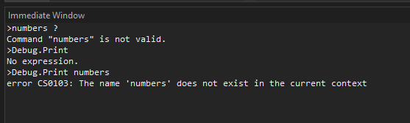

**Call Stack**: Shows the sequence of method calls that led to the current point in the program. This helps you trace how the code arrived at the breakpoint.

**Editing**

When the program is paused at a breakpoint, you can modify your code, such as fixing bugs or changing logic, without restarting the debugging session.

If you modify a value then you will out of the dub point.

**Conditional break points**

You can control when and where a breakpoint executes by setting conditions.

You have to add a hit count and filter condition.

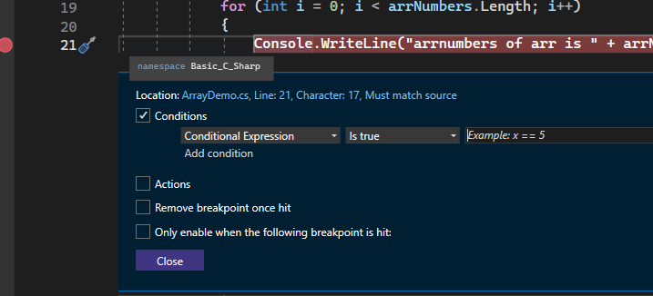

**Data inspector**

The Data Inspector window helps you view and manipulate complex data structures while debugging

It allows you to inspect objects, collections, and any other data types in a more readable format.

**Conditional compilation**

Include or exclude code based on build configurations (e.g., Debug vs Release).

