Remote Bioinformatics Report: Exploratory RNA-seq Visualization
Public dataset: GSE334005 | Organism: Mus musculus

1. Research Question
How can exploratory visualization of a public bulk RNA-seq expression matrix help assess sample-level expression distributions, similarity, and major sources of variation across tumor samples treated with PBS, oncolytic virus M1 (OVM), or M1-mutIL-18 (OVM18)?

2. Dataset and Source
The dataset GSE334005 is described as bulk RNA-seq from murine CT26 colon cancer, B16F10 melanoma, and LLC lung cancer tumor models following PBS, OVM (M1), or OVM18 (M1-mutIL-18) treatment. The GEO series and its supplementary expression tables are the source of the data.
GEO record: https://www.ncbi.nlm.nih.gov/geo/query/acc.cgi?acc=GSE334005
Supplementary tables reported for this series include read counts, FPKM, and TPM. The specific table used in the analysis should be recorded in the final repository/notebook. The exact downloaded file size and sample count were not independently recorded for this report.

3. Methods
- Data acquisition: Obtain the processed expression table and sample metadata from the GEO series record. Keep the original file unchanged and record its filename, download date, and file size.
- Data inspection: Load the table using Python and Pandas; inspect dimensions, column names, missing values, duplicated identifiers, and whether the first column contains gene IDs. Match sample columns to treatment and tumor-model metadata.
- Expression scale: Use a processed TPM/FPKM matrix with a log2(value + 1) transformation for exploratory visualization. If using raw read counts, do not treat them as normalized expression; use an appropriate normalization workflow before boxplots, correlation, or PCA.
- Boxplot: Plot the distribution of transformed expression values for each sample to compare medians, spread, and potential outliers.
- Correlation heatmap: Calculate pairwise sample correlations using the same transformed expression matrix and display them as a heatmap to inspect sample similarity.
- PCA: Transpose the expression matrix so samples are rows, select an appropriate set of informative genes if needed, and run PCA on transformed expression values. Color or label points by tumor model and treatment only when metadata has been checked.
- Reproducibility: Save the notebook/script, figures, input filename, software versions, and a short README in a public GitHub repository or an accessible Drive folder.

4. Results
This report defines three descriptive outputs: (1) a boxplot comparing per-sample expression distributions, (2) a sample-correlation heatmap, and (3) a PCA plot showing the largest axes of variation. No numerical summaries or plot images were supplied when this report was drafted, so specific observations—such as which samples cluster together, the percentage of variance explained by PC1/PC2, or whether any sample is an outlier—are intentionally not invented. Insert the actual figures and describe only patterns visible in them before submitting.
Suggested result wording after inspecting the actual plots: “The boxplot showed [describe observed distribution differences]. The correlation heatmap showed [identify observed high/low-similarity sample pairs or clusters]. In PCA, [describe observed sample grouping/separation], with PC1 and PC2 explaining [actual percentages] of variance.” Replace every bracketed phrase with the observed result.
Boxplo1 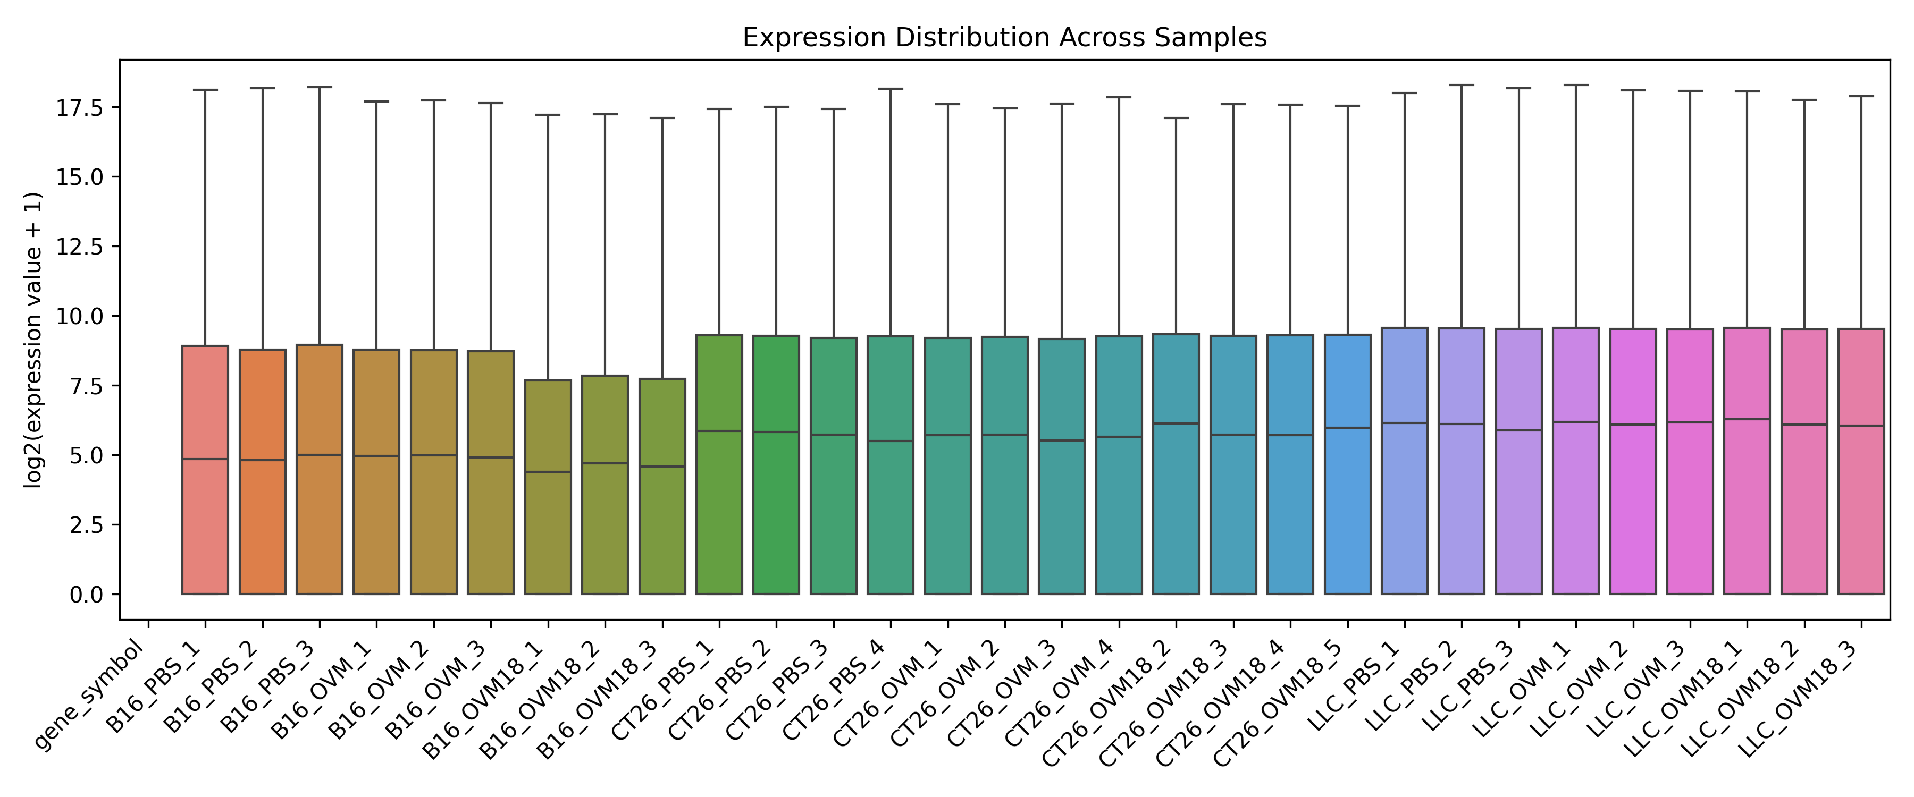

Sample_correlation plot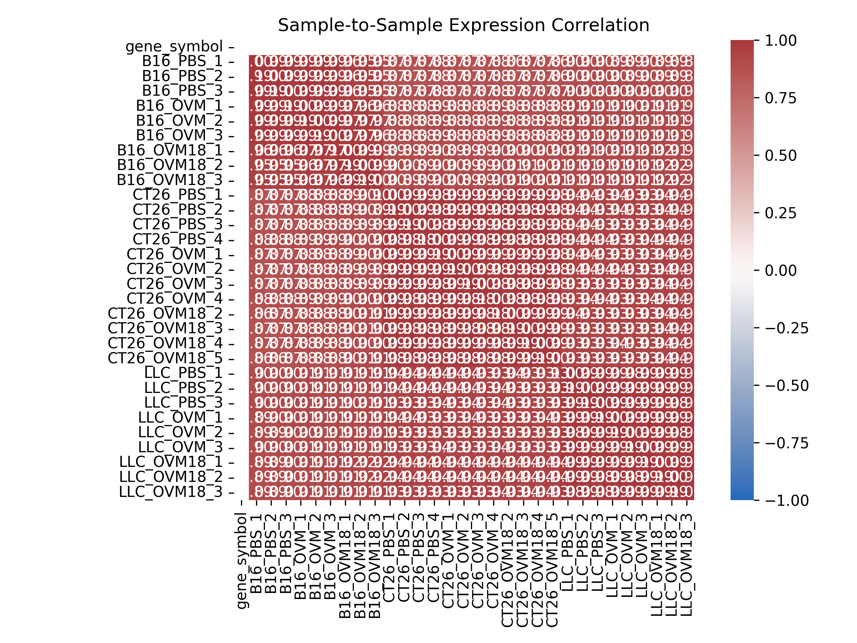

Pca plot 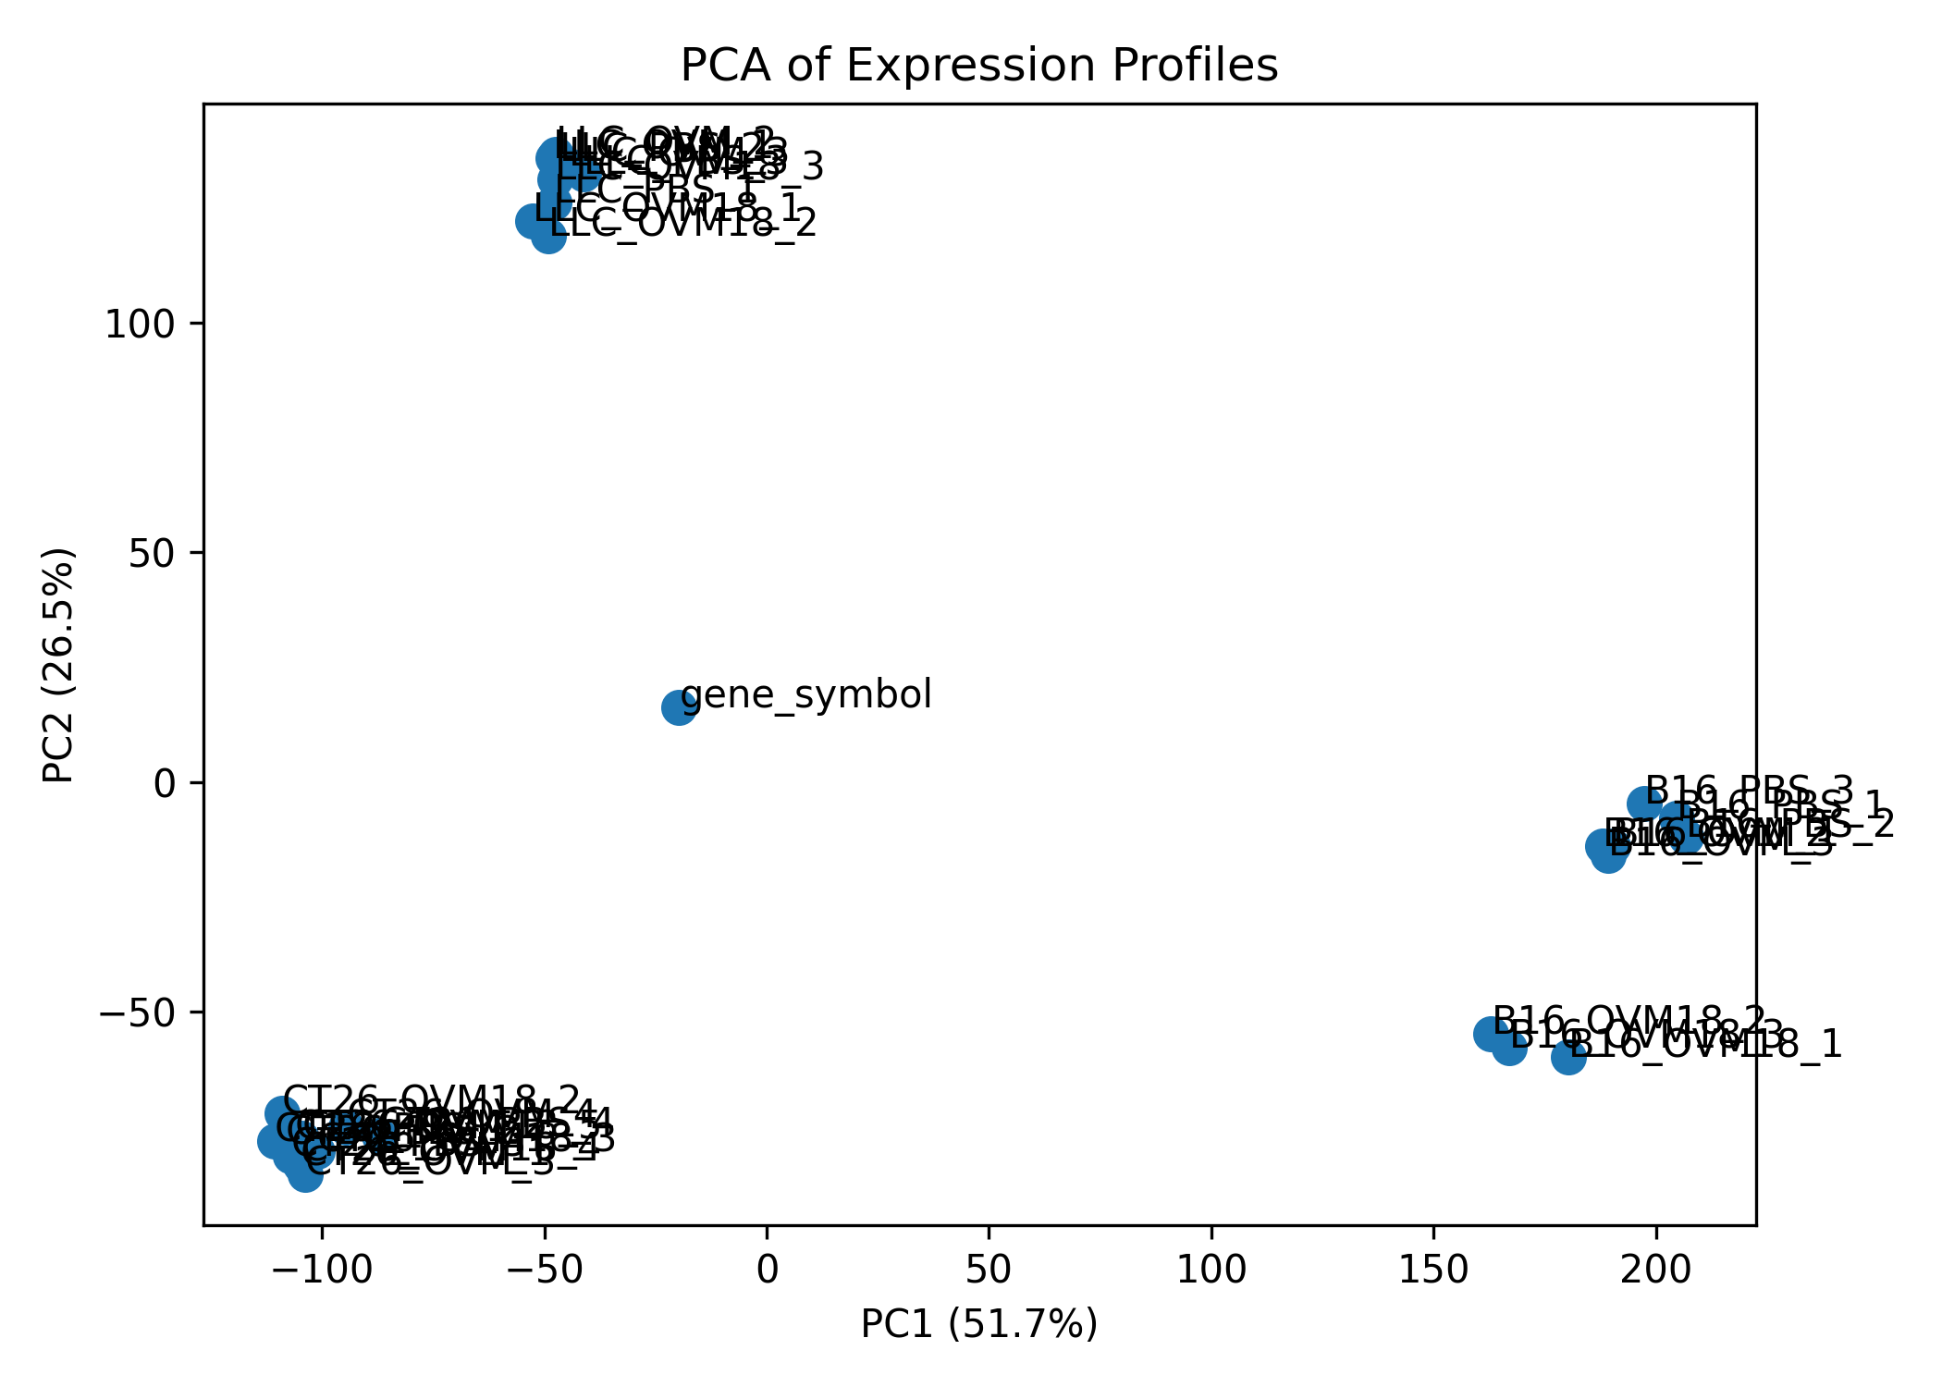

5. Scientific Interpretation

A boxplot summarizes expression distributions; it does not identify individual differentially expressed genes. A correlation heatmap describes similarity across the expression profiles used; similarity can reflect biology, technical effects, or both. PCA is an unsupervised summary of variation and can reveal broad patterns, but visual separation alone is not evidence of statistical significance or causation. Treatment effects should be tested with a suitable differential-expression design that accounts for tumor model and other relevant experimental factors.

6. Limitations
- This is an exploratory visualization, not a complete differential-expression analysis.
- The analysis depends on the accuracy of sample metadata and correct matching of sample columns to groups.
- The exact downloaded file, file size, sample count, and observed plot values must be documented from the actual files.
- Processed TPM/FPKM values are useful for visualization but should not be substituted for raw counts in count-based differential-expression tools such as DESeq2.
- Batch effects, sample quality, biological replicate structure, and confounding factors cannot be ruled out from these plots alone.
- No biological conclusions about treatment efficacy should be drawn without formal statistical testing and biological context.

7. Conclusion
Public bulk RNA-seq data can be explored remotely with Python using expression-distribution boxplots, sample-correlation heatmaps, and PCA. Together, these plots support an initial assessment of data structure and sample relationships. Their findings must be reported from the generated figures, and any claims about treatment-associated expression changes require appropriate downstream statistical analysis.

8. Tools
Python; Pandas; NumPy; Matplotlib; Seaborn; scikit-learn; Jupyter Notebook or Google Colab.

9. References
- NCBI Gene Expression Omnibus (GEO). GSE334005: Bulk RNA-seq of CT26, B16F10, and LLC tumor models treated with PBS, M1, or M1-mutIL-18. https://www.ncbi.nlm.nih.gov/geo/query/acc.cgi?acc=GSE334005
- NCBI GEO Overview. https://www.ncbi.nlm.nih.gov/geo/info/overview.html
- Love, M. I., Huber, W., & Anders, S. (2014). Moderated estimation of fold change and dispersion for RNA-seq data with DESeq2. Genome Biology, 15, 550. https://doi.org/10.1186/s13059-014-0550-8
- The scikit-learn developers. Principal component analysis (PCA) documentation. https://scikit-learn.org/stable/modules/generated/sklearn.decomposition.PCA.html

