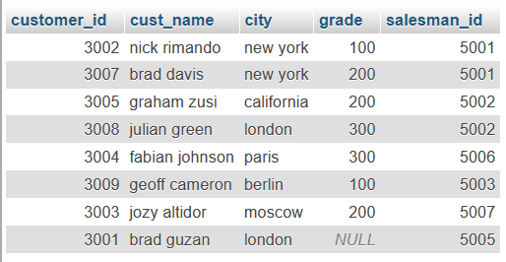

**CREATE**

CREATE TABLE customer(customer_id int(30),cust_name varchar(70),city int(20),grade int(30),salesman_id int(30));

**INSERT**

INSERT INTO customer(customer_id,cust_name,city,grade,salesman_id) VALUES (3002,’nick Rimando’,’new york’,100,5001), (3007,’brad davis’,’new york’,200,5001), (3005,’graham zusi’,’california’,200,5002), (3008,’julian green’,’london’,300,5002), (3004,’fabian johnson’,’paris’,300,5006), (3009,’geoff cameron’,’berlin’,100,5003), (3001,’jozy altidor’,’moscow’,200,5007);

INSERT INTO customer(customer_id,cust_name,city,salesman_id) VALUES (3001,’brad guzan’,’london’,5005);

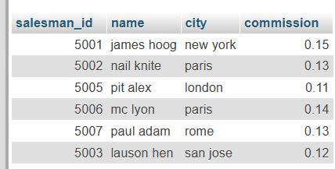

**CREATE**

CREATE TABLE salesman(salesman_id int(30),name varchar(70),city varchar(100),commission REAL);

**INSERT**

INSERT INTO salesman(salesman_id,name,city,commission) VALUES (5001,’james hoog’,’new york’,0.15), (5002,’nail knite’,’paris’,0.13), (5005,’pit alex’,’london’,0.11), (5006,’mc lyon’,’paris’,0.14), (5007,’paul adam’,’rome’,0.13), (5003,’lauson hen’,’san jose’,0.12);