PSC Innovative Assignment

* Roll no

19BCE171

19BCE196

* PROJECT Topic

Notepad using tkinter

* Description

In this project we create Notepad.

Features

1.we can create a new file and also open a file from our pc.

2.we can perform cut,copy and paste command.

3.we can save the file.

4. we can also create exit button to exit from notepad

* Run App Local

This app is created in Python Tkinter.

1.Python:

2.Install Tkinter in your IDE

Home page:-

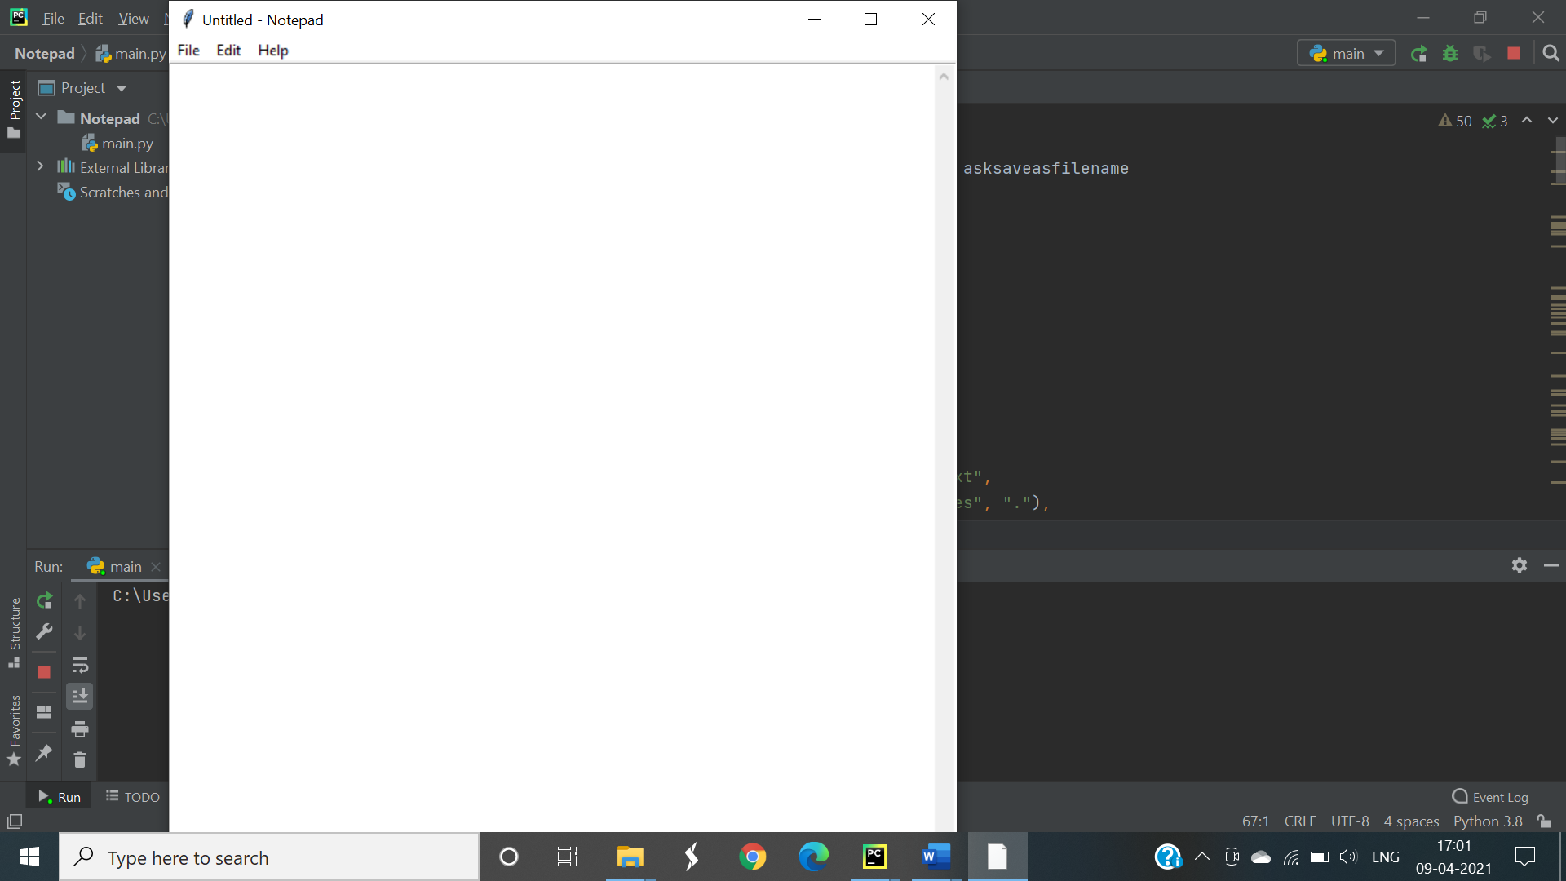

Create a new file:-

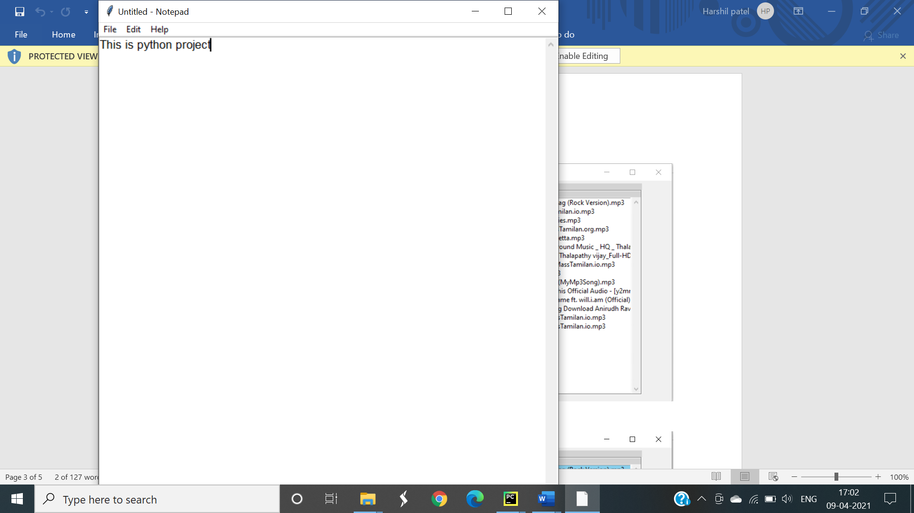

Save a File:

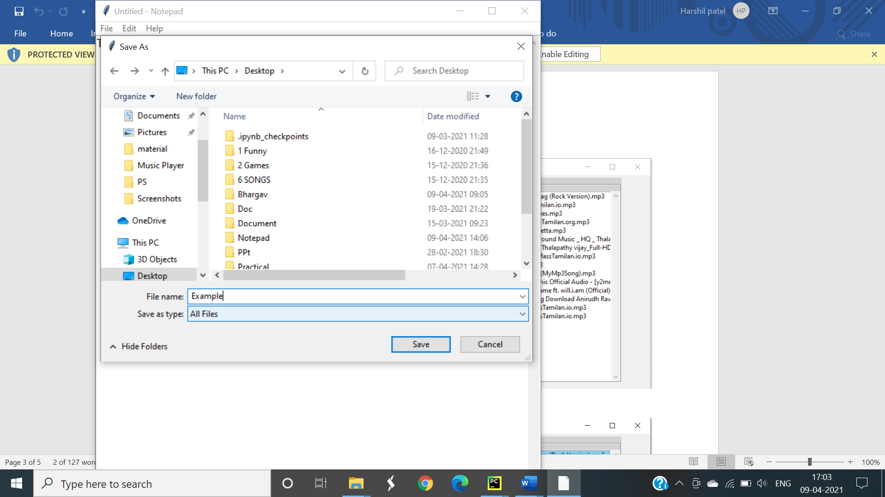

Perform cut copy and paste:-

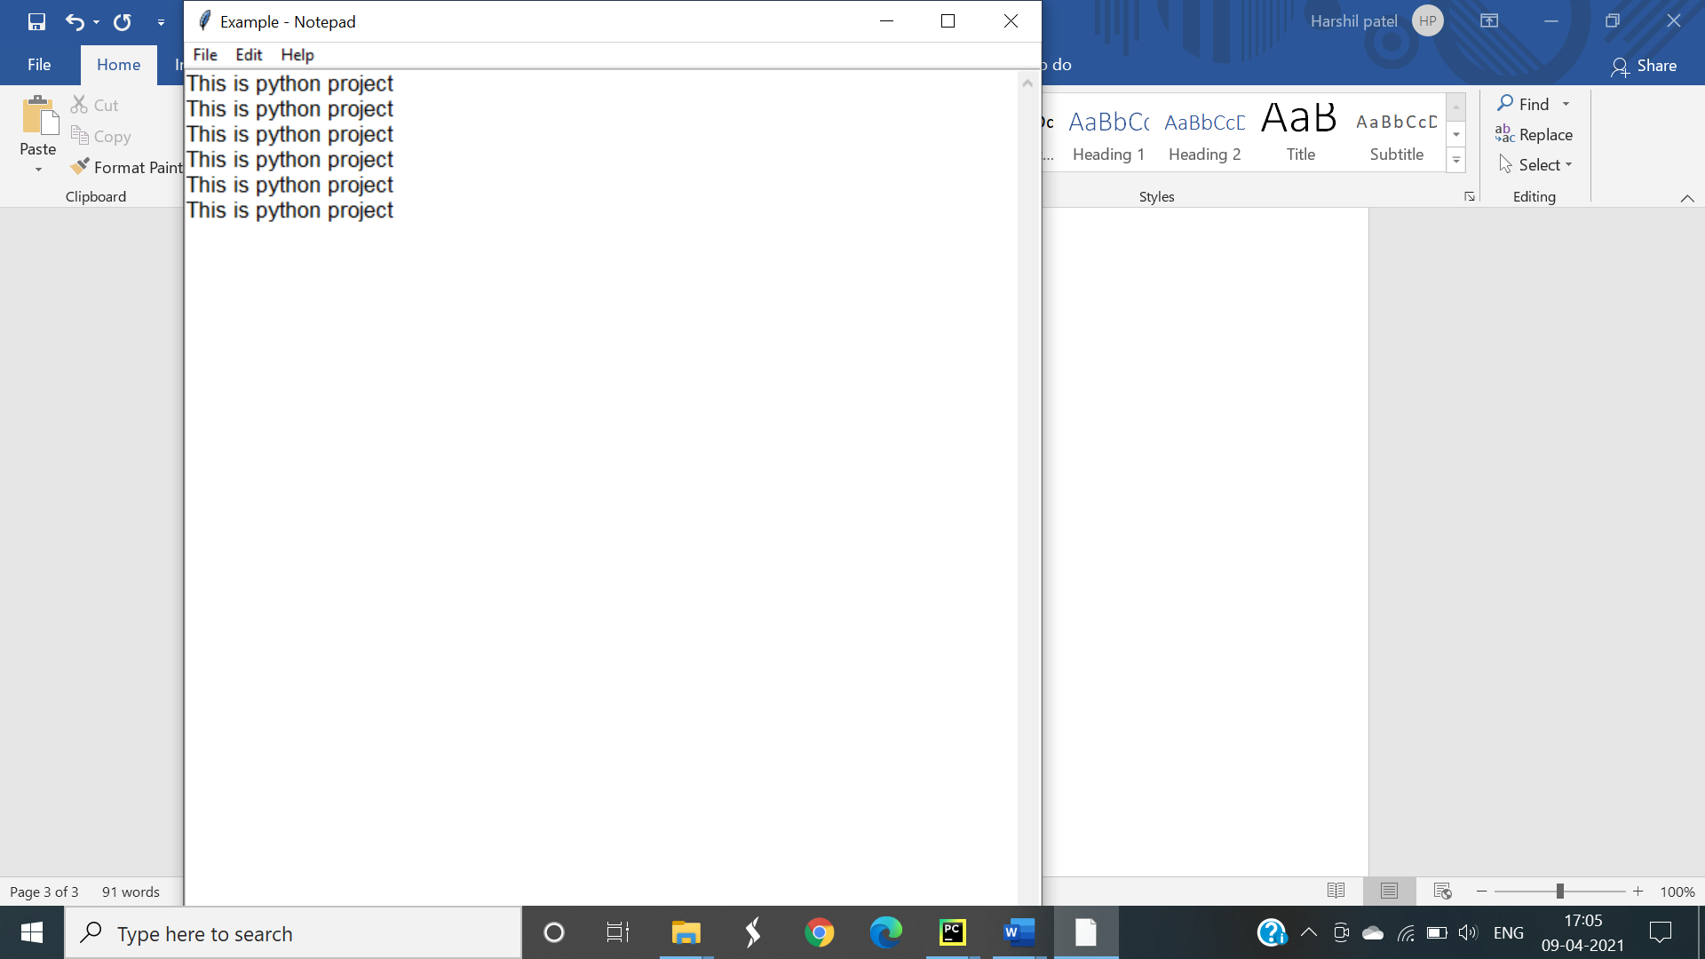

Thank you