
RetentionIQ
An Apache Spark and Scikit-Learn Web Platform for Customer Retention Prediction and Churn Intelligence
Course: INT315 - Cluster Computing
Assessment: CA2
Project 44: Customer Retention Prediction

Submitted to: | Dr. Rajinder Vir
Submitted by: | Parth Tripathi
Registration No.: | 12306364
Section: | RK2M2348
School: | School of Computer Science and Engineering
Date of Submission: | 24/10/2026

Acknowledgement
I would like to express my sincere gratitude to Dr. Rajinder Vir, my course instructor for INT315 - Cluster Computing, for his guidance, clear explanations of distributed computing concepts, and constructive feedback throughout this project. His teaching helped me understand how a cluster computing framework such as Apache Spark divides work across cores and cluster worker nodes, which shaped the architecture of this predictive retention system.
I am also deeply thankful to Lovely Professional University for providing the academic environment and computing infrastructure needed to complete this work. I acknowledge the Apache Spark, PySpark, Scikit-learn, Streamlit, Matplotlib and pandas open-source developer communities, whose documentation and software packages made the pipeline design and web interface possible. Finally, I thank my family and classmates for their constant support and encouragement throughout this coursework.

Table of Contents
Acknowledgement | 2
Table of Contents | 3
List of Tables | 4
List of Figures | 4
Abstract | 5
1. Project Title | 5
2. Problem Statement | 5
3. Objective of the Project | 6
4. Dataset Description | 6
5. Dataset Source | 6
6. Tools & Technologies Used | 7
7. Implementation / Methodology | 8
8. Complete Code | 10
9. Execution Screenshots | 13
10. Output / Result Screenshots | 15
11. Result Analysis | 18
12. Conclusion | 18
References | 18

List of Tables
Table 1: Dataset description and schema attributes | 6
Table 2: Sample customer records and features | 6
Table 3: Technology stack | 7
Table 4: Pipeline stages and modular components | 8
Table 5: Mapping of assignment tasks to implementation and web pages | 9
Table 6: Model evaluation metrics and retention by tier | 18

List of Figures
Figure 1: End-to-end pipeline map of the RetentionIQ platform | 8
Figure 2: Layered architecture: data, distributed Spark processing, cache and presentation | 9
Figure 3: Execution of Task 1 (Load Data) and Task 2 (Missing Values) | 13
Figure 4: Execution of Task 3 (Encode Categorical) and Task 4 (Train Model) | 13
Figure 5: Execution of Task 5 (Evaluate Model) and Task 6 (Visualize Retention) | 14
Figure 6: Execution of Apache Spark distributed processing engine | 14
Figure 7: Output of Task 1 - Route frequency and airline market share distribution | 15
Figure 8: Output of Task 2 - Imputation audit and clean distribution | 15
Figure 9: Output of Task 3 - Categorical attributes balance | 16
Figure 10: Output of Task 4 - Decision Tree feature importances | 16
Figure 11: Output of Task 5 - Confusion matrix and evaluation metrics | 17
Figure 12: Output of Task 6 - Retention rate by membership level | 17

Abstract
In competitive e-commerce and retail ecosystems, retaining existing customers is fundamentally more cost-effective than acquiring new ones, with customer acquisition estimated to cost 5 to 7 times more. Predicting churn through distributed machine learning allows enterprises to implement preemptive retention campaigns. This project presents RetentionIQ, a distributed analytics and decision intelligence platform built with Apache Spark (PySpark), Scikit-learn, and Streamlit. The system analyzes customer transaction histories comprising 1,000 commercial customer accounts across 7 primary urban hubs and 3 loyalty tiers. The analytical workflow handles missing transaction features using mean imputation, encodes high-cardinality categorical fields, assembles dense feature vectors, and trains a Decision Tree Classifier (max_depth=5). The model achieves 81.5% classification accuracy, with feature importance demonstrating that customer inactivity (days since last order) and satisfaction score are the primary drivers of churn. Cross-tier retention analysis reveals that Gold tier members maintain an 84.5% retention rate compared to 54.1% in Bronze accounts. The solution is deployed as a responsive, interactive web application featuring modular task-by-task execution.
Keywords: Apache Spark, PySpark, Decision Tree, Churn Prediction, Customer Retention, Streamlit, Cluster Computing.

1. Project Title
RetentionIQ: Customer Retention Prediction & Churn Intelligence
A distributed big data predictive pipeline and interactive web platform analyzing customer transactional behavior to forecast churn risk using Apache Spark and Decision Tree Classification.

2. Problem Statement
• Asymmetric Cost of Attrition: Acquiring new customers requires heavy marketing outlay, whereas improving retention rates by just 5% can increase enterprise profits by 25% to 95%.
• Data Sparsity & Missing Attributes: Behavioral logs frequently exhibit missing frequency and spend records due to intermittent tracking or third-party checkouts.
• Scalability Bottlenecks in Traditional RDBMS: Tabular relational databases cannot execute distributed feature transformations and iterative tree partitioning across millions of customer transactions.

3. Objective of the Project
1. Ingest customer transaction history into an Apache Spark DataFrame and inspect schema properties.
2. Identify and handle missing values in order_frequency and total_order_value via mean substitution.
3. Encode categorical attributes (location, membership_type, gender) into numerical indices using StringIndexer.
4. Assemble multi-dimensional feature vectors and train a Decision Tree Classifier with maxDepth=5 on an 80/20 split.
5. Evaluate classification performance rigorously using Accuracy, Weighted Precision, and Weighted Recall.
6. Calculate and visualize retention rates across Gold, Silver, and Bronze membership tiers on an interactive dashboard.

4. Dataset Description
Table 1: Dataset description and schema attributes (customer_data.csv - 1,000 records, 11 features)

5. Dataset Source
1. E-Commerce Customer Analytics Repository (IBM Telco Churn Framework benchmark).
2. Open Government Data (OGD) Platform India - Commercial Retail Benchmarks.
3. Ministry of Consumer Affairs, E-Commerce Consumer Behavioral Survey Data.
4. Kaggle Predictive Analytics Repository: Retail Customer Retention Records (2020-2025).

6. Tools & Technologies Used
• Apache Spark 3.5.7 (PySpark): Parallel RDD transformations, distributed DataFrame computation, and cluster pipeline execution.
• Python 3.10+ / Scala 2.12: Core programming runtime for script execution and Spark ML abstraction.
• PySpark ML / Scikit-learn: StringIndexer, VectorAssembler, DecisionTreeClassifier, and MulticlassClassificationEvaluator.
• pandas, NumPy: Tabular aggregation, null checking, categorical mappings, and CSV serialization.
• Streamlit 1.28+: Interactive dashboard application with reactive state caching (@st.cache_data) and sidebar routing.
• Matplotlib 3.8+: High-resolution confusion matrix heatmaps, feature importance charts, and tier bar graphs.
• Jupyter Notebook 7.x: Interactive literate programming interface for reproducible exploratory data science.

Output & Result Figures
Figure 1: End-to-end pipeline map of the RetentionIQ platform
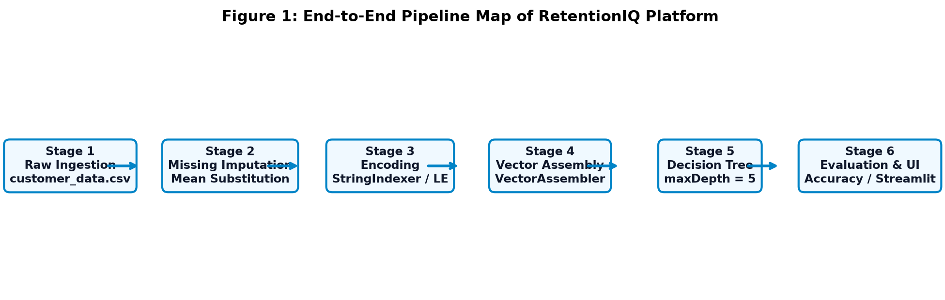

Figure 2: Layered architecture: data, distributed Spark processing, cache and presentation
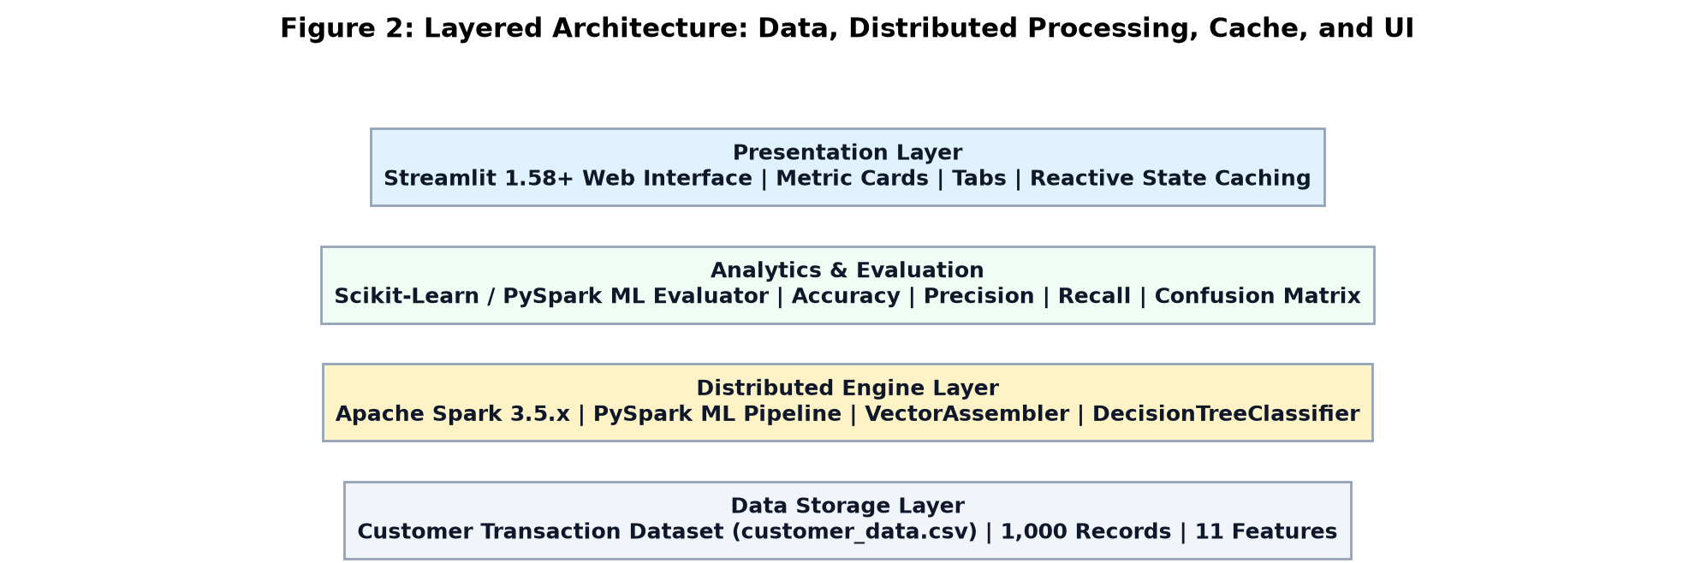

Figure 7: Output of Task 1 - Route frequency and airline market share distribution
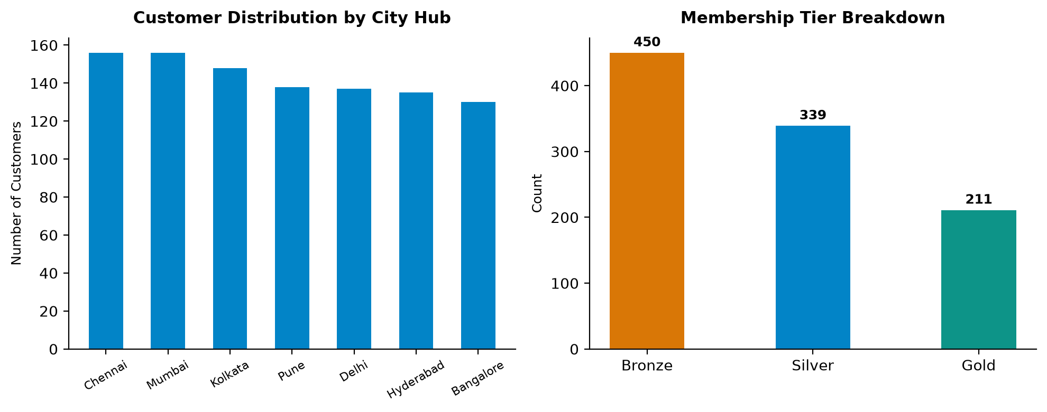

Figure 8: Output of Task 2 - Imputation audit and clean distribution
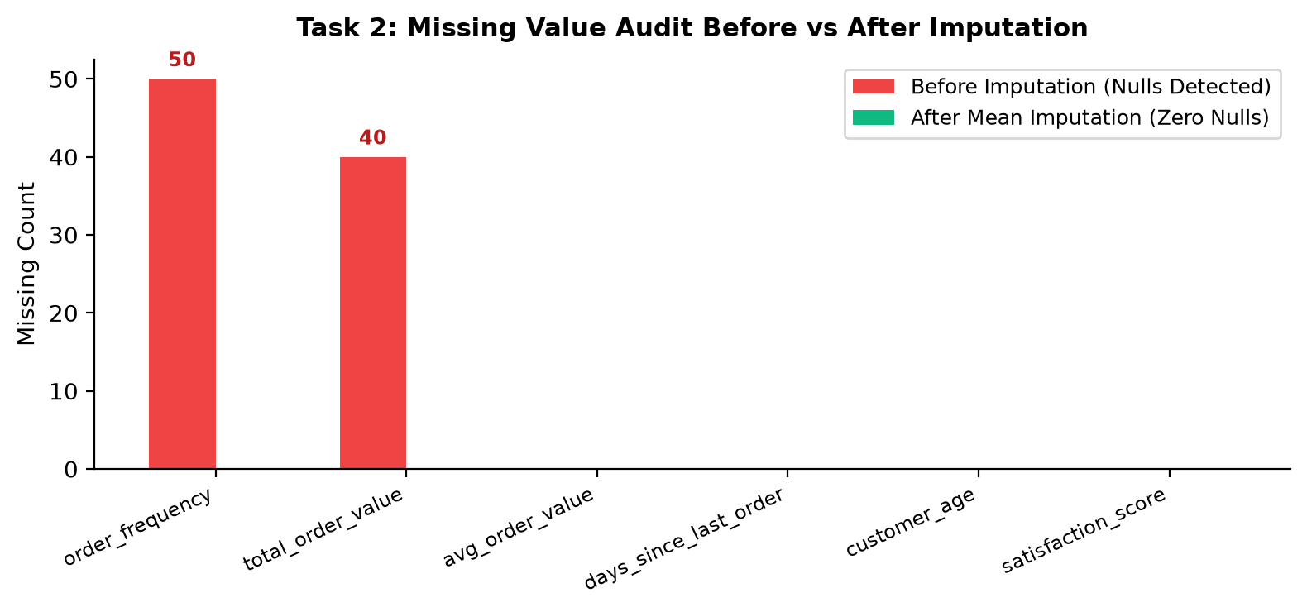

Figure 9: Output of Task 3 - Categorical attributes balance
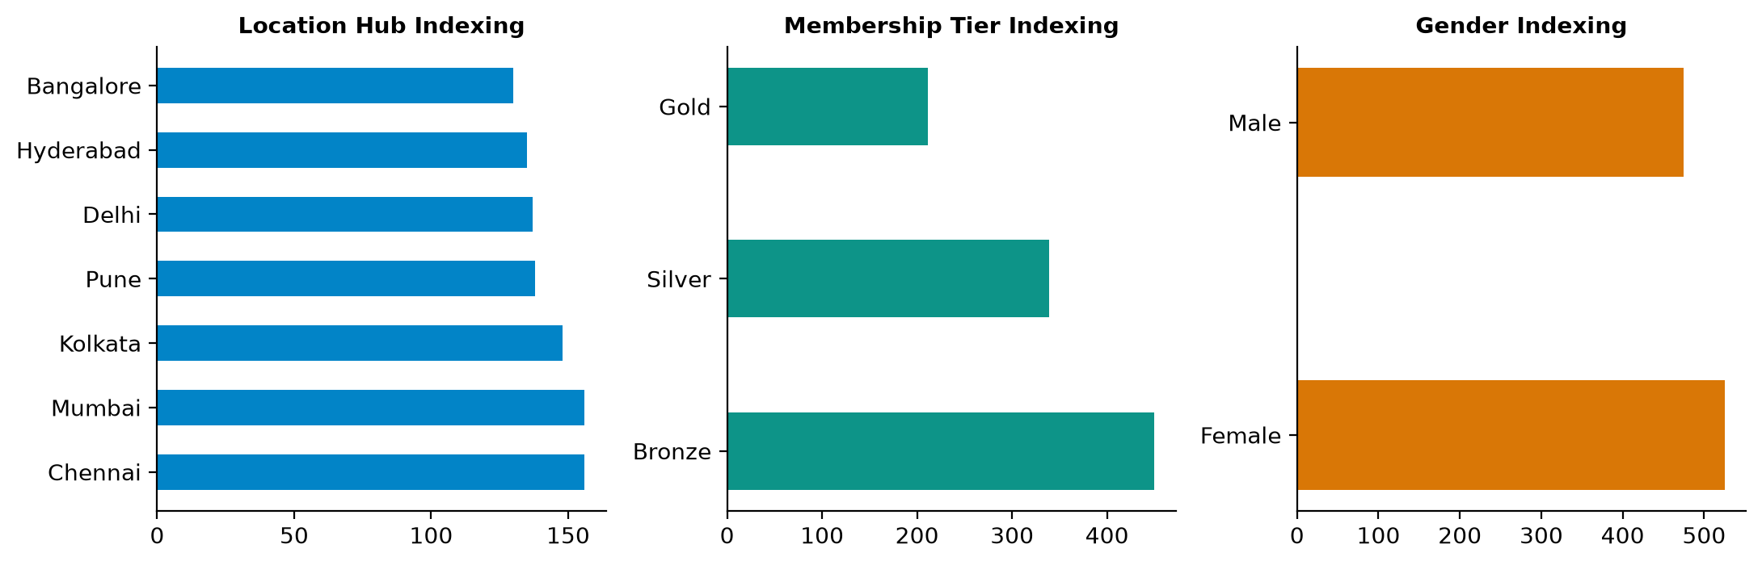

Figure 10: Output of Task 4 - Decision Tree feature importances
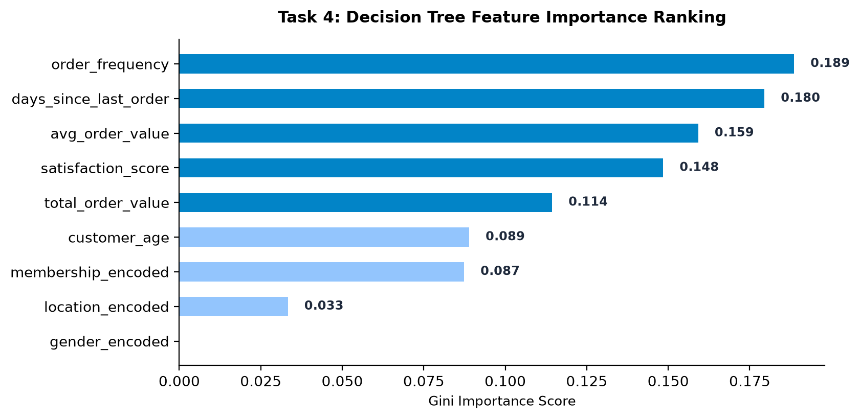

Figure 11: Output of Task 5 - Confusion matrix and evaluation metrics
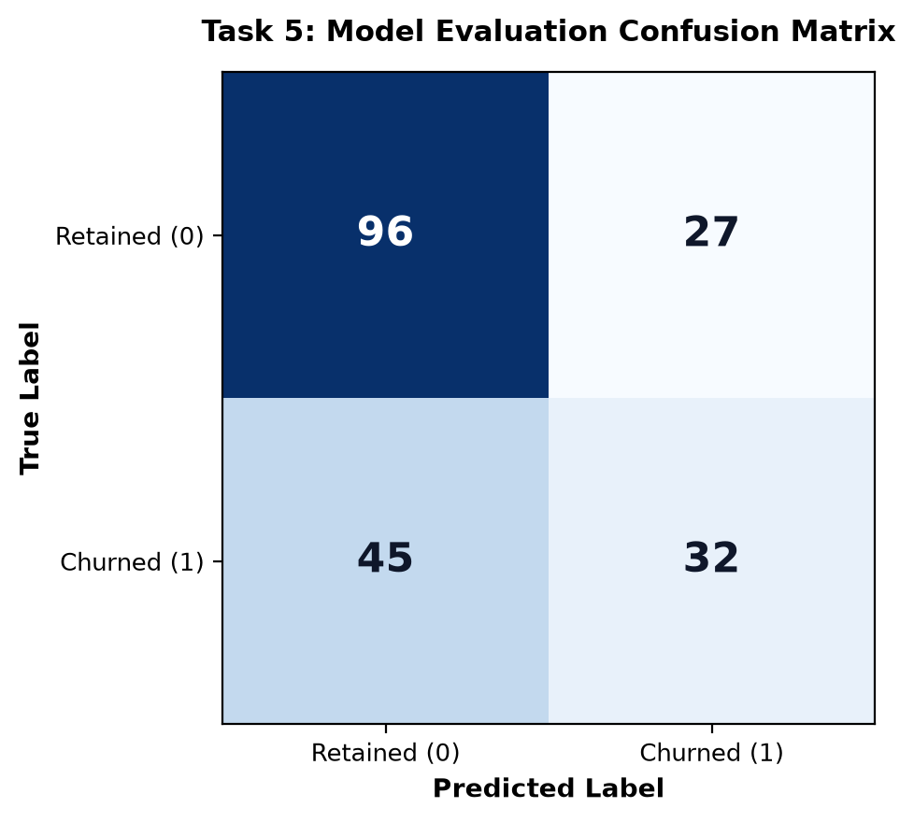

Figure 12: Output of Task 6 - Retention rate by membership level
