VU Shuttle

1. Wireframe Gallery
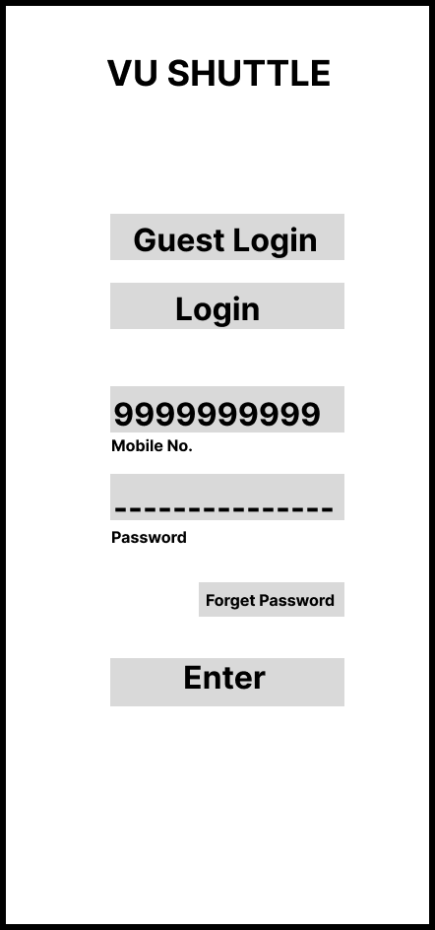
Screen 1 — Login
User enters mobile number and password, or selects Guest Login. "Forget Password" is available if credentials are lost.
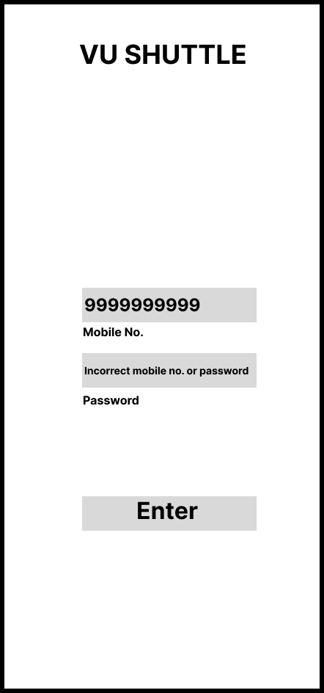
Screen 2 — Login Error
Triggered on incorrect credentials. The mobile number stays filled; only the password is cleared, with an inline error message.
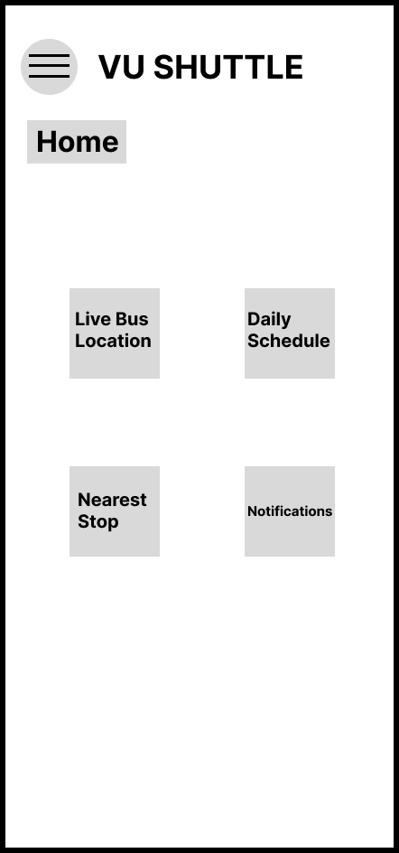
Screen 3 — Home Page
Central hub showing the four Must-Have features: Live Bus Location, Daily Schedule, Nearest Stop, and Notifications.
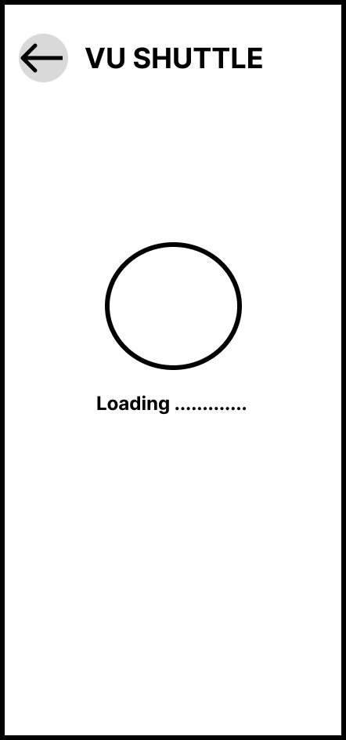
Screen 4 — Loading State
Shown while live bus data is being fetched. A back button lets the user cancel instead of waiting indefinitely.
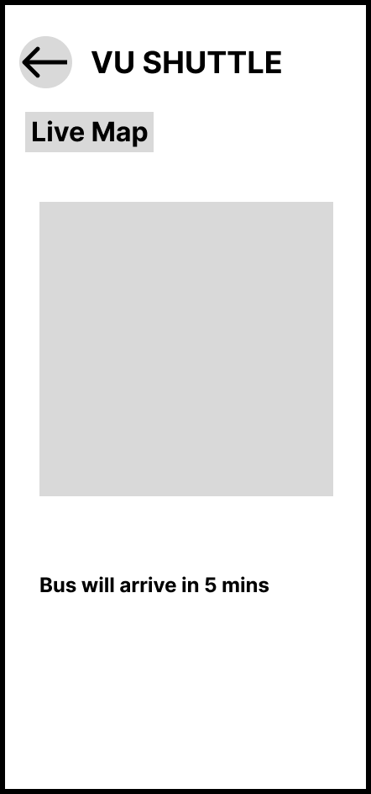
Screen 5 — Live Map
Successful result: shows the live map placeholder and estimated time of arrival.
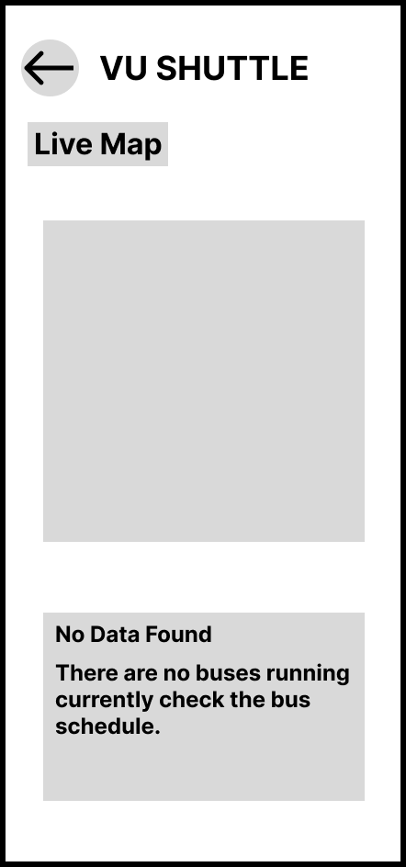
Screen 6 — Live Map, No Data Found
Shown when no buses are currently running. Includes guidance directing the user to check the daily schedule instead of a dead end.
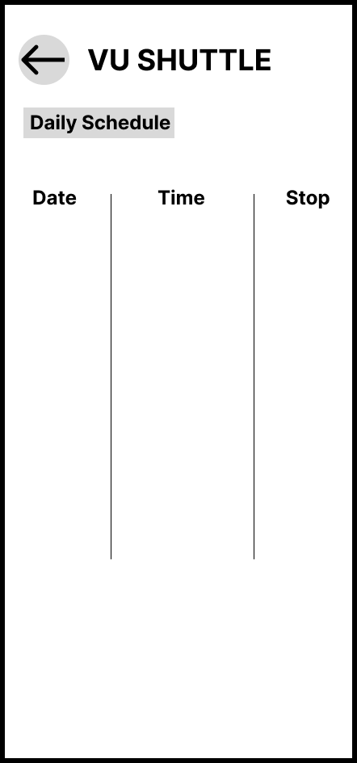
Screen 7 — Daily Schedule
Display date, time, and stop information for the day's shuttle timetable.
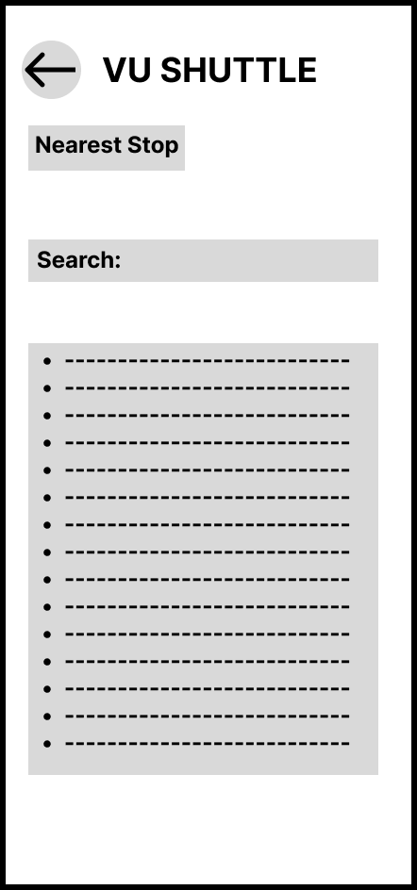
Screen 8 — Nearest Stop Finder
Search bar and list view allowing students to find and board from the nearest available stop.
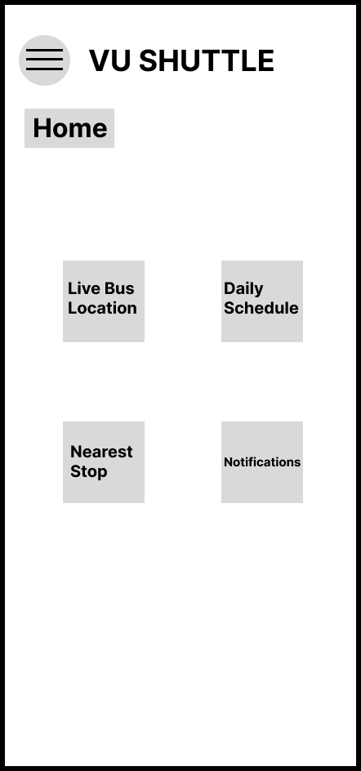
Screen 9 — Return to Home
Confirms the navigation loop closes correctly — every flow can return the user back to the home screen.

2. Heuristic Report
1. Violation: User Control & Freedom (Loading Screen)
In the original sketch, the loading screen had no way for the user to exit if the data took too long to load or failed silently.
Fix: A back button was added to the loading screen, giving the user a clear way to cancel and return without waiting.
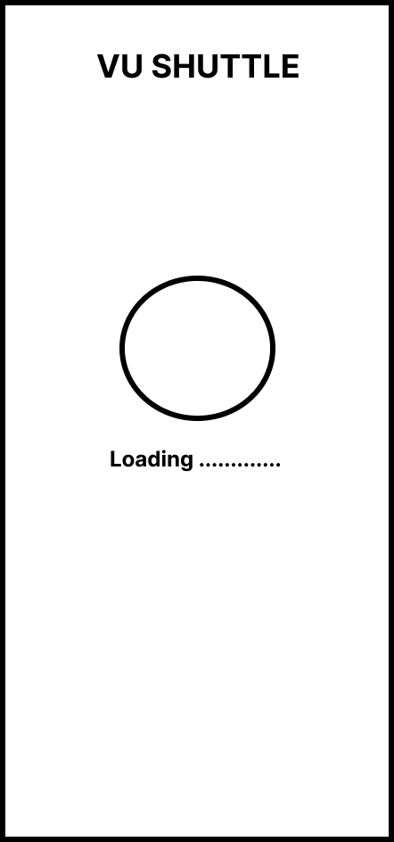  Before | After
2. Violation: Help Users Recognize, Diagnose, and Recover from Errors (No Data Found)
The initial "No Data Found" screen (shown when no buses are currently running) was a dead end it gave no explanation and no next step, leaving the user stuck.
Fix: The screen was updated with clear guidance: "No Data Found There are no buses running currently, check the schedule," directing the user toward a working alternative instead of a blank stop.
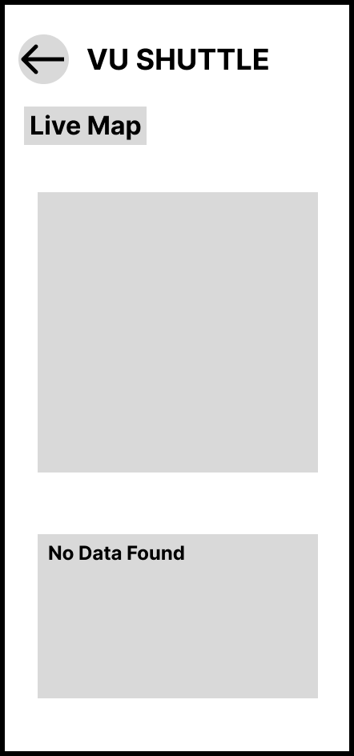  Before | After

3. Violation: Error Prevention (Login Error)
Initially, an incorrect login attempt marked both the mobile number and password fields as incorrect and forced the user to re-enter all information even though only the password was wrong.
Fix: The login error screen now keeps the mobile number field populated and only prompts the user to re-enter the password, reducing unnecessary re-entry and minimizing user memory load.
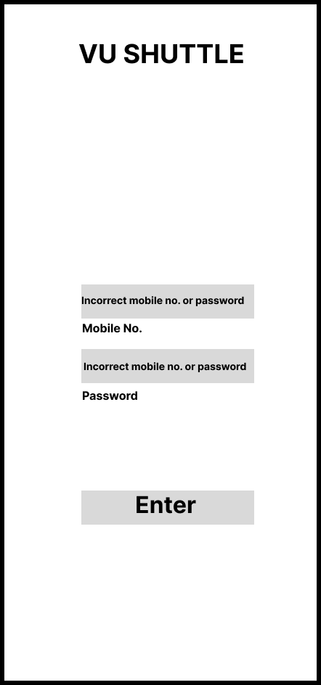  Before | After

3. Prototype Link
https://www.figma.com/proto/It6uSypPDmtOqGStwJ1ztP/UI-UX_UT2?node-id=1-2&t=HVLDKRKHOcI64G9v-1

