NFL Team Power Rankings

Landon Hill ([lhill5@g.clemson.edu](mailto:lhill5@g.clemson.edu))

Tre’zjon Bell ([trezjob@clemson.edu](mailto:trezjob@clemson.edu))   
Tyler Piel ([tpiel@g.clemson.edu](mailto:tpiel@g.clemson.edu))  
Parth Patel ([pbp@g.clemson.edu](mailto:pbp@g.clemson.edu))

**Abstract:**

The use of artificial intelligence to generate weekly power rankings of NFL teams was explored in this project. The SAGA solver and lasso regression model were used to accurately predict the rank of each NFL team based on select team performance metrics. Data was collected from 2003 to 2021 to provide a more precise machine learning model. The data was compared to the rankings of teamrankings.com.

**Contribution Summary:**

| Tasks | Investigator(s) | Working hours | Others |
| --- | --- | --- | --- |
| Project idea brainstorming & research | Parth Patel, Tyler Piel, Tre’zjon Bell, Landon Hill | 2 |  |
| Web scraping & data formatting | Parth Patel and Landon Hill | 14 |  |
| Data processing | Tyler Piel and Tre’zjon Bell | 5 |  |
| Model Implementation | Tyler Piel and Parth Patel | 5 |  |
| Training and testing data predictions | Landon Hill and Parth Patel | 2 |  |
| Presentation | Parth Patel, Tyler Piel,  Tre’zjon Bell, Landon Hill | 2 |  |
| Report | Tre’zjon Bell, Tyler Piel, Parth Patel | 3 |  |

# Objective

The objective of the project is to create a machine learning model to accurately predict weekly NFL team power rankings based on select offensive and defensive metrics. For offense, the metrics chosen were completion percentage, interceptions (thrown by quarterback), red zone completion percentage, third down conversions, touchdowns per game, yards per game, and yards per point. For defense, the metrics chosen were opponent completion percentage allowed, opponent red zone completion percentage allowed, sacks, takeaways (interceptions, turnover on downs, forced fumbles), opponent third down conversions allowed, opponent yards per game allowed. As a team, we decided to select these specific metrics as they are the most important stats to consider when determining the strength/weakness of a team.

# Background

The National Football League (NFL) is the United States of America’s most popular sport. The league is made up of thirty-two teams that are split into two conferences: American Football Conference (AFC) and National Football Conference (NFC). Each conference is separated into four divisions: north, east, south, and west. With this structure, the NFL season lasts from September to February, giving each team a preseason of 17 games plus the number of games each team advances in the superbowl bracket. Famous sports services like ESPN record and analyze the statistics of teams and players to evaluate their performance and power rankings.

# Introduction

The use of artificial intelligence to predict real-time sports teams power rankings is common among a variety of sports services. Machine learning extends our capabilities to predict which are the best and worst teams in the NFL. From this prediction, it can be concluded that higher ranking teams are expected to win against lower ranked teams in future matchups.

# Methodology

Data from the 2003-2021 NFL seasons was web scrapped from teamrankings.com using the selenium library in Python. The metrics of interest were hand-picked and each metric yielded its own separate CSV file consisting of columns year, month, day, team and value. These individual csv files underwent data formatting and cleanup. Ultimately, all of the metrics/csv files were merged together into a complete dataset, which consisted of 32 teams playing 17 games a season from 2003 to 2021 duplicated (i.e. ravens vs brown = entry 1 while browns vs ravens = entry 2). The final dataset was split into a training dataset and a testing dataset. The training data was football seasons 2003 to 2020, while the testing dataset was only football season 2021.

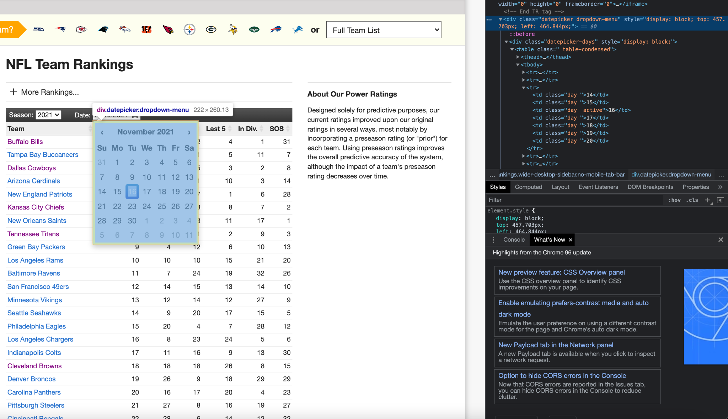

**Figure 1**: shows the web scraping of teamrankings.com using the selenium library

The python libraries pandas, numpy and sklearn were used to standardize the data and generate machine learning regression models. The gradient descent, stochastic gradient descent, and stochastic average gradient were attempted, but ultimately, the SAGA solver provided the best results. The SAGA solver is a variant of the stochastic average gradient model that is capable of performing L1 regularization, also known as lasso regression, as opposed to just the standard L2 regularization SAG uses. The key difference between the L1 and L2 regularization is that L1 is capable of dropping unimported feature weights to the value of 0 for faster and more accurate prediction results. This feature makes it more efficient when dealing with large datasets with many features. Thus, it was more suitable to use this model with the 24 features in our data to optimize accuracy and training speed.

# Results

5 NFL teams (Kansas City Chiefs, Pittsburgh Steelers, Tennessee Titans, Cleveland Browns, and San Francisco 49ers) were chosen at random amongst the total 32 teams to compare the actual rank versus the predicted rank. By observation, these values were very close and there was found to be a positive correlation between the ranks. The accuracy from sklearn was found to be higher than 31%. As expected, some teams dropped in ranking while other teams rose in ranking, demonstrating the success of the regression model.

| **Team Name** | **Actual Rank** | **Predicted Rank** |
| --- | --- | --- |
| Kansas City Chiefs  (2021-10-03) | 2 | 3 |
| Pittsburgh Steelers  (2021-10-10) | 19 | 22 |
| Tennessee Titans  (2020-10-10) | 17 | 18 |
| Cleveland Browns  (2021-10-03) | 6 | 9 |
| San Francisco 49ers  (2021-10-31) | 16 | 24 |

**Table 1:** shows the actual rank vs the predicted rank for the testing dataset

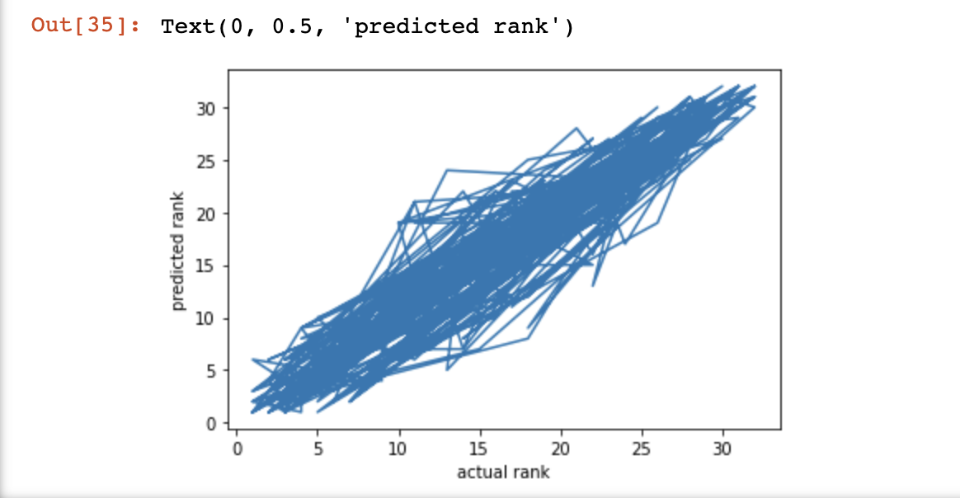

**Figure 2**: shows the correlation between predicted rank and actual rank.

# Conclusions

The SAGA solver with L1 regularization model was successful in predicting the power rankings of NFL teams. However, there are some limitations and risks to consider. The presence of skewed data can be accounted for in the fact that offensive and defensive metrics were weighted the same. In addition, there were duplications in weekly stats to evaluate each metric from an offensive and defensive perspective (Ex. completion percentage [offense] vs completion percentage allowed [defense]). Ultimately, it should be noted that the data source can also be biased as rankings are human influenced and teams with almost identical performances have subjective rankings.