**William Bates: Bates method**

Get 20/20 vision in a month!

Unless you are willing to spend a couple of months of your life with false hope of achieving 20/20 vision, I would advise against trusting the Bates method.

**What is the Bates method?**

As its advertised, The bates method is an alternative treatment for myopia. It is secret that eye doctors don’t want to tell you. The legend is that the treatment was developed by a unjustly treated ophthalmologist named William bates.

The wonders of the bates method is that it does not require any special instruments or even a physician. It can be performed anywhere: home or work. The method is so effective that doctors are not allowed to refer it to you. It is a deep dark secrets kept from the general public.

The reality is, however, the bates method doesn’t work.

The method works by the theories of William Bates. Instead of adhering the models of his time that described the inner working of the eyes, bates was different. He proposed new theories about how the eyes works. Such as: extra-ocular muscles (muscles that surround the eyeball) allow you to focus, not the lens, and your refractive errors are due to eye strain.

The general understanding of the eyes has been

* Lens and associated muscles allow the eyes to change focus, near and far.
* The extra-ocular muscles move the eyes around. Up, down, side to side.

Bates on the other hand theorized

* The Lens and associated muscles did not serve a purpose in focusing
* The extra-ocular muscles allow us to change focus, and move the eyes around.

Bates was different, and the bates method which followed these theories was advertised to be immensely successful.

When really it is used as another money-making scheme.

The first part of the method is to get rid of your glasses

Bates believed that poor vision could be cured, and unlike many other contemporary eye doctors, he didn’t think glasses were the solution. Glasses were “eye crutches” that would only harm the eyes and they should be thrown away.

The second part is to perform “eye exercises” to exercise your muscles and keep them from causing refractive errors.

Legit? Bates followers today push the exercises of the Bates method as the holy grail. Some of the main ones are:

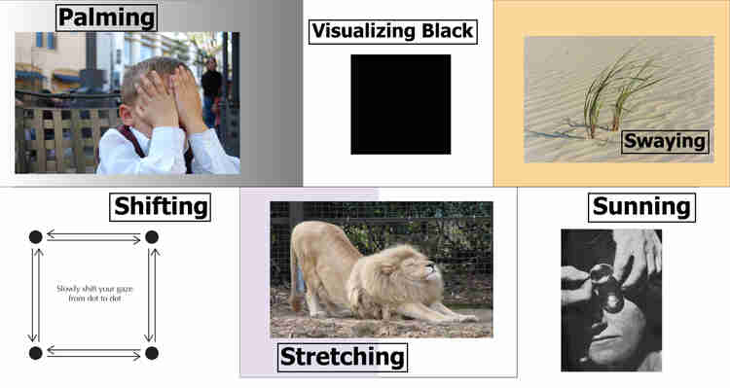

Bates method eye exercises

The goal, as bates believed, was to help you relax your eyes. Relaxing would help get rid of the eye strain that causes your problems. Out of all the exercises, palming is the most important. It goes like this.

1. First, you get comfortable. Sit down if you can and relax
2. Next, you want to remove your glasses
3. Then you rub your hands together and warm your palms up
4. Cover your eyes completely with your palms; Make sure no light gets through
5. Hold position while retaining normal breathing. Relax

Sounds cool, and gives you temporary clear flashes. But like the other exercises, does nothing in the long-run. The exercises were for a good cause, but don’t really work… Sure they help you relax, but they are not the mystic power to “reverse your myopia in 30 days” as they were made out to be.

No one has ever reversed myopia and achieved 20/20 vision from the Bates method and unfortunately, no one ever will. There is just too much false advertising on the internet about these exercises. All a bunch of money-making schemes: offer a compelling story of a doctor that was covered up for developing groundbreaking theories and techniques, hype it up, and cash in. It’s all a bunch of BS.

Bates theories and methods are even rejected by the ophthalmologist community on a scientific basis. Yet, that doesn’t stop the internet.

**What does it actually do?**

What does the bates method actually help with? It isn’t completely trash. I was 10/10 recommend some bates method eye exercises to relax your eyes. Certain exercises such as palming, and swinging definitely help you reduce stress, eye strain, and leave you refreshed afterward. Many of the eye movement exercises are also used in vision therapy. These are exercises used to treat many eye disorders such as Crossed eyes, which is when the two eyes don’t face the same direction. Eye exercises can help exercise the muscles to get the eyes back on track.

Unfortunately, not all the exercises are useful like this. For example, looking at the sun is not a recommended activity by any measure. Keeping your eyes open will definitely leave permanent eye damage. Even with your eyelids closed, UV rays from the sun can get through and damage your eyes. It's just safe overall to avoid looking at the sun when possible.

The useful and non-harmful eye exercises of the bates method still fail to solve the underlying problem of myopia. Many of the eye exercises do help maintain health of the eyes. But for myopia……. Not so useful. William Bates had good intentions with the Bates method, but the method just doesn’t work. The basis theories have been proven false. At most, the users experience a slight improvement. And even this small improvement, if any, comes from relaxation and the increased awareness about activities that affect the eyes. The method does not give you any permanent improvement.

It’s very sad to see that the Bates method is clogging the internet and is clouding the real science behind vision improvement. The followers claim to help you achieve 20/20 but shadow the actual science. Isn’t that ironic?

The reality is these guys are just out there to make money from Bates: selling kits, pinhole glasses and etc…