# Do I really NEED my glasses?

Glasses generally come in a large variety of frames. Some people think glasses look cute. Can’t say they are completely wrong. You can go for a ivy league look, vintage look, sophisticated look, and many more. Coordinating face shape, outfit, and frames can make for a killer appearance. At its basis, glasses are just another accessory that you can add to your look, kind of like a hat. Of course there are limitations; you can’t pull off a beach hat at formal meetings. Glasses for fashion, have certain rules too. Similar to hats, they are one of those items that can look normal at some occasions, fashionable at others, or just not work at all.

**What do glasses actually do?**

Aside from fashion, they are normally given to people who are farsighted or nearsighted them see clearly

If you are farsighted that means your eyeball is too short. The light can’t focus on the back of the eye (retina). The lighted is focused too far behind; So glasses pull that light a little forwards.

On the other hand, If you are nearsighted your eyeball is too long. The light wants to reach the back of the eye, but it just can’t; it's too far of a reach. Glasses helps by pushing the light a little further back so that the light hits exactly the retina.

To the normal, non-sciency folk, in summary glasses help you see better. Contact lens do the same thing, but the only difference is that they go inside your eye while glasses are on your face.

From the way, I described it. Glasses seem like an amazing accessory that can look fashionable and can help your see better. But, the game changes completely when you don’t have a CHOICE besides wearing them all the time. They suck, you go from trying to look “cute” to being called “four-eyes”

Glasses aren’t viable, you literally have a piece of plastic/metal hanging on your face 24/7. It’s like having braces with an orthodontic headgear; Your teeth already hurt enough and now you also look like cyborg. The only difference between headgear and glasses is that glasses are more socially accepted, because so many people are wearing them

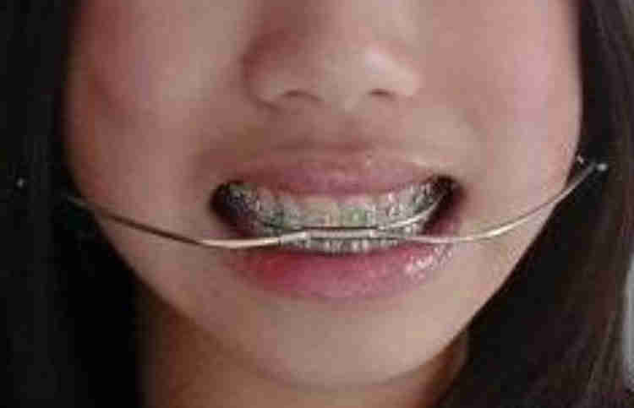

There is no fun in having to be reliant on something to normally carry out daily activities. So, that's when the question comes out: do you really need your glasses? For people that have extremely high myopia 10+, of course you need your glasses! But for the rest of us Sure they help you see clearer, but are they worth the pain-in-the-butt?

The real answer is: it depends. But simply put... **Yes, you should keep your glasses. Don’t throw them away!**

If you have very mild myopia, let’s say -0.25 in both eyes. Then you can probably get by without glasses. But for people who have a decent amount of myopia in the range of -1.00 to -3.00, you will want to keep wearing glasses. The reason is you want to avoid blur adaptation.

Blur adaptation

I’m going to let you in on a secret, getting rid of your glasses makes your vision better. This has been proven over and over. Here is a link to a study. ([link](https://www.ncbi.nlm.nih.gov/pubmed/15365384))

Before you flip in your chair and start chanting Bates’s name, here me out. Getting rid of your glasses does improve your vision, but it will NOT get you 20/20 vision.

Vision is a joint effort between your eyes and brain. The brain is needed to interpret images, clarify images, coordinate the eyes, and much more. If you stop wearing your glasses, the brain covers for you. It senses that something is wrong, and going to try to clear the image that its receiving. It does this by neurological adaptation. Your brain will adapt itself to a blurry image.

This same thing happens when you start working out. For example, did you know that your strength depends on your nervous system as much as it depends on your muscles. Your nervous system is the control system in your body. It consists of the wires that connect between the brain/spinal cord to the other parts of the body. These wires known as nerves control the rest of the body parts from moving, breathing and even pooping.

When you first start working out, the majority of the strength gains come from your nervous system. The nerves adapt to the increasing weight load and the increased stress, by developing better response times, activating more muscle, and other cool sciency stuff. As a matter of fact, it takes a while for you to make actual muscle gains, because it's easier to adjust neurons than to make more muscle. Here is a link to a cool study to know for the gym ([link](https://www.sciencedaily.com/releases/2017/07/170710091652.htm)).

Imagine your eye to be a muscle just like your actual muscles. Vision consists of as much of the nervous system as it does the physical eye. When you take your glasses off, your body wants to go in the direction of as close to perfect vision as it can. So instead of adjusting the physical eye ( which is what we want! ) it adjust the brain, because that’s easier.

**We DONT want blur adaptation**

You need your glasses, because you don’t want to adapt to blurriness. You don’t want to adjust your brain to see clearly, you want to adjust your ACTUAL eyes. Blur adaptation does not get rid of the problem, it just masks over it.

Here is a article for blur adaptation for more ([link](https://www.ncbi.nlm.nih.gov/pubmed/15365384)).

Guys, keep on your glasses. They are ugly, and annoying, but they’ll help you not run into a pole one day. Plus your eyes will thank you.