class MyThread extends Thread {
public MyThread(String name) {
super(name);
}

public void run() {
for (int i = 1; i <= 5; i++) {
System.out.println(Thread.currentThread().getName() +
" (Priority: " + Thread.currentThread().getPriority() + ") -> Count: " + i);
try {
Thread.sleep(500);
}
catch (InterruptedException e) {
System.out.println(e);
}
}
}

public static void main(String[] args) {
MyThread t1 = new MyThread("Thread-A");
MyThread t2 = new MyThread("Thread-B");
MyThread t3 = new MyThread("Thread-C");

// Setting different priorities
t1.setPriority(Thread.MIN_PRIORITY); // 1
t2.setPriority(Thread.NORM_PRIORITY); // 5 (default)
t3.setPriority(Thread.MAX_PRIORITY); // 10

// Starting threads
t1.start();
t2.start();
t3.start();
}
}
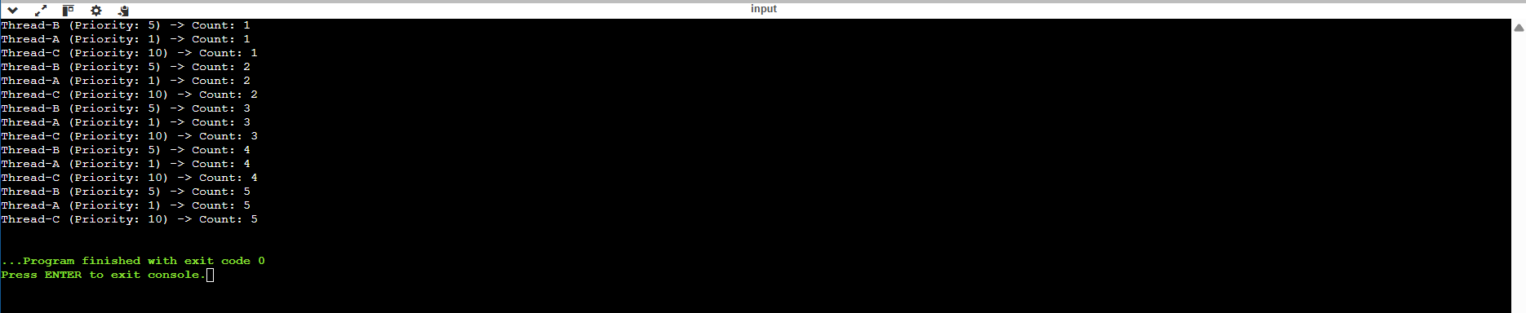
------------------------------------------------------------------------------------------------------------------------------------------------------------------------------------------------------------------------------------------------------------------------------------------------------------------------------------------------
class TrainReservation{
int total_berths = 12;
synchronized void bookBreth (int berths) {
if(total_berths >= berths) {
System.out.println(berths + " Berths booked successfully");
total_berths = total_berths - berths;
System.out.println("Berths left: " + total_berths);
}
else {
System.out.println("Booking failed");
System.out.println("Berths left: " + total_berths);
}
}
}

class TrainBookingApp extends Thread {
TrainReservation reservation = new TrainReservation();
int berths;
public void run() {
reservation.bookBreth(berths);
}
public static void main(String[] args) {
TrainBookingApp p1 = new TrainBookingApp();
p1.berths = 8;
p1.start();

TrainBookingApp p2 = new TrainBookingApp();
p2.berths = 6;
p2.start();
}
}
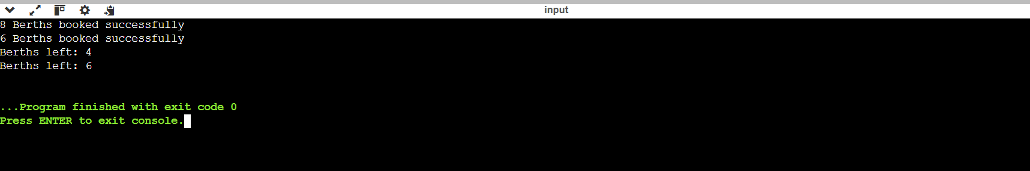
------------------------------------------------------------------------------------------------------------------------------------------------------------------------------------------------------------------------------------------------------------------------------------------------------------------------------------------------
class Buffer {
int data;
boolean isFull = false;

// synchronized method for producer
synchronized void produce(int value) {
// agar buffer full hai, producer wait karega
while (isFull) {
try {
wait();
} catch (InterruptedException e) {
System.out.println(e);
}
}
data = value;
System.out.println("Produced: " + value);
isFull = true;
notify(); // consumer ko jagao
}

// synchronized method for consumer
synchronized void consume() {
// agar buffer empty hai, consumer wait karega
while (!isFull) {
try {
wait();
} catch (InterruptedException e) {
System.out.println(e);
}
}
System.out.println("Consumed: " + data);
isFull = false;
notify(); // producer ko jagao
}
}
// Producer Thread
class Producer extends Thread {
Buffer buffer;

Producer(Buffer buffer) {
this.buffer = buffer;
}

public void run() {
int i = 1;
while (i <= 5) { // produce 5 items
buffer.produce(i);
try {
Thread.sleep(1000);
} catch (InterruptedException e) {
System.out.println(e);
}
i++;
}
}
}

// Consumer Thread
class Consumer extends Thread {
Buffer buffer;

Consumer(Buffer buffer) {
this.buffer = buffer;
}

public void run() {
int i = 1;
while (i <= 5) { // consume 5 items
buffer.consume();
try {
Thread.sleep(1500);
} catch (InterruptedException e) {
System.out.println(e);
}
i++;
}
}
}

// Main class
public class ProducerConsumerExample {
public static void main(String[] args) {
Buffer buffer = new Buffer();

Producer producer = new Producer(buffer);
Consumer consumer = new Consumer(buffer);

producer.start();
consumer.start();
}
}
