Chapter 7: Advanced Topics

7.1 Introduction to Software-Defined Networking (SDN), basic architecture,importance and application

What is SDN?
Software-Defined Networking (SDN) is an innovative network architecture where the control plane is logically separated from the data plane. Rather than having routing intelligence distributed across every individual device, a centralized software-based controller governs all forwarding decisions.
It enables network programmability and automation, making the infrastructure far more flexible and responsive to changing demands.
SDN was developed to overcome the limitations of traditional networks: static configurations, vendor lock-in, and difficulty scaling to meet modern cloud and data centre workloads.

SDN Architecture (3 Layers):
SDN operates through a three-layer


Application Layer

Northbound APIs

Control Layer

Southbound APIs

Infrastructure Layer

Fig: SDN architecture

Application Layer:
Hosts network services and applications such as load balancers, intrusion detection systems, and bandwidth monitors.
Enables administrators to program high-level network behaviour and policies.
Eg: Firewall, Traffic Analyser

Control Layer:
It contain SDN Controller (e.g., Ryu, ONOS, Floodlight).
Acts as the network's 'brain', computing forwarding paths and issuing instructions to devices.

Infrastructure Layer (Data Plane):
Comprises physical network hardware (switches and routers) that forwards packets strictly according to rules received from the controller.

Eg: OpenFlow-enabled Switches

Key interfaces in SDN:
• Northbound API: Interface between the Application Layer and Control Layer,
enabling apps to request services from the controller (e.g., RESTful APIs,
RESTCONF).
• Southbound API: Interface between the Controller and Infrastructure Layer, used to program flow tables in switches (e.g., OpenFlow, NETCONF).

Importance of SDN:
• Unified Network Control: A single controller manages the entire network,
eliminating the need to configure every device individually.
• Programmability: Network behaviour is defined in software, allowing instant
changes without hardware replacement.
• Scalability & Flexibility: Easily scales to support large cloud deployments and
adapts to new workloads dynamically.
• Cost Efficiency: Uses inexpensive commodity hardware since intelligence resides in the controller software.
• Global Network Visibility: The controller maintains a real-time, topology-wide view for optimal routing and resource utilization.

Applications of SDN:
• Cloud Data Centre: Automates provisioning and management of virtual networks
across thousands of VMs.
• SD-WAN: Intelligently routes enterprise traffic over multiple WAN links (MPLS,
broadband, LTE).
• Network Slicing (5G): Creates isolated virtual networks for different service types
(IoT, video, critical communications).
• Cyber security: Pushes real-time blocking rules across all network devices in
response to threats.
• Research & Experimentation: Allows researchers to test new protocols on live
infrastructure safely.

7.2 Network Security and Its Importance
What is Network Security?
Network security refers to the combination of hardware, software, and procedural strategies employed to safeguard computer networks and their data from unauthorised access, exploitation, disruption, or destruction. It ensures the network remains trustworthy and operational for legitimate users at all times.

Goals of Network Security (CIA Triad):
• Confidentiality: Ensures that sensitive data is accessible only to those with proper
authorisation. Example: Symmetric and asymmetric encryption (AES, RSA).

• Integrity: Guarantees that data has not been altered or corrupted during storage or
transmission. Example: Hash algorithms (SHA-256, MD5).

• Availability: Ensures network services and resources remain accessible to
authorised users whenever needed. Example: Redundant servers, anti-DDoS
systems.

Common Network Threats:

Threats | Description | Example
Malware | Self-replicating malicious code that spreads through systems | Virus,Worm, Conficker
Phishing | Social engineering attack to steal credentials via deception | Fake university login pages
Man-in-the-Middle | Attacker secretly intercepts and possibly alters communications | SSL Stripping, ARP Poisoning
DoS / DDoS | Flooding target with traffic to make it inaccessible | Mirai Botnet Attack
Ransomware | Malware that encrypts victim data and demands payment | WannaCry, Ryuk
Insider Threat | Malicious or careless actions by authorised users Employee | data exfiltration

Network Security Measures / Techniques:

• Firewall: Monitors and filters incoming/outgoing packets based on predefined security rules.Acts as the boundary between trusted internal networks and untrusted external networks.

• Encryption: Transforms data into cipher-text readable only by intended recipients.
Common protocols:TLS/SSL for web traffic,AES for file encryption,IPSec for VPN tunnels.

• IDS (Intrusion Detection System): Passively analyses traffic and logs for suspicious patterns, generating alerts for administrators.

• IPS (Intrusion Prevention System): Extends IDS by actively blocking detected threats in real time before they cause harm.

• VPN (Virtual Private Network): Establishes an encrypted tunnel over a public network, enabling secure remote access to private resources.

• Authentication: Validates the identity of users and devices before granting access.
Methods include passwords, smart cards, biometric, and Multi-Factor Authentication (MFA).

• PKI (Public Key Infrastructure): Uses digital certificates and public/private key cryptography to verify identities and encrypt communications.

Importance of Network Security:
• Safeguards personal and organisational data from theft, leakage, or ransomware
attacks.
• Prevents unauthorised intrusions and ensures only legitimate users access resources.
• Guarantees business continuity by mitigating DoS/DDoS disruptions.
• Builds customer confidence and ensures compliance with data protection regulations
(GDPR, ISO 27001).
• Defends critical national infrastructure such as power grids and communications from cyber warfare.

7.3 Overview of Content Delivery Networks (CDN), Named Data
Networking (NDN), and Intent-Based Networking (IBN)

- Content Delivery Networks (CDN):
A Content Delivery Network (CDN) is a globally distributed system of proxy servers and datacentres, strategically positioned to serve web content to users from the closest geographic location. CDNs cache and deliver static content including web pages, images, videos, and scripts reducing the distance data must travel and significantly improving load times.

How CDN Works:
- A user requests a web resource (e.g., a Netflix video or an image on a news site).
- The CDN's DNS system directs the request to the nearest edge server (Point of Presence).
- If the content exists in the edge server's cache (cache hit) ® served immediately.
- If not (cache miss) ® the edge server fetches from the origin, caches it locally, then serves the user.
- Future requests from users in that region are served directly from the edge cache.

Benefits of CDN:
  - Dramatically reduces page load times by minimising geographic distance to the user.
  - Offloads traffic from origin servers, preventing overload during peak demand.
  - Improves fault tolerance if one edge server fails, requests are rerouted to the next nearest.
  - Absorbs DDoS attack traffic across a distributed network of servers.
  - Examples: Cloudflare, Akamai, Amazon CloudFront, Fastly, Azure CDN.

- Named Data Networking (NDN):
Named Data Networking (NDN) is a clean-slate future internet architecture proposed to
fundamentally rethink how the internet operates. Traditional IP networks route data based
on where it is located (IP address). NDN shifts this to route based on what the data is,
using hierarchical content names.

Key Concepts in NDN:
• Content-Based Routing: Data is identified by a unique name (e.g.,
/IOE/BCT/semester6/networks/chapter7.pdf) rather than an IP address. Routers
forward Interest packets based on name prefixes.

• In-Network Caching: Every NDN router maintains a Content Store (CS) that caches recently retrieved data. Any future request for the same content can be served directly by an intermediate router.

• Interest & Data Packets: A consumer sends an Interest packet specifying the
desired content name. Any node holding that content responds with a Data packet.

• Data-Centric Security: Each Data packet is cryptographically signed by its original
publisher. Trust is bound to the data itself, not the channel it travels on.

Advantages of NDN:
• Naturally eliminates redundant traffic the same video only needs to traverse a link once, and subsequent users are served from the cache.
• Supports seamless mobility content names remain stable even as devices move
between networks.
• Built-in multicast: multiple Interest packets for the same content are merged into one, and a single Data packet satisfies all requesters.

Feature | Traditional IP Network | Named Data Network (NDN)
Addressing | IP Address (destination-based) | Content Name (name-based)
Security | Secured at transport channel (TLS) | Secured at the data level (signed packets)
Caching | Only at dedicated CDN/proxy servers | Any intermediate router can cache data
Routing | Based on destination IP address | Based on hierarchical content names

- Intent-Based Networking (IBN) :
Intent-Based Networking (IBN) is an advanced form of network automation where the
network administrator specifies the desired business outcome or intent in plain language,
and the system automatically translates this into configurations and continuously validates
compliance. It extends SDN by adding a layer of intelligence and closed-loop assurance.
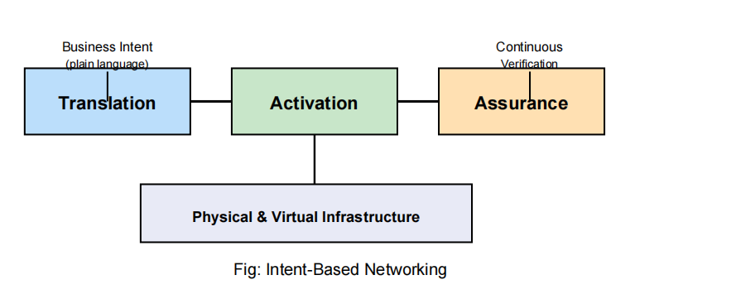

How IBN Works (4 Steps):

- Step 1 Translation: The administrator's intent (e.g., 'All student devices must be isolated from staff servers') is parsed and translated into network policies.

- Step 2 Activation: The IBN system automatically pushes configurations to all relevant network devices without manual CLI commands.

- Step 3 Physical & Virtual Infrastructure: The actual hardware and virtualized devices (routers, switches, firewalls, virtual machines) where policies are enforced.

- Step 4 Assurance: The system continuously monitors the network and verifies that the declared intent is being met, alerting or auto-remediating if deviations occur.

Benefits of IBN:
• Eliminates human error from manual device-by-device configuration.
• Allows non-technical stakeholders to express network requirements in business
language.
• Provides continuous compliance verification and self-healing capabilities.
• Accelerates deployment of new network services and policy changes.
• Example: Cisco DNA Center, Juniper Apstra, VMware NSX Intelligence.

7.4 Quantum Network, Network Virtualization, and Recent Trends in Networking

- Quantum Networking:
Quantum networking is an emerging paradigm that exploits principles of quantum mechanics to transmit information with properties impossible in classical systems. Rather than classical binary bits (0 or 1), quantum networks use quantum bits (qubits), which can represent 0, 1, or a superposition of both simultaneously.

Key Concepts in Quantum Networking:

• Qubit and Superposition: A qubit can exist as 0, 1, or any combination of both at the same time due to superposition. This allows quantum systems to explore many solutions simultaneously.

• Quantum Entanglement: Two entangled qubits share a correlated quantum state measuring one instantly defines the state of the other, regardless of distance. This forms the basis of quantum communication.

• Quantum Key Distribution (QKD): A provably secure key exchange method. Any attempt to eavesdrop disturbs the quantum states, making interception immediately detectable. Implements BB84 and E91 protocols.

• Quantum Repeaters: Classical signal amplifiers destroy quantum information. Quantum repeaters use entanglement swapping to extend quantum network range without collapsing qubit states.

Advantages of Quantum Networking:
• Unconditional security eavesdropping is physically detectable due to quantum
measurement disturbance.
• Enables distributed quantum computing, connecting quantum processors over a
network.
• Can solve certain computational problems exponentially faster than classical
systems.

- Network Virtualization
Network Virtualization is the process of abstracting physical network resources into software-defined logical entities. Multiple independent virtual networks can operate simultaneously over the same physical hardware, each appearing as a completely separate network to its users.

Types of Network Virtualization:

• VLANs (Virtual Local Area Networks): Logically segments a physical network into multiple isolated broadcast domains using IEEE 802.1Q tagging. Example: separating student and staff networks on the same switches.

• Overlay Networks: Creates logical networks on top of physical ones using tunneling protocols (VXLAN, GRE). Widely used in cloud infrastructure to extend Layer-2 segments across data centres.

• SDN-Based Virtualization: Decouples control from the underlying hardware, enabling centrally managed virtual networks that can be created, modified, or deleted instantly through software.

• Network Function Virtualization (NFV): Moves hardware-based network functions (firewalls, NAT, load balancers, DPI) to software running on general- purpose servers. These are called Virtual Network Functions (VNFs).

Benefits of Network Virtualization:
• Reduces capital expenditure by consolidating multiple network functions onto
commodity hardware.
• Accelerates service deployment new virtual networks can be provisioned in
minutes rather than weeks.
• Provides strong isolation between tenants, improving security in multi-tenant
environments.
• Enables elasticity virtual networks can scale up or down based on demand.
• Foundation of modern cloud platforms: AWS VPC, Azure Virtual Network, Google
Cloud VPC.

- Recent Trends in Networking :
The networking industry is undergoing rapid transformation. Key trends shaping the future
include:
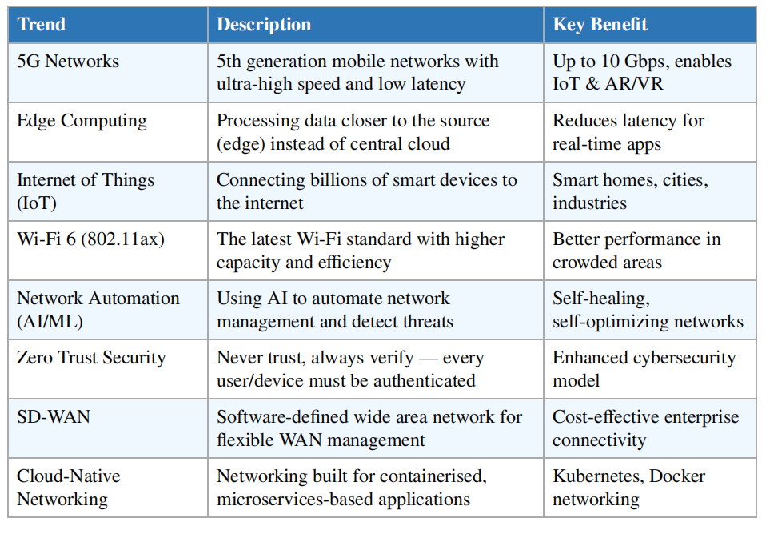

5G and Its Impact:
• Speed: Peak downlink of 10 Gbps approximately 100x faster than 4G LTE networks.
• Latency: End-to-end latency as low as 1 millisecond, enabling real-time control
systems.
• Capacity: Supports up to 1 million connected devices per square kilometre.
• Enables: Autonomous vehicles, remote robotic surgery, massive IoT deployments, immersive AR/VR.
• Uses millimetre wave (mmWave) frequencies and Massive MIMO antenna arrays.

Edge Computing:
• Moves computation from centralised cloud data centres to servers at the network
edge base stations, gateways, or on-premises equipment.
• Dramatically reduces bandwidth usage and round-trip latency for time-sensitive
applications.
• Examples: Autonomous vehicle processing, real-time factory automation, smart grid
monitoring.

